3GPP TS 23.014 V10.0.0 (2011-03)

Technical Specification

3rd Generation Partnership Project;

Technical Specification Group Core Network and Terminals;

Support of Dual Tone Multi-Frequency (DTMF) signalling

(Release 10)

 

The present document has been developed within the 3rd Generation Partnership Project (3GPP TM) and may be further elaborated for the purposes of 3GPP.  
The present document has not been subject to any approval process by the 3GPPOrganisational Partners and shall not be implemented.  
This Specification is provided for future development work within 3GPPonly. The Organisational Partners accept no liability for any use of this Specification.  
Specifications and reports for implementation of the 3GPP TM system should be obtained via the 3GPP Organisational Partners' Publications Offices.

Keywords

GSM, UMTS, network, DTMF

***3GPP***

Postal address

3GPP support office address

650 Route des Lucioles - Sophia Antipolis

Valbonne - FRANCE

Tel.: +33 4 92 94 42 00 Fax: +33 4 93 65 47 16

Internet

http://www.3gpp.org

***Copyright Notification***

No part may be reproduced except as authorized by written permission.  
The copyright and the foregoing restriction extend to reproduction in all media.

© 2011, 3GPP Organizational Partners (ARIB, ATIS, CCSA, ETSI, TTA, TTC).

All rights reserved.

UMTS™ is a Trade Mark of ETSI registered for the benefit of its members

3GPP™ is a Trade Mark of ETSI registered for the benefit of its Members and of the 3GPP Organizational Partners  
LTE™ is a Trade Mark of ETSI currently being registered for the benefit of its Members and of the 3GPP Organizational Partners

GSM® and the GSM logo are registered and owned by the GSM Association

Contents

Foreword 4

1 Scope 5

2 References 5

3 Abbreviations 5

4 Requirement 5

5 Cause of DTMF generation 6

6 Support of DTMF across the air interface 6

6.1 General 6

6.2 Specific 6

6.3 Tone durations 7

7 Effect of Handover 10

7.1 Internal Handover 10

7.2 External Handover 11

Annex A (informative): Change history 12

# Foreword

This Technical Specification has been produced by the 3rd Generation Partnership Project (3GPP).

The present document defines Dual Tone Multi Frequency (DTMF) signalling within the 3GPP system.

The contents of the present document are subject to continuing work within the TSG and may change following formal TSG approval. Should the TSG modify the contents of this TS, it will be re-released by the TSG with an identifying change of release date and an increase in version number as follows:

Version x.y.z

where:

x the first digit:

1 presented to TSG for information;

2 presented to TSG for approval;

3 Indicates TSG approved document under change control.

y the second digit is incremented for all changes of substance, i.e. technical enhancements, corrections, updates, etc.

z the third digit is incremented when editorial only changes have been incorporated in the specification;

# 1 Scope

The present document describes how Dual Tone Multi Frequency (DTMF) signals are supported in the 3GPP system.

# 2 References

The following documents contain provisions which, through reference in this text, constitute provisions of the present document.

* References are either specific (identified by date of publication, edition number, version number, etc.) or non‑specific.
* For a specific reference, subsequent revisions do not apply.
* For a non-specific reference, the latest version applies. In the case of a reference to a 3GPP document (including a GSM document), a non-specific reference implicitly refers to the latest version of that document *in the same Release as the present document*.

[1] Void.

[1a] 3GPP TR 21.905: "Vocabulary for 3GPP Specifications".

[2] 3GPP TS 45.002: "Multiplexing and Multiple Access on the Radio Path".

[3] ETSI ES 201 235-1, v1.1.1: "Specification of Dual Tone Multi-Frequency (DTMF); Transmitters and Receivers; Part 1: General".

[4] ETSI ES 201 235-2, v1.2.1: "Specification of Dual Tone Multi-Frequency (DTMF); Transmitters and Receivers; Part 2: Transmitters".

[5] ETSI ES 201 235-3, v1.2.1: "Specification of Dual Tone Multi-Frequency (DTMF); Transmitters and Receivers; Part 3: Receivers".

[6] ITU-T Recommendation H.245: "Control protocol for multimedia communication"

# 3 Abbreviations

For the purposes of the present document, the abbreviations used in the present document are listed in 3GPP TR 21.905 [1a].

# 4 Requirement

Dual Tone Multi Frequency (DTMF) is an inband one out of four plus one out of four signalling system, primarily used from terminal instruments in telecommunication networks. The international recommendations which apply are ETSI ES 201 235 [3, 4, 5] as detailed in subclauses 6.2 and 6.3. For PCS 1900 for North America the Standards which apply are operator specific.

In the 3GPP system the MSC must support DTMF in the mobile to land direction.

The support of this facility in the land to mobile direction is for further study.

The use of DTMF is only permitted:

- when the speech teleservice is being used or during the speech phase of alternate speech/data and alternate speech/facsimile teleservices; the DTMF is transmitted across the radio interface as specified in subclause 6 of this specification; and

- during a multimedia call; the DTMF is transmitted across the radio interface using the H.245 UserInputIndication message (see ITU-T H.245 [6]). This is transparent for the MSC.

The responsibility for checking this lies in the MS.

# 5 Cause of DTMF generation

A user may cause a DTMF tone to be generated by depression of a key in the Mobile Station (MS). Optionally (on a MS basis) manufacturers of mobile equipment may choose to allow DTMF to be controlled from a remote terminal.

The man-machine interface questions associated with this facility are not discussed further in the present document.

# 6 Support of DTMF across the air interface

## 6.1 General

A message based signalling system is used across the 3GPP system air interface.

This requires that the relevant user action (e.g. a key depression) is interpreted by the MS as a requirement for a DTMF digit to be sent, this is converted by the MS into a message, the message is transmitted across the air interface, and is converted by the MSC into a DTMF tone which is applied towards the network, which should then respond with an acknowledgement. When the user completes the key depression, an message that the DTMF sending should cease is also passed to the MSC, which again will respond with an acknowledgement.

## 6.2 Specific

The messages to be sent across the air interface will use the frame stealing mode of transmission.

The messages when sent across the air interface should contain the following information:

a) START DTMF: Containing the digit value (0-9,A,B,C,D,*,#);

b) START DTMF ACKNOWLEDGE: Containing the digit value (0-9,A,B,C,D,*,#) corresponding to the DTMF tone that the network applies towards the remote user;

c) STOP DTMF: No further info;

d) STOP DTMF ACKNOWLEDGE: No further info.

Only a single digit will be passed in each START DTMF and START DTMF ACKNOWLEDGE message.

The messages will be passed transparently through the base station and interpreted at the MSC.

On receipt of a START DTMF message, the MSC will connect the correct dual-tone to line. This tone will remain connected until either the call is cleared or a STOP DTMF message is received.

As an operator option, the tone may be ceased after a pre-determined time whether or not a STOP DTMF message has been received.

The tones that are to be generated by the MSC are specified as follows:

- Frequencies are defined in ETSI ES 201 235-1 [3] (for PCS 1900 for North America this is operator specific);

- Tone sending levels are defined in ETSI ES 201 235-2 [4] (for PCS 1900 for North America this is operator specific);

- Durations as specified below.

## 6.3 Tone durations

The network shall ensure that the minimum length of tone and the minimum gap between two subsequent tones according to ETSI ES 201 235-2 [4] is achieved. For PCS 1900 for North America this is operator specific.

NOTE 1: In ETSI ES 201 235-2 [4] the minimum duration of a DTMF tone is 65 ms.

NOTE 2: In ETSI ES 201 235-2 [4] the minimum gap between DTMF tones is 65 ms.

There is no defined maximum length to the tone, which will normally cease when a STOP DTMF message is received from the MS. However, the operator may choose to put a pre-defined time limit on the duration of tones sent to line as mentioned in clause 6.2.

Figures 1 to 3 show an overview of how the DTMF should operate.

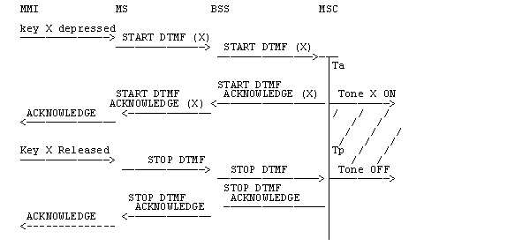

Ta Association time for DTMF Generator in MSC, implementation dependent but low.

Tp Pre-determined maximum tone length, operator option.

T1 Minimum length of tone.

NOTE: If the Network operator implements the time limit option (see subclause 6.2), then the tone ends if the timer expires before the 'Stop DTMF' is received.

Figure 1: Single DTMF Transmission

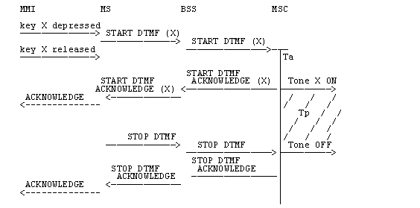

Ta Association time for DTMF Generator in MSC, implementation dependent but low.

Tp Pre-determined maximum tone length, operator option.

T1 Minimum length of tone.

Figure 2: Single DTMF Transmission, Short Key Press

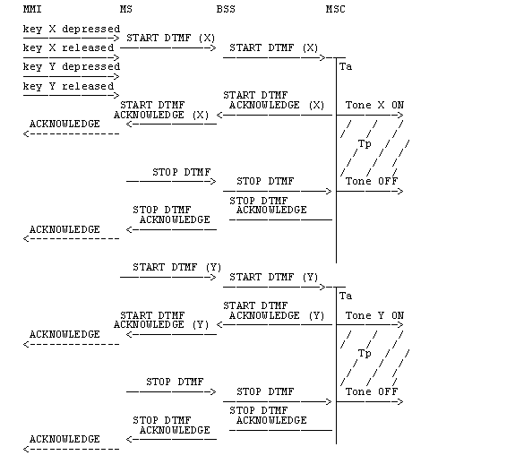

Ta Association time for DTMF Generation in MSC, implementation dependant but low.

Tp Pre-determined maximum tone length, operator option.

T2 Minimum gap between tones.

Figure 3: Two Single DTMF Transmission

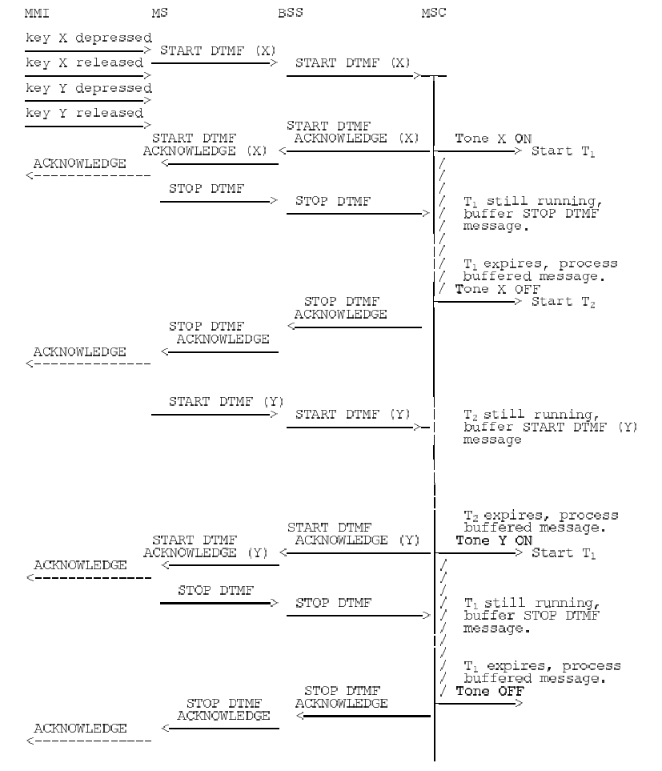

T1 Minimum length of tones

T2 Minimum gap between tones.

Figure 4: Two Single DTMF Transmissions, Short Gap Between Key Presses

# 7 Effect of Handover

## 7.1 Internal Handover

There is unlikely to be any impact on DTMF due to internal handover.

## 7.2 External Handover

Depending on the exact moment when handover occurs, there may be a slight possibility of cutting short a DTMF tone.

For protocol reasons, in the case of an MSC receiving a STOP DTMF message when no tone is being sent, it should respond with an acknowledgement as usual.

No other impact is seen due to external handover.

Annex A (informative):  
Change history

| Change history | | | | | | |
| --- | --- | --- | --- | --- | --- | --- |
| TSG CN# | Spec | Version | CR | <Phase> | New Version | Subject/Comment |
| Apr 1999 | 3GPP TS 03.14 | 7.0.0 |  |  |  | Transferred to 3GPP CN1 |
| CN#03 | 23.014 |  |  |  | 3.0.0 | Approved at CN#03 |
| CN#06 | 23.014 | 3.0.0 | 001r1 | R99 | 3.1.0 | Clarification of DTMF procedure |
| CN#11 | 23.014 | 3.1.0 |  | Rel-4 | 4.0.0 | TSG CN#11 decided to issue this specification as Release 4 on 03-2001 |
| NP-16 | 23.014 | 4.0.0 |  | Rel-5 | 5.0.0 | TSG CN#16 decided to issue this specification as part of release 5 on June 2002.  ETSI/MCC updated this version with references and editorials. |
| NP-17  NP-020365 | 23.014 N1-021655 (wrongly used N1-021654 inside the CR itself) | 5.0.0 | 006 | Rel-5 | 5.1.0 | Dual Tone Multi-Frequency signalling : Support in the whole 3GPP system, and editorial modifications.  Cat A CR |
| NP-26 | 23.014 | 5.1.0 | 007 | Rel-6 | 6.0.0 | Introduction of new references for DTMF |
|  |  | 6.0.0 |  |  | 7.0.0 | Upgraded to Rel-7 (MCC) |
| CP-42 | 23.014 | 7.0.0 | 008r1 | Rel-8 | 8.0.0 | DTMF transmission during multimedia call |
| CP-46 |  | 8.0.0 |  | Rel-9 | 9.0.0 | Upgraded to Rel-9 (MCC) |
| CP-51 |  | 9.0.0 |  | Rel-10 | 10.0.0 | Upgraded to Rel-10 (MCC) |