3GPP TS 23.086 V10.0.0 (2011-03)

Technical Specification

3rd Generation Partnership Project;

Technical Specification Group Core Network and Terminals;

Advice of Charge (AoC) supplementary services; Stage 2

(Release 10)



The present document has been developed within the 3rd Generation Partnership Project (3GPP TM) and may be further elaborated for the purposes of 3GPP.  
The present document has not been subject to any approval process by the 3GPPOrganisational Partners and shall not be implemented.  
This Specification is provided for future development work within 3GPPonly. The Organisational Partners accept no liability for any use of this Specification.  
Specifications and reports for implementation of the 3GPP TM system should be obtained via the 3GPP Organisational Partners' Publications Offices.

Keywords

LTE, GSM, UMTS, network, AOC, supplementary service, stage 2

***3GPP***

Postal address

3GPP support office address

650 Route des Lucioles - Sophia Antipolis

Valbonne - FRANCE

Tel.: +33 4 92 94 42 00 Fax: +33 4 93 65 47 16

Internet

http://www.3gpp.org

***Copyright Notification***

No part may be reproduced except as authorized by written permission.  
The copyright and the foregoing restriction extend to reproduction in all media.

© 2011, 3GPP Organizational Partners (ARIB, ATIS, CCSA, ETSI, TTA, TTC).

All rights reserved.

UMTS™ is a Trade Mark of ETSI registered for the benefit of its members

3GPP™ is a Trade Mark of ETSI registered for the benefit of its Members and of the 3GPP Organizational Partners  
LTE™ is a Trade Mark of ETSI currently being registered for the benefit of its Members and of the 3GPP Organizational Partners

GSM® and the GSM logo are registered and owned by the GSM Association

Contents

Foreword 4

0 Scope 5

0.1 References 5

0.2 Abbreviations 5

1 Advice of Charge (Information) (AoCI) 5

1.1 Advice of Charge (Information) MSC SDL diagram 5

1.2 Advice of Charge (Information) mobile equipment SDL diagram 6

1.3 Advice of Charge (Information) information flow diagram 6

1.4 Information stored in the HLR 9

1.5 State transition model 10

1.6 Transfer of Information from HLR to VLR 10

1.7 Information stored in the VLR 10

1.8 Handover 10

2 Advice of Charge (Charging) (AoCC) 10

2.1 Advice of Charge (Charging) MSC SDL diagram 10

2.2 Advice of Charge (Charging) mobile equipment SDL diagram 11

2.3 Advice of Charge (Charging) information flow diagram 11

2.4 AoCC subscriber roaming requirements 11

2.5 Information stored in the HLR 15

2.6 State transition model 16

2.7 Transfer of Information from HLR to VLR 16

2.8 Information stored in the VLR 16

2.9 Handover 16

Annex A (normative): Information stored in the MSC 17

Annex B (informative): Change history 18

# Foreword

This Technical Specification (TS) has been produced by the 3rd Generation Partnership Project (3GPP).

The present document defines the stage 2 of the Advice of Charge (AoC) supplementary services within the 3GPP system.

The contents of the present document are subject to continuing work within the TSG and may change following formal TSG approval. Should the TSG modify the contents of the present document, it will be re-released by the TSG with an identifying change of release date and an increase in version number as follows:

Version x.y.z

where:

x the first digit:

1 presented to TSG for information;

2 presented to TSG for approval;

3 or greater indicates TSG approved document under change control.

y the second digit is incremented for all changes of substance, i.e. technical enhancements, corrections, updates, etc.

z the third digit is incremented when editorial only changes have been incorporated in the document.

# 0 Scope

The present document gives the stage 2 description of the Advice of Charge (AoC) supplementary services.

The charging supplementary services currently defined are:

- Advice of Charge (Information) (AoCI) (clause 1);

- Advice of Charge (Charging) (AoCC) (clause 2).

## 0.1 References

The following documents contain provisions which, through reference in this text, constitute provisions of the present document.

* References are either specific (identified by date of publication, edition number, version number, etc.) or non‑specific.
* For a specific reference, subsequent revisions do not apply.
* For a non-specific reference, the latest version applies. In the case of a reference to a 3GPP document (including a GSM document), a non-specific reference implicitly refers to the latest version of that document *in the same Release as the present document*.

[1] 3GPP TR 21.905: " Vocabulary for 3GPP Specifications ".

[2] 3GPP TS 22.024: "Description of Charge Advice Information (CAI)".

[3] 3GPP TS 22.086: "Advice of Charge (AoC) Supplementary Services; Stage 1".

[4] 3GPP TS 23.011: "Technical Realization of Supplementary Services - General Aspects".

## 0.2 Abbreviations

Abbreviations used in the present document are listed in 3GPP TR 21.905 [1].

# 1 Advice of Charge (Information) (AoCI)

## 1.1 Advice of Charge (Information) MSC SDL diagram

The SDL diagram for the Advice of Charge (Information) supplementary service within the MSC is given in figure 1.1.

NOTE 1: AoC (Information) is not applicable to emergency calls.

NOTE 2: The request of generation of the Charge Advice Information (CAI) applies to AoC initiation or charge modification.

## 1.2 Advice of Charge (Information) mobile equipment SDL diagram

The SDL diagram for the Advice of Charge (Information) supplementary service within the mobile equipment is given in figure 1.2. This SDL indicates when charging calculations are started, amended and stopped, within the mobile equipment. The mobile equipment should start charging calculations as soon as possible after receiving the charging information. Charging calculations should be amended by the mobile equipment in accordance with GSM 02.24.

NOTE: The point at which the charging calculations are amended can occur before or after sending the AoC Acknowledge.

Charging calculations are stopped when the call ends for any reason.

The reception of the CAI shall be acknowledged only if the MS supports the AoCI functionality specified in GSM 02.24 and GSM 02.86, however the network does not action this acknowledgement in the AoC (Information) case.

## 1.3 Advice of Charge (Information) information flow diagram

The Advice of Charge (Information) information flow diagrams are shown in figure 1.3.



Figure 1.1: SDL diagram of advice of charge (information) in the MSC



Figure 1.2: SDL diagram of advice of charge (information) in the mobile equipment

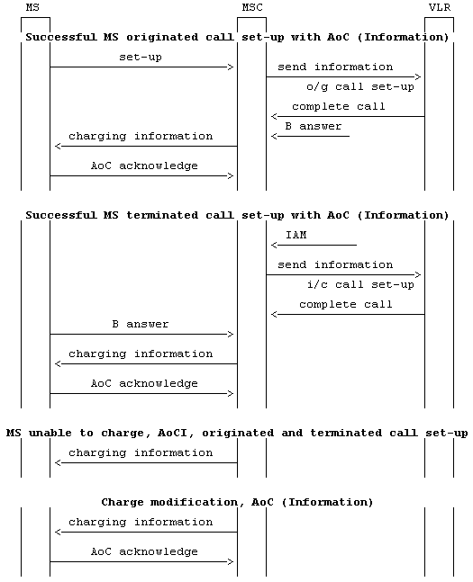

Figure 1.3: Information flow for Advice of Charge (Information)

## 1.4 Information stored in the HLR

AoCI may have the following logical states (refer to GSM 03.11 for an explanation of the notation):

**Provisioning State Registration State Activation State HLR Induction State**

(Not Provisioned, Not Applicable, Not Active, Not Induced)

(Provisioned, Not Applicable, Active and Operative, Not Induced)

The HLR shall store the logical state of AoCI (which shall be one of the valid states listed above) on a per subscriber basis.

## 1.5 State transition model

The following figure shows the successful cases of transition between the applicable logic states of AoCI. The state changes are caused by actions of the service provider.

Note that error cases are not shown in the diagram as they normally do not cause a state change. Additionally, some successful requests may not cause a state change. Hence they are not shown in the diagram.

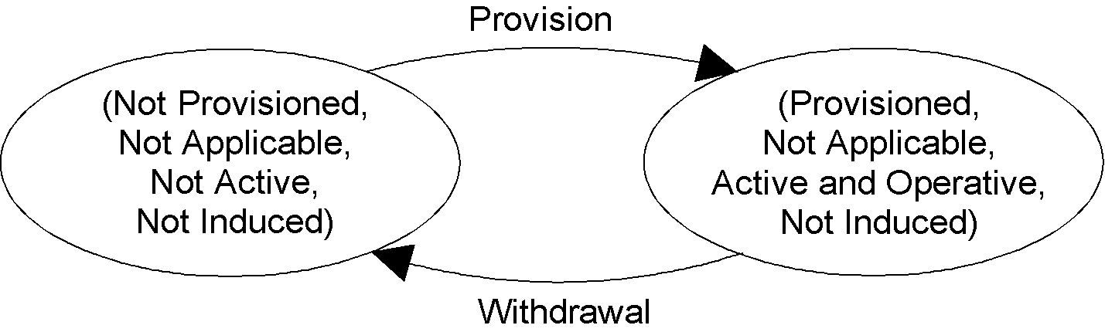

Figure 1.4: State transition model for AoCI

## 1.6 Transfer of Information from HLR to VLR

If the provisioning state for AoCI is "Provisioned" then when the served subscriber registers on a VLR the HLR shall send that VLR information about the logical state of AoCI.

If the logical state of AoCI is changed while a subscriber is registered on a VLR, then the HLR shall inform the VLR of the new logical state of AoCI.

## 1.7 Information stored in the VLR

For the supplementary service AoCI the VLR shall store the service state information received from the HLR.

## 1.8 Handover

Handover will have no impact on AoC control procedure.

# 2 Advice of Charge (Charging) (AoCC)

## 2.1 Advice of Charge (Charging) MSC SDL diagram

The SDL diagram for the Advice of Charge (Charging) supplementary service within the MSC is given in figure 2.1. At invocation of the Advice of Charge (Charging) supplementary service the network shall send the "Charging" MS the CAI. The network shall allow the call to proceed whilst waiting for an acknowledgement of the CAI. The waiting period is governed by Timer T(AoC). On expiry of T(AoC) the network shall initiate call clearing.

NOTE 1: AoC (Charging) is not applicable to emergency calls.

NOTE 2: The request of generation of CAI applies to AoC initiation or charge modification.

## 2.2 Advice of Charge (Charging) mobile equipment SDL diagram

The SDL diagram for the Advice of Charge (Charging) supplementary service within the mobile equipment is given in figure 2.2. The SDL indicates when charging calculations are started, amended and stopped, within the mobile equipment. The mobile equipment should start charging calculations as soon as possible after receiving the charging information. Charging calculations should be emended by the mobile equipment in accordance with GSM 02.24.

NOTE: The point at which charging calculations are amended can occur before or after sending the AoC Acknowledge.

Charging calculations are stopped when the call ends for any reason.

The reception of the CAI shall be acknowledged only if the MS supports the AoCC functionality specified in GSM 02.24 and GSM 02.86.

For mobile originated calls, the MS shall prevent a call set-up attempt if the ACM value is equal to or greater than ACMmax.

For mobile terminated calls, a call set-up attempt shall be allowed even if the ACM value is equal to or greater than ACMmax. In this case, when the MS detects that this is a chargeable call and that the ACM value is equal to or greater than ACMmax then the call shall be released.

During an active call, when the MS detects that ACM is equal to or greater than ACMmax then the MS shall release the call.

## 2.3 Advice of Charge (Charging) information flow diagram

The Advice of Charge (Charging) information flow diagrams are shown in figure 2.3.

## 2.4 AoCC subscriber roaming requirements

When an AoCC subscriber first roams into an MSC area not supporting AoCC, or the subscription is given to him while he is roaming in an MSC area not supporting AoCC the following applies:

The HLR shall indicate to the VLR that roaming is restricted in this MSC area due to unsupported feature, and it prevents further mobile terminated traffic. In this case the MS is not reachable.

When entering an AoCC supporting area the AoCC related roaming restriction shall be removed in the HLR.

When AoCC is withdrawn the AoCC related roaming restriction shall be removed in the HLR and VLR. This is independent from roaming restrictions due to other reasons.



Figure 2.1: SDL diagram of advice of charge (charging) in the MSC



Figure 2.2: SDL diagram of advice of charge (charging) in the mobile equipment

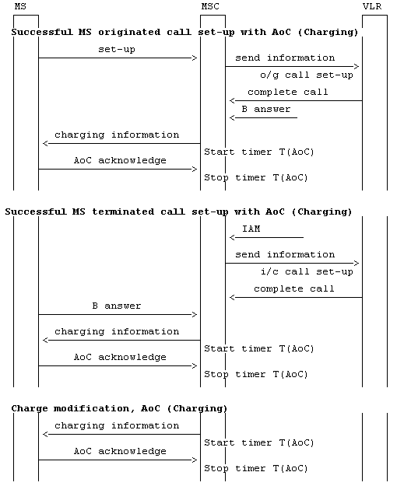

Figure 2.3 (sheet 1 of 2): Information flow for Advice of Charge (Charging)

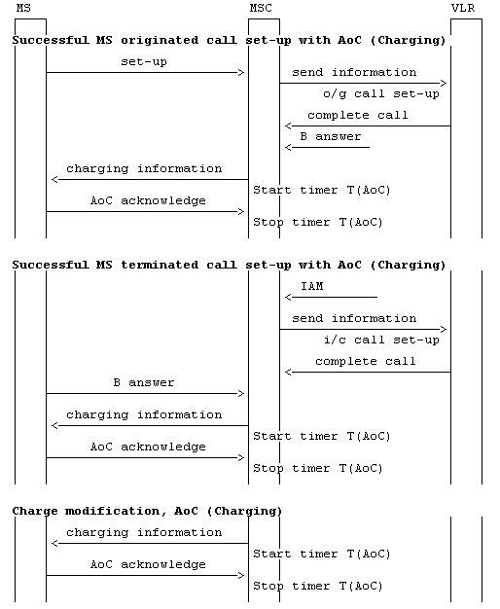

Figure 2.3 (sheet 2 of 2): Information flow for Advice of Charge (Charging)

## 2.5 Information stored in the HLR

AoCC may have the following logical states (refer to GSM 03.11 for an explanation of the notation):

**Provisioning State Registration State Activation State HLR Induction State**

(Not Provisioned, Not Applicable, Not Active, Not Induced)

(Provisioned, Not Applicable, Active and Operative, Not Induced)

The HLR shall store the logical state of AoCC (which shall be one of the valid states listed above) on a per subscriber basis.

## 2.6 State transition model

The following figure shows the successful cases of transition between the applicable logic states of AoCC. The state changes are caused by actions of the service provider.

Note that error cases are not shown in the diagram as they normally do not cause a state change. Additionally, some successful requests may not cause a state change. Hence they are not shown in the diagram.



Figure 2.4: State transition model for AoCC

## 2.7 Transfer of Information from HLR to VLR

If the provisioning state for AoCC is "Provisioned" then when the served subscriber registers on a VLR the HLR shall send that VLR information about the logical state of AoCC.

If the logical state of AoCC is changed while a subscriber is registered on a VLR, then the HLR shall inform the VLR of the new logical state of AoCC.

## 2.8 Information stored in the VLR

For the supplementary service AoCC the VLR shall store the service state information received from the HLR.

## 2.9 Handover

Handover will have no impact on AoC control procedure.

Annex A (normative):  
Information stored in the MSC

The MSC shall have access to the following tables to enable the call handling function to generate the Charge Advice Information (CAI), see GSM 02.24. The table will give the CAI element values corresponding to service request, call destination, type of day and the time of day.

- Units per interval table (e1 values);

- Seconds per internal table (e2 values);

- Scaling factor table (e3 values);

- Unit increment table (e4 values);

- Units per data interval table (e5 values);

- Segments per data interval table (e6 values);

- Initial seconds per time interval table (e7 values).

Annex B (informative):  
Change history

| Change history | | | | | | | | |
| --- | --- | --- | --- | --- | --- | --- | --- | --- |
| TSG CN# | Spec | Old Ver | CR | Rev | Phase | Cat | New Ver | Subject/Comment |
| Apr 1999 | GSM 03.86 | 6.0.0 |  |  | R97 |  |  | Transferred to 3GPP CN1 |
| CN#03 | 23.086 |  |  |  | R99 |  | 3.0.0 | Approved at CN#03 |
|  | 23.086 | 3.0.0 |  |  | R99 |  | 3.0.1 | Reference list updated from 2G to 3G |
| CN#09 | 23.086 | 3.0.1 | 001 | 1 | R99 | F | 3.1.0 | SDL refresh |
| CN#11 | 23.086 | 3.1.0 |  |  | Rel-4 |  | 4.0.0 | Release 4 after CN#11 |
| CN#16 | 23.086 | 4.0.0 |  |  | Rel-5 |  | 5.0.0 | Release 5 after CN#16 |
| CN#26 | 23.086 | 5.0.0 |  |  | Rel-6 |  | 6.0.0 | Release 6 after CN#26 |
| CT#30 | 23.086 | 6.0.0 | 0002 |  | Rel-6 |  | 6.1.0 | Incorrect References |
| CT#36 | 23.086 | 6.1.0 |  |  | Rel-7 |  | 7.0.0 | Upgraded unchanged from Rel-6 |
| CT#42 | 23.086 | 7.0.0 |  |  | Rel-8 |  | 8.0.0 | Upgraded unchanged from Rel-7 |
| CT#46 | 23.086 | 8.0.0 | - | - | Rel-9 |  | 9.0.0 | Update to Rel-9 version (MCC) |
| 2011-03 | 23.086 | 9.0.0 | - | - | Rel-10 |  | 10.0.0 | Update to Rel-10 version (MCC) |