|  |  |
| --- | --- |
| 3GPP TR 22.843 V19.0.0 (2023-06) | |
| Technical Report | |
| 3rd Generation Partnership Project;  Technical Specification Group TSG SA;  Study on Uncrewed Aerial Vehicle (UAV) Phase 3  (Release 19) | |
|  | |
|  |  |
| The present document has been developed within the 3rd Generation Partnership Project (3GPP TM) and may be further elaborated for the purposes of 3GPP. The present document has not been subject to any approval process by the 3GPPOrganizational Partners and shall not be implemented. This Specification is provided for future development work within 3GPPonly. The Organizational Partners accept no liability for any use of this Specification. Specifications and Reports for implementation of the 3GPP TM system should be obtained via the 3GPP Organizational Partners' Publications Offices. | |

|  |
| --- |
|  |
| ***3GPP***  Postal address  3GPP support office address  650 Route des Lucioles - Sophia Antipolis  Valbonne - FRANCE  Tel.: +33 4 92 94 42 00 Fax: +33 4 93 65 47 16  Internet  http://www.3gpp.org |
| ***Copyright Notification***  No part may be reproduced except as authorized by written permission. The copyright and the foregoing restriction extend to reproduction in all media.  © 2022, 3GPP Organizational Partners (ARIB, ATIS, CCSA, ETSI, TSDSI, TTA, TTC).  All rights reserved.  UMTS™ is a Trade Mark of ETSI registered for the benefit of its members  3GPP™ is a Trade Mark of ETSI registered for the benefit of its Members and of the 3GPP Organizational Partners LTE™ is a Trade Mark of ETSI registered for the benefit of its Members and of the 3GPP Organizational Partners  GSM® and the GSM logo are registered and owned by the GSM Association |

Contents

Foreword 5

Introduction 6

1 Scope 7

2 References 7

3 Definitions of terms, symbols and abbreviations 7

3.1 Terms 7

3.2 Abbreviations 8

4 Overview 8

5 Use cases 8

5.1 Use case on UAV detection 8

5.1.1 Description 8

5.1.2 Pre-conditions 8

5.1.3 Service Flows 9

5.1.4 Post-conditions 9

5.1.5 Existing features partly or fully covering the use case functionality 9

5.1.6 Potential New Requirements needed to support the use case 9

5.2 Use case on supporting UAV pre-flight preparation 9

5.2.1 Description 9

5.2.2 Pre-conditions 9

5.2.3 Service Flows 10

5.2.4 Post-conditions 10

5.2.5 Existing features partly or fully covering the use case functionality 10

5.2.6 Potential New Requirements needed to support the use case 10

5.3 Use case on Geofencing for Visual Line-of-Sight UAV missions 11

5.3.1 Description 11

5.3.2 Pre-conditions 11

5.3.3 Service Flows 11

5.3.4 Post-conditions 12

5.3.5 Existing features partly or fully covering the use case functionality 12

5.3.6 Potential New Requirements needed to support the use case 12

5.4. Use case on network-assisted UAV DAA 12

5.4.1 Description 12

5.4.2 Pre-conditions 12

5.4.3 Service Flows 13

5.4.4 Post-conditions 13

5.4.5 Existing features partly or fully covering the use case functionality 13

5.4.6 Potential New Requirements needed to support the use case 14

5.5 Use case on the 3GPP network as an information source to the UTM 14

5.5.1 Description 14

5.5.2 Pre-conditions 15

5.5.3 Service Flows 15

5.5.4 Post-conditions 15

5.5.5 Existing features partly or fully covering the use case functionality 16

5.5.6 Potential New Requirements needed to support the use case 16

5.6 Use case on supporting UAV inflight operations 16

5.6.1 Description 16

5.6.2 Pre-conditions 16

5.6.3 Service Flows 17

5.6.4 Post-conditions 17

5.6.5 Existing features partly or fully covering the use case functionality 17

5.6.6 Potential New Requirements needed to support the use case 18

5.7 Use case on UAV flight route tracking at Rendezvous points 18

5.7.1 Description 18

5.7.2 Pre-conditions 19

5.7.3 Service Flows 19

5.7.4 Post-conditions 19

5.7.5 Existing features partly or fully covering the use case functionality 19

5.7.6 Potential New Requirements needed to support the use case 19

5.8 Use case on UAV simultaneous traffic over two networks 19

5.8.1 Description 19

5.8.2 Pre-conditions 20

5.8.3 Service Flows 20

5.8.4 Post-conditions 20

5.8.5 Existing features partly or fully covering the use case functionality 21

5.8.6 Potential New Requirements needed to support the use case 21

5.9 Use case on UAV traffic over alternative networks 22

5.9.1 Description 22

5.9.2 Pre-conditions 22

5.9.3 Service Flows 23

5.9.4 Post-conditions 23

5.9.5 Existing features partly or fully covering the use case functionality 23

5.9.6 Potential New Requirements needed to support the use case 24

5.10 Use case on UAV control in different aerial flight zones 24

5.10.1 Description 24

5.10.2 Pre-conditions 25

5.10.3 Service Flows 25

5.10.4 Post-conditions 26

5.10.5 Existing features partly or fully covering the use case functionality 26

5.10.6 Potential New Requirements needed to support the use case 26

6 Consolidated potential requirements 27

6.1 Network support and exposure for UAV usage 27

6.2 Safety and Security 28

7 Conclusion and recommendations 28

Annex A (informative): Change history 29

# Foreword

This Technical Report has been produced by the 3rd Generation Partnership Project (3GPP).

The contents of the present document are subject to continuing work within the TSG and may change following formal TSG approval. Should the TSG modify the contents of the present document, it will be re-released by the TSG with an identifying change of release date and an increase in version number as follows:

Version x.y.z

where:

x the first digit:

1 presented to TSG for information;

2 presented to TSG for approval;

3 or greater indicates TSG approved document under change control.

y the second digit is incremented for all changes of substance, i.e. technical enhancements, corrections, updates, etc.

z the third digit is incremented when editorial only changes have been incorporated in the document.

In the present document, modal verbs have the following meanings:

**shall** indicates a mandatory requirement to do something

**shall not** indicates an interdiction (prohibition) to do something

The constructions "shall" and "shall not" are confined to the context of normative provisions, and do not appear in Technical Reports.

The constructions "must" and "must not" are not used as substitutes for "shall" and "shall not". Their use is avoided insofar as possible, and they are not used in a normative context except in a direct citation from an external, referenced, non-3GPP document, or so as to maintain continuity of style when extending or modifying the provisions of such a referenced document.

**should** indicates a recommendation to do something

**should not** indicates a recommendation not to do something

**may** indicates permission to do something

**need not** indicates permission not to do something

The construction "may not" is ambiguous and is not used in normative elements. The unambiguous constructions "might not" or "shall not" are used instead, depending upon the meaning intended.

**can** indicates that something is possible

**cannot** indicates that something is impossible

The constructions "can" and "cannot" are not substitutes for "may" and "need not".

**will** indicates that something is certain or expected to happen as a result of action taken by an agency the behaviour of which is outside the scope of the present document

**will not** indicates that something is certain or expected not to happen as a result of action taken by an agency the behaviour of which is outside the scope of the present document

**might** indicates a likelihood that something will happen as a result of action taken by some agency the behaviour of which is outside the scope of the present document

**might not** indicates a likelihood that something will not happen as a result of action taken by some agency the behaviour of which is outside the scope of the present document

In addition:

**is** (or any other verb in the indicative mood) indicates a statement of fact

**is not** (or any other negative verb in the indicative mood) indicates a statement of fact

The constructions "is" and "is not" do not indicate requirements.

# Introduction

This clause is optional. If it exists, it shall be the second unnumbered clause.

# 1 Scope

The present document provides additional use cases of UAV and identifies potential requirements to improve 5G system’s support of UAV applications, UAV operations and management, including:

* Provide additional information to the UAV operator/USS to execute pre-flight preparations and inflight operation (e.g, flight mission application, flight path recommendation, flight monitoring and control);
* Use 5G system to support enhancing the UAV flight/route management based on network capacity and QoS information along the planned route;
* Use 5G system to further enhance the safety and security of UAV operations, e.g. supporting UTM in UAV detection and DAA(Detect and Avoid);
* Identify potential new security, charging and regulatory requirements on 5GS, when used for UAS operation;
* Identify potential new requirements related to redundancy and reliability of command and control (C2) traffic for UAV.

For the identified use cases, a gap analysis is performed between potential new service requirements and existing 3GPP requirements and functionalities.

NOTE: This study investigates requirements for additional 5GS capabilities to assist UTM, with the assumption that liability and responsibility for UAV operation remain under the domain of the UTM/UAV operator.

NOTE: Potential overlaps with ongoing stage-2 work (on UAS), and other SA1 studies (e.g. FS_Sensing) have been considered and avoided.

# 2 References

The following documents contain provisions which, through reference in this text, constitute provisions of the present document.

- References are either specific (identified by date of publication, edition number, version number, etc.) or non‑specific.

- For a specific reference, subsequent revisions do not apply.

- For a non-specific reference, the latest version applies. In the case of a reference to a 3GPP document (including a GSM document), a non-specific reference implicitly refers to the latest version of that document *in the same Release as the present document*.

[1] 3GPP TR 21.905: "Vocabulary for 3GPP Specifications".

[2] Global UTM Association UTM Architecture v1: https://www.gutma.org/docs/Global_UTM_Architecture_V1.pdf

[3] 3GPP TS 22.125: "Uncrewed Aerial System (UAS) support in 3GPP".

# 3 Definitions of terms, symbols and abbreviations

## 3.1 Terms

For the purposes of the present document, the terms given in 3GPP TR 21.905 [1] and the following apply. A term defined in the present document takes precedence over the definition of the same term, if any, in 3GPP TR 21.905 [1].

**example:** text used to clarify abstract rules by applying them literally.

## 3.2 Abbreviations

For the purposes of the present document, the abbreviations given in 3GPP TR 21.905 [1] and the following apply. An abbreviation defined in the present document takes precedence over the definition of the same abbreviation, if any, in 3GPP TR 21.905 [1].

BRID Broadcast Remote Identification

BVLOS Beyond Visual Line of Sight

CAA Civil Aviation Authority

C2 Command and Control

C2C Command and Control Centre

DAA Detect And Avoid

GUTMA Global UTM Association

UTM Unmanned Aerial System Traffic Management

VLoS Visual Line of Sight

# 4 Overview

The present document focuses on improving the 3GPP support for the applications and security for various scenarios using low altitude UAVs. The present document provides potential use cases and defines potential new service level requirements and KPIs for supporting identified use cases by 3GPP system. Use cases cover various scenarios to enhance the combination of 3GPP system and UAV ecosystem and this study presents use cases based on continuation/enhancement of TS 22.125. The present document considers service requirements related to further enhancement of the Network support and exposure for UAV usage and further enhancement of the control, safety, and security of UAV operations.

# 5 Use cases

## 5.1 Use case on UAV detection

### 5.1.1 Description

3GPP aerial features are activated based on "aerial subscription" flag specified in Rel-15. This implies that an operator using these features will provide UAV users with USIMs that are associated to a user profile with the "aerial subscription" flag set.

It is however technically possible for a UAV user to insert a USIM not meant for UAV in a UE that is on board a UAV (this UE being used for C2C or for other purpose). The user could do that either intentionally (e.g. to have a lower tariff or to bypass some restrictions applied to UAVs) or not (e.g. because he/she is not aware that UAVs need to be used with specific USIMs).

In this case, with current specifications, the 3GPP network is not able to recognize that the UE is on board a UAV and therefore cannot activate aerial features. More importantly, the 3GPP network will not perform UAV Authentication and Authorization procedures with the UTM, and may cause the UE to use a frequency band that is not allowed for aerial usage where the UAV is located due to the risk of interference to users or adjacent frequency bands (e.g. military installation, weather radar). This has security implications. In addition, the 3GPP network cannot fulfill the requirements of TS 22.125 applicable to UE on board a UAV.

From Rel-17 onwards, the 3GPP network is able to reject registration when the UE provides a "CAA-level UAV ID" and does not have the "aerial subscription" flag set in its subscription. This mitigates the above issue, but the issue still exists if the UE is pre-R17 or is not configured with a CAA-level UAV ID.

There is therefore a need to enable the 5G System network to detect that a UE is on board a UAV, without relying on subscription information or on indication provided by the UE.

### 5.1.2 Pre-conditions

A UAV user has inserted in a UE on board a UAV, a USIM that is associated to a user profile without the "aerial subscription" flag set.

### 5.1.3 Service Flows

1. The UE registers in 5GS and starts communicating. The UAV takes off.

2. The network detects that the UE is on board a UAV.

3. The network takes action, e.g. activates aerial features, changes the QoS, populates charging records, alert the UTM and/or let the UTM take over the communication used to control the UAV.

### 5.1.4 Post-conditions

The UTM may take over the communication used to control the UAV and force the UAV to land safely.

Later, the UTM and/or network operator informs or reminds the user that a specific USIM needs to be used for proper operation of a UE on board a UAV.

### 5.1.5 Existing features partly or fully covering the use case functionality

- "aerial subscription" flag in subscription;

- Provision of "CAA-level UAV ID" by the UE;

- detection of UE above altitude thresholds by the eNB / gNB (per TS 36.331 & TS 38.331).

### 5.1.6 Potential New Requirements needed to support the use case

[PR 5.1.6-001] The 5G system shall be able to detect that a connected UE is airborne, while UE’s subscription does not include the "aerial subscription" flag set.

## 5.2 Use case on supporting UAV pre-flight preparation

### 5.2.1 Description

During the operation of UAVs using the 3GPP network access, the network needs to ensure that the UAVs can access the network smoothly and timely. UAV flight mission need to be ensured for the real-time performance and stability of flight control link to guarantee the continuity of the flight.

5G network can provide wide-area, high-quality and secure connectivity that can enable cost-efficient UAV operations beyond visual line-of-sight (BVLOS) range. In some industrial UAV scenarios, the UAV would be provided pre-scheduled flight plan for autonomous flying. When UAV uses 3GPP network as the access type, the UTM/UAV operator may need to acknowledge the network status for flight path scheduling with the help of 3GPP network.5G system can assist the UTM and drone operator with providing alternative flight path based on the supported QoS in specific area or reconfigure network resources to achieve the needed QoS.

### 5.2.2 Pre-conditions

Pipeline company uses UAV A and logistics company uses UAV B. UAV A and UAV B are both individual terminals that subscribe to the communication service from 5G network.

Operator A provides 5G network coverage and communication services for remote commands and control (C2) communication between UAV and UAV control platform.

The UTM has good cooperation with Operator A to have UAV-related information which is fetched from the 5G network.

### 5.2.3 Service Flows

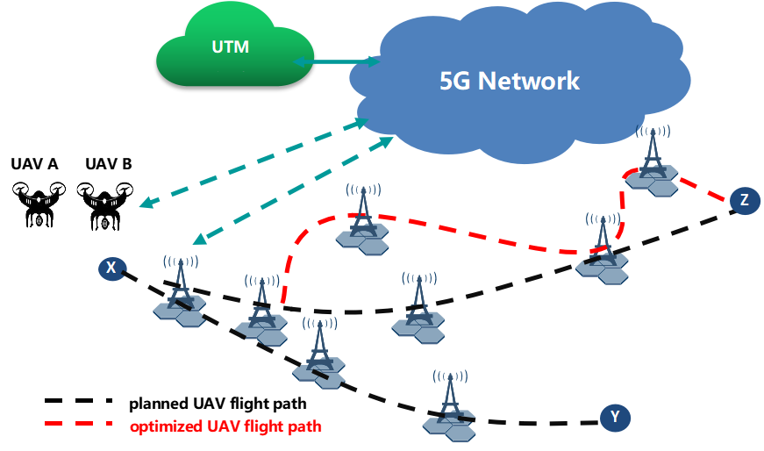

Figure 5.2.3-1: Supporting UAV pre-flight preparation

1. The pipeline company plans to use UAV A to provide video inspection of pipelines from X to Y and the logistics company uses UAV B to deliver express from X to Z.

2. UAV/UAV-C A and UAV/UAV-C B register in 5G network and can communicate with UTM though 5G network.

3. The UAV-C A provides planned flight path information from X to Y to UTM (e.g. waypoints and required QoS from X to Y). The UAV-C B provides planned flight path on start point X, end point Z and needed QoS.

4. UTM checks with 5G system for required and needed QoS information in predictions/statistics (e.g. end-to-end latency, QoE) along required and possible flight paths.

5. Based on the available analytics information, the 5G system can provide confirmation that required QoS is available for UAV A flight path or alternatively can reconfigure network resources to be able to provide the required QoS to UAV A along the flight path. As UAV B can take alternative routes, 5G system can provide optimized flight path considering where the QoS is available.

6. UTM/UAS determines the final flight paths based on the information from Operator A and sends to UAV/UAV-C A and UAV/UAV-C B separately.

7. UAV A and UAV B receive the flight path information from UTM/UAS via the 5G system and start flight mission.

### 5.2.4 Post-conditions

UAV A and UAV B can finish their respective tasks with the support of 5G system.

### 5.2.5 Existing features partly or fully covering the use case functionality

None.

### 5.2.6 Potential New Requirements needed to support the use case

[P.R 5.2.6-001] Based on operator’s policy, the 5G system shall be able to support a method to predict network conditions and QoS (e.g. bitrate, latency, reliability) along a continuous geographic planned flight path of a UAV at specific times of its expected flight duration.

[P.R 5.2.6-002] Based on operator’s policy, the 5G system shall be able to provide UTM with the information about geographic areas where UAV service requirements could or could not be met based on predicted network conditions and QoS (e.g. bitrate, latency, reliability).

[P.R 5.2.6-003] Based on 3rd party request, the 5G system shall be able to provide to the 3rd party alternative UAV flight paths, as long as UTM-provided required waypoints (e.g. start/end locations), required QoS, and exclusion zones are fulfilled.

[P.R 5.2.6-004] Based on 3rd party request and operator’s policy, the 5G system shall be able to reconfigure network resources to provide the required QoS along a UAV planned flight path, e.g. at particular geographical area(s) and time(s).

## 5.3 Use case on Geofencing for Visual Line-of-Sight UAV missions

### 5.3.1 Description

3GPP has specified a wide range of aerial features, activated through an "aerial subscription". Three types of C2 communications have been defined for R17, in TS.22.125:

* Direct C2 communications (when the UAV controller and UAV establish a direct C2 link to communicate with each other);
* Network-Assisted C2 communications (when the UAV controller and UAV communicate with each other via 5G network);
* UTM-Navigated C2 communication (for pre-scheduled autonomous flights).

3GPP features for Network-Assisted C2 communications and UTM-Navigated C2 communication mostly cover Beyond Visual Line-of-Sight (BVLoS) UAV operations, and Direct C2 communications are constrained by their radio coverage range, which is generally much wider than the VLoS constraints imposed by airspace authorities.

In all three cases, it is thus technically possible that an UAV controller does not comply with airspace regulatory requirements related to VLoS operations.

Ensuring that an aerial UE is complying with regulatory Visual Line-of-Sight constraints, by supporting pre-flight preparations and inflight operation flight monitoring and control, enhances the safety and security of UAV operations.

There is a need to enable the 5G system to be aware if VLoS constraints should be applied to UAV operations, and if so, to monitor the relative positions of an aerial UE with respect to its pilot to ensure that this aerial UE is complying with Line-of-Sight constraints.

NOTE: The pilot, or UAV-C, can be a UE (connected to the same PLMN or to another PLMN), or not, but remains attached to the DN using other technologies.

### 5.3.2 Pre-conditions

The UAV is associated with an aerial UE profile and a “VLoS” option is activated together with its subscription. The UAV is associated with an UAV Controller (UAV-C). The 5G system is informed by the UTM of the maximal distance authorized between the UAV and the UAV-C (VLoS distance threshold, usually around 200 or 300m), which usually depends on airspace regulation and may potentially account for other conditions (e.g. weather, type of environment, type of UAV, temporary or localized special authorization, etc.).

### 5.3.3 Service Flows

1. The UAV registers in 5GS as an aerial UE with the VLoS option activated.

2. The UAV is associated with an UAV-C. The UAV takes off.

3. The network tracks the geolocalization of both the UAV and UAV-C, and deduces the distance between both. If the UAV-C does not belong to the 3GPP system, its geolocalization may be obtained, for example, from the UTM/USSP.

4. In case this distance exceeds the VLoS threshold, the network takes action, e.g. alerts the UTM and/or lets the UTM takes over the communication used to bring back the UAV within the authorized VLoS constraints, or sends a new waypoint within the authorized VLoS constraints.

### 5.3.4 Post-conditions

The UTM may take over the communication used to control the UAV and force the UAV to land safely.

Later, the UTM and/or network operator informs or reminds the user that a specific USIM needs to be used for proper operation of a UE on board a UAV.

### 5.3.5 Existing features partly or fully covering the use case functionality

- "Aerial subscription" option in subscription, as specified in Rel-15;

- UAV / UAV-C association, as in TS 23.256 for example;

- Tracking of the geolocalization of the UAV as in TS 23.256 for example.

### 5.3.6 Potential New Requirements needed to support the use case

[PR 5.3.6-001] The 5G system shall be able to be informed of VLoS regulatory requirements (e.g. maximal distance threshold) and shall be informed if the UTM needs to be supported in meeting such requirements for a given UAS.

[PR 5.3.6-002] The 5G system shall be able to track the UAV-Controller, regardless of the type of connection.

[PR 5.3.6-003] Based on MNO policies and/or regulatory requirements, the 5G system shall be able to alert the UTM, when the 5G system detects that a condition is met (e.g. maximal distance threshold exceeded).

[PR 5.3.6-004] Based on MNO policies and/or regulatory requirements, the 5G system shall enable the UTM to take over the communication used to control the UAV, when the 5G system detects that a condition is met (e.g. maximal distance threshold exceeded).

## 5.4. Use case on network-assisted UAV DAA

### 5.4.1 Description

Collection of information for UAV detection and avoidance in order to support tactical deconfliction is one of the key functions to guarantee UAV service safety. Previous studies on 3GPP mostly focused on the aspect that the detection and resolution of collisions is locally performed between UAVs using direct UAV to UAV communication over PC5. However, UAV to UAV DAA is only one component of the overall solution and, as in current aviation system, support by ground systems for tactical deconfliction and collision avoidance is an essential complement. With the development of network capabilities for the support of UAVs, new system capabilities like sensing in the 3GPP network can also effectively assist the UAV DAA scenario to ensure the flight safety by providing a ground-assisted component.

### 5.4.2 Pre-conditions

UAV A is 3GPP aerial UE and subscribes the communication service from 5G network.

UAV B is an aerial vehicle not capable of 3GPP communications and could setup communication with USS/UTM directly.

UAV C is an aerial vehicle not capable of 3GPP communications, with C2 provided by a non-3GPP UAV controller and could setup communication with USS/UTM directly or via UAV controller.

UAV A and UAV B can setup remote commands and control (C2) communication to a UAV controller within 5G network with UTM.

### 5.4.3 Service Flows

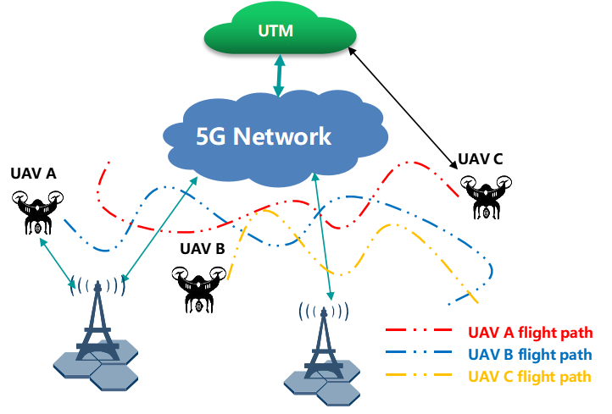

Figure 5.4.3-1: Network-assisted UAV DAA

1. UAV A registers in 5G network and can setup communications with UTM though 5G network. UAV B setup communication with UTM directly and UAV C setup communication with UTM via UAV controller.

2. The UTM subscribes network-assisted UAV DAA service from Operator M.

3. Operator M could use base station(s) to perform sensing to collect information about the UAV A, B and C in certain area and provide the collected information to UTM for DAA operation or to UAV A and UAV C.

4. Operator M could also collect information from UAV A and controller of UAV C about the flight status and reports to UTM.

5. UTM could trigger DAA notifications for the flying UAV A, B and C under its area based on the information from network.

6. UAV A, B, and C receive the notification and take actions accordingly.

### 5.4.4 Post-conditions

UAV A, B, and C can fly safely under the control of UTM with the support of 5G network.

### 5.4.5 Existing features partly or fully covering the use case functionality

SA1 has performed study on UAV DAA in previous releases, where related normative stage 1 requirements are introduced in TS 22.125 [3].

**TS 22.125 clause 6.2 introduces the network support for UAV detection as below:**

[R-5.2.1-001] The 3GPP system shall provide a mechanism for a UTM to provide route data, along with flight clearance, to a UAV.

[R-5.2.1-002] The 3GPP system shall be able to deliver route modification information received from a UTM to a UAS with a latency of less than 500ms.

[R-5.2.1-003] The 3GPP system shall be able to deliver the notifications received from a UTM to a UAV controller with a latency of less than 500ms.

[R-5.2.1-004] Based on MNO policies and/or regulatory requirements, the 3GPP system shall enable the UTM to take over the communication used to control the UAV.

**TS 22.125 clause 5.2 introduces the introduces network support for UAV avoidance as below:**

[R-6.2-001] The 3GPP system shall provide means to allow a 3rd party to request and obtain real-time monitoring the status information (e.g., location of UAV, communication link status) of a UAV.

[R-6.2-002] Based on operator 's policy, the 3GPP system shall provide means to provide a 3rd party with the information regarding the service status for UAVs in a certain geographical area and/or at a certain time.

### 5.4.6 Potential New Requirements needed to support the use case

[P.R 5.4.6-001] Based on operator’s policy, the 5G system shall be able to provide a method to provide UTM and UAVs with the information collected or generated by the 5G system (e.g., based on sensing results), including e.g. the location or relative distance of 3GPP UAVs and other flying objects (can be drones not using 3GPP connectivity).

## 5.5 Use case on the 3GPP network as an information source to the UTM

### 5.5.1 Description

The UTM is a complex system in which actors outside the 3GPP System work to ensure the required safety level of UAS operations. For this reason, the UTM is defined by GUTMA (Global UTM Association) as “a system of stakeholders and technical systems collaborating in certain interactions, and according to certain regulations, to maintain safe separation of unmanned aircraft, between themselves and from ATM users, at very low level, and to provide an efficient and orderly flow of traffic”

A system like UTM requires a high-quality set of data flows to remain fully aware of the system it is operating within and to effectively meet the mission brief. In figures 1 and 2 below, the GUTMA architecture [2] shows that a high number of data sources are considered to keep the UTM functional.

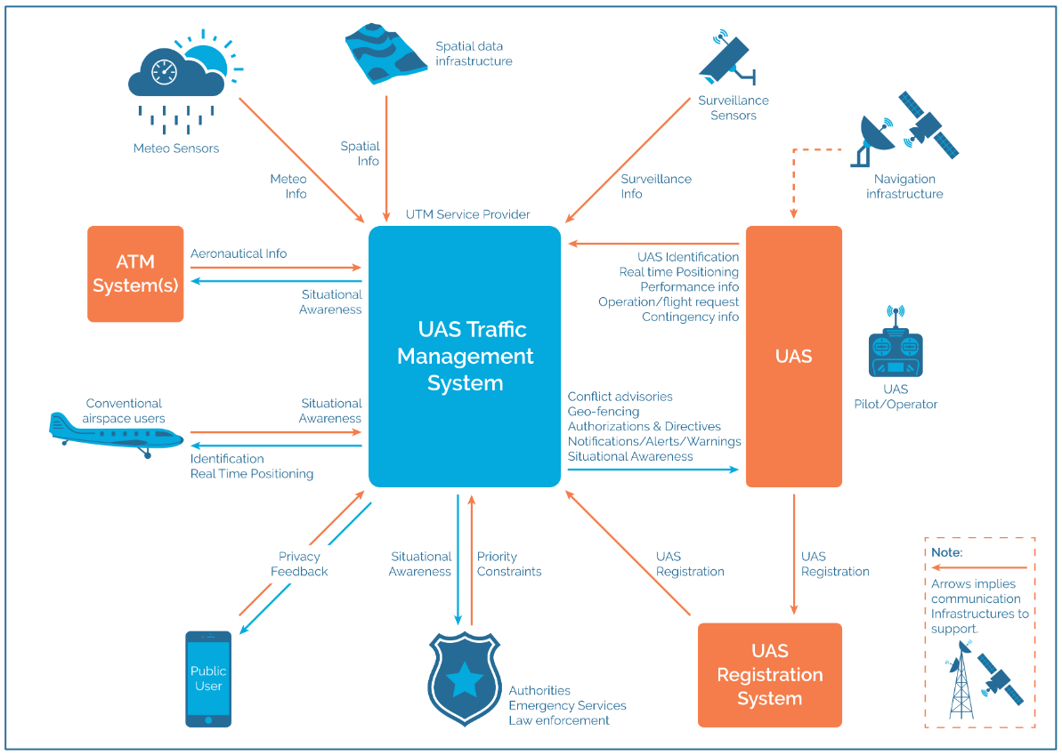

Figure 5.5.1-1: A view of a UTM system (source: GUTMA Global UTM Architecture v1 [2])

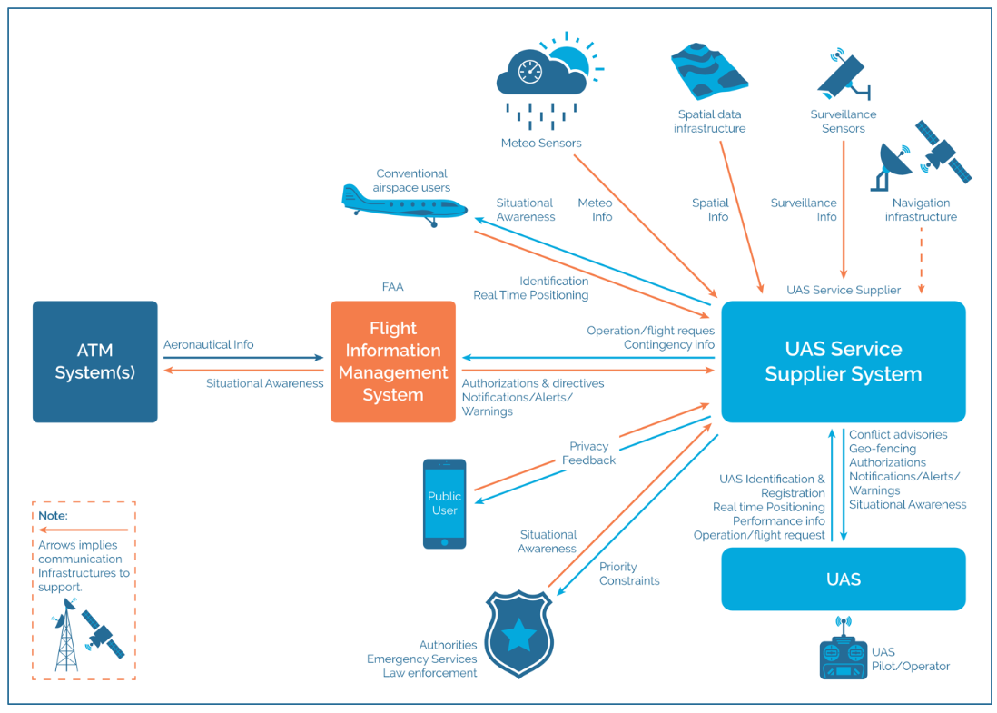

Figure 5.5.1-2: NASA UTM system (source: GUTMA Global UTM Architecture v1 [2])

The 3GPP System can act as a data source towards the UTM in order to provide spatial, surveillance, meteorological, and real-time positioning information.

### 5.5.2 Pre-conditions

A UTM exists which is capable of accepting a 3GPP network as data source. A partner 3GPP operator is prepared to supply information to the UTM based on the capabilities of the network. Agreements on trust, responsibility, liability, privacy, and data management have been made.

### 5.5.3 Service Flows

1. A UTM determines what data is required from the 3GPP network which can act as an information source.

2. Based on the capabilities of the 3GPP network, an operator begins to gather data according to agreements made with a UTM operator where the UTM provides the type of information and optional conditions regarding such information (e.g. reporting for a specific area, reporting specific events, etc.). This data is gathered from a number of sources which may include the following: RAN awareness of UE altitude (detect UEs above a certain altitude from the ground), Wireless Sensing results, UE registration, UE location reporting, network-based UE location determination.

3. The operator begins to feed data towards a UTM according to the information requested by the UTM.

4. The UTM accepts the data from the operator and is responsible for processing (corelating data sets, identifying objects, deduplication) and acting on (warnings, notifications) this data according to mechanisms outside the scope of 3GPP.

### 5.5.4 Post-conditions

The UTM has an increased situational awareness because of the increased data provided by the 3GPP network.

### 5.5.5 Existing features partly or fully covering the use case functionality

**Related requirements in TS 22.125:**

[R-5.1-003] The 3GPP system shall enable a UAS to send UTM the UAV data which can contain: unique identity (this may be a 3GPP identity), UE capability of the UAV, make & model, serial number, take-off weight, position, owner identity, owner address, owner contact details, owner certification, take-off location, mission type, route data, operating status.

[R-5.1-004] The 3GPP system shall enable a UAS to send UTM the UAV controller data which can contain: unique identity (this may be a 3GPP identity), UE capability of the UAV controller, position, owner identity, owner address, owner contact details, owner certification, UAV operator identity, UAV operator license, UAV operator certification, UAV pilot identity, UAV pilot license, UAV pilot certification and flight plan.

[R-5.1-006] The 3GPP system shall support capability to extend UAS data being sent to UTM with the evolution of UTM and its support applications in future.

[R-5.1-009] The 3GPP system should enable an MNO to augment the data sent to a UTM with the following: network-based positioning information of UAV and UAV controller.

[R-5.1-017] The 3GPP system shall support the UTM in detection of UAV operating without authorization.

[R-6.3-001] The 3GPP network shall be able to support network-based 3D space positioning (e.g., with altitude 30~300m) of a UE onboard UAV.

Table 7.3-1 lists typical scenarios and the corresponding positioning requirements for horizontal and vertical accuracy, availability, heading, latency, and UE speed.

**Related requirements in TS 22.261:**

The 5G system shall be able to make the position-related data available to an application or to an application server existing within the 5G network, external to the 5G network, or in the User Equipment.

NOTE: the position service latency can be tailored to the use cases.

### 5.5.6 Potential New Requirements needed to support the use case

[PR 5.5.6-1] Based on operator policy and UTM’s request, the 5G system shall be able to provide UTM with a UEs’ location and identity.

Editor’s Note: this requirement is FFS

[PR 5.5.6-2] Subject to user consent and national or regional regulation, based on operator policy, and the UTM’s request, the 5G system may be able to provide Sensing results to the UTM.

Editor’s Note: the relationship of Sensing and location in the above 2 requirements is FFS

## 5.6 Use case on supporting UAV inflight operations

### 5.6.1 Description

For UAVs operated using the 3GPP network access, the network needs to ensure that the UAVs can use the network reliably and with adequate performance. UAV flight mission need to be monitored for the real-time performance and stability of flight control link to guarantee the safety and continuity of the flight.

5G network can provide wide-area, high-quality and secure connectivity that can enable cost-efficient UAV operations beyond visual line-of-sight. When UAV uses 3GPP network for communications, the UTM/UAV operator may need to monitor the network status along the flight path with the help of 3GPP network.

### 5.6.2 Pre-conditions

In the logistics company, UAV A and UAV B are both individual terminals for express delivery and subscribe the communication service from the 5G network.

Operator A provides 5G network coverage and communication services for remote commands and control (C2) communication between UAV and UAV control platform.

The UTM relies on Operator A to monitor and provide network status from the 5G network for UAV inflight related information.

### 5.6.3 Service Flows



Figure 5.6.3-1: Supporting UAV inflight monitoring

1. The logistics company uses UAV A and UAV B to perform delivery operations. UAVs planned flight paths shared a common portion, along waypoint #1 and waypoint #2.

2. UAV/UAV-C A and UAV/UAV-C B register in 5G network and can communicate with UTM though 5G network.

3. The UAV-C A provides planned flight path #A information to UTM (e.g., flight path and required QoS along the planned flight path).

4. UAV A receive the flight path information from UTM/UAS via 5G network and start flight mission.

5. UTM requests 5G network for network condition information (e.g., bitrate, latency, reliability) along the flight path of UAV A.

6. The 5G network provides the requested statistics (e.g., end-to-end latency, QoE) for specific requested area/areas (e.g., degraded QoE at waypoint #2).

7. The UAV-C B provides planned flight path #B (along waypoint #1 and waypoint #2) information to UTM.

8. UTM/UAS determines the final flight path #B (e.g., adjusted to take waypoint #2') and scheduling for UAV/UAV-C B based on the information from Operator A along UAV A flight route, and sends it to UAV/UAV-C B.

9. UAV B receive the flight path #B information from UTM/UAS via 5G network and start flight mission.

### 5.6.4 Post-conditions

UAV A and UAV B can finish their delivery tasks with the support of 5G network.

### 5.6.5 Existing features partly or fully covering the use case functionality

Existing related service requirements are captured in 3GPP TS 22.125 [3] clause 6.2 "Network exposure for UAV services".

[R-6.2-001] The 3GPP system shall provide means to allow a 3rd party to request and obtain real-time monitoring the status information (e.g., location of UAV, communication link status) of a UAV.

[R-6.2-002] Based on operator 's policy, the 3GPP system shall provide means to provide a 3rd party with the information regarding the service status for UAVs in a certain geographical area and/or at a certain time.

NOTE: Service status is about the information of whether the communication service to the UAV can be provided with a certain QoS by the network.

These requirements do not include explicit requirements on QoS related network conditions like bitrate, latency and reliability.

### 5.6.6 Potential New Requirements needed to support the use case

[P.R 5.6.6-001] Based on operator’s policy, the 5G system shall be able to provide a method to monitor and provide a 3rd party with information about network conditions and QoS (e.g. bitrate, latency, reliability) along a UAV flight path.

[P.R 5.6.6-002] Based on operator’s policy, the 5G system shall be able to provide a method to monitor and provide a 3rd party with information about deviations and violations along a UAV flight path and time.

NOTE: Deviations can be e.g. in location and/or time with respect to the original flight plan. Violations can be e.g. with respect to exclusion zones provided together with the flight plan or known via other means.

## 5.7 Use case on UAV flight route tracking at Rendezvous points

### 5.7.1 Description

Commercial UAV flights are usually BVLOS. Tracking the UAV flights to ensure that they are sticking to the planned route is critical to the success of the mission and the safety of the public. For UAVs that have network communication capability, cellular networks can greatly assist in UAV flight route tracking thanks to their ubiquitous network coverage. However, there are UAVs in the markets today that lack 5G network connection capabilities and probably will remain so for a long time. For such non-networked UAVs, ground stations or stationary devices can provide means to UTM/UAV operator in flight route tracking.

Ground stations or stationary devices can be operated by the 5G network operator which has service agreements with the USS/UTM or by a third-party service provider. The ground stations or stationary devices are deployed along popular flight routes. The UTM/UAV operator can have a need to track the flight route of a non 3GPP capable UAVs using the assistance of 5G network and ground station devices to further enhance the safety and security of UAV operations (e.g., for DAA) while also supporting legacy UAVs.



Figure 5.7.1-1: UAV flight route tracking at Rendezvous points

### 5.7.2 Pre-conditions

A USS/UTM provides environmental surveillance services in an area. It regularly sends out UAVs to fly a planned route collecting environmental data. The UAV is not the subscriber UE of the 5G cellular network operator and can be considered as non-networked UAV for the 5G operator.

A 5G cellular network operator provides 5G network services in the area.

A 5G cellular network operator provides UAV tracking service in the area. For example, it has several ground stations or stationary devices deployed in strategic areas (e.g., along popular flight routes, close to important infrastructure as airports). The ground stations or stationary devices are capable of 5G connectivity and also detection or communication with non-networked UAVs using e.g. 5G device-to-device communication technologies. The 5G network operator has access to information about the available ground stations.

The technologies for detection of any UAV along a flight route is outside the scope of the use-case, however the tracking mechanisms for specific UAV needs to support unambiguous identification of the UAVs to ensure reliable and accurate tracking data about the UAV.

### 5.7.3 Service Flows

1. The USS/UTM requests tracking of one of more UAVs from the 5G operator.

2. The 5G network to track those non-network UAVs. The USS/UTM provides the planned flight route information to the 5G network (e.g., waypoints, ETA).

3. The 5G network start to track those UAV, such as requests selected ground stations to monitor the presence of the target UAVs in its proximity. The ground stations monitor the UAV flight route based on the available information about the planned flight route.

4. When a ground station detects and identifies the target UAV in its proximity, e.g., by receiving BRID information from the target UAV, the ground station in the 5G network informs the UTM that the UAV is following the planned route.

5. At estimated time-of-arrival (ETA), the relevant ground station(s) monitor the presence of the target UAV in its proximity and the 5G network informs the UTM that the UAV has completed its flight as scheduled.

### 5.7.4 Post-conditions

The UAV finishes the mission with USS/UTM reassured during the whole flight.

### 5.7.5 Existing features partly or fully covering the use case functionality

Identification of UAVs which don’t have subscription with the 5G operator for DAA has been specified in Rel-18. Tracking for such UAVs is currently not covered in Rel-18 because release 18 only supports the capability to allow the 5G operator tracking of those UAVs which have the subscription with the 5G operator.

### 5.7.6 Potential New Requirements needed to support the use case

[P.R 5.7.6-001] The 5G system shall be able to support a mechanism to enable a network operator to track a UAV which doesn’t have subscription with this network operator.

## 5.8 Use case on UAV simultaneous traffic over two networks

### 5.8.1 Description

Reliability of UAV traffic is a very important challenge and target for the aviation industry, e.g., for command and control (C2) or other critical data. One scenario of interest includes UAVs, provided with dual SIM/subscription, able to connect simultaneously via two networks for transferring different type of traffic, e.g., using the most reliable network for C2 or other critical data, while other type of traffic is transmitted over the second network.

As an example, let us assume the case of a UAV company (“SafeSky”) that offers monitoring and surveillance services for specific venues (e.g., stadiums) or public events. Their drones are 5G-capable and configurable with dual subscription, one for nationwide PLMN connectivity (with MNO-A), one for ad-hoc UAV coverage using networks deployed in specific public safety venues/locations (can be a PLMN or NPN, managed by MNO-A or other MNO).

In such scenario, when there is available coverage from both NWs, SafeSky can configure their UAVs to transfer C2 traffic with a local UAV-Controller (UAV-C) via the ad-hoc PLMN1/NPN (most suitable for low volume/data rate, but very stringent real-time latency and reliability), while less critical user data is exchanged with the UAV Supplier Service (USS) and UTM via the wide-area PLMN2 coverage. This is illustrated, at high level, in Figure 5.8.1-1, where PLMN1/NPN is the local NW and PLMN2 is the wide area network.

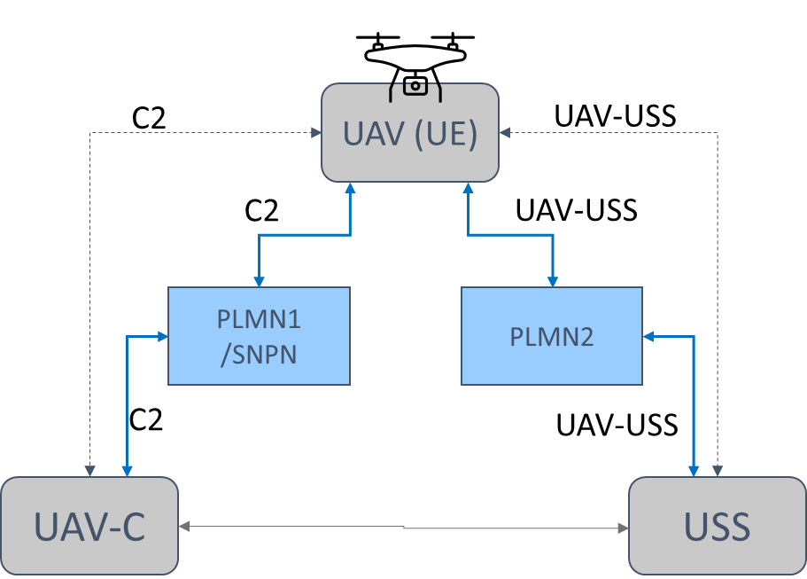

Figure 5.8.1-1: Example of separating UAV traffic over two PLMNs

In other examples, different traffic differentiation configurations are possible (in a similar venue scenario), e.g., UAVs may transfer real-time critical payload traffic (e.g., streaming a 4K video of a sport event) with a local endpoint via the ad-hoc PLMN1/NPN, while C2 and UAV monitoring data via the wide-area PLMN2 network.

### 5.8.2 Pre-conditions

SafeSky UAV has dual subscription (dual SIM, or SIM and NPN credentials) to two different PLMNs (or a PLMN and an NPN). It is assumed that SafeSky has negotiated with both MNOs proper data policies for traffic generated by its UAVs over their respective networks (e.g., QoS, traffic profile/activity, charging, etc.).

UAV is capable of dual radio operation (e.g., NR+NR).

UAV’s application configuration policies include when/where to use connectivity via two PLMNs, which network to use for which traffic, specific C2 traffic/QoS parameters, etc. In this example, C2 traffic should go over PLMN1/NPN1 (offering ultra-reliable connectivity), other traffic over PLMN2.

It is assumed, in this use case, that UAV connects to the same USS/UTM and UAV-C during the whole flight operation.

This scenario assumes mostly UAV-originated traffic and/or that UTM is aware of which data goes over each PLMN connection, so that corresponding uplink and downlink traffic (e.g., for C2 communication) is transferred over the same PLMN connection (e.g., PLMN1).

### 5.8.3 Service Flows

Based on UAV configuration policy:

1. SafeSky UAV registers to both PLMN1/NPN1 and PLMN2, using their respective home subscription.

2. When monitoring surveillance service is started, UAV connects with both networks.

3. UAV traffic is transferred simultaneously on both networks, where C2 communication with the UAV-C is routed over PLMN1 and other traffic monitoring data with USS/UTM is routed over PLMN2.

### 5.8.4 Post-conditions

The surveillance service runs smoothly, with no glitch in UAV operation and manoeuvring.

### 5.8.5 Existing features partly or fully covering the use case functionality

There are no service requirements in 22.125 about UAS multi-NW/PLMN support. Other requirements (e.g., from TS 22.261 or 22.101) do not cover the specific target UAV scenarios and functionalities. Some examples of existing requirements are captured below:

**[from 22.261 sec. 6.18: Multi-network connectivity and service delivery across operators]**

The 5G system shall enable users to obtain services from more than one network simultaneously on an on-demand basis.

For a user with a single operator subscription, the use of multiple serving networks operated by different operators shall be under the control of the home operator.

When a service is offered by multiple operators, the 5G system shall be able to maintain service continuity with minimum service interruption when the serving network is changed to a different serving network operated by a different operator.

NOTE 1: A business agreement is required between the network operators.

In the event of the same service being offered by multiple operators, unless directed by the home operator's network, the UE shall be prioritized to receive subscribed services from the home operator's network.

NOTE 2: If the service is unavailable (e.g., due to lack of network coverage) from the home operator's network, the UE may be able to receive the service from another operator's network.

NOTE 3: QoS provided by the partner operator's network for the same service will be based on the agreement between the two operators and could be different than that provided by the home operator's network.

**[from 22.101 sec. 13.4]**

The 3GPP system shall support ME with multiple USIMs (on the same UICC or on different UICCs) that are registered at the same time.

The 3GPP system shall treat each registration from the USIMs of a MUSIM UE independently. Each registered USIM in a MUSIM UE shall be associated with a dedicated IMEI/PEI.

**[from others]**

In addition, there are existing UAV requirements (from TS 22.125) on 3GPP system to provide monitoring and notification regarding C2 communication changes, which are not specific to inter-PLMN connectivity, for example:

The 3GPP system shall support C2 communication with required QoS for pre-defined C2 communication models (e.g. using direct ProSe Communication between UAV and the UAV controller, UTM-navigated C2 communication based on flight plan between UTM and the UAV).

The 3GPP system shall support C2 communication with required QoS when switching between the C2 communication models.

The 3GPP system shall support a mechanism for the UTM to request monitoring of the C2 communication with required QoS for pre-defined C2 communication models (e.g. using direct ProSe Communication between UAV and the UAV controller, UTM-navigated C2 communication between UTM and the UAV).

### 5.8.6 Potential New Requirements needed to support the use case

[PR.5.8-001] The 5G system shall be able to support service enablement layer exposure mechanisms for the UTM or other authorized 3rd party to provide the UAV application with configuration information to route different traffic across different PLMN connections simultaneously, e.g. C2 traffic via one PLMN and other data via the second PLMN.

NOTE 1: The above requirements can be extended to scenarios where one network is a PLMN and one is an NPN.

NOTE 2: There is no impact on legacy network selection.

NOTE 3: It is assumed that UAV traffic handling, over each PLMN, is subject to network control mechanisms (e.g. in accordance with MNO traffic routing priorities, available QoS/resources, etc.).

## 5.9 Use case on UAV traffic over alternative networks

### 5.9.1 Description

One of the Aviation industry recommendations for UAV operation (and AAM - Advanced Air mobility) is the ability to support robust reliability and flexible redundancy of critical communication links, including cellular, e.g., for Command and Control (C2) and other flight-critical communications.   
Within the context of improving 5G reliability and redundancy for UAVs, scenarios with dual subscription and multi-NW connectivity become of interest. For example, drones can be equipped with dual SIM (or dual credentials) and use one subscription for active communication with one network while the second subscription for setting up a “stand-by” connection path, to be used in case the first network becomes unsuitable or unavailable.

Figure 5.9.1-1 shows, at high level, the two connectivity options, where UAV traffic is first active on the preferred network (PLMN-1), then switched to the second network (PLMN-2). Other options are not precluded, e.g., one of the two networks could be an NPN.

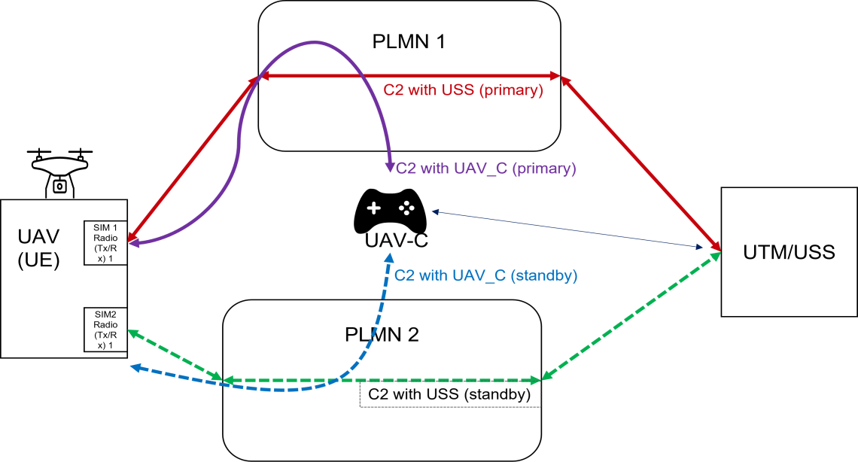

Figure 5.9.1-1: UAV traffic over two alternative PLMNs (one active at a time)

Which PLMN to use, and when to switch between them, would be based on specific conditions and policies configurable by the UAV owner/operator.

One example is about a UAV operator (“SkyTV”), offering professional aerial video/TV services, in an environment where there is 5G coverage provided by PLMN1 (possibly shared with other PLMNs) overlapping with 5G coverage provided by PLMN2. It can be that both PLMNs are managed by the same MNO (MNO-A), or different MNOs, using different SIM/subscription credentials to access each PLMN. In order to support seamless aerial service and UAV traffic management, the whole flight path can require consistent network connection and complete network coverage. In certain areas, though, the coverage of the first PLMN can not be guaranteed, or is not preferrable (e.g. due to network congestion), while the coverage of PLMN2 is better, or preferred.

In such environment, SkyTV is contracted by a national TV broadcaster for video streaming of e.g., outdoor events, races, marathons etc. To improve the reliability and QoS experience, SkyTV can equip its UAVs with dual SIM subscription (to PLMN1 and PLMN2) and configure them such that PLMN-1 is the preferred network, while PLMN-2 should be the stand-by network, together with policies and conditions for switching between them. The example is further elaborated below.

### 5.9.2 Pre-conditions

SkyTV UAV has dual SIM subscription to PLMN1 and PLMN2. It is assumed that SkyTV has negotiated with both MNOs proper data subscriptions for traffic generated by its UAVs (e.g., QoS, traffic profile/activity, charging, etc.).

UAV’s application is configured to use both PLMNs via both subscriptions (USIM1/USIM2), transfer user data via PLMN-1 if/when available or suitable, otherwise switch to PLMN-2. Network switch is decided and controlled by UAV or UTM, based on configured application policies in the UAV or UTM.

UAV’s application policy can include e.g., when/where to use connectivity via two PLMNs, which PLMN should be active/stand-by, specific C2 traffic/QoS policies, switch conditions, etc.

It is assumed, in this use case, that UAV’s application connects to the same USS/UTM or UAV-C during the whole flight operation (regardless of which PLMN connection is used).

This scenario assumes mostly UAV-originated traffic and/or that UTM is aware of which PLMN connection is used by the UAV, so that both uplink and downlink traffic are transferred over the same active PLMN connection, and USS/UTM interacts with the active PLMN e.g., for UAS identification and traffic management. For example, when UAV application sends the data packets over one PLMN connection, the UTM can reply over the same PLMN connection.

### 5.9.3 Service Flows

1. An outdoor marathon event is starting, and SkyTV UAV is set to follow the peloton for all the itinerary (20 miles). SkyTV service provider has configured the UAV application with specific policy on how to route traffic over the two subscribed PLMN networks.

2. Before the kick-off, UAV’s communication module using USIM1 and USIM2 is registered to both PLMNs, has established C2 connection with the UAV-C or USS/UTM, using respective subscriptions/USIM credentials, and is idle (no traffic). Based on UAV operator (SkyTV) policy, PLMN-1 is configured initially as active network (to transfer video data and C2 data) while PLMN-2 is configured as standby network.

2. At the start, UAV’s application transfers real-time video data and exchange control and command data with the USS/UTM or UAV-C via PLMN1, while PLMN-2 connection remains inactive (standby connection).

3. Based on configured UAV application policies, along the itinerary, UAV video traffic and C2 data is switched over PLMN-2: UAV switches its active C2 connection with UAV-C or USS/UTM to PLMN2 while PLMN-1 becomes the standby network.

4. Later, video and C2 traffic is switched back by UAV to PLMN-1 (PLMN2 is inactive).

Steps 3&4 can be repeated along the route.

### 5.9.4 Post-conditions

SkyTV video service runs smoothly for all 20 miles, with no service degradation when transitioning in and out of PLMN-1 spotty coverage areas and the UAV is under control and monitored by USS/UTM and UAV-C all the time.

### 5.9.5 Existing features partly or fully covering the use case functionality

There are no service requirements in 22.125 about UAS multi-NW/PLMN support. Other requirements (e.g., from TS 22.261 or 22.101) do not cover the specific target UAV scenarios and functionalities. Some examples of existing requirements are captured below:

**[from 22.261 sec. 6.18: Multi-network connectivity and service delivery across operators]**

The 5G system shall enable users to obtain services from more than one network simultaneously on an on-demand basis.

For a user with a single operator subscription, the use of multiple serving networks operated by different operators shall be under the control of the home operator.

When a service is offered by multiple operators, the 5G system shall be able to maintain service continuity with minimum service interruption when the serving network is changed to a different serving network operated by a different operator.

NOTE 1: A business agreement is required between the network operators.

In the event of the same service being offered by multiple operators, unless directed by the home operator's network, the UE shall be prioritized to receive subscribed services from the home operator's network.

NOTE 2: If the service is unavailable (e.g., due to lack of network coverage) from the home operator's network, the UE may be able to receive the service from another operator's network.

NOTE 3: QoS provided by the partner operator's network for the same service will be based on the agreement between the two operators and could be different than that provided by the home operator's network.

**[from 22.101 sec. 13.4]**

The 3GPP system shall support ME with multiple USIMs (on the same UICC or on different UICCs) that are registered at the same time.

The 3GPP system shall treat each registration from the USIMs of a MUSIM UE independently. Each registered USIM in a MUSIM UE shall be associated with a dedicated IMEI/PEI.

**[from others]**

In addition, there are existing UAV requirements (from TS 22.125) on 3GPP system to provide monitoring and notification regarding C2 communication changes, which are not specific to inter-PLMN connectivity, for example:

The 3GPP system shall support C2 communication with required QoS for pre-defined C2 communication models (e.g., using direct ProSe Communication between UAV and the UAV controller, UTM-navigated C2 communication based on flight plan between UTM and the UAV).

The 3GPP system shall support C2 communication with required QoS when switching between the C2 communication models.

The 3GPP system shall support a mechanism for the UTM to request monitoring of the C2 communication with required QoS for pre-defined C2 communication models (e.g., using direct ProSe Communication between UAV and the UAV controller, UTM-navigated C2 communication between UTM and the UAV).

### 5.9.6 Potential New Requirements needed to support the use case

[PR 5.9.6-001] The 5G system shall be able to support service enablement layer exposure mechanisms for the UTM or other authorized 3rd party to provide the UAV application with configuration information to route and switch traffic between one active and one standby PLMN connection, e.g. for C2 communication reliability and redundancy purpose.

NOTE 1: The above requirement can be extended to scenarios where one network is a PLMN and one is an NPN.

NOTE 2: There is no impact on legacy network selection.

NOTE 3: It is assumed that UAV traffic handling, over each PLMN, is subject to NW control mechanisms (e.g. in accordance with MNO routing priorities, available QoS/NW resources, etc.).

## 5.10 Use case on UAV control in different aerial flight zones

### 5.10.1 Description

5G networks can provide connectivity to UAV for a variety of services, e.g., command and control, telemetry, remote ID, DAA, payload transfer (e.g., video), etc. In some scenarios, it would be beneficial to control and differentiate UAV operation and communication, e.g., regarding the use of specific network resources and/or specific application(s) settings, in different geographical areas. Some aspects of the 5G connectivity configuration, indeed, may need to be different depending on the area where the UAV is flying, e.g., in urban versus rural, or in areas close to high-risk obstacles or with stricter safety restrictions, like airports, stadiums, etc. This use case describes some means to efficiently support and control differentiation of UAV traffic across different zones and corresponding potential requirements.

For example, the UAV and UTM provider may identify different types of aerial flight zones in the territory, e.g., based on data traffic information, flight statistics, network topology. local conditions, events, etc. Based on business agreement with an MNO, the UTM and network can configure specific information on different flight zones, which can include e.g., the geographical location (footprint or 3D volume) of the flight zones and their mapping to different network areas, associated zone type or other means to identify a specific flight zone, and target UAV communication/QoS parameters (per flight zone).

UTM and/or the network can then convey to the UAV corresponding policy configuration (static or dynamic), controlling how the UAV should use connectivity services for various applications in different flight zones (e.g., per zone type). The network should also assist UAV to identify and differentiate specific flight zones, so that a UAV can apply the right configured policy based on the actual flight zone it is currently located in.

A general example of flight zones settings is illustrated in Fig.1, based on different geographical, logistical and safety factors (e.g., around city centre, stadiums, airports, harbour, rural areas, etc.). The figure may represent the flight zone settings for a specific day, or time of the day, and may vary based on local/temporary change of conditions.

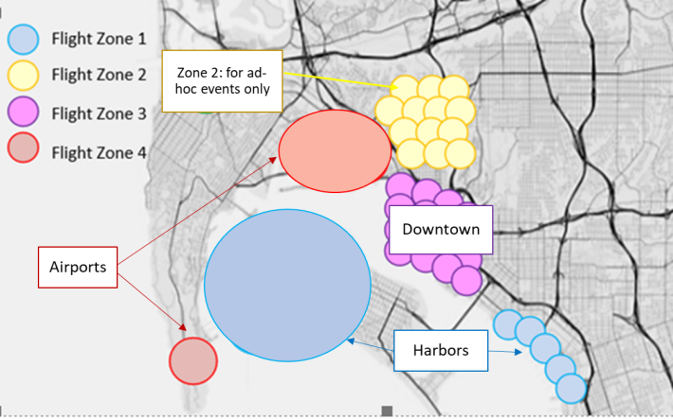

Figure 5.10.1-1: Example of UAV flight zones configuration

The UAV policy could also contain a default configuration that can be used when no specific flight zone type is applicable or not indicated/available to the UAV.

The above would provide the ability for UTM to collaborate with the 5G network to provide flexible control of UAV communication over the identified flight zones, including scalable and dynamic adaptation based on temporary/local changes (e.g., data traffic, NW resources, environmental changes, local events or restrictions), by creating new flight zones that map on specific network areas and/or modifying existing zone types, etc.

One specific scenario and flow is further elaborated below.

### 5.10.2 Pre-conditions

A UAV service provider (U-Serv), offering monitoring & surveillance UAV services in multiple cities of the country, has an agreement with PLMN-A operator, including the configuration of two different flight zones (for all cities) mapped to different parts of the territory and network, with the following UAV application/traffic policies and conditions:

* - Zone A (no restriction/condition): for most areas/location of the cities’ territory

○ normal/default UAV application and communication settings

* - Zone B (with restriction/condition): for areas/locations e.g., with larger data traffic/congestion and/or higher drones’ density (e.g., where/when special events or emergency situations happen).

○ Increased frequency and QoS of C2 communication (for more reliable command and control operation)

○ Reduced data traffic activity/QoS for other communications (to reduce network congestion)

The Zone B policy configuration may also include other options, e.g., restrictions/conditions may vary based on UAV altitude (above / below a certain threshold, or within a certain range), time of the day, etc.

### 5.10.3 Service Flows

1. 1. A U-Serv UAV, located in Zone A, is registered to PLMN-A and starts its daily surveillance service.
2. 2. The UAV detects it is in Zone A, e.g., if indicated by the network or based on UAV available information or pre-configuration, and connects to the network using the corresponding traffic policy for Zone A (normal/default operation).
3. 3. Along the UAV itinerary, UAV detects or is notified of being in a new zone type, Zone B, thus UAV application will apply corresponding traffic settings according to Zone B policy.
4. 4. If UAV detects or is notified that flight zone type changes to Zone A, UAV application will switch back to default traffic policy.

Note that change of flight zone type may happen due to the UAV moving across different geographical areas (associated to different zone types) or by change of zone type for the same UAV geographical location (e.g., based on temporary events).

### 5.10.4 Post-conditions

U-Serv UAV application can provide smooth service and is able to adapt its communication settings when flying across special locations/areas (zone B), based on UAV traffic policies and flight zone settings under control of UTM and network.

### 5.10.5 Existing features partly or fully covering the use case functionality

None identified.

### 5.10.6 Potential New Requirements needed to support the use case

[PR 5.10.6-001] The 5G system shall be able to support mechanisms for the UTM to configure different aerial flight zones where UAV application settings and communication QoS may be different, and provide network and UAV with means to identify those flight zones.

[PR 5.10.6-002] The 5G system shall be able to support mechanisms for the UTM to provide network and UAV with policy information including UAV application settings and communication QoS to be applied in specific aerial flight zones, e.g. based on flight zone type indicated or available to the UAV in a certain geographical location.

# 6 Consolidated potential requirements

## 6.1 Network support and exposure for UAV usage

| CPR # | Consolidated Potential Requirement | Original PR # | Comment |
| --- | --- | --- | --- |
| CPR 6.1-001 | Based on operator’s policy, the 5G system shall be able to support a method to predict, monitor network conditions and QoS (e.g. bitrate, latency, reliability) and report to 3rd party along a continuous geographic planned flight path of a UAV at specific times of its expected flight duration. | P.R 5.2.6-001  P.R 5.6.6-001 |  |
| CPR 6.1-002 | Based on operator’s policy, the 5G system shall be able to provide UTM with the information about geographic areas where UAV service requirements could or could not be met based on predicted network conditions and QoS (e.g. bitrate, latency, reliability). | P.R 5.2.6-002 |  |
| CPR 6.1-003 | Based on a 3rd party request, the 5G system shall be able to provide to the 3rd party alternative UAV flight paths, as long as UTM-provided required waypoints (e.g. start/end locations), required QoS, and exclusion zones are fulfilled. | P.R 5.2.6-003 |  |
| CPR 6.1-004 | Based on a 3rd party request and operator’s policy, the 5G system shall be able to reconfigure network resources to provide the required QoS along a UAV planned flight path, e.g. at particular geographical area(s) and time(s). | P.R 5.2.6-004 |  |
| CPR 6.1-005 | The 5G system shall be able to support a mechanism to enable a network operator to track a UAV which doesn’t have subscription with this network operator. | P.R 5.7.6-001 |  |
| CPR 6.1-006 | The 5G system shall be able to support service enablement layer exposure mechanisms for the UTM or other authorized 3rd party to provide the UAV application with configuration information to route and switch traffic between one active and one standby PLMN connection, e.g. for C2 communication reliability and redundancy purpose, or to route different traffic across different PLMN connections simultaneously, e.g. C2 traffic via one PLMN and other data via the second PLMN.  NOTE 1: The above requirement can be extended to scenarios where one network is a PLMN and one is an NPN.  NOTE 2: There is no impact on legacy network selection.  NOTE 3: It is assumed that UAV traffic handling, over each PLMN, is subject to NW control mechanisms (e.g. in accordance with MNO routing priorities, available QoS/NW resources, etc.). | P.R 5.8.6-001  P.R 5.9.6-001 |  |
| CPR 6.1-007 | The 5G system shall be able to support mechanisms for the UTM to configure different aerial flight zones where UAV application settings and communication QoS may be different, and provide network and UAV with means to identify those flight zones. | P.R 5.10.6-001 |  |
| CPR 6.1-008 | The 5G system shall be able to support mechanisms for the UTM to provide network and UAV with policy information including UAV application settings and communication QoS to be applied in specific aerial flight zones, e.g. based on flight zone type indicated or available to the UAV in a certain geographical location. | P.R 5.10.6-002 |  |

## 6.2 Safety and Security

|  |  |  |  |
| --- | --- | --- | --- |
| CPR # | Consolidated Potential Requirement | Original PR # | Comment |
| CPR 6.2-001 | The 5G system shall be able to detect that a connected UE is airborne, when UE’s subscription does not include “aerial”. | PR 5.1.6-001 |  |
| CPR 6.2-002 | The 5G system shall be able to be informed of VLoS regulatory requirements (e.g. maximal distance threshold) and shall be informed if the UTM needs to be supported in meeting such requirements for a given UAS. | PR 5.3.6-001 |  |
| CPR 6.2-003 | Based on operator’s policy, the 5G system shall be able to support a method to monitor and provide a 3rd party with information about deviations and violations along a UAV flight path and time.  Note: Deviations can be e.g. in location and/or time with respect to the original flight plan. Violations can be e.g. with respect to exclusion zones provided together with the flight plan or known via other means. | P.R 5.6.6-002 |  |
| CPR 6.2-004 | Based on operator’s policy, the 5G system shall be able to support a method to provide UTM and UAVs with the information collected or generated by the 5G system (e.g., based on sensing results), including e.g. the location or relative distance of 3GPP UAVs and other flying objects (can be drones not using 3GPP connectivity). | P.R 5.4.6-001 |  |
| CPR 6.2-005 | The 5G system shall be able to track the UAV-Controller, regardless of the type of connection. | PR 5.3.6-002 |  |
| CPR 6.2-006 | Based on MNO policies and/or regulatory requirements, the 5G system shall be able to alert the UTM, when the 5G system detects that a condition is met (e.g. maximal distance threshold exceeded). | PR 5.3.6-003 |  |
| CPR 6.2-007 | Based on MNO policies and/or regulatory requirements, the 5G system shall enable the UTM to take over the communication used to control the UAV, when the 5G system detects that a condition is met (e.g. maximal distance threshold exceeded). | PR 5.3.6-004 |  |

# 7 Conclusion and recommendations

Editor's Note: to be provided.

Annex A (informative):  
Change history

|  |  |  |  |  |  |  |  |
| --- | --- | --- | --- | --- | --- | --- | --- |
| **Change history** | | | | | | | |
| **Date** | **Meeting** | **TDoc** | **CR** | **Rev** | **Cat** | **Subject/Comment** | **New version** |
| 2022-08 | SA1#99-e | S1-222402 |  |  |  | TR skeleton | 0.0.0 |
| 2022-09 | SA1#99-e | S1-222403,  S1-222404,  S1-222405,  S1-222406 |  |  |  | Scope  Overview  New use case - UAV detection  New use case_Supporting UAV pre-flight preparation | 0.1.0 |
| 2022-11 | SA1#100 | S1-223436  S1-223616  S1-223719  S1-223720  S1-223721 |  |  |  | pCR on use case on supporting UAV pre-flight preparation  New use case: Support UAV inflight monitoring  New use case_VLoS_geofencing  New use case on network-assisted UAV DAA  New use case: 3GPP network as an information source to the UTM | 0.2.0 |
| 2023-02 | SA1#101 | S1-230357  S1-230786  S1-230787 |  |  |  | New use case on UAV flight route tracking at Rendezvous points  pCR: Update on UTM pre-/in-flight operation support  Update of the use case “Geofencing for Visual Line-of-Sight UAV missions” | 0.3.0 |
| 2023-03 | SA#99 | SP-230221 |  |  |  | MCC clean-up for presentation to SA | 1.0.0 |
| 2023-05 | SA1#102 | S1-231258  S1-231608  S1-231610  S1-231611  S1-231614  S1-231617  S1-231622  S1-231638  S1-231762  S1-231773 |  |  |  | pCR on Abbreviations section  TR 22843 FS_UAV_ph3 quality improvement CR  Use Case on UAV simultaneous traffic over two networks  Use Case on UAV flying zones  pCR on Use case Geofencing VLoS  pCR on updating use case 5.2 Supporting UAV flight preparation  pCR on use case on network-assisted UAV DAA  Use Case on UAV traffic over two alternative networks  pCR on FS-UAV-Ph3_Overview section  pCR on consolidated requirements for UAV Phase3 | 1.1.0 |
| 2023-06 | SA#100 | SP-230517 |  |  |  | MCC clean-up for approval by SA | 2.0.0 |
| 2023-06 | SA#100 | SP-230517 |  |  |  | Raised to v.19.0.0 by MCC following approval by SA | 19.0.0 |