

UNIVERSITY OF LA SALETTE, INC.

College of Information Technology

PCCBSIT 006 — Application Development and Emerging Technologies
Assessment A2 — Application Planning and Design

Co-opSync
Integrated Cooperative & Supply-Chain Management System

CLIENT ORGANIZATION
San Miguel Farmers Cooperative (Agricultural Cooperative)

GROUP MEMBERS
Abon, Alexandrie C. Balaba, Marcky Paolo E. Santiago, Adrian Lester G. Serrano, Lanther Han M.

BSIT 3A

September 17, 2026

TABLE OF CONTENTS

TABLE OF CONTENTS 2
- PROPOSED SYSTEM / SYSTEM TITLE 4
- STATEMENT OF THE PROBLEM 4
- STAKEHOLDERS 6
Table 1: Stakeholders and System Benefits 6
  - User Access Module 7
  - Farmer-Member Records 7
  - Warehouse Receiving Module 7
  - Inventory Management 7
  - Field Coordinator Portal 8
  - Real-Time Data Transmission 8
  - Payment and Reconciliation 8
  - Receipt Module 8
  - Audit Trail 8
  - Dashboard and Reporting 8
- OBJECTIVES 9
General Objective 9
Specific Objectives 9
- SCOPE 10
  - In-Scope 10
  - Out-of-Scope 11
- FUNCTIONAL REQUIREMENTS 12
Table 3: Functional Requirements of the Proposed System 12
FR-01 Diagram 13
FR-02 Diagram 14
FR-03 Diagram 14
FR-04 Diagram 15
FR-05 Diagram 15
FR-06 Diagram 16
FR-07 Diagram 16
FR-08 Diagram 17
FR-09 Diagram 17
FR-10 Diagram 18
FR-11 Diagram 18
FR-12 Diagram 19
FR-13 Diagram 19
- NON-FUNCTIONAL REQUIREMENTS 20
Table 4: Non-Functional Requirements of the Proposed System 20
Figure 1: Co-opSync Three-Tier Real-Time Online Architecture 22
10. COMPONENTS 22
Table 5: System Components and Their Purpose 22
Figure 2: Co-opSync Data Flow Diagram 24
Figure 3: Co-opSync Navigation Plan 26
13. INTERFACE / WIREFRAMES 27
Figure 4: Login Screen Wireframe 27
Figure 5: Farmer Members Wireframe 27
Figure 6: Warehouse Receiving Wireframe 28
Figure 7: Inventory & Stocks Wireframe 28
Figure 8:Field Portal Wireframe 29
Figure 9: Sync & Transmission Wireframe 29
Figure 10: Payment & Recon Wireframe 30
Figure 11: Receipt Module Wireframe 30
Figure 9: Audit Trial Logs Wireframe 31
Figure 10: Dashboard and Report Wireframe 31
Table 6: Technology Selection and Justification 32
Table 8: Consultation Meeting Agenda 34
- FINAL DESIGN 35
Figure 11: Final System Design 35
Final Design Summary 36
- CONCLUSION 36

PROPOSED SYSTEM / SYSTEM TITLE

System Title: Co-opSync — Integrated Cooperative & Supply-Chain Management System
The proposed Co-opSync Management System is a lightweight, centralized web-based management system designed for San Miguel Farmers Cooperative. The system will centralize important cooperative records such as farmer-member information, harvest deliveries, quality inspection, inventory, field updates, payment records, receipts, and reports.
Currently, different cooperative activities are handled using separate paper records, spreadsheets, and messaging applications. This can result in duplicated information, delayed updates, and difficulty checking records.
Co-opSync will provide a centralized system where authorized users can record, view, update, and monitor cooperative transactions. Because the system is web-based and internet-connected, records entered by any authorized user are transmitted to the central database in real time, so updates become immediately visible to the other roles that depend on them.

STATEMENT OF THE PROBLEM

San Miguel Farmers Cooperative currently uses manual and separate records for its daily operations. This creates difficulties in recording harvest deliveries, communicating field updates, processing payments, updating inventory,

tracking changes, and preparing reports. Specifically, the cooperative experiences the following problems:
- Inconsistent Harvest and Quality Records: Harvest weights and quality results are recorded manually. This may cause differences between warehouse records and the information used for payment processing.
- Delayed Field Updates: Field Coordinators record expected deliveries, schedule changes, and field input requests through separate communication methods. This may delay information received by the Warehouse Assistant.
- Difficulty in Payment Processing: Accounting staff need to check harvest and quality records before calculating payments. Checking separate records takes time and may result in incorrect payment information.
- Limited Access During Internet Outages: Unstable internet connection can interrupt field data entry and prevent Field Coordinators from immediately submitting important updates.
- Manual Tracking of Transactions and Changes: Important changes to harvest, payment, inventory, and other records can be difficult to track when records are maintained manually.
- Time-Consuming Report Preparation: The Cooperative Manager needs to gather information from different records when preparing harvest, inventory, member, and payment reports.

- Difficulty in Managing Inventory Records: Inventory information needs to be updated based on received harvest and released supplies. Manual updating can cause outdated or inconsistent inventory records.
- Lack of Clear Payment Records for Farmer-Members: Farmer-Members need clear information about their accepted harvest quantity, quality adjustments, and payment amount.

STAKEHOLDERS

Table 1: Stakeholders and System Benefits

Stakeholder | Needs | System Benefit
Farmer-Members | Simple processes and transparent payment calculations | Itemized receipts showing accepted net weight, quality adjustments, and payment breakdown
Warehouse Assistant | Fast harvest receiving and quality recording | Streamlined receiving and inspection forms
Field Coordinators | Easy field updates using mobile devices | Mobile-friendly online forms for schedules, expected deliveries, and input requests submitted in real time
Accounting Clerk | Verified harvest information for payment processing | Direct access to verified harvest and quality records
Cooperative Manager | Accurate information for monitoring and reporting | Dashboard, summaries, and report export

PROPOSED APPLICATION
Table 2: Proposed Application Overview



Item | Description
Application Name | Co-opSync — Integrated Cooperative & Supply-Chain Management System
Application Type | Web-based application accessible through desktop and mobile browsers over an internet connection
Main Purpose | To centralize harvest, quality, inventory, field, and payment records of the cooperative
Target Users | Warehouse Assistant, Field Coordinator, Accounting Clerk, Cooperative Manager, Farmer-Members
Problem Addressed | Manual and separated recordkeeping that causes inconsistent records, delayed field updates, slow payment processing, and time-consuming reporting
The proposed application will consist of several connected modules:

User Access Module
Provides login and role-based access for authorized users. The system will show features according to the user's assigned role.

Farmer-Member Records
Stores farmer-member information and allows authorized users to search and view member transaction history.

Warehouse Receiving Module
Allows the Warehouse Assistant to record harvest deliveries, including farmer-member, delivery date, product, gross weight, quality result, deductions, rejected quantity, and accepted net weight.

Inventory Management
Updates inventory based on approved harvest receipts and inventory releases.

Field Coordinator Portal
Allows Field Coordinators to record expected deliveries, schedule changes, and field input requests.

Real-Time Data Transmission
Sends every submitted record to the central database over the internet as soon as it is saved, so that harvest, field, inventory, and payment updates become immediately available to the other modules and users.

Payment and Reconciliation
Allows the Accounting Clerk to view verified harvest and quality information, calculate payments, and record payment information.

Receipt Module
Generates an itemized receipt containing the farmer-member, accepted net weight, quality adjustments, and payment amount.

Audit Trail
Records important changes made to system records, including the user, date, time, and reason for change.

Dashboard and Reporting
Provides the Cooperative Manager with summary information about harvest, inventory, farmer-members, and payments. The manager can also generate and export reports.

OBJECTIVES

General Objective
To develop a centralized cooperative management system that improves the recording, processing, monitoring, and reporting of harvest, inventory, field, and payment information for San Miguel Farmers Cooperative.

Specific Objectives
- To improve the recording of harvest and quality information by providing the Warehouse Assistant with digital forms for harvest deliveries, gross weight, quality results, deductions, rejected quantity, and accepted net weight.
- To improve the recording of field updates by providing Field Coordinators with a system for expected deliveries, schedule changes, and field input requests.
- To improve payment processing by providing the Accounting Clerk with verified harvest and quality information and a system for calculating and recording payment amounts.
- To provide real-time information sharing by transmitting submitted records to the central database over the internet so that updates are immediately available to the other users.
- To improve tracking of important record changes by maintaining an audit trail that records the user, date, time, and reason for each important change.

- To reduce report preparation time by providing the Cooperative Manager with a dashboard and reports containing harvest, inventory, member, and payment information.
- To improve inventory record management by automatically updating inventory records based on approved harvest receipts and inventory releases.
- To provide farmer-members with clear payment information through itemized receipts showing accepted net weight, quality adjustments, and payment amount.

SCOPE

In-Scope
The system will include the following functions:

    - User login and role-based access
    - Farmer-member records
    - Harvest delivery recording and gross weight recording
    - Quality inspection, deductions, rejected quantity, and accepted net weight recording
    - Inventory updates
    - Expected delivery recording, field schedule changes, and field input requests
    - Real-time transmission and updating of submitted records
    - Verified harvest information for Accounting

    - Payment calculation, recording, status, and reference information
    - Itemized payment receipts
    - Transaction and payment history
    - Audit trail
    - Manager dashboard
    - Harvest, inventory, member, and payment reports with report export

Out-of-Scope
The system will not include:

    - Payroll and employee management
    - Human resource management
    - E-commerce and direct-to-consumer selling
    - Online banking services
    - Government tax integration
    - Full farm management, crop monitoring, and weather monitoring
    - External supplier systems
    - External buyer systems
    - Offline field data entry and synchronization of offline records

FUNCTIONAL REQUIREMENTS
Table 3: Functional Requirements of the Proposed System

ID | Functional Requirement | Actor / User
FR-01 | The system shall allow authorized users to log in according to their assigned role. | All Authorized Users

ID | Functional Requirement | Actor / User
FR-02 | The system shall allow the Warehouse Assistant to record a farmer-member's harvest delivery, including delivery date, product, and gross weight. | Warehouse Assistant
FR-03 | The system shall allow the Warehouse Assistant to record the quality result, deductions, rejected quantity, and accepted net weight of a harvest delivery. | Warehouse Assistant
FR-04 | The system shall update inventory records based on approved harvest receipts and inventory releases. | Warehouse Assistant
FR-05 | The system shall allow the Field Coordinator to record expected deliveries, schedule changes, and field input requests. | Field Coordinator
FR-06 | The system shall allow the Accounting Clerk to view verified harvest and quality information for payment processing. | Accounting Clerk
FR-07 | The system shall calculate the payment amount using accepted net weight, price, and applicable adjustments. | Accounting Clerk
FR-08 | The system shall allow the Accounting Clerk to record the payment amount, payment date, payment status, and reference information. | Accounting Clerk
FR-9 | The system shall generate an itemized receipt showing the farmer-member, accepted net weight, quality adjustments, and payment amount. | Farmer-Member  / Accounting Clerk
FR-10 | The system shall provide the Cooperative Manager with a dashboard showing recorded harvest, inventory, member, and payment information. | Cooperative Manager
FR-11 | The system shall allow the Cooperative Manager to generate and export harvest, inventory, member, and payment reports. | Cooperative Manager
FR-12 | The system shall record important changes to system records, including the user, date, time, and reason for the change. | Authorized Users
FR-13 | The system shall allow authorized users to search and view farmer-member transactions and payment history. | Accounting Clerk / Manager

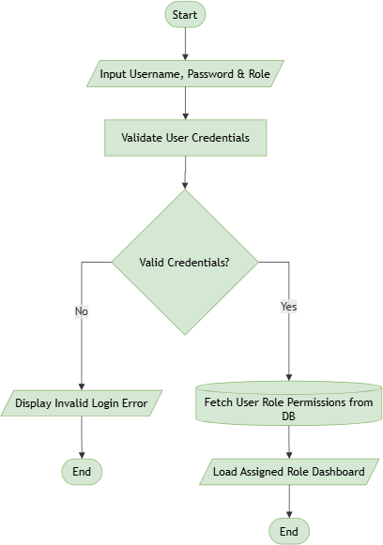

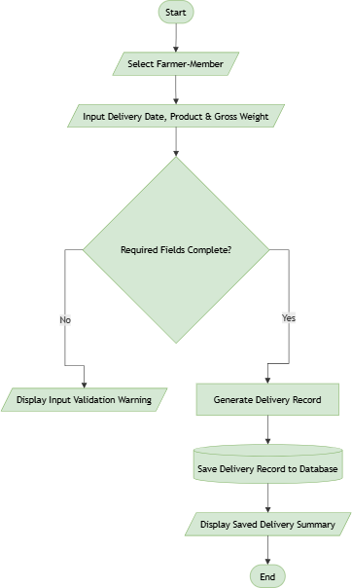
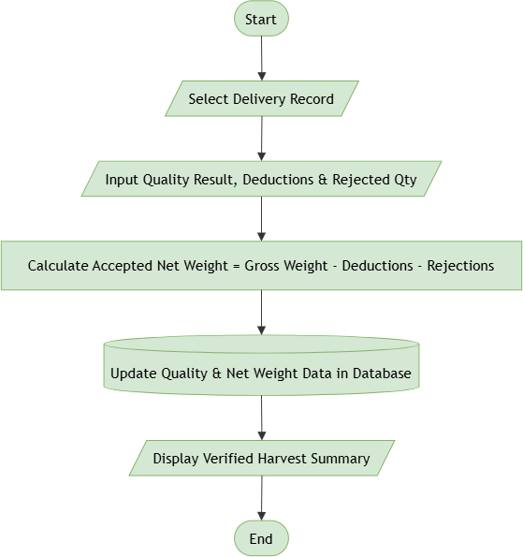

FR-03 Diagram

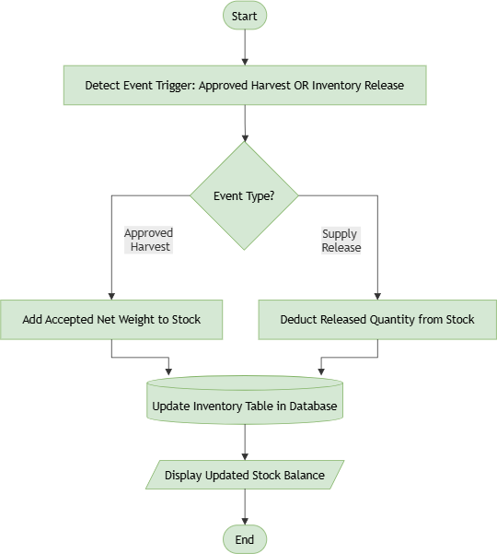
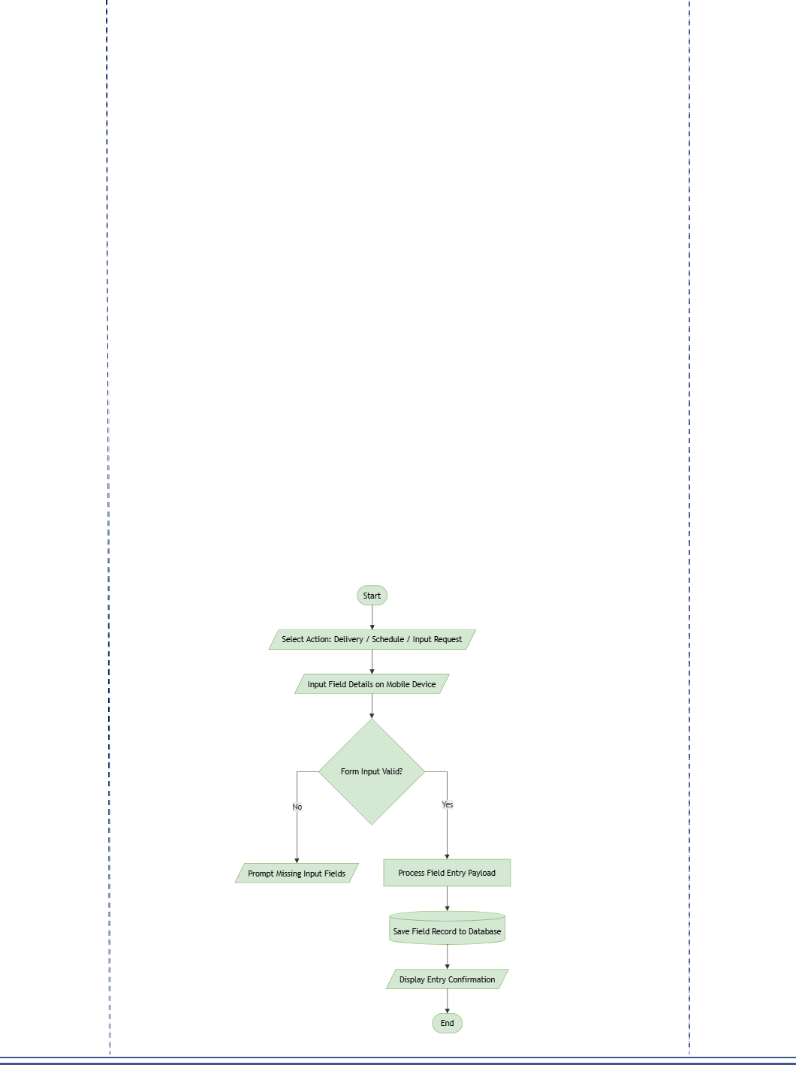

FR-05 Diagram

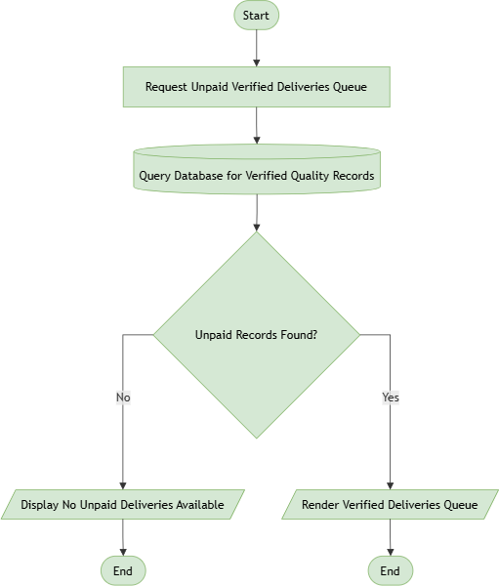
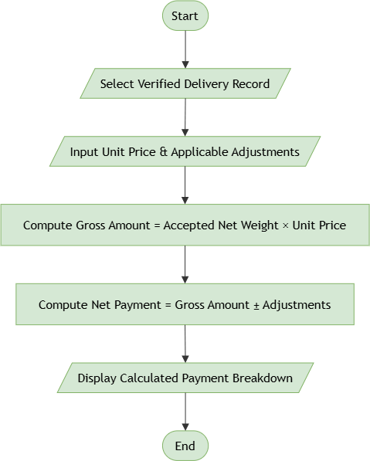

FR-07 Diagram

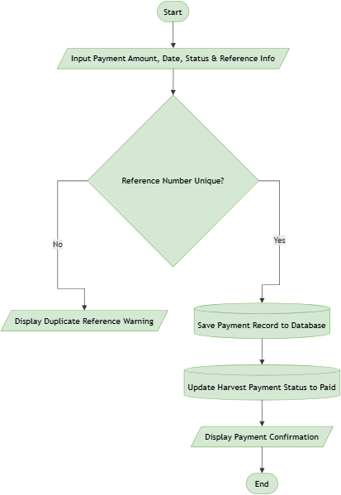
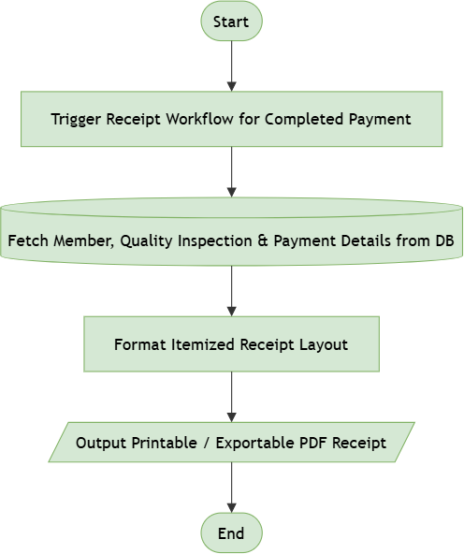

FR-09 Diagram

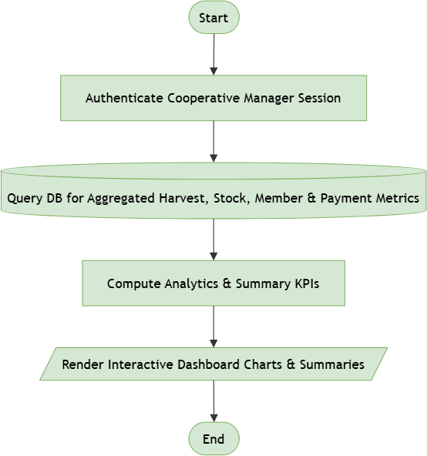
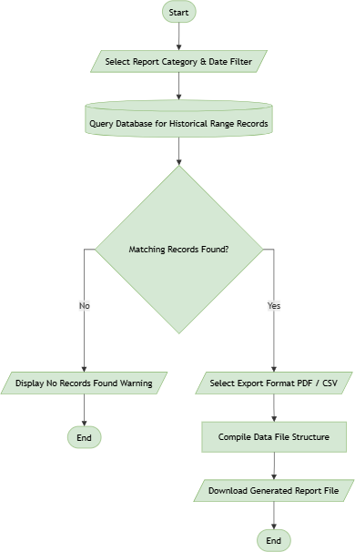

FR-11 Diagram

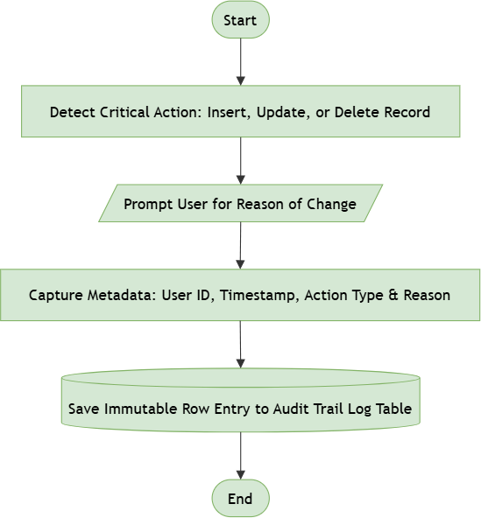
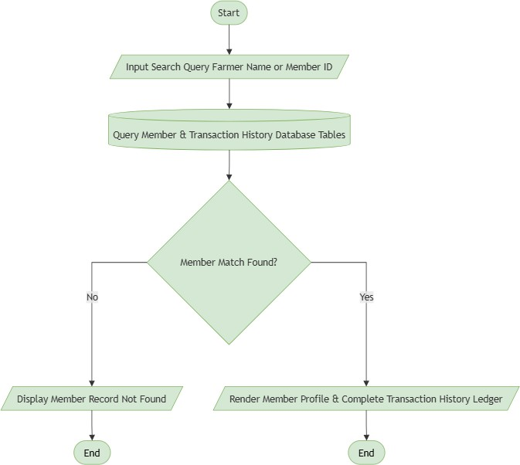
FR-12 Diagram

FR-13 Diagram

NON-FUNCTIONAL REQUIREMENTS
Table 4: Non-Functional Requirements of the Proposed System

ID | Category | Requirement
NFR-01 | Usability | The system shall provide simple forms and clear navigation for users with different levels of technical knowledge.
NFR-02 | Performance | Common form actions should respond within an acceptable time under normal operating conditions.
NFR-03 | Connectivity | The system shall require an active internet connection and shall notify the user when the connection is lost.
NFR-04 | Real Time Updating | Submitted records shall be saved to the central database and reflected in related screens without requiring manual refreshing or re-encoding.
NFR-05 | Security | The system shall require authorized login and restrict functions based on user roles.
NFR-06 | Reliability | The system shall confirm successful submission of each record and shall prevent incomplete records from being saved when a transmission fails.
NFR-07 | Auditability | Important record changes shall be traceable to the user and time of the change.
NFR-08 | Portability | The system should be usable through supported desktop and mobile devices.
NFR-09 | Maintainability | The application should use a modular structure so individual components can be maintained or updated.
NFR-10 | Scalability | The system should be able to support additional members, transactions, and records as the cooperative grows.
The system will use a three tier client-server architecture. All users connect to the same central application and database through the internet, so recorded information is transmitted and stored centrally in real time.

Presentation Layer
This layer contains the interfaces used by the Warehouse Assistant, Field Coordinator, Accounting Clerk, and Cooperative Manager. The interface will be accessible through supported desktop and mobile devices using a web browser with an internet connection.
Application Layer
The application layer will process user authentication, harvest recording, quality inspection, inventory updates, field updates, real-time record transmission, payment calculation, receipt generation, audit logging, and reporting.

Data Layer
The data layer will store the system's centralized records in a single central database, so that all users read from and write to the same source of information.

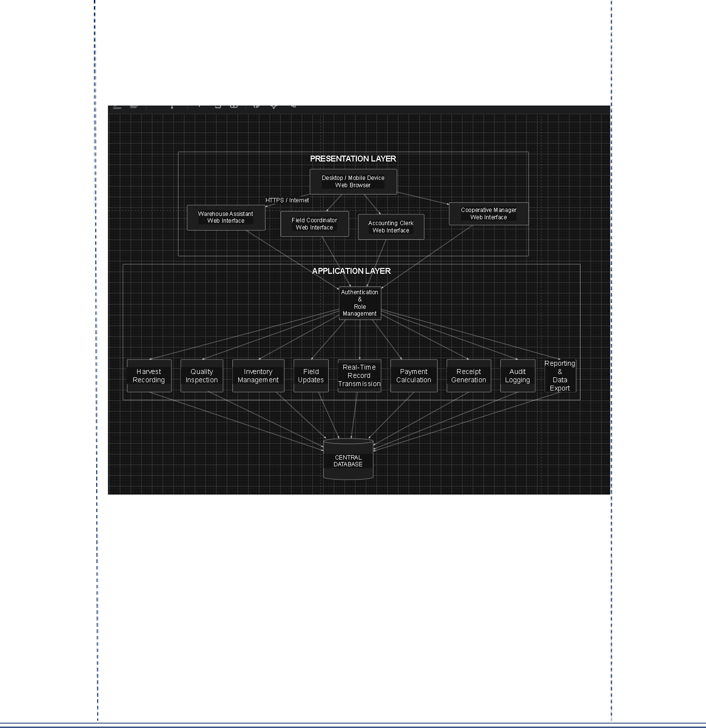
Figure 1: Co-opSync Three-Tier Real-Time Online Architecture

COMPONENTS
Table 5: System Components and Their Purpose

Component | Purpose
Login Component | Handles user authentication and role access

Component | Purpose
Member Component | Stores and retrieves farmer-member information
Harvest Component | Records incoming harvest deliveries
Quality Component | Records quality results and deductions
Inventory Component | Updates inventory records
Field Component | Records schedules, expected deliveries, and input requests
Transmission Component | Sends submitted records to the central database and confirms successful saving
Payment Component | Calculates and records payments
Receipt Component | Generates itemized receipts
Audit Component | Records important changes
Dashboard Component | Displays management summaries
Reporting Component | Generates and exports reports
Database Component | Stores centralized system records

DATA FLOW

The system will use the following general data flow:

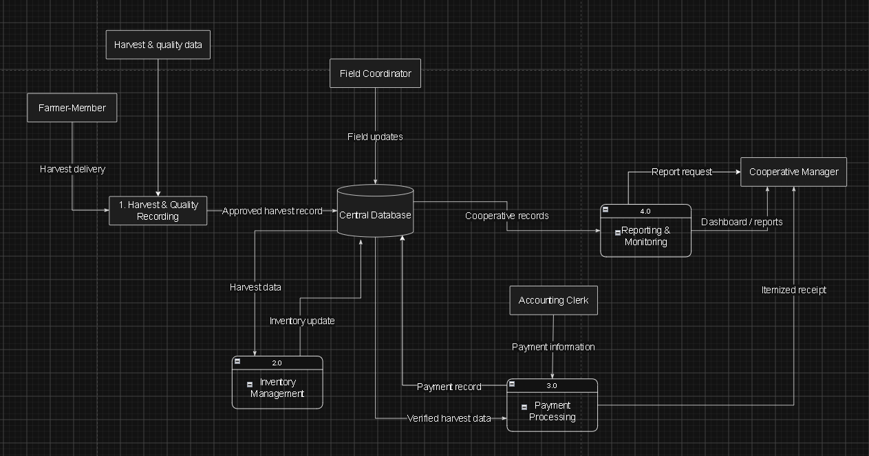
Figure 2: Co-opSync Data Flow Diagram

Main Data Flow Sequence
- Farmer-Member submits harvest delivery information.
- Warehouse Assistant records the harvest and quality information.
- The approved harvest record is saved in the Central Database.

- Harvest information is used to update inventory records.
- Verified harvest data is provided to the Accounting Clerk for payment processing.
- The Accounting Clerk enters payment information and records the payment.
- The system generates an itemized receipt containing the payment details.
- Field Coordinator submits field updates, expected deliveries, schedule changes, and input requests.
- Cooperative Manager views cooperative records through the dashboard and generates reports.

NAVIGATION PLAN

After logging in, each user is directed to the dashboard assigned to their role. From there, users can access only the functions related to their responsibilities.

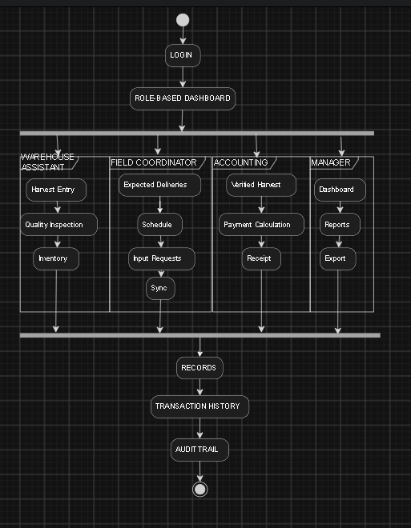
Figure 3: Co-opSync Navigation Plan

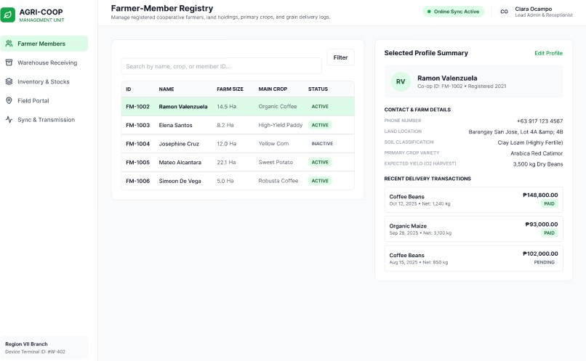
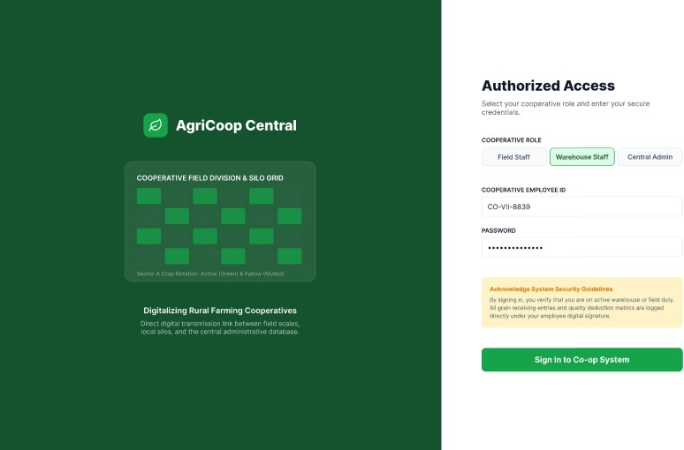
INTERFACE / WIREFRAMES

Login Interface
Figure 4: Login Screen Wireframe

Farmer Members Interface
Figure 5: Farmer Members Wireframe

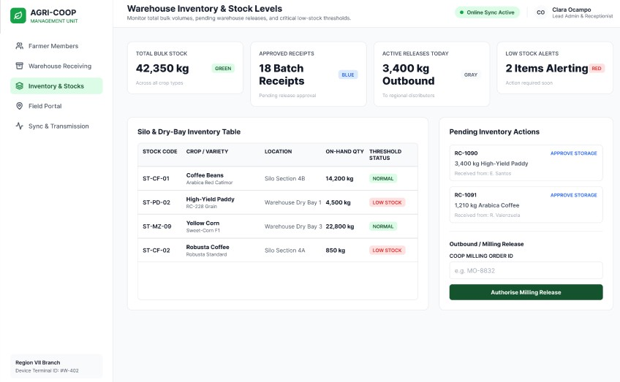
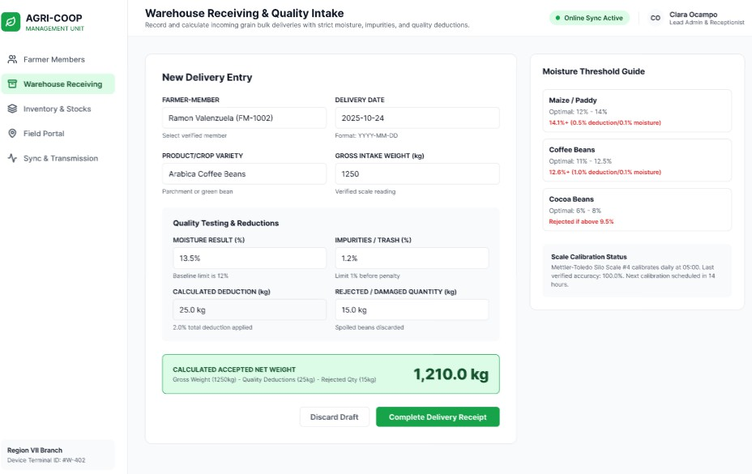

Warehouse Receiving Interface
Figure 6: Warehouse Receiving Wireframe

Inventory & Stocks Interface
Figure 7: Inventory & Stocks Wireframe

ULS College of Information Technology 28

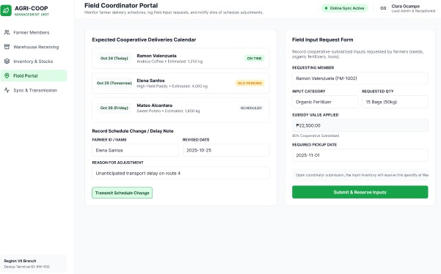
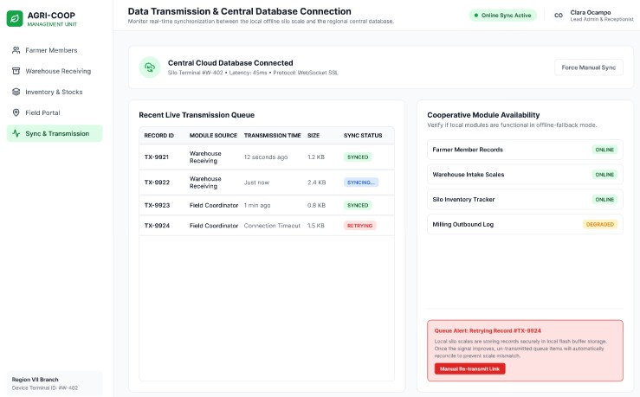

Field Portal Interface
Figure 8:Field Portal Wireframe

Sync & Transmission Interface
Figure 9: Sync & Transmission Wireframe

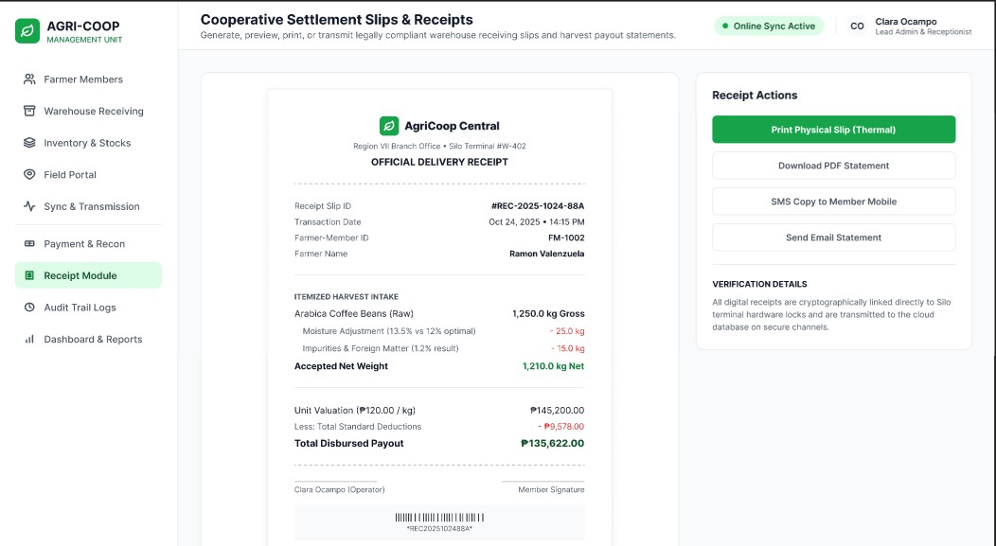
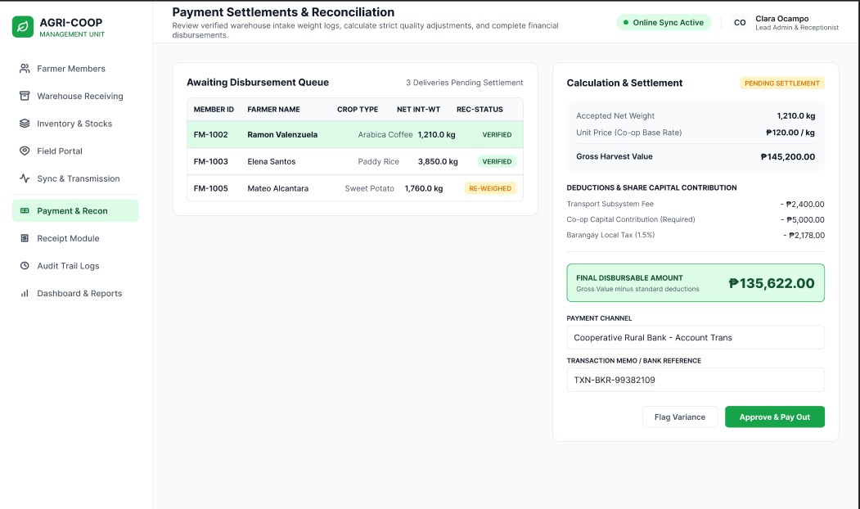

Payment & Recon Interface
Figure 10: Payment & Recon Wireframe

Receipt Module Interface
Figure 11: Receipt Module Wireframe

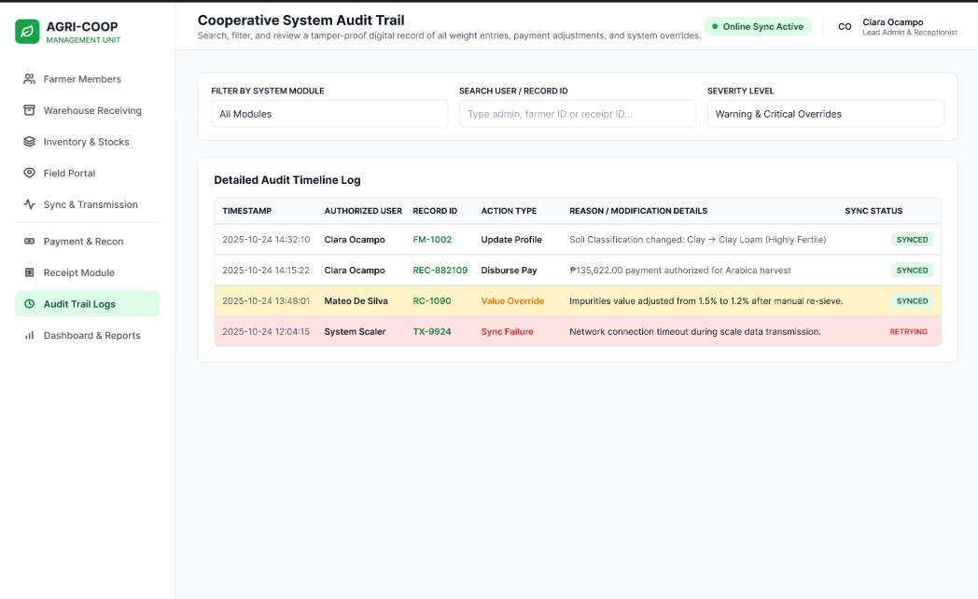
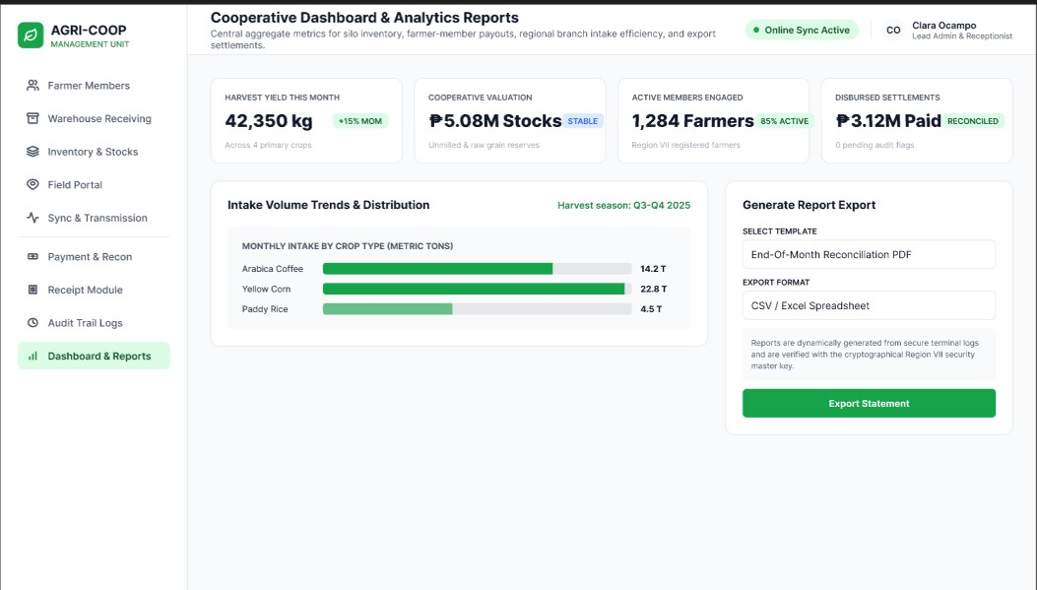

Audit Trial Logs Interface
Figure 9: Audit Trial Logs Wireframe

Dashboard and Report Interface
Figure 10: Dashboard and Report Wireframe

TECHNOLOGY SELECTION
Table 6: Technology Selection and Justification

Category / Technology | Purpose | Reason / Justification
Framework / PHP LARAVEL | Backend framework | Provides a robust, structured MVC architecture for server-side logic and API handling
Database / MYSQL | Central database | Serves as the primary relational database system for core records management
Programming Languages  / PHP, JavaScript, HTML, CSS | Application development | Standardized web technologies for server logic, client interactivity, and UI rendering
User Interface / HTML & CSS | User interface | Core web technologies for rendering accessible and responsive design layouts
Platform Architecture  / Web Application | Multi-device browser access | Delivers a centralized, browser-accessible system without requiring local installation
Data Flow Strategy / Direct Client-Server Sync | Real-time database management | Processes user inputs directly to the central database in real time while online
Reporting | Export utility | Enables generation of printable receipts, administrative invoices, and summary reports
The selected technologies support the project's need for a lightweight system, centralized records, and field operations.

USABILITY CONSIDERATIONS

- Simple Forms: Forms will only display information needed for the current task.

- Clear Navigation: Menus will be organized according to the user's role.
- Role-Based Interface: Users will only see functions related to their responsibilities.
- Mobile-Friendly Field Forms: Field Coordinator forms will be designed for use on mobile devices.
- Connection Feedback: The system will inform the user when the internet connection is lost so that records are not assumed to be saved.
- Clear Payment Information: Receipts will display accepted net weight, quality adjustments, and payment amounts clearly.
- Error Prevention: The system will validate required fields before saving records.
- Confirmation Messages: The system will provide messages when records are successfully saved, updated, submitted, or exported.

REQUIREMENTS-TO-DESIGN TRACEABILITY
Table 7: Requirements-to-Design Traceability Matrix

Functional Requirement | Design / Module | Main Actor
FR-01 Login | Login and Role Access | All Authorized Users
FR-02 Harvest Delivery | Warehouse Receiving | Warehouse Assistant
FR-03 Quality Info | Quality Inspection | Warehouse Assistant
FR-04 Inventory Update | Inventory Management | Warehouse Assistant
FR-05 Field Updates | Field Coordinator Portal | Field Coordinator
FR-06 Verified Harvest | Payment and Reconciliation | Accounting Clerk

Functional Requirement | Design / Module | Main Actor
FR-07 Payment Calculation | Payment Component | Accounting Clerk
FR-08 Payment Record | Payment Component | Accounting Clerk
FR-9 Itemized Receipt | Receipt Component | Farmer-Member / Accounting Clerk
FR-10 Dashboard | Management Dashboard | Cooperative Manager
FR-11 Reports & Export | Reporting Module | Cooperative Manager
FR-12 Change Tracking | Audit Trail | Authorized Users
FR-13 History View | Member / Transaction Records | Accounting Clerk / Manager

CONSULTATION AND REVISION — MEETING AGENDA

Meeting Purpose: To review the proposed Co-opSync Management System with the cooperative representatives and identify necessary revisions before finalizing the system design.
Table 8: Consultation Meeting Agenda

Time / Activity | Discussion
1. Project Introduction | Present the purpose and proposed system
2. Current Process Review | Discuss the existing recording, receiving, payment, and reporting processes
3. Stakeholder Review | Confirm the responsibilities and needs of each stakeholder
4. Functional Requirements | Review the proposed system functions
5. Payment Process | Review payment calculation and receipt requirements
6. Reports | Identify the reports required by the Cooperative Manager
7. Interface Review | Review the proposed screens and navigation
8. Feedback and Revisions | Record concerns, suggestions, and required changes
9. Final Agreement | Confirm the revised system scope and design

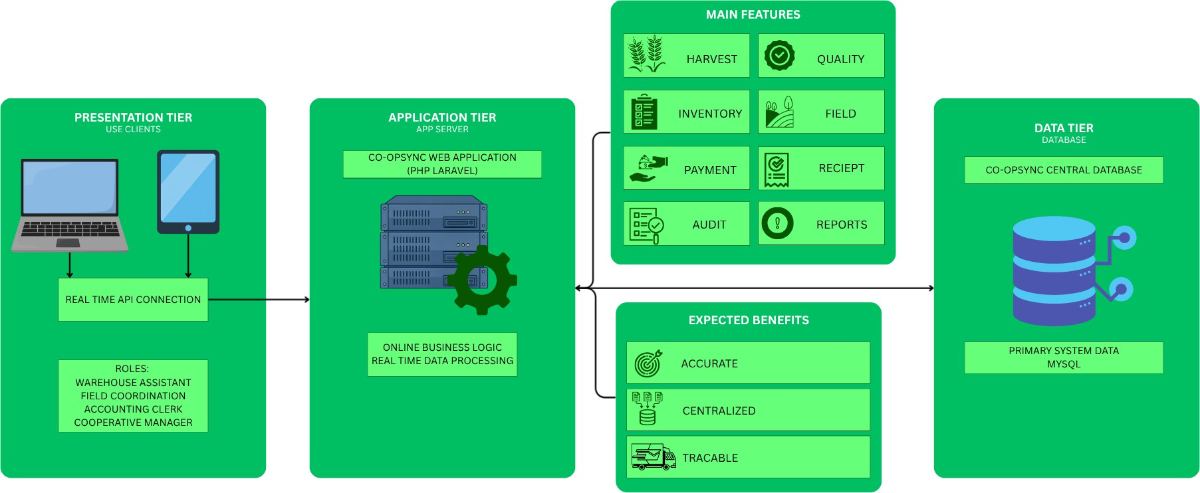

Expected Output: The consultation will result in confirmed system requirements, revised functional requirements, confirmed stakeholder responsibilities, revised interface designs, confirmed reports, and finalized system scope.

Feedback Received
[Record the actual feedback received during the consultation]

Action Taken
[Describe the revisions made in response to the feedback]

Result
[Explain how the revision improved the proposed design]

FINAL DESIGN

The final design of Co-opSync will consist of five main user areas.
Figure 11: Final System Design

Final Design Summary
- The Warehouse Assistant will handle harvest receiving, quality inspection, and inventory-related records.
- The Field Coordinator will manage expected deliveries, schedule changes, and field input requests using mobile devices, and these records are transmitted to the central database in real time.
- The Accounting Clerk will access verified harvest information, calculate payments, record payment information, and generate receipts.
- The Cooperative Manager will monitor cooperative activities through the dashboard and generate reports.
- Farmer-Members will receive clear and itemized payment information.
- The system will maintain an audit trail to help the cooperative track important changes to its records.

CONCLUSION

The proposed Co-opSync Management System directly addresses the problems caused by manual and separate paper-based recordkeeping at San Miguel Farmers Cooperative. By centralizing all operations into a single online system powered by a PHP Laravel backend and a MySQL database, Co-opSync brings together farmer-member records, harvest receiving, quality inspection, inventory tracking, field updates, payment processing, and administrative reporting into one connected platform.

The system provides tailored, role-based features designed specifically for the daily tasks of the Warehouse Assistant, Field Coordinator, Accounting Clerk, Cooperative Manager, and Farmer-Members. Because the application operates fully online, every record entered is saved directly to the central database in real time, making updates immediately available across all departments.
By eliminating duplicate data entry, manual field delays, and calculation errors, Co-opSync ensures accurate inventory tracking, faster payment processing with itemized receipts, transparent change logging through audit trails, and instant report generation for management. Ultimately, Co-opSync delivers a reliable, easy-to-use digital solution that improves operational efficiency, transparency, and service delivery for the entire cooperative.

