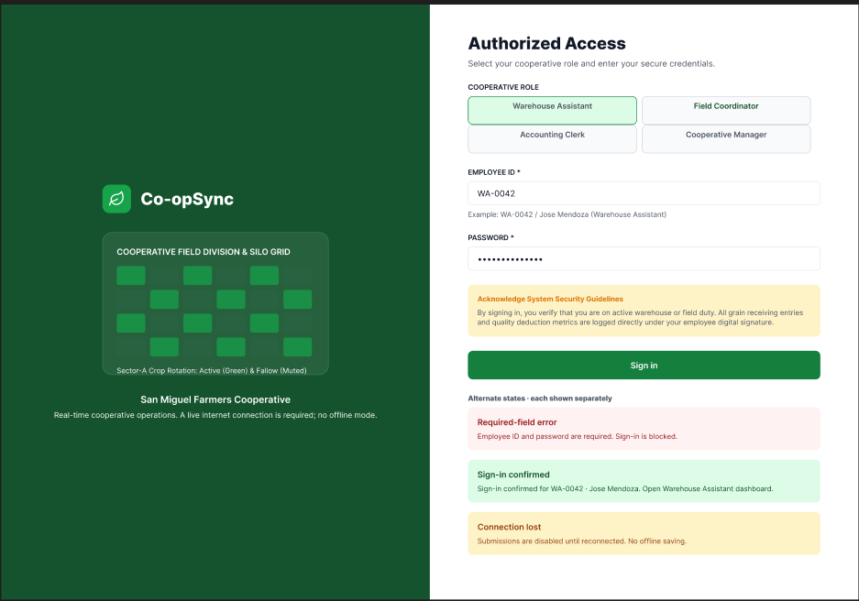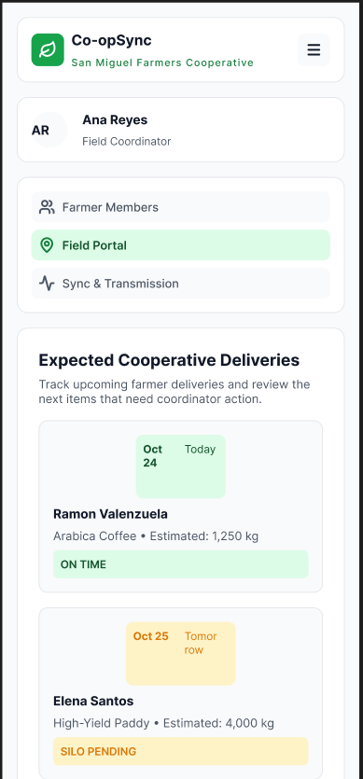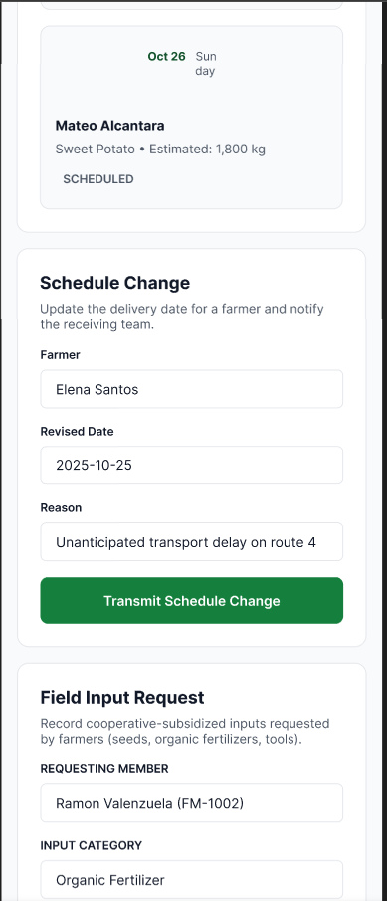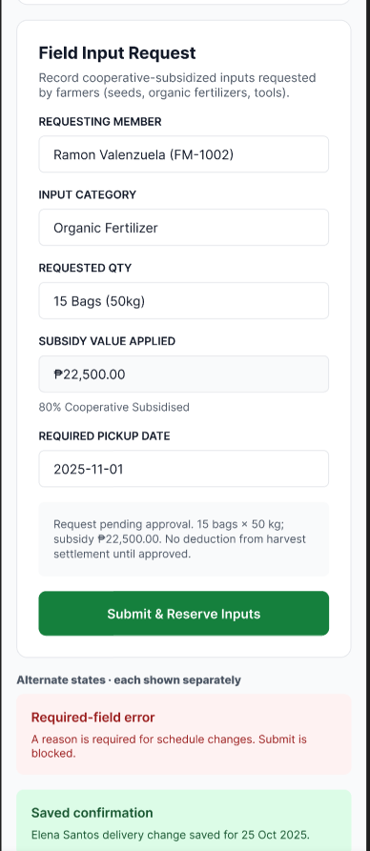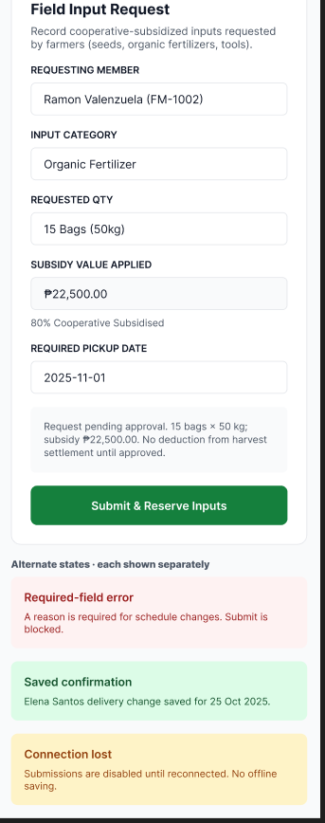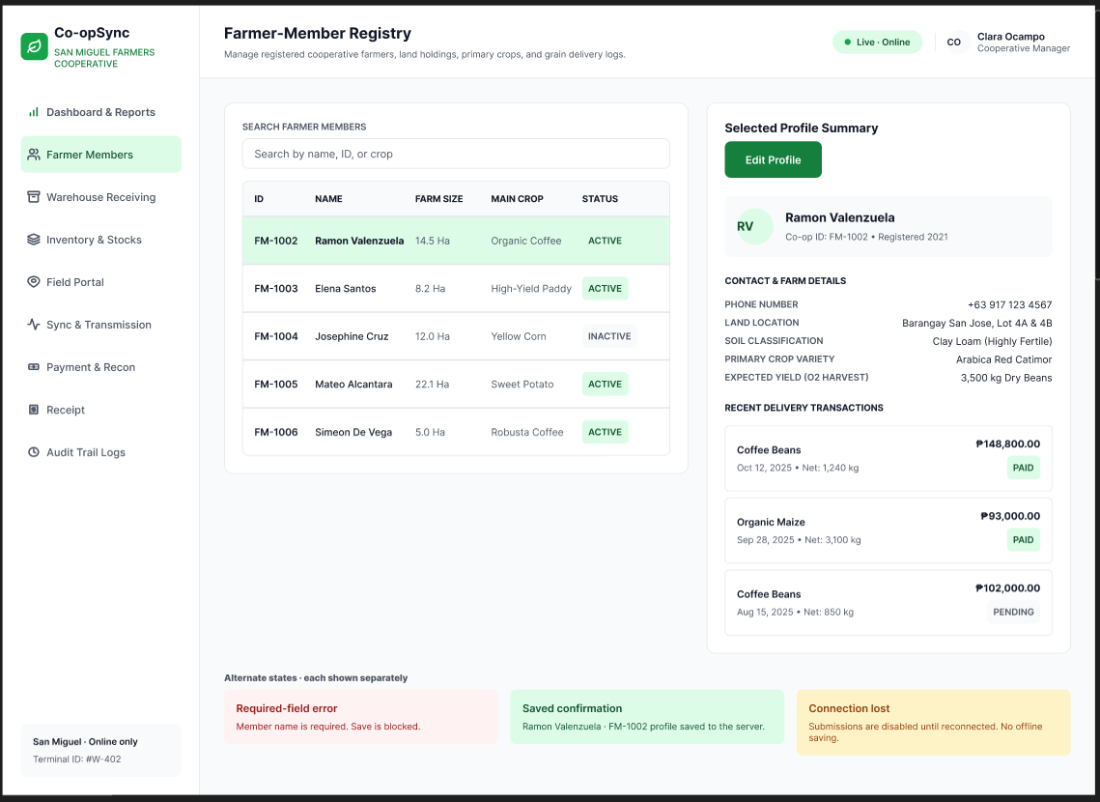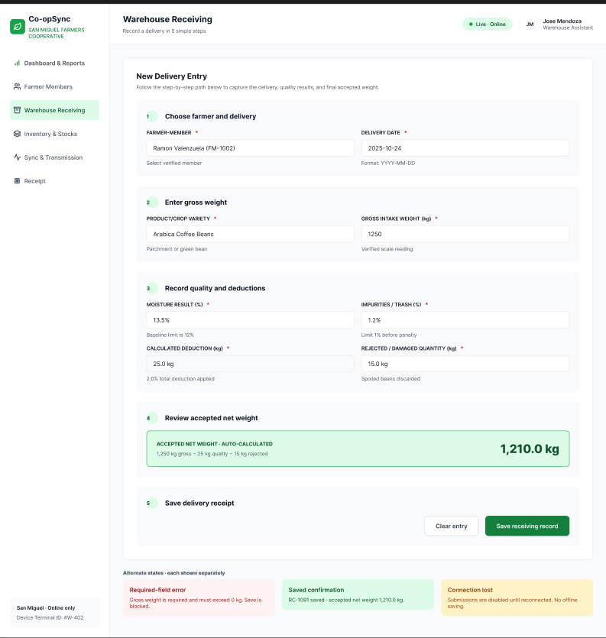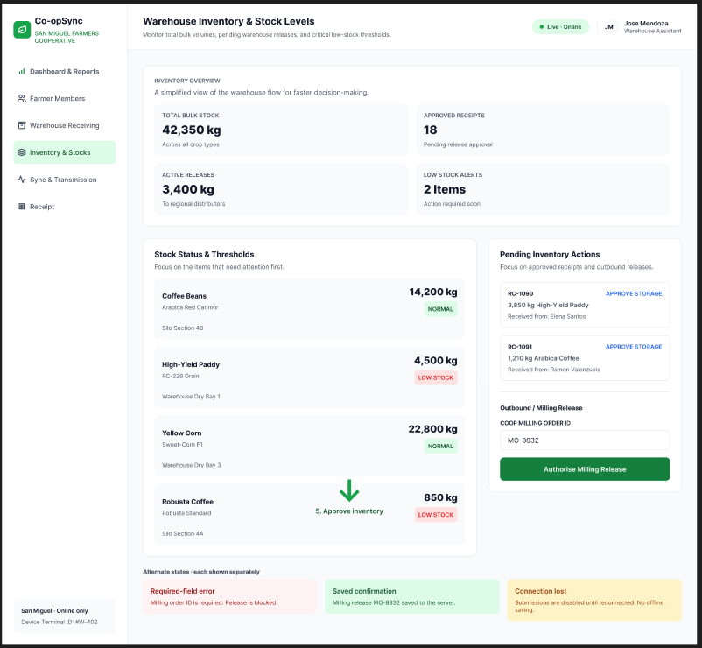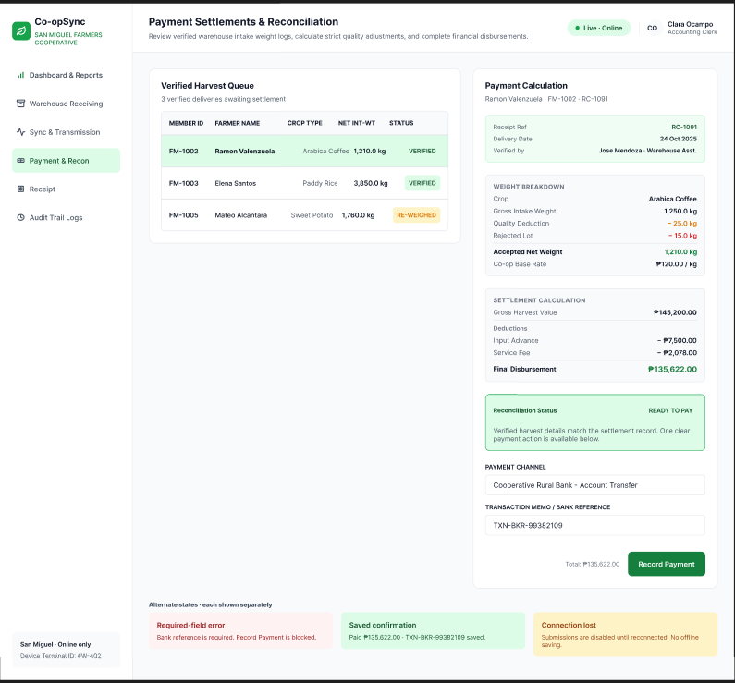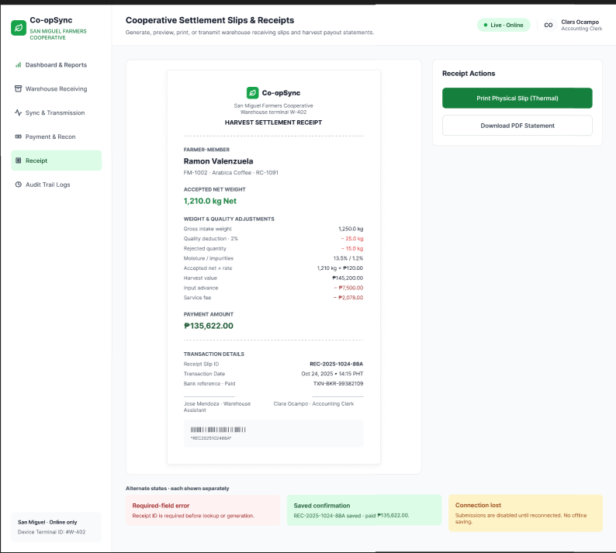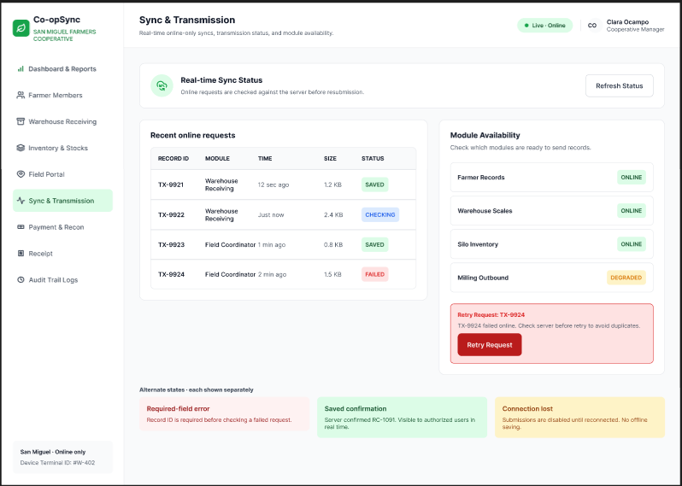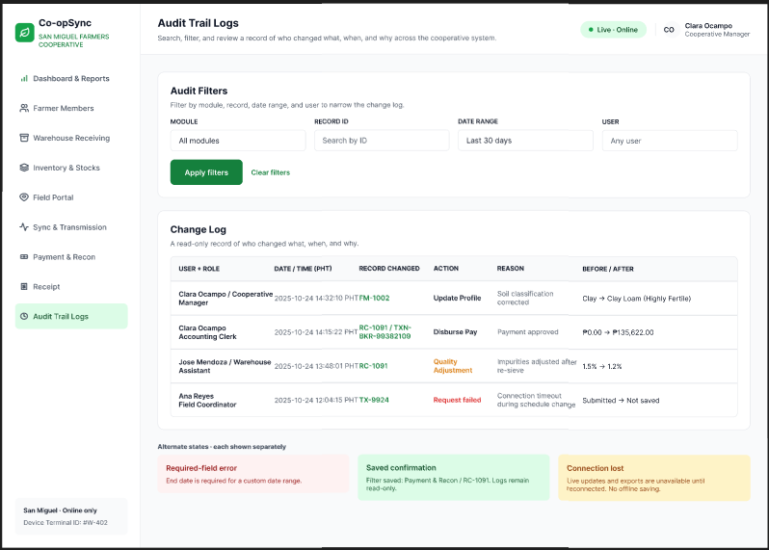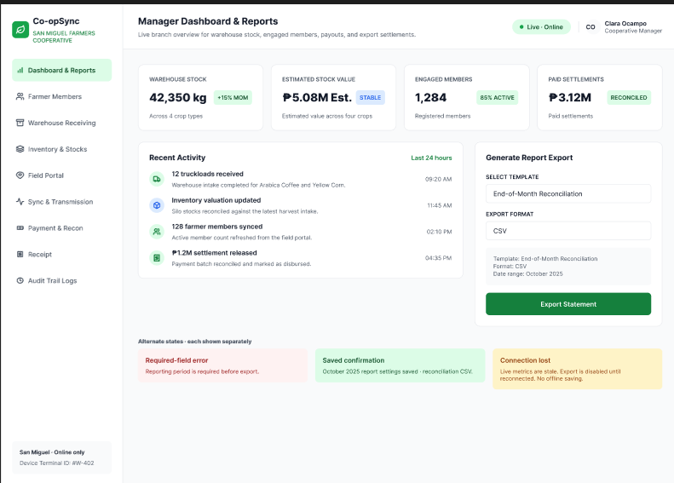

Co-opSync: flow for all roles
Shared start (everyone)
- Start
- Login
- Valid credentials? If no, go back to Login. If yes, continue.
- The system checks the user’s role and opens that role’s dashboard.
Warehouse Assistant
- Warehouse Dashboard
- Warehouse Receiving: record the delivery (farmer, product, gross weight, quality, deductions, rejected qty)
- Accepted net weight is calculated and saved
- Inventory & Stocks is updated
- End
Field Coordinator (mobile)
- Field Dashboard
- Field Portal: submit an expected delivery, schedule change, or field input request
- Connected? If no, a “connection lost” banner shows and the user resubmits. If yes, continue.
- Sync & Transmission: the update goes to the central database
- End
Accounting Clerk
- Accounting Dashboard
- Payment & Recon: view the verified harvest data
- Calculate and record the payment
- Receipt Module: generate the itemized receipt
- End
Cooperative Manager
- Manager Dashboard
- Dashboard & Reports: view the summaries, then export reports
- Audit Trail Logs: review who changed what, and when
- End
How the roles connect
- The Field Coordinator’s update reaches the Warehouse Assistant before the delivery arrives.
- The Warehouse Assistant’s accepted net weight feeds Payment & Recon.
- The Accounting Clerk’s payment appears in the Manager’s dashboard and reports.

