**CENFOTEC**

**Task 4:**

**Complete a Data Science Capstone Project**

**Mentor: Diego Alfaro**

**By: Adrian Aguilar**

Contents

1. Topic Information 3

2. Goal of this Study 3

3. Insights 4

4. Additional Data 7

Checkpoints 7

Errors (only last days) 7

RMSE 8

MAE 9

Coverage 9

Answers to the temperature questions? 10

# Topic Information

Global warming is the mainly human-caused rise of the average temperature of the Earth's climate system and has been demonstrated by direct temperature measurements and by measurements of various effects of the warming.[4] It is a major aspect of climate change which, in addition to rising global surface temperatures,[5] also includes its effects, such as changes in precipitation.[6] While there have been prehistoric periods of global warming, observed changes since the mid-20th century have been unprecedented in rate and scale.

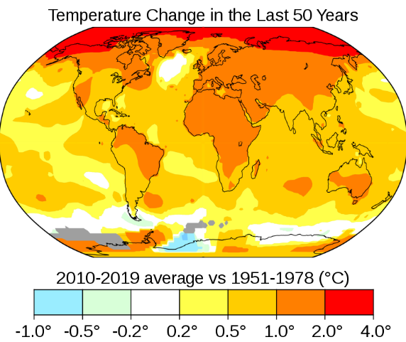

# Goal of this Study

Prediction of temperature months variances of year 2020, by having clear source data from

1880.

# Insights

* Temperature variations drop from 1878 down near by 1900 then exponentially grow until todays.

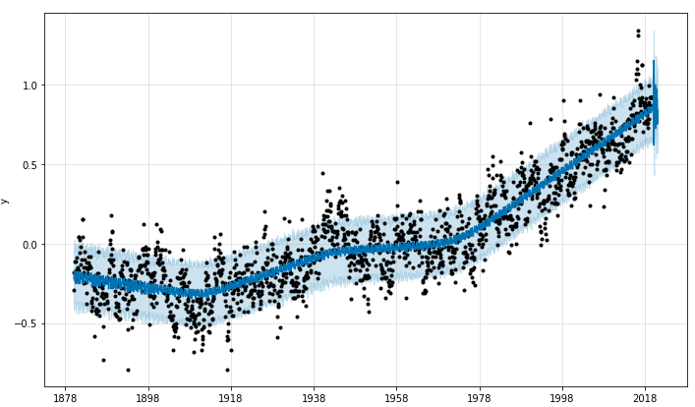

* After 1978 we can see temperature go over 0.2 and raise up dramatically.
* Last negative temperature was capture at June/30/1972 with a variance of -0.00435.
* After July of 1972 the temperature variances are positives, meaning global warming began.

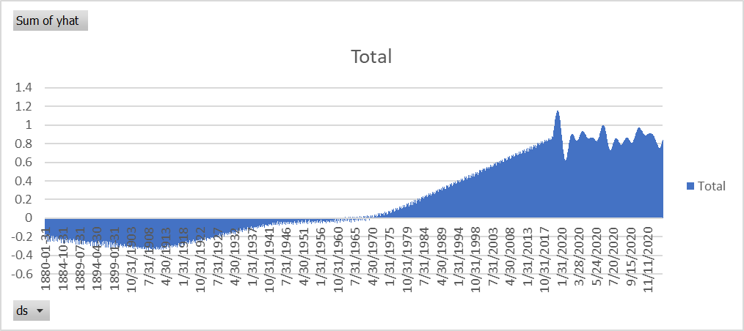

* Temperature variance going up is clear

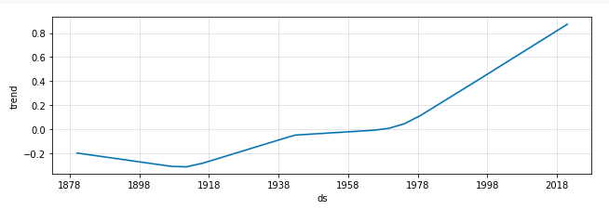

* Changing points have critical behavior before 1918, 1938 from 1600 till 1978 and 1990.

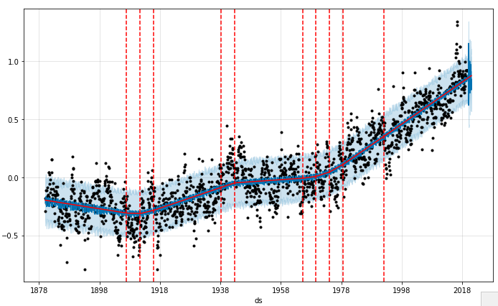

***Historical facts correlated with Checkpoints chart***

***COLD Temperatures below 0 correlates first checkpoint:***

*Tyndall’s laboratory tests in the 1860s showed that coal gas (containing CO2, methane and volatile hydrocarbons) was especially effective at absorbing energy. He eventually demonstrated that CO2 alone acted like sponge in the way it could absorb multiple wavelengths of sunlight.*

***HOT Temperatures below 0 correlates thirds and fourth checkpoints:***

*By the 1930s, at least one scientist would start to claim that carbon emissions might already be having a warming effect. British engineer Guy Stewart Calendar noted that the United States and North Atlantic region had warmed significantly on the heels of the Industrial Revolution.*

*1988: Global Warming Gets Real*

*The early 1980s would mark a sharp increase in global temperatures. Many experts point to 1988 as a critical turning point when watershed events placed global warming in the spotlight.*

# Additional Data

## Checkpoints

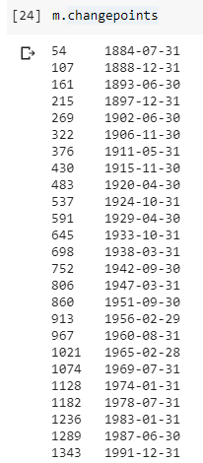

# Errors (only last days)



## RMSE

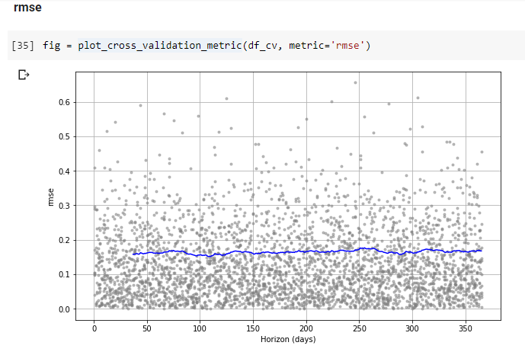

## MAE

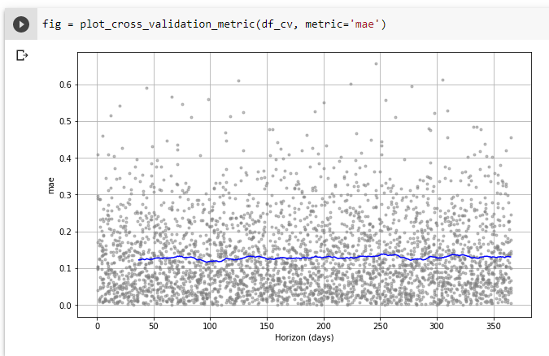

## Coverage

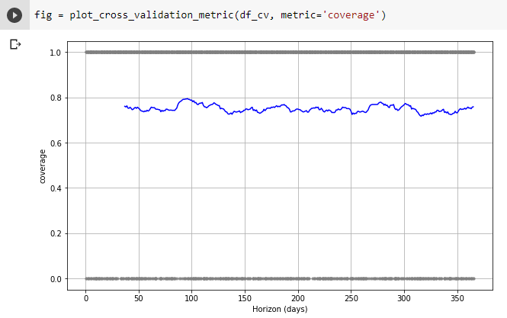

# Answers to the temperature questions?

**Can we predict 2020 temperate variances?**

Yes, is possible based in a very good consistency trend.

Note: Due to the cona-19 virus Scientifics noticed a reduction of the 30% if ozone layer and worlds winds started to behave in a different way. So is very possible that trend will be dramatically affected making this result not accurate. However, this only isolated issue that no predictions model can handle.

**See Results**

See predictions for each temperature variance for month of year 2020.

Prophet model provided also the temperature variance every day.



**Errors data:**

Data shows low numbers on errors and better number in coverage.

MSE ~ 0.2, RMSE ~ 0.1, MAE ~ 0.1, MDAPE 0.5 and COVERAGE 0.7.