Plot Sizing QA Gallery
Generated by qa_plot_sizing_gallery(). PNG previews are screenshots produced through AutoQuant::ObjectToPNG, the production artifact screenshot helper.
LLM interpretation purpose
This document is an artifact screenshot corpus, not a polished human report. Its purpose is to compress modeling context into dense visual evidence that an LLM can inspect with minimal raw-data/token burden.
Interpretation criteria: plots must not be blank; titles, plot type, axes, scales, legends, and primary visual patterns should be recoverable. Crowded or clipped labels are acceptable when the chart structure and enough category identity remain inferable.
Metadata contract: each artifact includes renderer, screenshot helper, row/column counts, category count, max label length, requested dimensions, aspect ratio, and axis-label sizing choices when applicable. These fields ground the visual image without dumping raw data.
Known stress cases: high category counts, long labels, dense heatmaps, large correlation matrices, and horizontal bars with long y-axis labels may be visually imperfect. These are retained because they reveal where static Word export sizing policy must improve.
Bar vertical 5 short labels
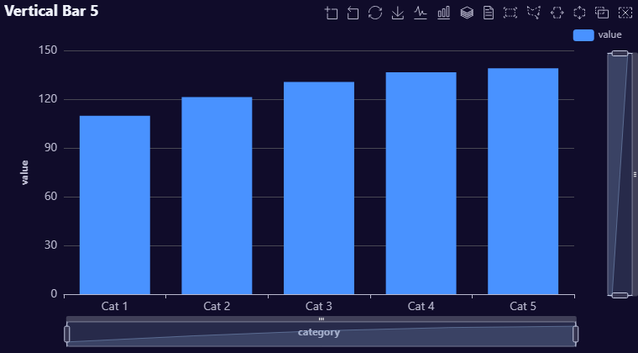
renderer_function: AutoPlots::Bar
screenshot_function: AutoQuant::ObjectToPNG
plot_type: Bar
rows: 5
columns: 2
categories: 5
max_label_length: 5
x_axis_label_rotate: 0
x_axis_label_font_size: 14
y_axis_label_font_size: NA
requested_width: 760
requested_height: 420
aspect_ratio: 1.81
notes: xAxis.axisLabel.rotate = 0, xAxis.axisLabel.fontSize = 14 based on categories = 5 and max_label_length = 5.
Bar vertical 15 short labels
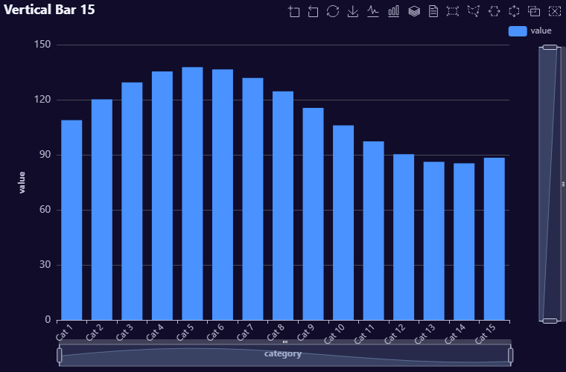
renderer_function: AutoPlots::Bar
screenshot_function: AutoQuant::ObjectToPNG
plot_type: Bar
rows: 15
columns: 2
categories: 15
max_label_length: 6
x_axis_label_rotate: 45
x_axis_label_font_size: 12
y_axis_label_font_size: NA
requested_width: 760
requested_height: 500
aspect_ratio: 1.52
notes: xAxis.axisLabel.rotate = 45, xAxis.axisLabel.fontSize = 12 based on categories = 15 and max_label_length = 6.
Bar vertical 30 short labels
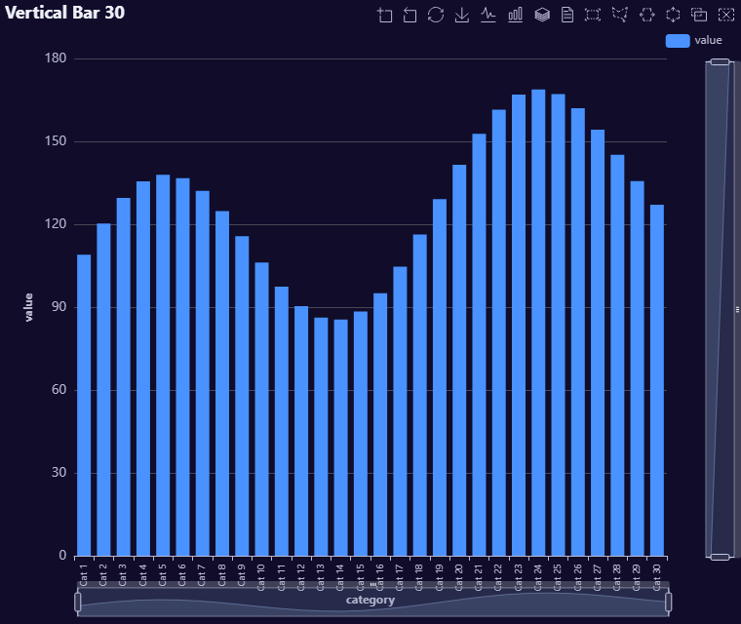
renderer_function: AutoPlots::Bar
screenshot_function: AutoQuant::ObjectToPNG
plot_type: Bar
rows: 30
columns: 2
categories: 30
max_label_length: 6
x_axis_label_rotate: 90
x_axis_label_font_size: 10
y_axis_label_font_size: NA
requested_width: 760
requested_height: 640
aspect_ratio: 1.188
notes: xAxis.axisLabel.rotate = 90, xAxis.axisLabel.fontSize = 10 based on categories = 30 and max_label_length = 6.
Bar vertical 60 short labels
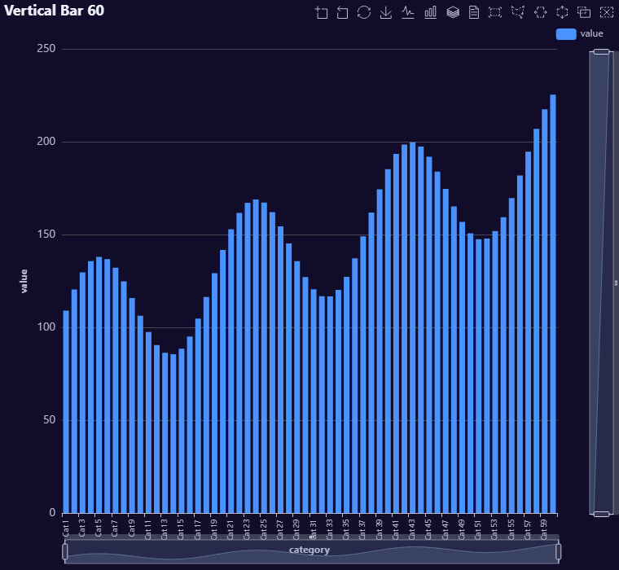
renderer_function: AutoPlots::Bar
screenshot_function: AutoQuant::ObjectToPNG
plot_type: Bar
rows: 60
columns: 2
categories: 60
max_label_length: 6
x_axis_label_rotate: 90
x_axis_label_font_size: 9
y_axis_label_font_size: NA
requested_width: 760
requested_height: 700
aspect_ratio: 1.086
notes: xAxis.axisLabel.rotate = 90, xAxis.axisLabel.fontSize = 9 based on categories = 60 and max_label_length = 6. High-cardinality vertical bars remain a stress case; compare against the flipped bar case with larger height.
Bar coordinate flipped 5 long labels
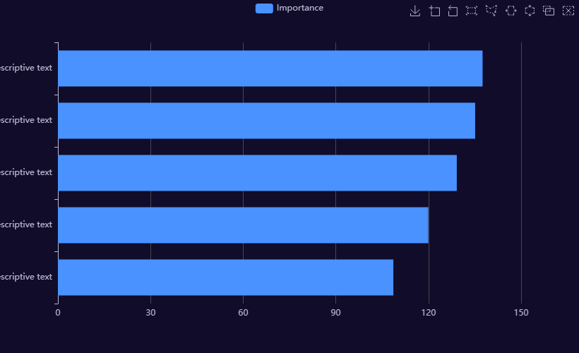
renderer_function: AutoPlots::VariableImportance
screenshot_function: AutoQuant::ObjectToPNG
plot_type: BarFlipped
rows: 5
columns: 2
categories: 5
max_label_length: 49
x_axis_label_rotate: NA
x_axis_label_font_size: NA
y_axis_label_font_size: NA
requested_width: 820
requested_height: 500
aspect_ratio: 1.64
notes: Coordinate-flipped high-label bar uses AutoPlots::VariableImportance, the canonical AutoPlots wrapper that produces horizontal bars from Bar(). Inputs: categories = 5 and max_label_length = 49.
Bar coordinate flipped 15 long labels
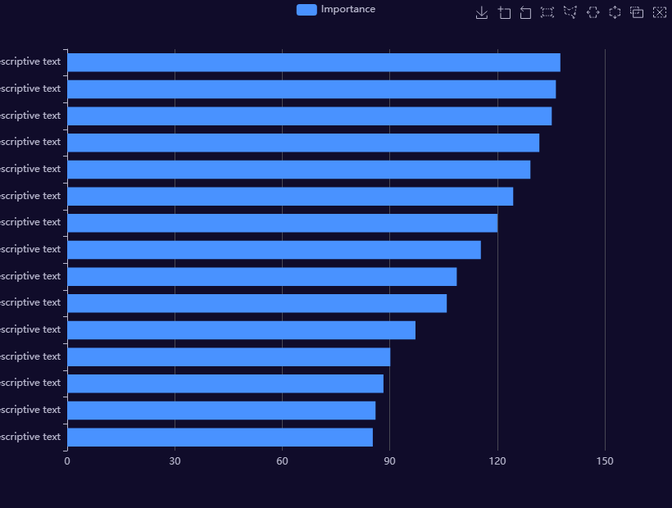
renderer_function: AutoPlots::VariableImportance
screenshot_function: AutoQuant::ObjectToPNG
plot_type: BarFlipped
rows: 15
columns: 2
categories: 15
max_label_length: 50
x_axis_label_rotate: NA
x_axis_label_font_size: NA
y_axis_label_font_size: NA
requested_width: 820
requested_height: 620
aspect_ratio: 1.323
notes: Coordinate-flipped high-label bar uses AutoPlots::VariableImportance, the canonical AutoPlots wrapper that produces horizontal bars from Bar(). Inputs: categories = 15 and max_label_length = 50.
Bar coordinate flipped 30 long labels
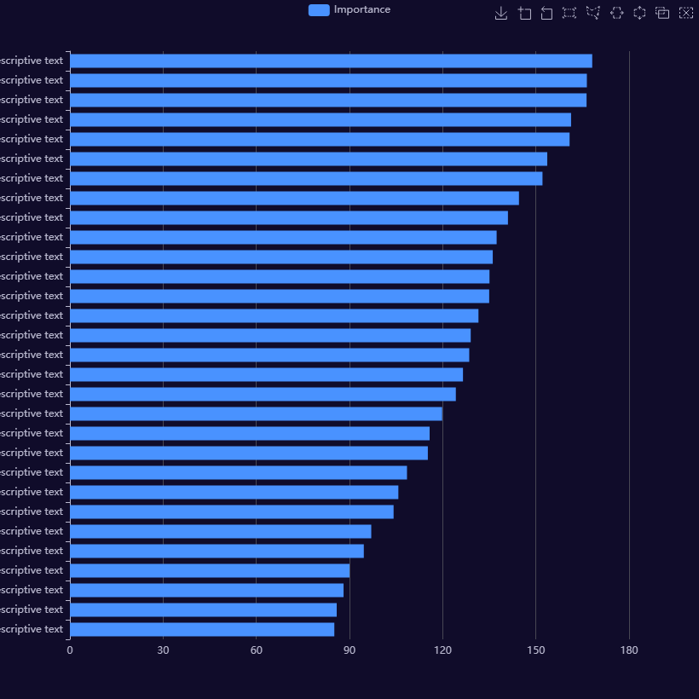
renderer_function: AutoPlots::VariableImportance
screenshot_function: AutoQuant::ObjectToPNG
plot_type: BarFlipped
rows: 30
columns: 2
categories: 30
max_label_length: 50
x_axis_label_rotate: NA
x_axis_label_font_size: NA
y_axis_label_font_size: NA
requested_width: 820
requested_height: 820
aspect_ratio: 1
notes: Coordinate-flipped high-label bar uses AutoPlots::VariableImportance, the canonical AutoPlots wrapper that produces horizontal bars from Bar(). Inputs: categories = 30 and max_label_length = 50; high-cardinality cases also use additional height for static Word-style output.
Bar coordinate flipped 60 long labels
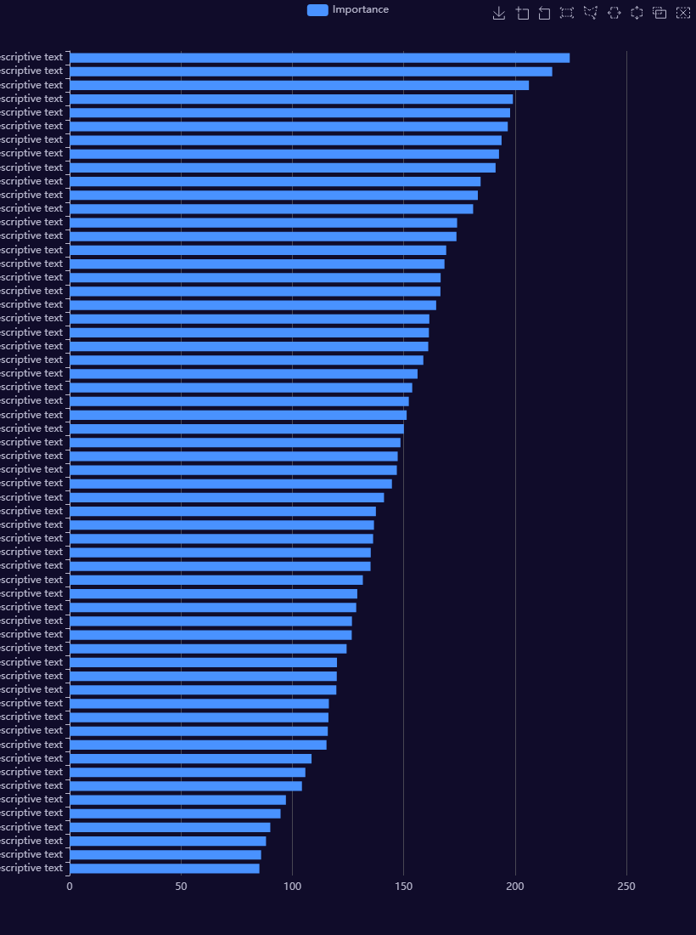
renderer_function: AutoPlots::VariableImportance
screenshot_function: AutoQuant::ObjectToPNG
plot_type: BarFlipped
rows: 60
columns: 2
categories: 60
max_label_length: 50
x_axis_label_rotate: NA
x_axis_label_font_size: NA
y_axis_label_font_size: NA
requested_width: 820
requested_height: 1100
aspect_ratio: 0.745
notes: Coordinate-flipped high-label bar uses AutoPlots::VariableImportance, the canonical AutoPlots wrapper that produces horizontal bars from Bar(). Inputs: categories = 60 and max_label_length = 50; high-cardinality cases also use additional height for static Word-style output.
Variable Importance Top 10
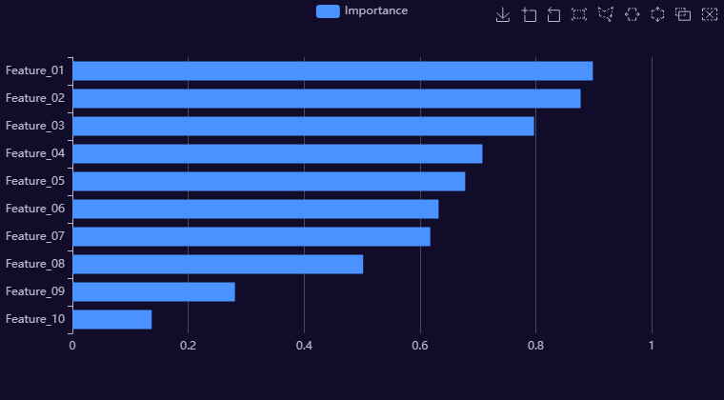
renderer_function: AutoPlots::VariableImportance
screenshot_function: AutoQuant::ObjectToPNG
plot_type: VariableImportance
rows: 10
columns: 2
categories: 10
max_label_length: 10
x_axis_label_rotate: NA
x_axis_label_font_size: NA
y_axis_label_font_size: NA
requested_width: 760
requested_height: 420
aspect_ratio: 1.81
Variable Importance Top 25
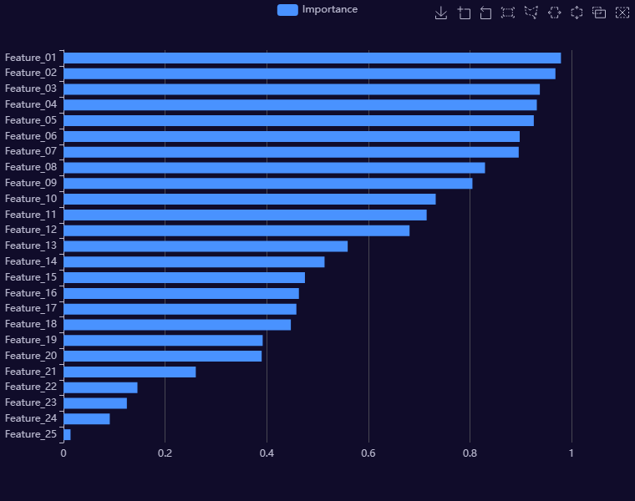
renderer_function: AutoPlots::VariableImportance
screenshot_function: AutoQuant::ObjectToPNG
plot_type: VariableImportance
rows: 25
columns: 2
categories: 25
max_label_length: 10
x_axis_label_rotate: NA
x_axis_label_font_size: NA
y_axis_label_font_size: NA
requested_width: 760
requested_height: 600
aspect_ratio: 1.267
Variable Importance Top 50
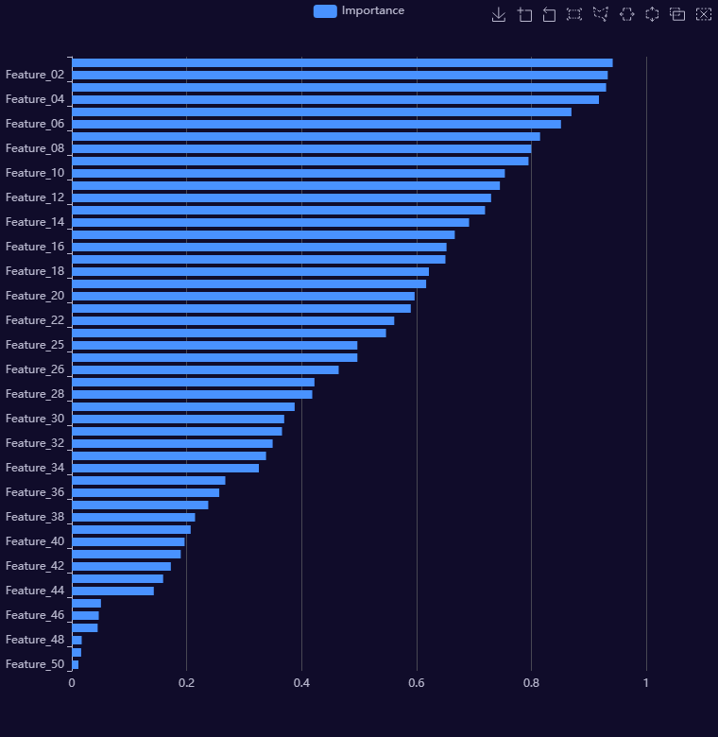
renderer_function: AutoPlots::VariableImportance
screenshot_function: AutoQuant::ObjectToPNG
plot_type: VariableImportance
rows: 50
columns: 2
categories: 50
max_label_length: 10
x_axis_label_rotate: NA
x_axis_label_font_size: NA
y_axis_label_font_size: NA
requested_width: 760
requested_height: 780
aspect_ratio: 0.974
Heatmap small
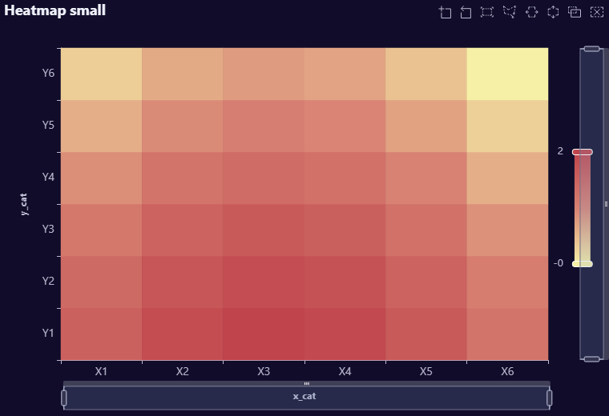
renderer_function: AutoPlots::HeatMap
screenshot_function: AutoQuant::ObjectToPNG
plot_type: HeatMap
rows: 36
columns: 3
categories: 6
max_label_length: 2
x_axis_label_rotate: 0
x_axis_label_font_size: NA
y_axis_label_font_size: NA
requested_width: 760
requested_height: 520
aspect_ratio: 1.462
Heatmap medium
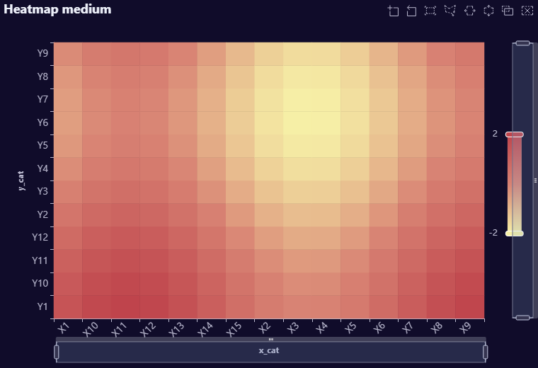
renderer_function: AutoPlots::HeatMap
screenshot_function: AutoQuant::ObjectToPNG
plot_type: HeatMap
rows: 180
columns: 3
categories: 15
max_label_length: 3
x_axis_label_rotate: 45
x_axis_label_font_size: NA
y_axis_label_font_size: NA
requested_width: 760
requested_height: 520
aspect_ratio: 1.462
Heatmap large
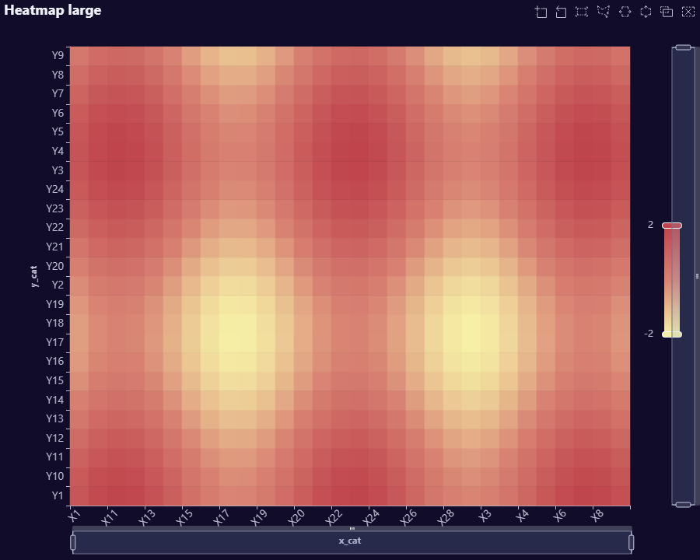
renderer_function: AutoPlots::HeatMap
screenshot_function: AutoQuant::ObjectToPNG
plot_type: HeatMap
rows: 720
columns: 3
categories: 30
max_label_length: 3
x_axis_label_rotate: 45
x_axis_label_font_size: NA
y_axis_label_font_size: NA
requested_width: 900
requested_height: 720
aspect_ratio: 1.25
Correlation Matrix small
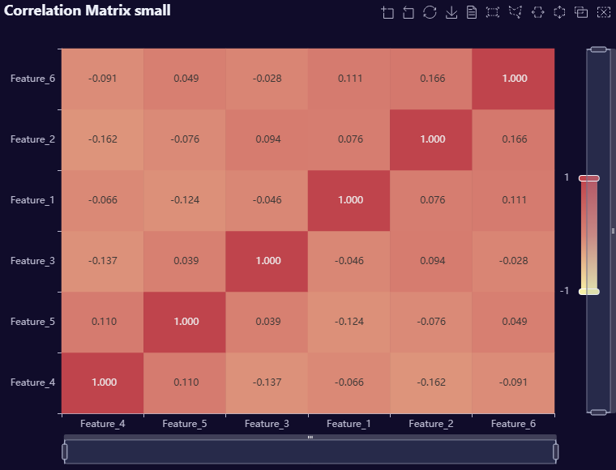
renderer_function: AutoPlots::CorrMatrix
screenshot_function: AutoQuant::ObjectToPNG
plot_type: CorrMatrix
rows: 120
columns: 6
categories: 6
max_label_length: 0
x_axis_label_rotate: NA
x_axis_label_font_size: NA
y_axis_label_font_size: NA
requested_width: 760
requested_height: 580
aspect_ratio: 1.31
Correlation Matrix medium
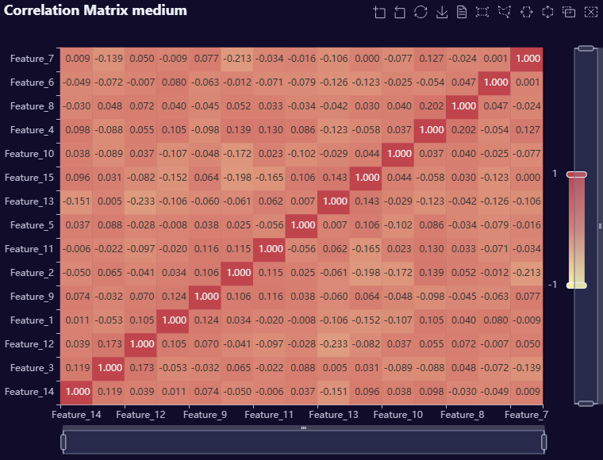
renderer_function: AutoPlots::CorrMatrix
screenshot_function: AutoQuant::ObjectToPNG
plot_type: CorrMatrix
rows: 120
columns: 15
categories: 15
max_label_length: 0
x_axis_label_rotate: NA
x_axis_label_font_size: NA
y_axis_label_font_size: NA
requested_width: 760
requested_height: 580
aspect_ratio: 1.31
Correlation Matrix large
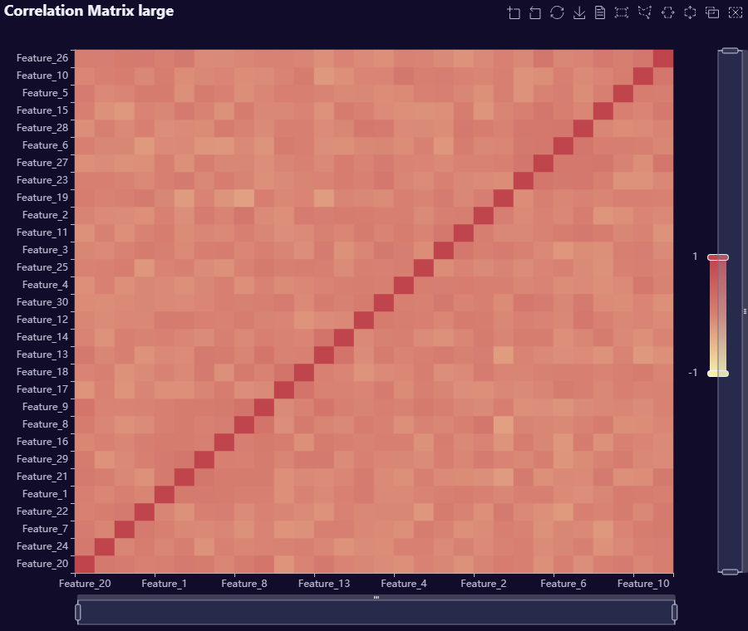
renderer_function: AutoPlots::CorrMatrix
screenshot_function: AutoQuant::ObjectToPNG
plot_type: CorrMatrix
rows: 120
columns: 30
categories: 30
max_label_length: 0
x_axis_label_rotate: NA
x_axis_label_font_size: NA
y_axis_label_font_size: NA
requested_width: 900
requested_height: 760
aspect_ratio: 1.184
Scatter sparse
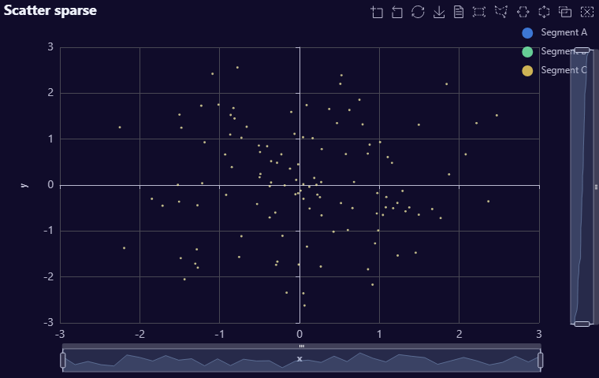
renderer_function: AutoPlots::Scatter
screenshot_function: AutoQuant::ObjectToPNG
plot_type: Scatter
rows: 120
columns: 3
categories: 3
max_label_length: 9
x_axis_label_rotate: NA
x_axis_label_font_size: NA
y_axis_label_font_size: NA
requested_width: 760
requested_height: 480
aspect_ratio: 1.583
Scatter dense
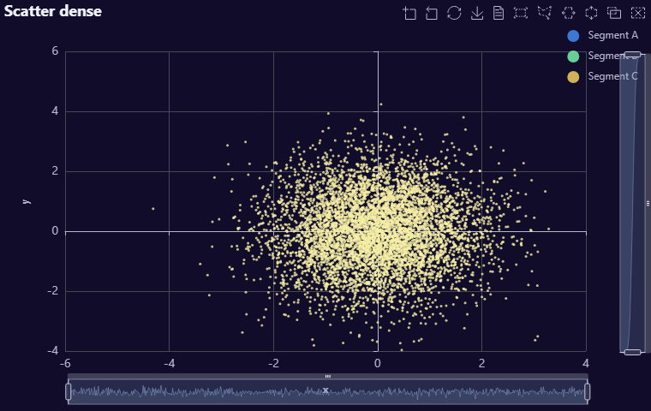
renderer_function: AutoPlots::Scatter
screenshot_function: AutoQuant::ObjectToPNG
plot_type: Scatter
rows: 6000
columns: 3
categories: 3
max_label_length: 9
x_axis_label_rotate: NA
x_axis_label_font_size: NA
y_axis_label_font_size: NA
requested_width: 760
requested_height: 480
aspect_ratio: 1.583
Scatter dense with transparency
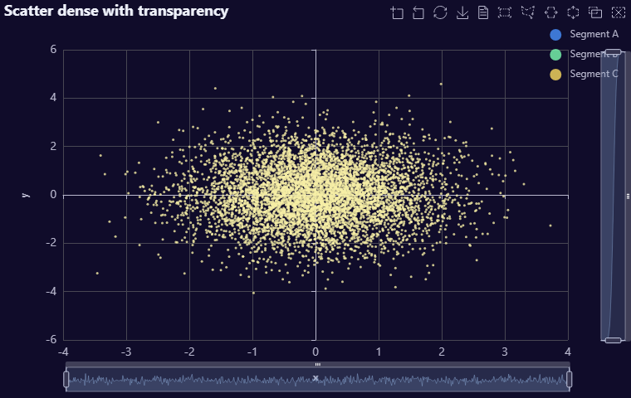
renderer_function: AutoPlots::Scatter
screenshot_function: AutoQuant::ObjectToPNG
plot_type: Scatter
rows: 6000
columns: 3
categories: 3
max_label_length: 9
x_axis_label_rotate: NA
x_axis_label_font_size: NA
y_axis_label_font_size: NA
requested_width: 760
requested_height: 480
aspect_ratio: 1.583
notes: Transparency case exercises the production AutoPlots scatter widget at dense row counts.
Box Plot 4 groups
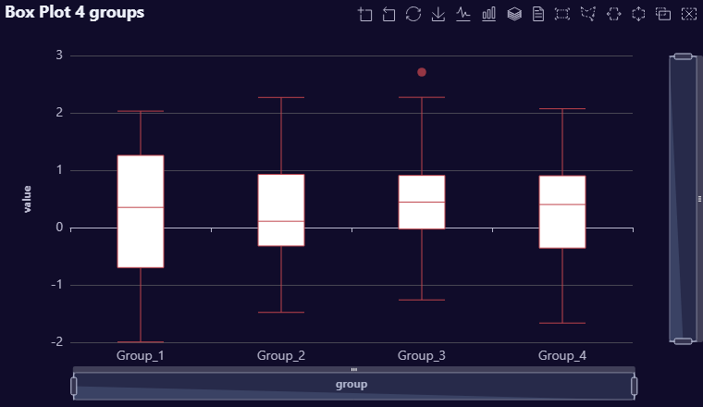
renderer_function: AutoPlots::Box
screenshot_function: AutoQuant::ObjectToPNG
plot_type: Box
rows: 160
columns: 2
categories: 4
max_label_length: 7
x_axis_label_rotate: 0
x_axis_label_font_size: NA
y_axis_label_font_size: NA
requested_width: 760
requested_height: 440
aspect_ratio: 1.727
Box Plot 30 groups
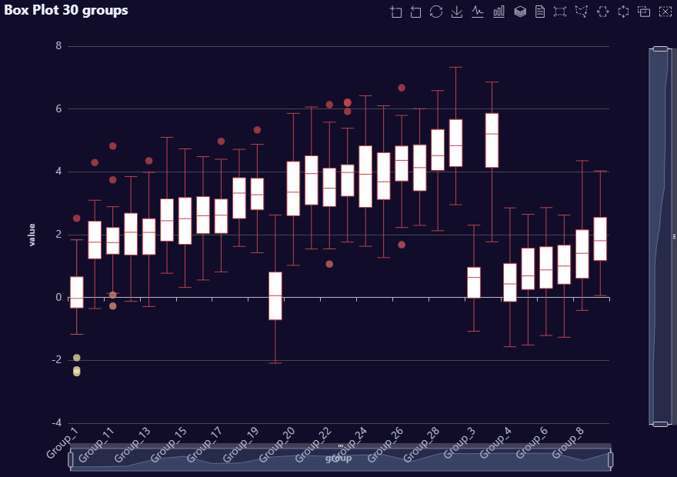
renderer_function: AutoPlots::Box
screenshot_function: AutoQuant::ObjectToPNG
plot_type: Box
rows: 1200
columns: 2
categories: 30
max_label_length: 8
x_axis_label_rotate: 45
x_axis_label_font_size: NA
y_axis_label_font_size: NA
requested_width: 880
requested_height: 620
aspect_ratio: 1.419
Line short time span ungrouped
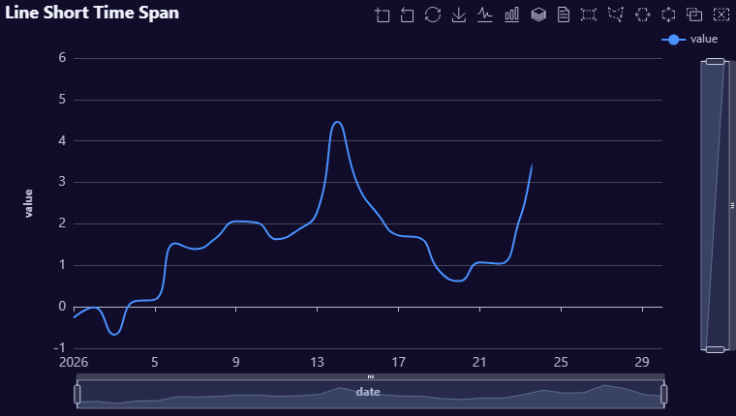
renderer_function: AutoPlots::Line
screenshot_function: AutoQuant::ObjectToPNG
plot_type: Line
rows: 30
columns: 2
categories: NA
max_label_length: 0
x_axis_label_rotate: NA
x_axis_label_font_size: NA
y_axis_label_font_size: NA
requested_width: 760
requested_height: 430
aspect_ratio: 1.767
Line long time span grouped
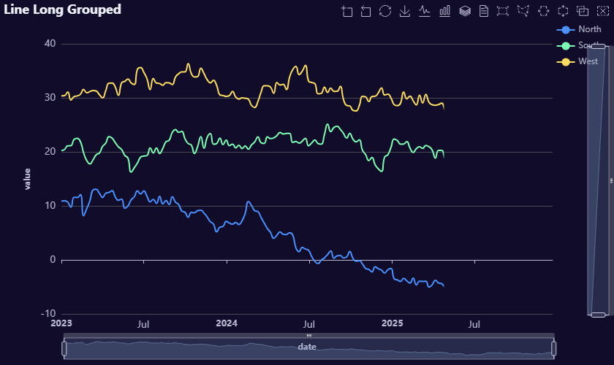
renderer_function: AutoPlots::Line
screenshot_function: AutoQuant::ObjectToPNG
plot_type: Line
rows: 468
columns: 3
categories: 3
max_label_length: 5
x_axis_label_rotate: NA
x_axis_label_font_size: NA
y_axis_label_font_size: NA
requested_width: 840
requested_height: 500
aspect_ratio: 1.68
Area short time span ungrouped
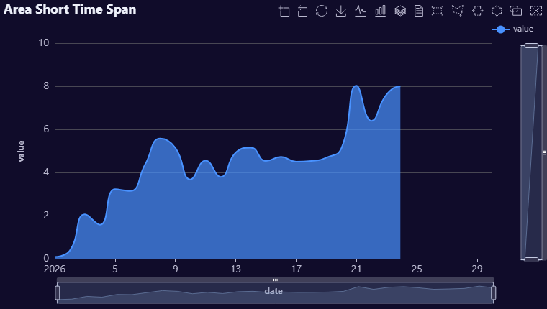
renderer_function: AutoPlots::Area
screenshot_function: AutoQuant::ObjectToPNG
plot_type: Area
rows: 30
columns: 2
categories: NA
max_label_length: 0
x_axis_label_rotate: NA
x_axis_label_font_size: NA
y_axis_label_font_size: NA
requested_width: 760
requested_height: 430
aspect_ratio: 1.767
Area long time span grouped
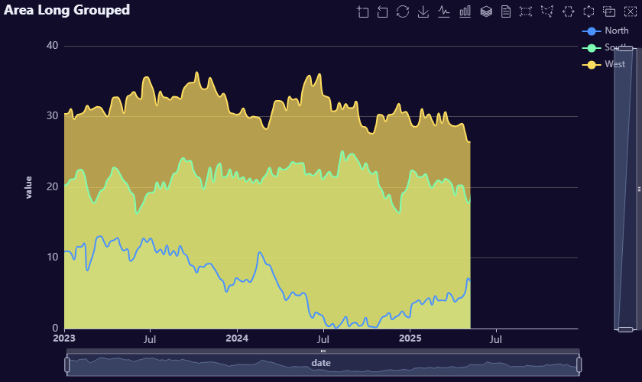
renderer_function: AutoPlots::Area
screenshot_function: AutoQuant::ObjectToPNG
plot_type: Area
rows: 468
columns: 3
categories: 3
max_label_length: 5
x_axis_label_rotate: NA
x_axis_label_font_size: NA
y_axis_label_font_size: NA
requested_width: 840
requested_height: 500
aspect_ratio: 1.68
SHAP-style dependence
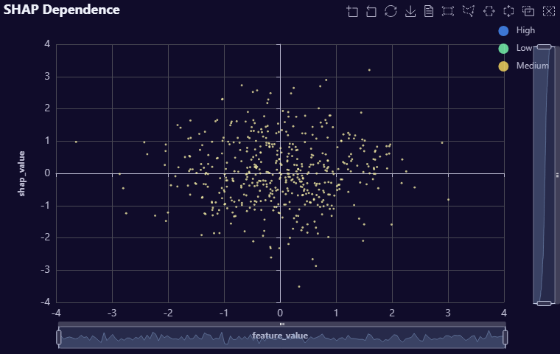
renderer_function: AutoPlots::Scatter
screenshot_function: AutoQuant::ObjectToPNG
plot_type: Scatter
rows: 500
columns: 3
categories: 3
max_label_length: 0
x_axis_label_rotate: NA
x_axis_label_font_size: NA
y_axis_label_font_size: NA
requested_width: 760
requested_height: 480
aspect_ratio: 1.583
SHAP-style interaction
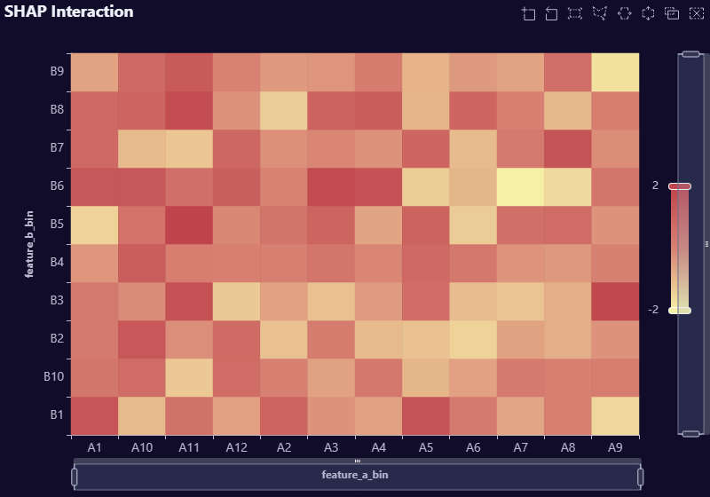
renderer_function: AutoPlots::HeatMap
screenshot_function: AutoQuant::ObjectToPNG
plot_type: HeatMap
rows: 120
columns: 3
categories: 12
max_label_length: 0
x_axis_label_rotate: NA
x_axis_label_font_size: NA
y_axis_label_font_size: NA
requested_width: 800
requested_height: 560
aspect_ratio: 1.429
SHAP-style importance
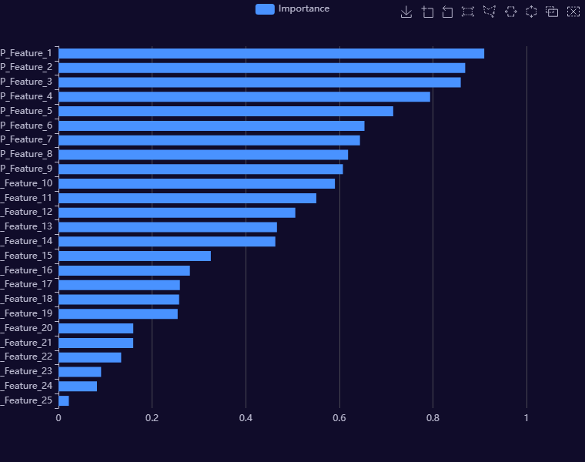
renderer_function: AutoPlots::ShapImportance
screenshot_function: AutoQuant::ObjectToPNG
plot_type: ShapImportance
rows: 25
columns: 2
categories: 25
max_label_length: 15
x_axis_label_rotate: NA
x_axis_label_font_size: NA
y_axis_label_font_size: NA
requested_width: 760
requested_height: 600
aspect_ratio: 1.267

