Checking/Creating GStreamer Pipeline for use with OpenCV

For capturing images we need to create a Gstreamer Pipeline. In this case, by using OpenCV and Jetson Nano:

Gstreamer
Gstreamer is an open source Pipeline-based Cross-Platform extensible multimedia framework. Is not a media player, nor a codec or protocol library, nor a transcoding tool and neither a streaming server, but can be used for all that.

Accessing PI camera using OPENCV framework
To have access to a camera by using OpenCV is just writing these following lines of code. This is just for a plane openCV framework:
int cam_id = 0; //first camera from Linux OS backend
VideoCapture vid_cam(cam_id); //Using OpenCV framework
vid_cam.set(CAP_PROP_FPS, 120); // matching J Nano
vid_cam.set(CAP_PROP_FRAME_WIDTH, 640);
vid_cam.set(CAP_PROP_FRAME_HEIGHT, 360);

To access it into Jason Nano though there is a very long string involved. In this website its provided everything.
https://github.com/JetsonHacksNano/CSI-Camera
This following approach is created in order to have 5 strings added together. Now, using the GSTREAMER device capture, we have to specify the pipeline (which is the long string) into the first argument for the videoCapture object.
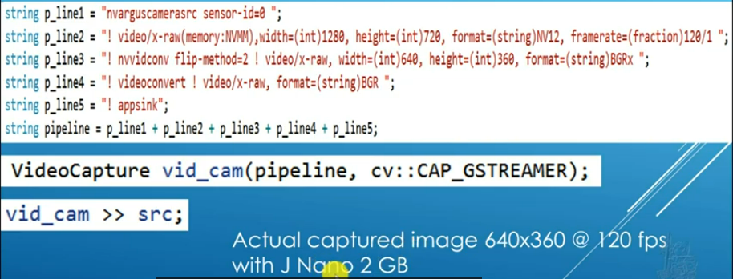

Pipeline approach
The main idea of the pipeline is creating a sort of conversions from the input source to the element that we have to use in our OpenCV code.
If we inspect with the Gstreamer documentation, they usually use this flowchart. Here we start form the source element which is the imx-219 camera on the Jnano and then we have the appsink which is the code app that we are working.
For this job we need two converters:
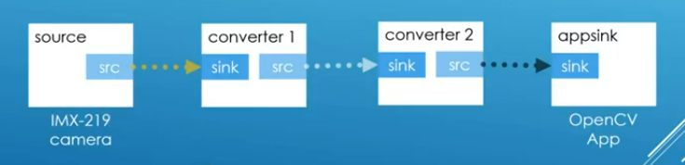
We must consider that the data source must be in a representation that the converter sink understand.
The way in which all these strings are connected in order to be understanded by the c code is:
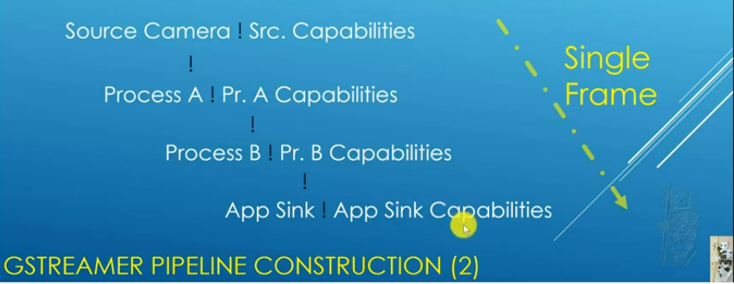
Diving into the different steps in the pipeline:

Camera source
Using gst-lauch-1.0. The camera source, or the plug-in, that represents the camera on the linux network name is nvarguscamerasrc. That’s the one that represent the source element in the pipeline
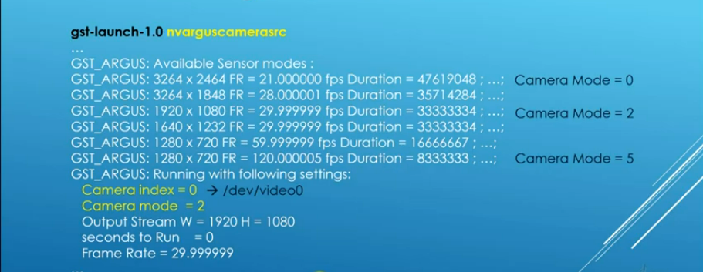
So when Gstream launch it, what it actually does is displays the image captured and displays lots of information. The information that we want to capture is the Available sensor modes .
This explains then the first two strings in the pipeline:
- String 1: has the name of the camera source and sets the id (the id its important in case we multiple cameras). Note that we have to set a blank space at the end in order to concatenate.
- String 2: sets up the capability of the source data, just repeats:

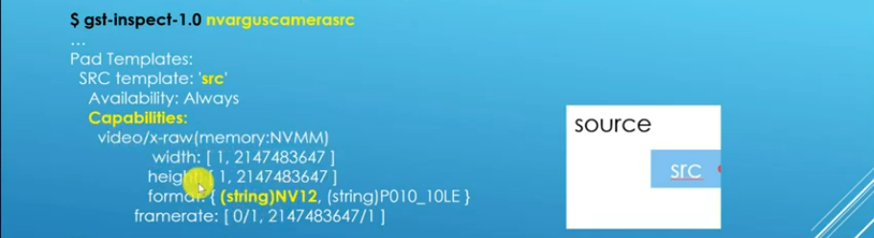

Converter 1
We will jump into the nvvidconv made from the nvidia people:
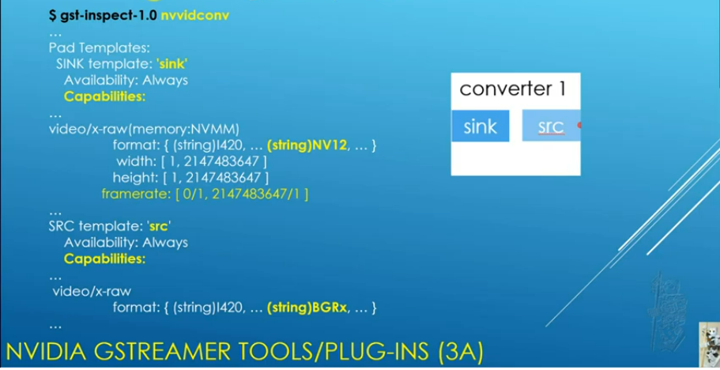
This also throws a lot of information but we must look for the sink template, this will just make sure that we can handle the information from the previous source.
The thing that we have to set here is the ‘src’. We have to convert the data into BGR because openCV needs BGR. The only one found here is the BGRx.
If we scan further in nnvidconv we have also element properties:
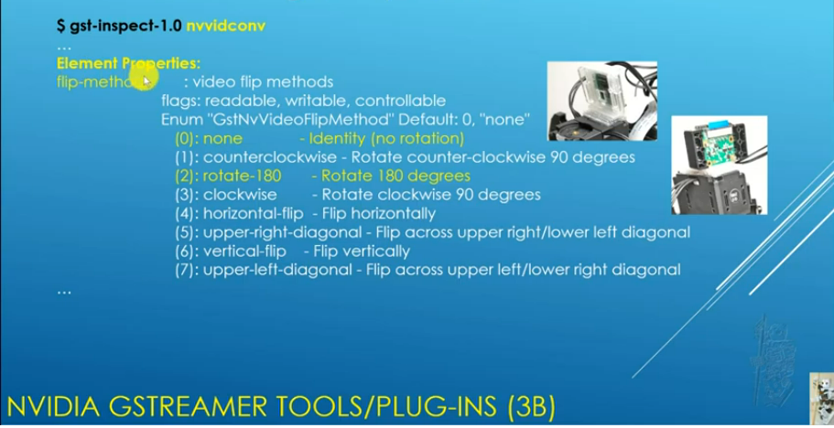
This includes the flip method, usefull in the case we have the camera rotated.
This then represents the 3rd string in the pipeline:
- String 3: specifies the nvvidconv flip-method (considerng here that the camera is flipped 180 degrees) and then the second part corresponds to the source in order to convert the video: we are converting to a 640 to a 360 video format and also converting to BGRx.

Converter 2
There is a converter named videoconvert and same thing, if we do gst-inspect-1.0 on it and we look for the sink we will see that supports BGRx as a sink and moving to the source capabilities we find out that there is a conversion to BGR which is the OpenCV format
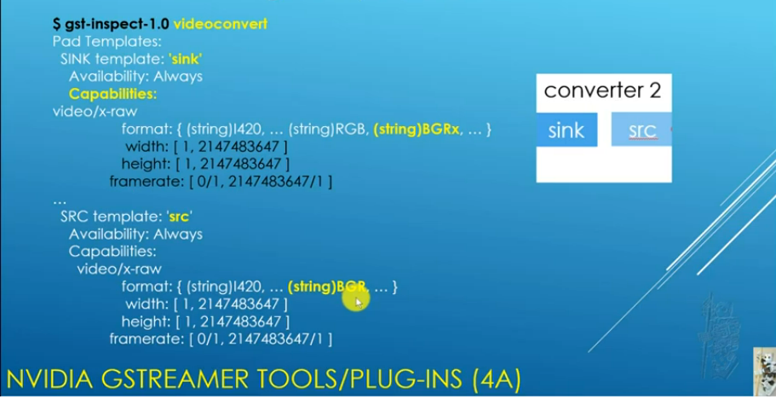
Also going down further until the element properties there is a bunch of things that we can use such as:
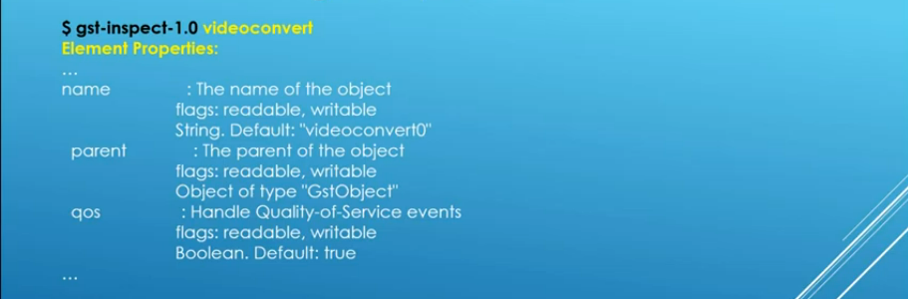
So this will represent our string 4 in the concatenation of strings:
- String 4: we don’t change the size of the image but we are changing the format to BGR

Appsink
Once we have the BGR format, if we give a look at appsink we find out that capabilities are ANY, which means that allows whatever source.
Therefore the last string will be:
- String 5: just the line that specifies the appsink.
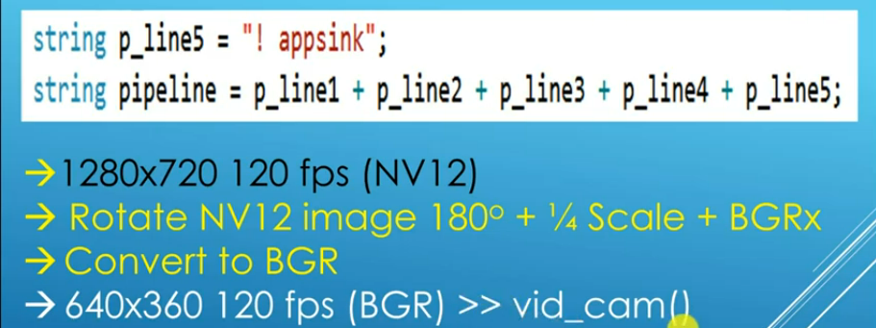

Jetson Nano:
Jetson Nano is a small, powerful computer designed to power entry-level edge AI applications and devices. The NVIDIA Jetson Nano module is ideal for AI-based computer vision applications and to perform AI vision tasks like image classification, image segmentation, object detection, and more. It is compatible with open-source computer vision software and machine learning libraries like OpenCV.
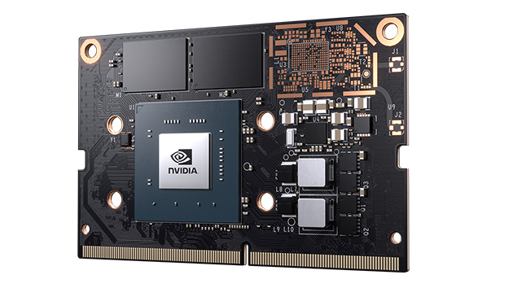

Some definitions

RTP
The Real-time Transport Protocol is a network protocol used to deliver streaming audio and video media over the internet, thereby enabling the Voice Over Internet Protocol (VoIP).
RTP is generally used with a signaling protocol, such as SIP, which sets up connections across the network. RTP applications can use the Transmission Control Protocol (TCP), but most use the User Datagram Protocol (UDP) instead because UDP allows for faster delivery of data.

TCP vs UDP
Data is sent through internet by using Ethernet, Ethernet is packed according to IP packet, which, among other things, splits the data in order to send large messages.
Into the IP packet we can find the TCP/IP stack, this stack is formed by all the communication protocols such as HTTP, FTP, SNMP and also TCP and UDP.
The difference between TCP and UDP is TCP is a protocol Acknowledge, which means that when you send a message you receive an acknowledge about the reception of the message. UDP, on the other side, is an unacknowledged model, just sends information without receiving feedback, this makes that the communication is faster.
Above the TCP/IP stack we have the Application. Applicarions could be MODBUS TCP. MODBUS TCP means that MODBUS application writes a message generated through the TCP/IP stack which goes into the TCP packet and at the same time goes into the IP packet which also goes inside the Ethernet packet and after all of that is read by the PHY of the device.

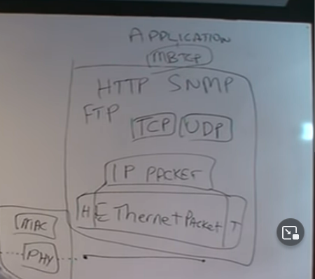
What about EthernetIP? EIP stack as application uses the TCP (like MBTCP) and UDP protocols but, in the end, everything uses IP and Ethernet.
Profinet however is different because bypasses all the steps and goes directly to Ethernet. Profinet is a communication protocol that has to be very well integrated in our system, it’s much more difficult to install.
