Local SA

Experiment
Purpose
- Identifying the most influential apparent competition-inducing mechanisms
- Searching for nonlinear relationships between AC-inducing parameters and AC proxies
- Confronting model results with theory
- Spotting potentially important interactions between AC-inducing mechanisms
- Highlighting parameters on which uncertainty could have an important impact on model outcomes
- Proof of concept (part 1)
Experimental plan
- Chose a parameter set resulting in a plausible, stable trophic system
- Set the parameter base values to this set
- Selected the most interesting AC-inducing parameters
  - Predator’s regime
  - Prey 2 to prey 1 catch probability ratio
  - Prey 2 to prey 1 resources per catch ratio
  - Prey 2 to prey 1 average number of offspring ratio (ability to sustain predation)
  - Prey 2 to prey 1 max consumption ratio (influences survival rate and reproduction success but also intra-specific competition for resources)
- Selected the most interesting AC proxies
  - Predator and preys’ extinction frequency
  - Prey 2 averaged density deviation from prey 1 before and after predator’s introduction (+ min and max to account for oscillations if present)
  - Preys’ averaged catch rates (+ min and max to account for oscillations if present)
- Varied AC-inducing parameters while keeping the others to base value, simulated over 20 replicates and measured AC proxies for each set of simulation

Code
- ABM (C++)
- Launching simulation loops (bash)
- Merge simulation results (R)
- Compute stats (R)
- Plot stats results (R)
- Fetch and store results for local SA (R)
- Plot local SA figures (R)

Figures and analysis

Predator’s regime

Extinction frquencies
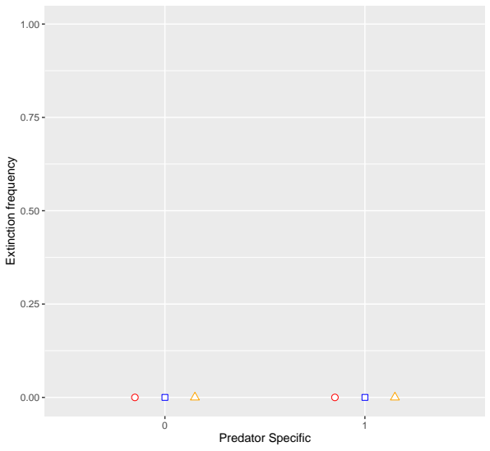
No effect at base values.

Prey’s catch rate
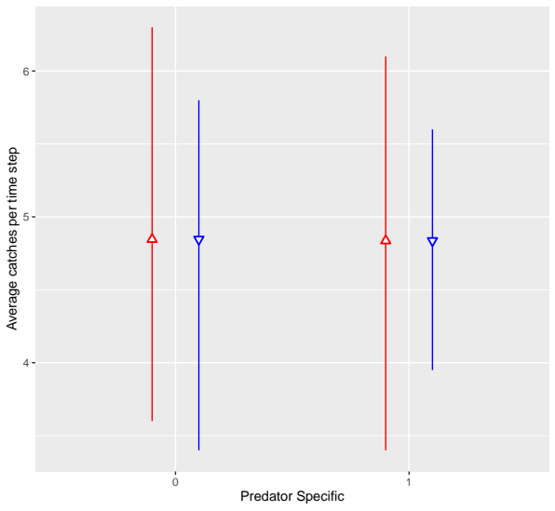
Very similar number of catches… There might be a problem with the hunting function, we expect the catch rate to be much higher for prey 1 if predators hunts them first systematically.

Prey 2 averaged density deviation from prey 1 before and after predator’s introduction
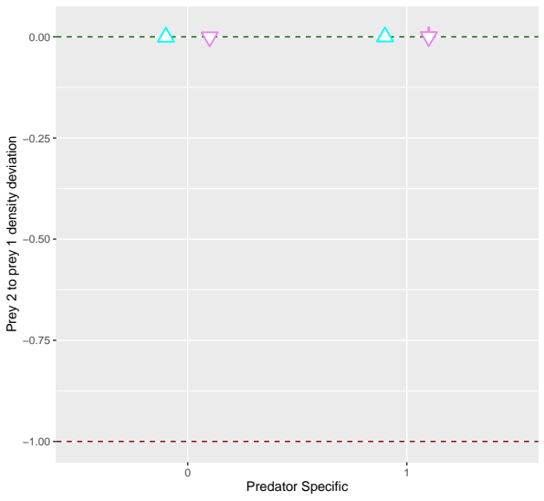
Prey 2 density deviation from prey 1 was very close to zero (very similar prey 1 and prey 2 densities) before and after depredation introduction. We expected prey 1 density to be lower than prey 2’s after predators introduction for specific predators hence a deviation > 0 after deviation.

Still rather unexpected, I would have guessed that the primary species would have been hunted preferably and thus steadily decreased sustaining a high number of predators while preys 2 thrived; and once prey 1 was low enough to leave cells to the other preys, those predators would have hunted prey 2 in numbers.
At base values prey species are identical, thus expected to be equally abundant on each cell. A predator would hunt the primary prey first, but with the same catch probability of 0.1 and max catches per ts of 1. This means that the predator will successfully hunt prey 1 first only 1 times out of 10 approximately. Probably not enough to make a difference. Can be easily tested by varying catch proba (same for both species) in interaction with regime.
I expect the regime to be an important interacting factor with other AC inducing mechanisms (predicted by Holt and Bonsall 2017, suggested by Schmitz and Booth 1995).

Prey 2 to prey 1 catch probability ratio

Extinction frequencies
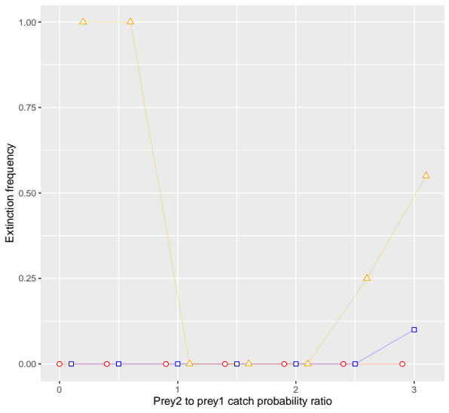
Ratio < 1 : prey 2 is much harder to catch than prey 1. Prey 1 alone cannot sustain predators when prey 2 is too hard to catch.
1 >= ratio >= 2 : prey 2 is easier to catch than prey 1. No particular change in the extinction frequency.
Ratio = 2.5 : prey 2 is much easier to catch than prey 1. Seems like prey 2 is depleted but not extinct which cannot sustain predators causing their in some replicates.

Preys’ averaged catch rates
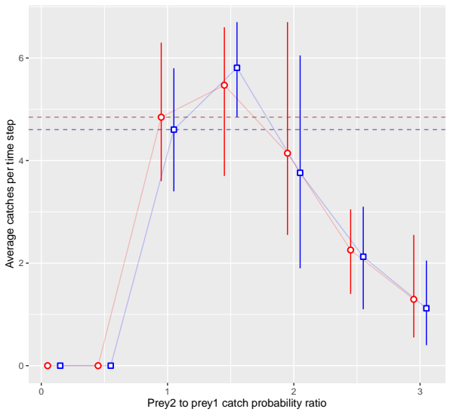
Ratio < 1 : predator get extinct quickly => no catches

Prey 2 averaged density deviation from prey 1 before and after predator’s introduction

Prey 2 to prey 1 resources per catch ratio

Prey 2 to prey 1 average number of offspring ratio (ability to sustain predation)

Prey 2 to prey 1 max consumption ratio

Summary

