SBC E-Docs:

Quality Assurance Electronic Documentation System

Presented to the College Department

St. Bridget College

Batangas City

In Partial Fulfillment of the Requirements for the Degree

Bachelor of Science in Information Technology

By:

Balmes, Adrian O.

Borbon, Aljhon R.

Nambio, Jenn Ashley Y.

January 2026

CHAPTER I

BACKGROUND AND ITS PROBLEM

Introduction
In the context of digital transformation, educational institutions are increasingly required to adopt systems and practices that enhance efficiency, transparency, and institutional quality. Central to these demands is the management of records and documentation that substantiate institutional performance, compliance, and continuous improvement. Accurate, accessible, and well-organized documentation functions as both evidence and instrument of accountability, informing data-driven decision-making, supporting accreditation efforts, and enabling systematic quality assurance across academic and administrative domains. Yet many schools continue to rely on fragmented, manual, or semi-digital documentation processes that give rise to misplaced records, inconsistent formats, delayed reporting, and constrained access to quality assurance data.
At St. Bridget College Batangas, documentation is integral to fulfilling the college’s mission of holistic formation and service excellence. Despite its critical role, current documentation workflows are scattered across multiple offices, departments, and storage platforms, which impedes comprehensive oversight and timely retrieval of evidence required for internal evaluation and accreditation. The resulting fragmentation complicates efforts to monitor compliance with national and institutional standards, generate reliable reports, and extract actionable insights for continuous improvement. Consequently, the institution is limited in its ability to leverage documentation as a strategic asset for quality enhancement.
To address these challenges, this capstone project proposes SBC E-Docs: Quality Assurance Electronic Documentation System, a web-based platform designed to centralize institutional records, standardize documentation workflows, and enable continuous quality monitoring. SBC E-Docs emphasizes automation, consistency, and accessibility: a unified repository for official records, workflow-driven document submission and approval, role-based access controls, and dashboards that provide real-time indicators of compliance and document completeness. By consolidating disparate records and embedding quality assurance processes into the documentation lifecycle, the system aims to reduce administrative burden, shorten reporting cycles, and improve the reliability of evidence used for accreditation and institutional planning.
Implementing SBC E-Docs will facilitate transparency and foster a culture of evidence-based decision-making by ensuring that critical documents are maintained in consistent formats, that ownership and status are visible, and that analytics support continuous assessment of institutional performance. Ultimately, the system is envisioned as a strategic tool that helps St. Bridget College Batangas meet contemporary quality standards, streamline accreditation preparation, and strengthen institutional capacity for sustained improvement in an increasingly digital educational landscape.

Objectives
The main objective of this study is to design and develop SBC E-Docs: Quality Assurance Electronic Documentation System. The study focuses on the design and development of the system intended to improve record management, document tracking, and accreditation readiness. Specifically, the study aims:
- To develop a centralized web-based electronic documentation system that provides the Quality Assurance Office with a single platform to store, manage, and organize all quality assurance and accreditation documents.
- To develop the system using PHP, JavaScript, MySQL, and Bootstrap with integrated modules for document tracking, compliance monitoring, and real-time status reporting, enabling Quality Assurance staff to systematically monitor all offices involved in accreditation and quality assurance.
- To develop a dashboard-driven monitoring module that enables Quality Assurance staff to track accreditation status and implementation progress, including document compliance and recommendation updates through real-time visual analytics and electronic tracking.
- To develop an automated reporting module that generates accurate Quality Assurance and accreditation reports using organized records and audit trails, enabling QA staff to efficiently respond to internal and external audits and accreditation reviews
- To evaluate the functionality, efficiency, and user satisfaction of the system using validation testing, performance metrics, and user acceptance feedback.

Significance of the Study
The development of SBC E-Docs: Quality Assurance Electronic Documentation System, a web-based documentation and quality monitoring system with real-time data collection and analytics, responds to the growing need for digital transformation in higher education institutions. The system addresses challenges in manual and fragmented documentation by improving efficiency, accuracy, and in quality assurance and accreditation processes. This study is significant in supporting evidence-based evaluation, institutional accountability, and continuous quality improvement at St. Bridget College Batangas.
For the Quality Assurance office, the system provides a centralized and structured platform that simplifies the management, monitoring, and retrieval of accreditation and quality-related documents. By automating workflows and enabling real-time tracking, QA personnel can efficiently assess document compliance, generate accurate reports, and respond promptly to internal and external audits.
For academic and administrative offices, the proposed system promotes accountability and consistency in documentation practices. Offices can easily submit, update, and monitor their required documents, reducing delays, duplication of work, and errors associated with manual and paper-based processes. This supports better coordination among departments and strengthens compliance with institutional and accreditation standards.
For management and decision-makers, the availability of real-time data, analytics, and dashboards supports evidence-based decision-making. The system enables administrators to identify performance gaps, monitor accreditation status, and evaluate the effectiveness of implemented programs, policies, and recommendations, thereby fostering continuous quality improvement.
For accreditation bodies and external auditors, the system ensures organized, accurate, and easily accessible records. This enhances transparency and credibility during accreditation reviews, audits, and evaluations, while also demonstrating the institution’s commitment to quality assurance and continuous improvement.
For students and the academic community, improved quality assurance processes contribute to better academic programs, student services, and institutional governance. Indirectly, this leads to enhanced learning experiences, stronger community engagement, and improved institutional reputation.
For future researchers and system developers, this study serves as a reference for developing similar web-based documentation and quality assurance systems in other educational institutions. It provides insights into system design, implementation, and the practical integration of real-time data collection and analytics in academic quality management

Scope and Limitations

Scope of the Study

This study focuses on the design and development of SBC E-Documentation Quality Assurance, a web-based platform intended to enhance the documentation, monitoring, and evaluation of quality assurance and accreditation processes at St. Bridget College Batangas.

The scope of the system includes the following modules and functionalities:

Centralized documentation management system

Standardized document submission and categorization

Document monitoring and compliance tracking

Document review and validation with electronic feedback

Real-time data tracking and automated report generation

Analytics dashboard and visualization tools

Digital archiving and secure record preservation

Web-based and cloud-enabled accessibility across devices

The proposed system provides a centralized documentation management platform that enables academic and administrative offices to submit, upload, update, and organize quality assurance and accreditation-related documents in a single digital repository. By using standardized submission formats and proper document categorization, the system prevents document duplication and minimizes version conflicts, ensuring a consistent and organized filing structure.

Quality Assurance personnel can monitor document submission status and compliance across offices through real-time indicators that track required, submitted, pending, and approved documents. The system also supports document review and validation processes, allowing QA staff to provide electronic feedback, comments, and revision requests directly to the concerned offices.

In addition, the system offers real-time data tracking and reporting, generating automated reports and dashboards that display compliance levels, accreditation status, and implementation progress. This supports data-driven evaluation and enhances decision-making through real-time analytics.

The platform ensures digital archiving and record preservation by providing secure storage and long-term preservation of past, current, and future accreditation and QA documents. This allows efficient retrieval of records during audits, evaluations, and accreditation reviews.

As a web-based and cloud-enabled platform, the system offers centralized and secure data storage accessible through desktops, laptops, tablets, and mobile browsers. Visual summaries of compliance rates, submission trends, and implementation status are presented through analytics and dashboard visualization to support informed decision-making by QA personnel and institutional administrators.

Limitations of the Study

The study acknowledges the following limitations:

The system is designed specifically for St. Bridget College Batangas.

Integration with existing institutional systems depends on third-party compatibility.

The system requires stable internet connection.

No standalone mobile application is included.

Reporting accuracy depends on timely and accurate document submissions.

Data security also depends on institutional policies and user compliance.

Evaluation is based only on pilot implementation.

The system is developed specifically for St. Bridget College Batangas and may require customization for use in other institutions. Integration with existing institutional systems is optional and depends on the availability and compatibility of third-party platforms and APIs.

Being web-based, the system requires stable internet connectivity, and performance may be affected in areas with limited or unstable access. Although optimized web browsers, including mobile browsers, the system does not include a standalone mobile application.

The effectiveness of documentation monitoring relies on timely and accurate submissions from offices; delays or incomplete uploads may affect reporting accuracy. While standard security measures are implemented, overall data protection also depends on institutional policies and user compliance.

Effective use of the platform may require orientation or training for users unfamiliar with digital documentation systems. Lastly, system evaluation is based on a pilot implementation involving selected offices and may not fully reflect institution-wide performance.

CHAPTER 2

REVIEW OF RELATED LITERATURE, STUDIES, AND SYSTEM
In this chapter, the researcher reviews various local and foreign literature, studies, and existing systems related to event management, quality assurance, and real-time analytics. This review provides a comprehensive understanding of current technological approaches and academic findings that support the development of SBC E-Docs: Quality Assurance Electronic Documentation System. By examining these scholarly works, the researcher gains deeper insight into established concepts, identifies gaps in existing practices, and strengthens the foundation for designing an innovative and data-driven event management solution for the institution.

Review of Related Literature
This chapter reviews both foreign and local studies relevant to the SBC E-Docs: Quality Assurance Electronic Documentation System, focusing on electronic document management systems and quality assurance in educational and organizational contexts. It critically examines previous research, highlighting strengths, limitations, and gaps that this study seeks to address.
In the modern digital society, organizations rely heavily on accurate and rapid dissemination of information to stakeholders. Files are commonly generated digitally, and reproducing large volumes of documents increases operational costs. An Electronic Document Management System (EDMS) addresses this challenge by enabling the preparation, upload, sharing, and retrieval of documents among multiple users, improving efficiency and collaboration (Sari & Wolor, 2025; Aliazas, Dela Cruz, & Ilagan, 2024).
Studies indicate that EDMS implementation across sectors such as universities, government institutions, and municipal units reduces operational costs, improves workflow efficiency, and fosters stakeholder collaboration. With features such as real-time access, document search and retrieval, workflow management, auditing, and secure sharing, EDMS allows multiple users to work simultaneously, improving organizational communication and connections between documents.
For instance, Sari and Wolor (2025) analyzed EDMS implementation in a corporate organization and found that the system significantly enhanced document management, accelerated data retrieval, and increased overall work efficiency. However, challenges such as reliance on physical documents, compatibility issues, network problems, and digital security concerns were noted. Recommendations included continuous IT infrastructure upgrades, employee training, and system feature development to maximize EDMS benefits.
Similarly, Aliazas, Dela Cruz, and Ilagan (2024) explored EDMS in a higher education institution in the Philippines, applying the Technology Acceptance Model (TAM) to assess perceived usefulness, ease of use, and behavioral intention to adopt the system. The study concluded that administrative processes significantly predict TAM components, and that EDMS positively impacts academic management, student services, and research activities. These findings suggest that EDMS adoption is both beneficial and influenced by organizational readiness and user perception.
The implementation of EDMS has also been linked to significant cost savings by reducing paper usage and overhead staff time, as well as improving corporate culture and income generation through operational efficiencies. Furthermore, testing of EDMS in simulated and real organizational environments demonstrates its capability to meet stakeholder expectations in terms of speed, efficiency, and security of document management (Gamido, Gamido, & Macaspac, 2023). Electronic Document Management Systems (EDMS) are designed to manage the creation, storage, retrieval, and sharing of documents electronically, offering organizations a solution to challenges associated with physical document handling. In today’s digital era, organizations increasingly rely on EDMS to reduce operational costs, improve efficiency, and facilitate collaboration among stakeholders (Gamido, Gamido, & Macaspac, 2023).
This research aims to describe a quality assurance system in improving the quality of education. The method used is a field description. The approach is a qualitative approach. The data collection methods used are observation, interviews and documentation. The stages in data analysis techniques are, collecting data, reducing data, presenting data and drawing up research. The results of this research are as follows. The quality assurance system in improving the quality of education in schools has not been running well, one of which is the participation of education stakeholders to support quality development, and lack of funding allocation. There are several factors inhibiting the quality assurance system in improving. The quality of education in schools is as follows, the self-evaluation tools used in self-evaluation activities in schools have not been used optimally and all teachers and parents have not been able to optimize school self-evaluations. Efforts made to overcome factors inhibiting the quality assurance system in improving the quality of education in schools are improving quality fulfillment, increasing quality priorities that have not been achieved, improving quality findings and improving aspects of quality improvement.

Related Studies Foreign Study
According to Sagir-Muhammad (2016), EDMS enables universities to centralize their data storage, eliminating the need for multiple disparate systems and reducing the risk of data duplication or loss. Authorized personnel can access relevant information quickly and efficiently with a centralized repository, enabling informed decision-making and enhancing collaboration across different departments (Shahmoradi et al., 2017).
Moreover, EDMS offers advanced search and retrieval capabilities, making it easier for university staff to locate specific data or documents within the system (Oladejo & Hadžidedić, 2021). This significantly improves efficiency and reduces the time spent searching through physical files or multiple digital folders. Quickly accessing and retrieving data allows university administrators, faculty, and staff to focus more on their core responsibilities and spend less time on administrative tasks (Höchtl et al., 2016).
Another key advantage of EDMS is its improved data security and compliance (Guo et al., 2021). According to Omotunde and Ahmed (2023), these systems typically incorporate robust security measures, including encryption, access controls, and audit trails to safeguard and protect sensitive information from unauthorized access or breaches. Additionally, EDMS often feature compliance mechanisms that help universities adhere to data protection regulations and privacy laws.
Furthermore, EDMS offers powerful data analytics capabilities, allowing universities to gain valuable insights from their data (Agasisti & Bowers, 2017). Universities can use data visualization and reporting features to identify trends, patterns, and correlations in their data, enabling evidence-based decision-making and strategic planning (Ray & Saeed, 2018). This analytical capability can be valuable for student enrollment and retention, academic performance analysis, and resource allocation (Colvin et al., 2016).
In addition to the operational benefits, EDMS contributes to sustainability efforts by reducing reliance on paper-based documentation (Malekani, 2023). With electronic document management, universities can significantly decrease paper consumption, leading to cost savings, environmental conservation, and streamlined workflows (Martins et al., 2021).
The Technology Acceptance Model (TAM) is a widely used theoretical framework for understanding users' acceptance and adoption of new technology (Alomary & Woollard, 2016). TAM focuses on the user's perception of how technology can enhance job performance (Panergayo & Aliazas, 2023). In higher education, faculty, staff, and administrators might assess whether an electronic document management system streamlines student record-keeping, grading, or research data management tasks (Zaineldeen et al., 2020). If they perceive that the system makes these tasks easier or more efficient, they are more likely to accept and use it (Mugo et al., 2017).
According to Shah and Attiq (2016), perceived ease of use refers to the user’s perception of how easy or difficult it is to use the technology. This could involve user interface design, navigation, and integration with existing workflows (Abdullah et al., 2016). Users who find the system intuitive and user-friendly are more likely to adopt it (Revythi & Tselios, 2019). TAM also considers the user’s general attitude toward technology use (Muchran & Ahmar, 2019). In higher education, this could include factors such as the perceived impact on teaching, research, or administrative tasks (Fathema et al., 2016). If users believe the electronic data management system will positively contribute to their work, they are more likely to accept it (Justina et al., 2022).
As technology advances, universities also explore emerging trends in electronic data management. For example, integrating artificial intelligence (AI) and machine learning (ML) can enhance data analysis and automate repetitive tasks, improving efficiency and accuracy (Ramachandran et al., 2022).
Additionally, cloud-based EDMS offers scalability and flexibility, allowing universities to adapt to changing data requirements and seamlessly accommodate growth. Universities recognize the importance of robust electronic data management systems in today’s digital age (Ribble, 2016). These systems provide a centralized, secure, and efficient platform for handling vast amounts of data, enabling seamless operations, informed decision-making, and improved productivity (Raj & Raman, 2017).

Review of Local Studies
In the process of documenting files for academic quality assurance and human resources recruitment, it is still conventional where there is still a physical accumulation of files, so that it can slow down the search for files or data needed and can result in the risk of losing important data. In addition, the unavailability of a Human Resources (HR) recruitment information system that can facilitate prospective applicants for lecturers and staff. The method of system development used in this study is the Structured Systems Analysis and Design (SSAD) Methodology. This methodology has several important stages that must be carried out in designing and building E-Document in the IIB Darmajaya Information Systems study program with the existence of a mobile-based quality assurance E-document system, it is hoped that it can assist the department in documenting quality assurance files. This system can be accessed by the KBK department, the department secretary and the head of the department of all str level study programs.

Conceptual Framework
OUPUT
- QA Electronic Dashboard
- Centralized Repository
- Compliance Monitoring Tools
- Summary Reports
PROGRESS
- Upload Categorations
- Status Classification
- Automated Notification
- Maintenance Tracking
- QA Validation & Review
INPUT
- QA Recommendation
- Internal Audit Reports
- Office Documents
- Historical Records
- CSSAO Request
- Staff Progress Updates

Figure 3.1 Conceptual Framework

As shown in figure 1.1, The conceptual framework for the SBC E-Docs: Quality Assurance Electronic Documentation System illustrates the relationship between the system’s inputs, processes, and outputs using the Input-Process-Output (IPO) Model.

Input
The system collects essential institutional data required for Quality Assurance monitoring and compliance, including:
- Quality Assurance (QA) recommendations and internal audit reports.
- Office-specific documents from HR, Finance, Purchasing, Registrar, and academic libraries.
- Digitized historical records (IBED 1999 and Accreditation 2006).
- CSSAO maintenance requests and related reports.
- Manual progress updates from staff on task implementation.
Process
The system processes and manages inputs through controlled and structured workflows handled by QA personnel:
- Uploading, categorizing, and organizing documents in a centralized platform.
- Classifying recommendations based on implementation status:
        - Implemented
        - Partially Implemented
        - Not Implemented
- Sending automated notifications via email and system alerts for updates and deadlines.
- Monitoring CSSAO maintenance activities with real-time status tracking.
- Conducting manual validation and quality review to ensure compliance with Institutional standards.

Output
The system produces reliable, transparent, and data-driven results to support institutional decision-making:
- SBC Quality Assurance Electronic Dashboard with real-time progress visualization
- A centralized, secure, and searchable digital repository
- Visual monitoring tools for document and compliance tracking
- Consolidated compliance and progress reports for administrative review

CHAPTER 3

Software Development Model
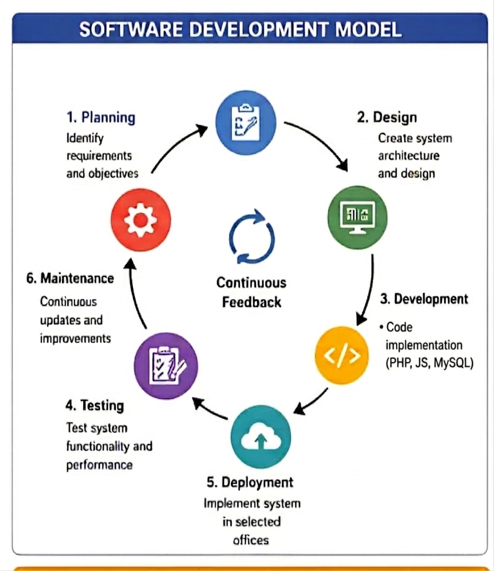

Figure 3.1 Software Development Sytsem

As shown in Figure 3.1, the software development model for the SBC E-Docs: Quality Assurance Electronic Documentation System utilizes the Agile Software Development approach. This model is selected because it supports continuous improvement, flexibility, and active user feedback throughout the development process.

The system is developed through iterative cycles or sprints, where each module such as document management, compliance tracking, and reporting is progressively designed, developed, tested, and enhanced. This approach ensures that the system adapts to user needs, improves functionality over time, and delivers efficient and reliable performance.

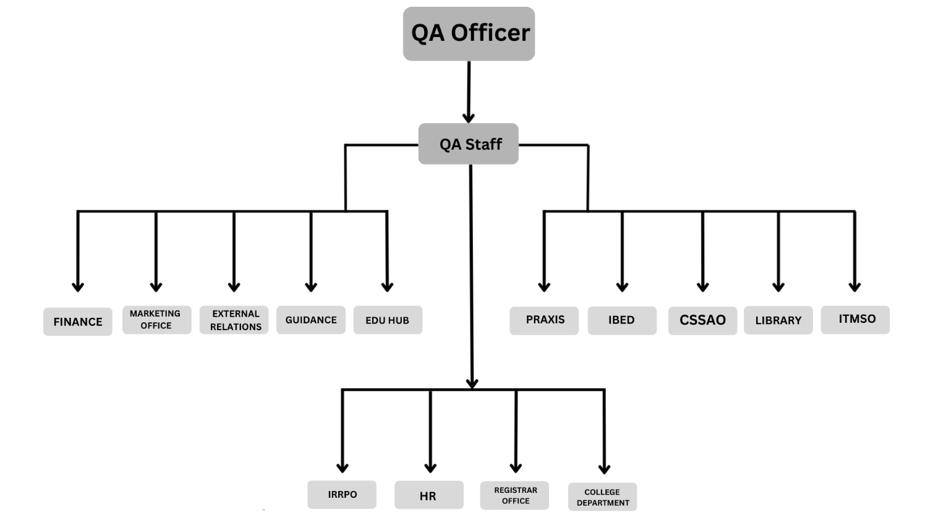
Organizational Chart

Figure 3.2 Organizational Chart
As shown in Figure 3.2, the organizational chart presents the structure of personnel and offices involved in the implementation of the SBC E-Docs: Quality Assurance Electronic Documentation System at St. Bridget College Batangas. It illustrates the hierarchical relationship between institutional administrators, the Quality Assurance Office, and various academic and administrative departments responsible for submitting and managing quality assurance and accreditation documents within the system.

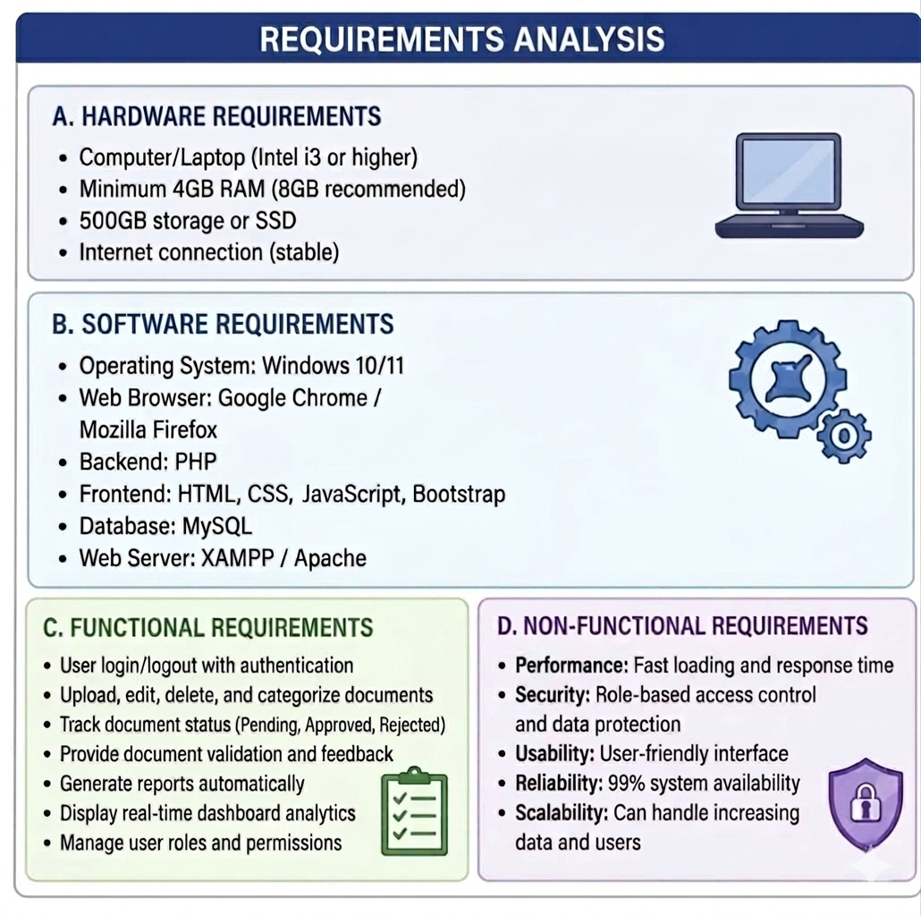
Requirements Analysis\
Figure 3.3 Requirements Analysis

References
Aliazas, J. V., Cruz, R. D., & Ilagan, N. (2024). Enhancing university operations: A study of the electronic document management systems (EDMS) of one higher education institution. Twist.
https://www.researchgate.net/publication/382398312_Enhancing_University_Operations_A_Study_of_the_Electronic_Document_Management_Systems_EDMS_of_One_Higher_Education_Institution
Gamido, M. V., & Gamido, H. V. (2023). Electronic document management system for local area network-based organizations. Indonesian Journal of Information Systems.
https://www.academia.edu/download/103996290/17516.pdf
Mohzana, M., Arifin, M., & Pranawukir, I. (2024). Quality assurance system in improving the quality of education in schools. Mudir: Jurnal Manajemen Pendidikan Islam.
https://ejournal.unsuda.ac.id/index.php/MPI/article/view/830
Sari, D. D. P., & Wolor, C. W. (2025). Analysis of electronic document management system (EDMS) implementation at Company X. In Proceedings of the International Student Conference on Business, Education, Economics, and Accounting.
https://journal.unj.ac.id
Yusof, Z. M., & Chell, R. W. (2021). Electronic records management in schools: The case study of school examination analysis system.
https://www.academia.edu/65558322/Electronic_Records_Management_in_Schools_The_Case_Study_of_School_Examination_Analysis_System

Abdullah, F., Ward, R., & Ahmed, E. (2016). Investigating the influence of the most commonly used external variables of TAM on students perceived ease of use and perceived usefulness. Computers in Human Behavior, 63, 1–12.
Agasisti, T., & Bowers, A. J. (2017). Data analytics and decision-making in higher education. Educational Researcher, 46(5), 245–256.
Alomary, A., & Woollard, J. (2016). How is technology accepted by users? A review of technology acceptance models and theories. International Journal of Technology Enhanced Learning, 8(1), 1–18
Colvin, C., Rogers, T., Wade, A., Dawson, S., Gasevic, D., Shum, S. B., Nelson, K., Alexander, S., Lockyer, L., & Kennedy, G. (2016). Student retention and learning analytics. Journal of Learning Analytics, 3(3), 8–20.
Fathema, N., Shannon, D., & Ross, M. (2016). Expanding the technology acceptance model in higher education. TechTrends, 60(2), 132–139.
Guo, X., Zhang, X., & Sun, Y. (2021). The privacy-personalization paradox in electronic document systems. Information & Management, 58(2), 103–117.
Höchtl, J., Parycek, P., & Schöllhammer, R. (2016). Big data in the public sector: Benefits and challenges. Journal of Organizational Computing and Electronic Commerce, 26(1–2), 1–20.
Malekani, F. (2023). Sustainable document management practices in higher education institutions. Sustainability, 15(4), 1–15.
Martins, J., Branco, F., Gonçalves, R., & Au-Yong-Oliveira, M. (2021). Assessing the success behind the use of cloud-based systems. Future Generation Computer Systems, 122, 167–180.
Mugo, D., Njagi, K., Chemwei, B., & Motanya, J. (2017). The technology acceptance model (TAM) and its application in education. International Journal of Education and Development using ICT, 13(2), 1–18.
Oladejo, E., & Hadžidedić, S. (2021). Document management systems: A review of features and benefits. Information Development, 37(3), 1–12.
Ramachandran, A., Chen, H., & Wang, Y. (2022). Artificial intelligence in higher education data management. Computers & Education: Artificial Intelligence, 3, 100–110.
Revythi, A., & Tselios, N. (2019). Extension of TAM in higher education. Education and Information Technologies, 24(4), 2345–2372.
Shahmoradi, L., Darrudi, A., Arji, G., & Nejad, A. (2017). Electronic health records and documentation systems in higher education and healthcare. Acta Informatica Medica, 25(3), 1–6.
Zaineldeen, S., Hongbo, L., & Hassan, S. (2020). Technology acceptance model in educational settings. Journal of Educational Computing Research, 57(8), 1–25.

