***Parteneri si Sponosori-ONG***

1.Cort Avon

2.Cort DJST

3. Cort ICTR : <https://l.facebook.com/l.php?u=https%3A%2F%2Fwe.tl%2Ft-6e5wnJTIEv%3Ffbclid%3DIwAR0k3mojsMxo8Z7ifDZNLc1Hv-3hHhujLmNMT0Wne9UwQRvNcdviLtX1t_o&h=AT3_mVhDYlal5tKrmwfpSJmFT11sJq4E4NQfB3Cc_cnjFvVODdHuDdqsmk5QC7gwVcJgjB2OHCBK4FuP_eNYTxgqk-HxaQdbF9l0UbAdclsFqhkM-d-rhRfSSfflz9e6AS2PtVTKDc6uCjhKaMle>

4.Teris

5.TIA-ACM

6.LIIS



7.Lisa Robot

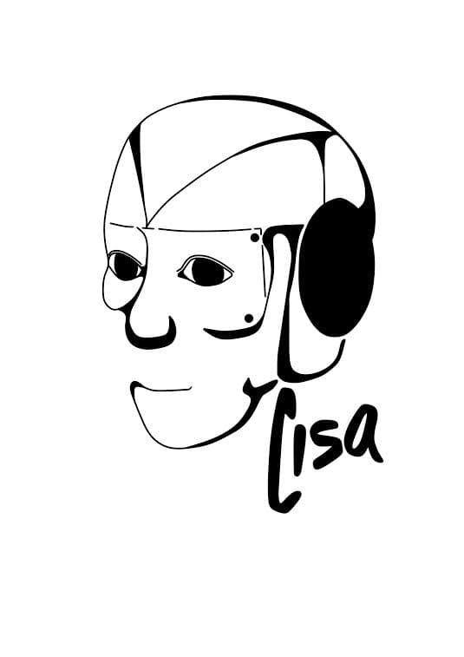

8.Tineri de success



9.Petran Music-

10.AIESEC-

<https://l.facebook.com/l.php?u=https%3A%2F%2Fdrive.google.com%2Fa%2Faiesec.net%2Ffile%2Fd%2F1oh9UsYTZioiP0TEKmYJduGMAfV7nXYFO%2Fview%3Fusp%3Ddrivesdk%26fbclid%3DIwAR1U9H-uU1K_aK03XMdN-Gb9J6N4bsNCiF1hw5UbpJLjEorokcXWXozwXv8&h=AT3x0Ch92Z6hoeG0YTif4asnqCGheG8z0pkOr7eqCts-ks6wxARtY5hWPiDG5JI8Jikd-PYhF1iMwN8l7cmMhyi9Nc3Y8sZx3vZFu5n5njIVsYaI8T64JALgRWRr8R-NczUSsUJ-2QMmrTqugyZQIg>

11.ASCIS-

12. Pompieri-



13.ETH-

14.Master Escape



15.LEX



16.Stomato rulles

17.SVAIS-

18,GISU-



19.Politia

20.Reporter pentru 1 minut

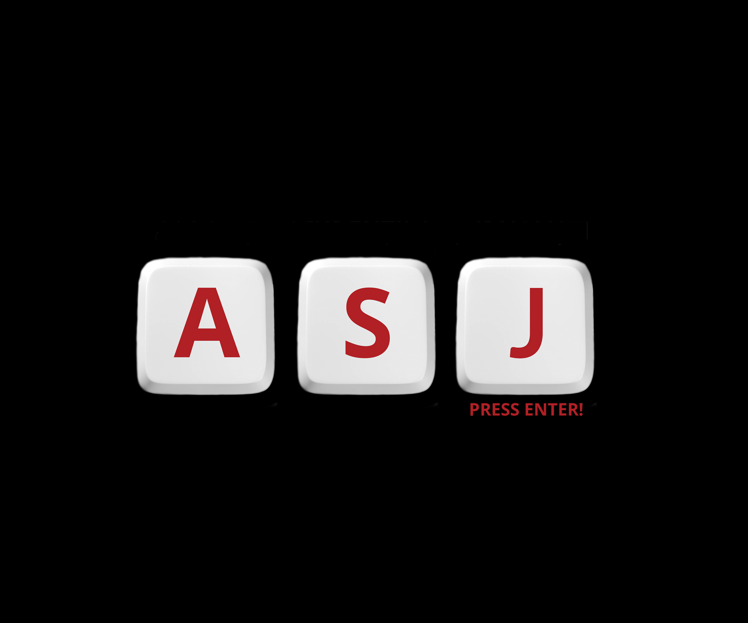

21.ETEAM-sondaje

22.LSGG



23. Iasi Travel



24.BCR

25. The Town Masks

k

26.Laser Tag



27.Hamak



28.Comunitate armenilor + proiect educational

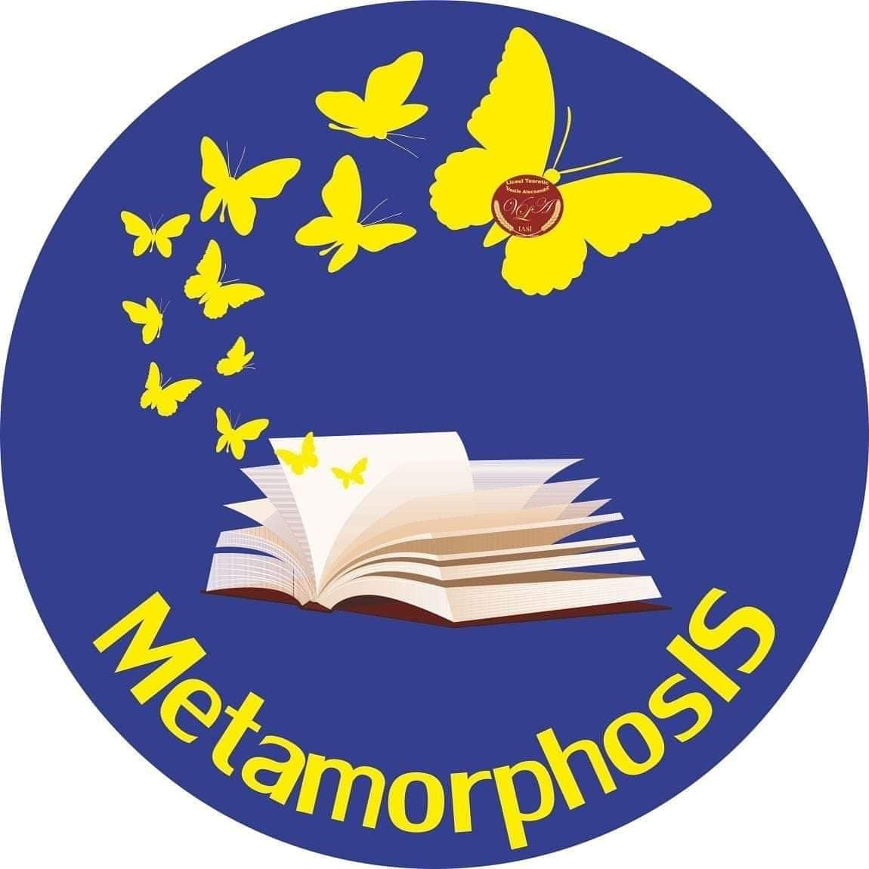



29.Dionisos

