**tCCA extension for the General Linear Model in Homer3:   
A brief introduction**

version May 2020

This document provides a brief introduction to the use of temporally embedded Canonical Correlation Analysis (tCCA) to generate more optimal nuisance regressors for the General Linear Model in fNIRS using the Homer3 toolbox. The method and its extensive evaluation and validation were published in NeuroImage 208 (2020), the manuscript can be accessed [here](10.1016/j.neuroimage.2019.116472) (DOI: 10.1016/j.neuroimage.2019.116472):

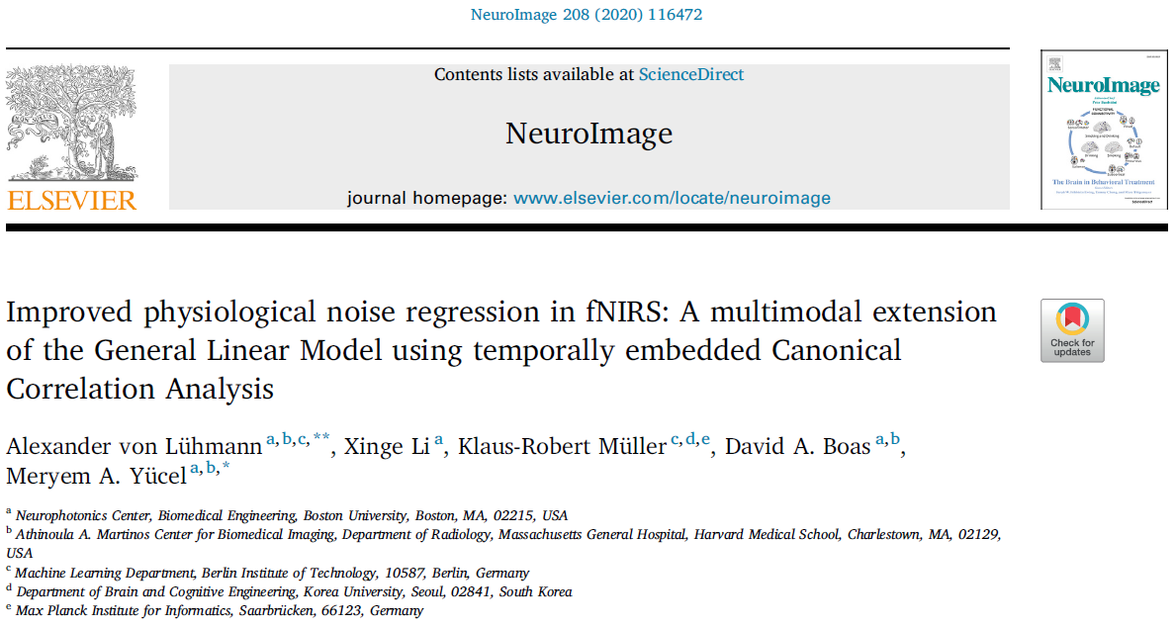

**What does the method do?**

* It reduces nuisance signals in fNIRS, which leads to more robust estimation of evoked brain activity.
* GLM with tCCA flexibly combines any available auxiliary signals into optimal nuisance regressors. The most important signals to use are short distance fNIRS channels and motion (accelerometer) measured at the head.
* The method significantly improves upon conventional GLM with short separation regression and can be used comparatively easily to extend existing processing pipelines
* GLM with tCCA improves HRF recovery particularly for low Contrast to Noise Ratios and low number of stimuli/trials.

**How does it work?**

The method consists of (at least) two different steps/runs:

1. A (machine) **learning** **run**, in which a resting state measurement (training run) is used to learn tCCA filters that generate the optimal nuisance regressors by linearly mixing time embedded (shifted copies of) auxiliary signals. It is important to use resting state data – not experimental data with stimuli that generate brain responses – to ensure the nuisance regressors fit physiological noise only. The tCCA filter matrix is saved in the group/subject folder as a text file named “”. If you change tCCA parameters, or delete the file, this filter will be newly trained.
2. The **analysis run(s)**, in which the tCCA filters are used to generate nuisance regressors for the subsequent GLM analysis of the fNIRS data that contains stimuli and corresponding brain responses.

In Homer3, this is incorporated by specifying the index of the resting run to use for training, and running a whole subject’s session. The session should at least contain the resting run, and one analysis run. If the resting run is not the first in the processing order, the training will only happen once the resting run is analyzed, and all other runs until then are skipped. In this case, after initial execution, just re-run the session to get complete results.

**How to incorporate tCCA into your Homer3 processing stream?**

You can simply add the hmrR_tCCA function to your processing stream, usually directly preceeding the hmR_GLM function. Please refer to the example processing stream tCCA_xmpl_procStream.cfg, that is provide with this documentation under …\Homer3\FuncRegistry\UserFunctions\tcca_glm\ and explained in the following:

Both fNIRS and auxiliary data need to be **bandpass-filtered to the same bands**, by default to   
[0.01 – 0.5] Hz

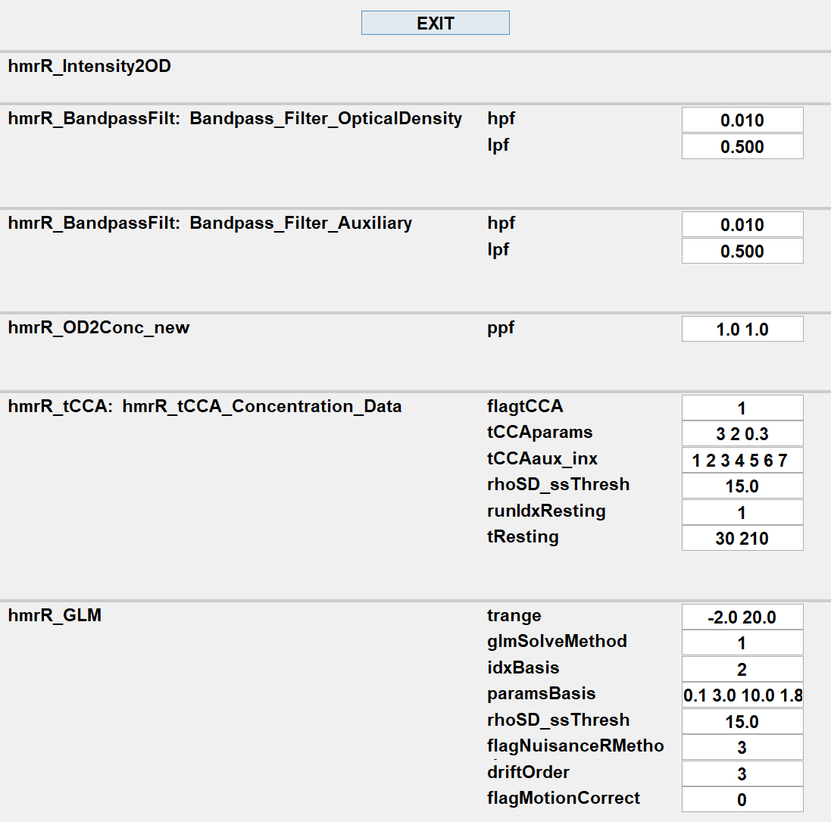

Indices of auxiliary signals to use

Index of resting run

Training window in resting run [s]

tCCA settings: [ A B C ]  
A: overall time lag [s]   
B: step size [smpl]   
C: correlation threshold

Short separation threshold [mm]

Turns method on/off

**Remarks on parameter selection**

BandpassFilt**:** You can choose any typical fNIRS band here. Please note, that the tCCA step might perform less good when higher frequency noise is not excluded (lpf high)

flagtCCA: Turns the tCCA method on (1) or off (0).

tCCAparams: The main parameters for tCCA analysis, as identified and evaluated in the NeuroImage publication: [timeLag stepSize corrThresh]  
timeLag: overall timespan in seconds, across which temporal embedding is performed. Default: 3s.  
stepSize: the step size (Δt) in samples for each time shift of auxiliary signals in the temporal embedding step. NOTE: The effective time shift will depend on your data’s sample frequency!   
 Default: 2 samples  
corrThresh: Correlation threshold (<=1). This threshold will be used to select (keep) only those tCCA regressors for the GLM nuisance removal, that have a canonical correlation with fNIRS signals in the CCA space that is greater than corrThresh. If set to 1, all regressors will be used. Default: 0.3.

tCCAaux_inx: indices of the auxiliary signals in the .snirf file that are to be used for the tCCA regression. NOTE: to not introduce additional noise, exclude auxiliary channels that are noisy or do not carry meaningful signals.

rhoSD_ssThresh: Same parameter as in the hmR_GLM function. Threshold to detect short separation channels in the data. All signals measured with a source-detector separation < rhoSD_ssThresh will be used as short separation channels and added to the auxiliary signals to find nuisance regressors in the tCCA step.

runIdxResting: Index of the run (dataset) that contains the resting data to be used for the tCCA filter training. We recommend to position your resting state data as the first run and set runIdxResting = 1. If your resting run is not the first, the tCCA function will skip all runs up to the training run to generate the tCCA filter and not output regressors before the filter is learnt. In that case, simply re-run the whole session after your first execution to generate results for the previous runs as well.

tResting: Window in seconds [start stop] to be used in the resting state run for tCCA training. We recommend to set the start time to at least a few seconds after the begin of resting state trial to make sure all signals are settled and no major artifacts are present. For better statistical performance, the window should not be shorter than 60s. Default: [30 210] (180s).