1. Introduction

1.1 Project Context

The College Guidance Center (CGC) of the Ateneo de Naga University is an office that handles mental and emotional welfare and distress of all students of the university and how well they are handling their personal transition and social interaction with the university’s environment and culture. The CGC plays a vital role in the growth and development of the students into physically and mentally stable men and women for others. Despite this, the current technological status and situation that is prevalent in both its inner and outer workings have limited the degree of security and accessibility for its possible patrons.

Currently, the CGC still mainly relies on archaic, traditional means of interacting with students. Student information is gathered through form distribution, gathered or submitted, and then manually encoded into their database. Such a process is time consuming and prone to conflicts when students wish to make an update or alteration to their recorded data as they will be required to go through the lengthy process once again.

In addition, their ability to provide counsel and guidance is also inhibited by their outdated systems of operation. Students are required to manually set an appointment in order to receive any form of assistance and doing so requires one to directly enter the CGC’s headquarters. This becomes an issue when one considers the fact that not every individual has the time to spare to make a detour for such a task. The need for scheduled appointments also presents an issue when the type and severity of a student’s issues come to light as some cases are time sensitive due to their nature and how long a students has been bearing these troubles.

1.2 Purpose & Description

The project aims to establish an easily accessible and readily available communication medium between the students of the Ateneo de Naga University and the College Guidance Center that will not only handle a student's initial and subsequent information submission, but also any future counseling appointments that a student may desire without the need of being physically present at the CGC’s headquarters.

The project will act as a sort of messenger application that will only be accessible through the school,s intranet. Students will be given accounts where their information will be gathered for the use of the CGC, but their usernames will be kept hidden for the sake of anonymity when they contact any of the CGC student volunteers and counselors for advice. The project will be constructed with the following programming languages: HTML, CSS, JAVASCRIPT, RAILS.

1.3 Objectives

1.3.1 General Objective

Establish a readily accessible communication system between Ateneo de Naga University’s Guidance Office and its students through the design, creation, and deployment of an online website using the Ruby on Rails framework.  
  
 1.3.2 Specific Objectives

To be able to meet the general objective, the project specifically plan to achieve the following:

* Analyze and Make Use of a *Mentally Comforting Color Pallet*
* Enable Users to Create Accounts Using a Display Name of their Choice
* Set up a database to store the user accounts of the CGC staff and the students
* Provide Accounts with Admin Privileges to Guidance Office Members
* Enable Students to Directly Message members of the Guidance Office
* Allow Guidance Members to Reply to Posts

1.4 Scope and Limitations  
  
 The scope of the project will only be for students registered in NOCS and may only be accessed inside the vicinity of the Ateneo de Naga University. Since the project is a web application, it requires a stable internet connection for it to be accessed. Although a user can type in any message he/she wants, the system would not handle filtering of spam messages, bad language, and such.

II. Review Of Related Literature

2.1 Related Literature

2.1.1 Student Access to Guidance Counseling in High School

The advice students receive on selecting a high school curriculum track or planning an appropriate course of study is likely to come from both home and school. The primary mechanism in America’s public high schools to assist students in making informed decisions about these important choices is guidance counseling.. Moreover, students who lack access to guidance counseling are more likely to be placed in nonacademic curricular tracks and to take fewer academic math courses. It appears that students who may need such guidance the most, since they come from home environments where knowledge of the consequences of curricular choices is limited, are least likely to receive it in their schools.[5]

2.1.2 WS-Messenger: a Web services-based messaging system for service-oriented grid computing

A Web services-based publish/subscribe system has the potential to create an Internet scale interoperable event notification system which is important for grid computing as it evolves a service-oriented architecture. WS-Messenger is designed to be a Web services-based message broker that can decouple event producers and event consumers and achieve scalable, reliable and efficient message delivery. In this paper, they discussed some challenges that are unique to Web services-based publish/subscribe systems and the key features that distinguish WS-Messenger from other existing message brokers.[6]

2.2 Related Systems

2.2.1 Talkspace

Talkspace is an online website that makes therapy available and affordable for all. Their mission is to provide more people with convenient access to licensed therapists who can help those in need live a happier and healthier life.Despite this,they are not trying to replace in-office therapy. Many people prefer that, which is fine. They created Talkspace so more people could benefit from therapy and overcome their day-to-day challenges in a stigma-free environment.  
 With Talkspace, you can send a therapist text messages, audio messages, as well as picture and video messages in a private, text-based chat room. Talkspace stands out because of the affordability, anonymity and convenience it provides.[1]

2.2.2 7 Cups of Tea

7 Cups of Tea is an online emotional support service. Through a secure, anonymous bridging technology, they connect those in need of emotional support with our network of Active Listeners, individuals from all walks of life who want to provide compassionate care. Connections to Listeners are private, one-on-one conversations initiated on demand.[2]

2.2.3 PlusGuidance

PlusGuidance is an on-demand therapy service that helps anyone get instant access to the therapy they need from the privacy and comfort of their own home wherein users can choose to speak to a therapist via secure video call, voice call, instant messaging, or offline in-person.  
 Their mission is to improve the world's mental health by creating immediate access to talking therapies.

2.2 SWOT Analysis

2.2.1 Strengths

* Anonymity Encourages Honesty – Anonymity is the state of being unidentified by name. With anonymity, it would be easier for people to share their problems with openness and sincerity, which would make it convenient for the CGC staff to help them accordingly.
* Decreases Delays in Receiving Aid –When a student has a problem and asks aid from the CGC staff, the student would usually set an appointment. This is taxing in the part of the.students. With the proposed system,the students does not have to schedule an appointment for their consultation. The student will only have to access the web application and post their problem then a guidance member will reply to them.
* Accessible – The proposed system can be accessed as long as the students is connected to a NOCS provided internet server in the university

2.2.2 Weakness

* Requires Internet Access - the proposed system requires a stable internet connection from the NOCS server for it to function, therefore it can’t be virtually accessed all the time, anywhere.
* Lacks a “Personal Touch” - the proposed system cannot replicate true human interaction and cannot simulate authentic communication between individuals thus making it highly susceptible to impersonalization despite reducing the possibility of biased responses

2.2.3 Opportunities

* Risk Reduction in Terms of Suicide Rates or Breakdowns - According to reports many students are having difficulties in life, there are times that they think of suiciding or to the point of breaking down so to reduce this problem the guidance center can help the student overcome his problem.
* Improve Student’s Emotional Development and Stability - Some students are having difficulties in controlling their emotion so with this we can help the students improve on how they will manage their emotion. Emotional Stability is important in personal studies of the student so if it is not solve the result is that the student will have a hard time maintaining his/her grades.
* Optimize Guidance Office’s Ability to Provide Services - The purpose is to extent the services provided by the guidance office to the student. The possibility of helping more students within the university.

2.2.4 Threats

* Guidance Office Personnel May Not Be Ready to Adapt to New System - Due to a new system that they still don’t know, the possibility is that they might have difficulty in adapting using the system provided.
* Possibility of Trolls Spammers - In the society today many are capable of trolling and spamming other users but we can’t stop this because whatever we do because it is already a habit of most people.
* Confidentiality Prevents Direct Confrontation of Possibly Dire Issues

III. Technical Background

3.1 Ruby on Rails

Ruby is a programming language. It was created 20 years ago by Yukihiro “Matz” Matsumoto. By most measures of programming language popularity, Ruby ranks among the top ten, though usually as tenth (or so) in popularity, and largely due to the popularity of Rails. Like Java or the C language, Ruby is a general-purpose programming language, though it is best known for its use in web programming.

Rails is a software library that extends the Ruby programming language. Rails is a framework for building websites. As such, Rails establishes conventions for easier collaboration and maintenance. These conventions are codified as the Rails API (theapplication programming interface, or directives that control the code). The Rails API is documented online and described in books, articles, and blog posts.

Rails combines the Ruby programming language with HTML, CSS, and JavaScript to create a web application that runs on a web server. Because it runs on a web server, Rails is considered a server-side, or “back end,” web application development platform (the web browser is the “front end”). Later, this article will describe web applications in greater depth and show why a web development framework is needed to build complex websites. [7]

3.2 Forms

A *form* is used to record information, such as the evaluation of an employee’s performance during the review cycle. Forms are generated from form templates. The form that each employee receives will contain all the elements of the form template on which it is based.[8]

In HTML and in Rails, Forms are required when you want to collect some data from the site visitor. For example during user registration you would like to collect information such as name, email address, credit card, etc.

A form will take input from the site visitor and then will post it to a back-end application such as CGI, ASP Script or PHP script etc. The back-end application will perform required processing on the passed data based on defined business logic inside the application.[9]

3.3 Forum

A forum is an online discussion board where people can ask questions, share their experiences, and discuss topics of mutual interest. Forums are an excellent way to create social connections and a sense of community. They can also help you to cultivate an interest group about a particular subject. By participating in a forum, you can exchange ideas, ask questions, and use the expertise of people in your organization. A forum can be stand-alone or be associated with a community. In a stand-alone forum, anyone can post a topic or respond to a topic, but only a community member can participate in a community forum.[10]

IV. Diagrams and Process Flows

4.1 Entity - Relationship Diagram

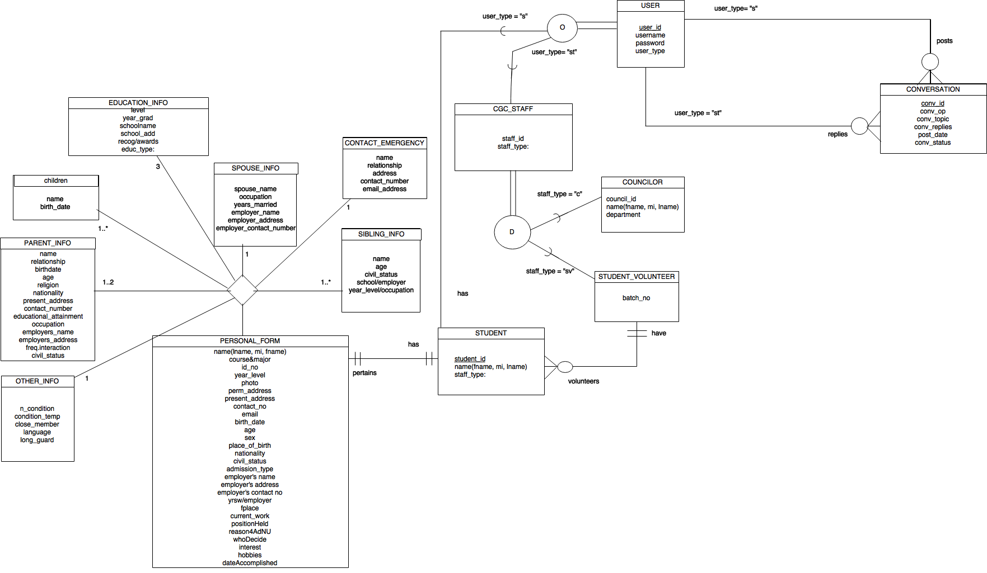

4.2 Web-map

webmap (3).png

References:

[1] “Talkspace”,about:https://www.talkspace.com/online-therapy/faqs/#q2

[2] “7 cups of tea”,about: https://www.7cups.com/about/faq.php

[3] “Plus Guidance”,about: https://plusguidance.com/faq-for-users

[4] “Peer Counseling: An In-Depth Look at Training Peer Helpers. Third Edition”, Tindall, Judith   
 A.

[5] “Student Access to Guidance Counseling in High School”,Valerie E. Lee, Ruth B.   
 Ekstrom,First Published June 1, 1987 research-article

[6] Yi Huang, A. Slominski, C. Herath and D. Gannon, "WS-Messenger: a Web services-based   
 messaging system for service-oriented grid computing," Cluster Computing and the Grid,   
 2006. CCGRID 06. Sixth IEEE International Symposium on, Singapore, 2006, pp. 8   
 pp.-173.

[7]”Ruby on Rails” about: http://railsapps.github.io/what-is-ruby-rails.html

[8]”Forms” definition: https://salesdemo4.successfactors.com/doc/AdminResourcesPage/

AdminResources/New_Topics/ar_templ_what_are_forms.htm

[9] “HTML Forms” definition: https://www.tutorialspoint.com/html/html_forms.htm

[10] “Forums” definition: https://www.ibm.com/developerworks/community/help/index.jsp  
 ?topic=%2Fcom.ibm.lotus.connections.forums.help%2Fc_forums_welcome.html