
ADRIÁN ELEUTERIO HERNÁNDEZ MARTÍNEZ
P05R01_BD_AEHM

BASE DE DATOS GenSep SQL SERVER

Orden de ejecución de Scripts
Proyecto P05R01_BD_AEHM
Ruta: "C:\Users\adria\Documents\GenSep\Proyectos\P05R01_BD_AEHM\SCRIPTS"
P05R01_01_CreateDatabase_AEHM.sql
P05R01_02_CreateTables_AEHM.sql
P05R01_03_CargaInicial_AEHM.sql
P05R01_04_CrearVistas_AEHM.sql
P05R01_05_CrearSPs_AEHM.sql
P05R01_06_CrearTriggers_AEHM.sql
P05R01_07_CrearJob_AEHM.sql

En caso de error correr contingencia:
Ruta: "C:\Users\adria\Documents\GenSep\Proyectos\P05R01_BD_AEHM\CONTINGENCIA"
P05R01_BD_A_JOBS_AEHM.sql
P05R01_BD_B_TRIGGERS_AEHM.sql
P05R01_BD_C_SPs_AEHM.sql
P05R01_BD_D_VISTAS_AEHM.sql
P05R01_BD_E_LIMPIEZA_DATA_AEHM.sql
P05R01_BD_F_DROP_TABLES_AEHM.sql
P05R01_BD_G_DROP_DATABASE_AEHM.sql

Diccionario de datos
Tabla Productos
Column_name | Type | Computed | Length | Prec | Scale | Nullable
ProductoID | int | no | 4 | 10 | 0 | no
Nombre | nvarchar | no | 200 |  |  | no
Categoria | nvarchar | no | 100 |  |  | no
Precio | decimal | no | 9 | 10 | 2 | no
Stock | int | no | 4 | 10 | 0 | yes
FechaCreacion | datetime | no | 8 |  |  | yes

Tabla Clientes
Column_name | Type | Computed | Length | Prec | Scale | Nullable
ClienteID | int | no | 4 | 10 | 0 | no
Nombre | nvarchar | no | 200 |  |  | no
Email | nvarchar | no | 200 |  |  | yes
Telefono | nvarchar | no | 30 |  |  | yes

Tabla Pedidos
Column_name | Type | Computed | Length | Prec | Scale | Nullable
PedidoID | int | no | 4 | 10 | 0 | no
ClienteID | int | no | 4 | 10 | 0 | yes
Fecha | datetime | no | 8 |  |  | yes
Total | decimal | no | 9 | 10 | 2 | yes
Estado | nvarchar | no | 40 |  |  | yes

Tabla DetallesPedido
Column_name | Type | Computed | Length | Prec | Scale | Nullable
DetalleID | int | no | 4 | 10 | 0 | no
PedidoID | int | no | 4 | 10 | 0 | yes
ProductoID | int | no | 4 | 10 | 0 | yes
Cantidad | int | no | 4 | 10 | 0 | no
PrecioUnitario | decimal | no | 9 | 10 | 2 | no

Tabla AuditoriaProductos
Column_name | Type | Computed | Length | Prec | Scale | Nullable
AuditoriaID | int | no | 4 | 10 | 0 | no
ProductoID | int | no | 4 | 10 | 0 | yes
Accion | nvarchar | no | 40 |  |  | yes
PrecioAnterior | decimal | no | 9 | 10 | 2 | yes
PrecioNuevo | decimal | no | 9 | 10 | 2 | yes
Usuario | nvarchar | no | 200 |  |  | yes
Fecha | datetime | no | 8 |  |  | yes

Diagrama entidad-relación

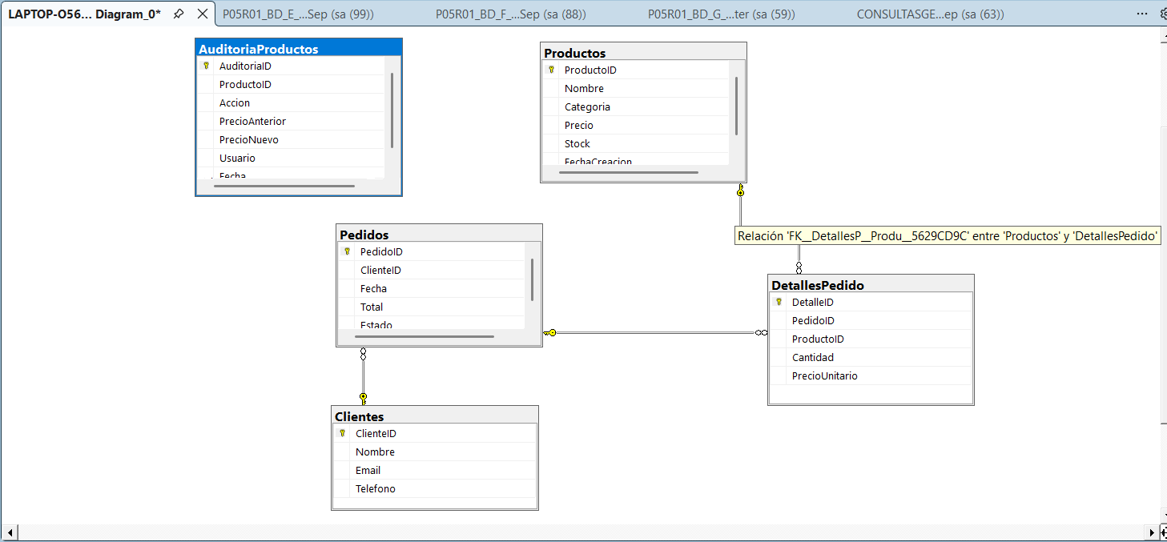
Frontend: No aplica
Backend: No aplica

Control de versiones:
Autor | Revisor | Aprobador | Fecha | Versión
Adrián Eleuterio Hernández Martínez |  |  |  | 1.0

