**Program Studi D4 Teknik Informatika**

**PEMROGRAMAN 4**



TUGAS SHARED PREFERENCE

**Adrian Firman Subianto**

**714242004**

**PROGRAM STUDI DIV TEKNIK INFORMATIKA**

**UNIVERSITAS LOGISTIK & BISNIS INTERNASIONAL**

**BANDUNG**

**2025**

1. 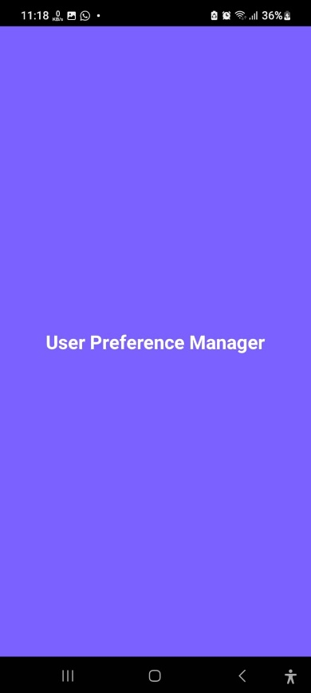**Splash Screen**
2. **Login**

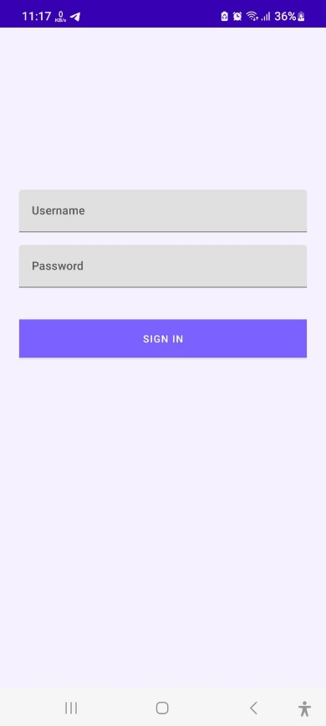

1. **Main**

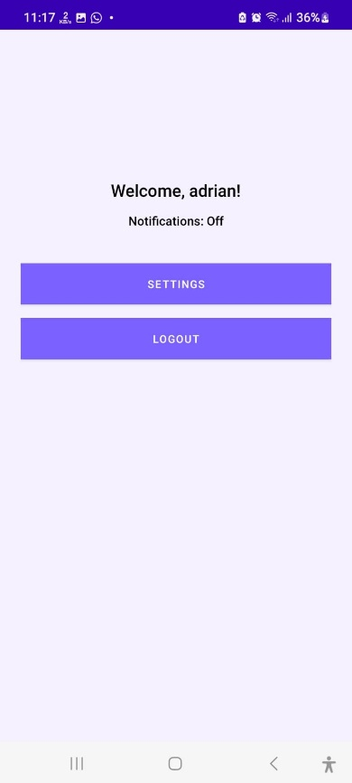

1. **Setting**

