**Wireless Waiter**

**Software Design Document**

**Revision History**

|  |  |  |  |
| --- | --- | --- | --- |
| **Date** | **Version** | **Description** | **Author(s)** |
| 17/04/16 | 1.0 | Initial Requirements Model  Preliminary Analysis & Design Model | Ronald Pai  Aleks Samardzija |
| 20/04/16 | 2.0 | Complete 1 Requirements Model  Initial Analysis & Design Model  Preliminary Implementation Model | Ronald Pai  Aleks Samardzija |

**Table of Contents**

1.0 Introduction

1.1 Document Purpose

1.2 Product Scope

1.3 Glossary (Definitions, Acronyms, and Abbreviations)

1.4 References

2.0 Overall Description

2.1 Product Functionality

2.2 End Users and Characteristics

2.3 System Stakeholders

2.4 Operating Environment

1. Specific Requirements
   1. User Interface
   2. Functional Requirements
   3. Use Case Diagram

3.3.1 Actors

3.3.2 Use-Cases

3.3.3 Use-Case Risk List

3.4 System Interfaces

3.4.1 Hardware Interfaces

3.4.2 Software Interfaces

3.4.3 Communications Interfaces

1. Non-functional Requirements
2. Architectural Representation
3. Architecture Development
   1. Classes/Objects
   2. Class Risk List
   3. Event Flow/Class Modeling
   4. Dynamic (State Chart) Modeling of Classes (optional)
      1. State Chart Model of Class 2
      2. State Chart Model of Class 5
4. System Class Diagram (Including most important attributes & methods)

____________________________________________________________________________________________________________

**- COMPLETE-1 REQUIREMENTS MODELLING –**

**1.0 Introduction**

## Document Purpose

The purpose of this document is to collect, analyze, and define high-level needs and features of the Wireless Waiter System. It focuses on bringing a steam lined approach to ordering form a food establishment. The needs of the system are outlined in the use case specifications.

## Product Scope

## Wireless Waiter will allow a customer to connect to a restaurant’s local server simply by connecting to its Wi-Fi with a mobile device. Once connected, an ordering screen will appear on the customer’s mobile device which will allow them to place an order. Payment can be done through PayPal or another online payment service. The customer will receive an order number and their mobile device’s MAC address will be saved. This will allow the restaurant to save customer information such as previous order.

## Definitions, Acronyms and Abbreviations

## 1.3a) POS: Point of Sale

## 1.3b) Wi-Fi: Is a wireless local area network that links two or more devices using a wireless distribution method

1.3c) User: The person who bought and is using the product for their business

1.3d) Customer: The person who the user will be servicing

1.3e) LAN: Local area network

1.3f) Restaurant: The client for our software

## References and Acknowledgments

1.4a) Fast food ordering times getting longer: <http://www.usatoday.com/story/money/business/2014/10/06/fast-food-drive-thru-times-restaurants-mcdonalds-taco-bell-wendys/16644673/>

1.4b) Wikipedia Wi-Fi definition:

<http://en.wikipedia.org/wiki/Wirless_LAN>

1. **Overall Description**

## 2.1 Product Functionality

## *2.1.1 POS Over LAN Using Customer’s Mobile Device*

The customer’s order will be placed through their mobile device by connecting to the restaurant’s Wi-Fi and sent directly to the restaurant’s local server over a LAN connection.

## *2.1.2 MAC Address Database*

The Wireless Waiter has a database that stores all devices that connect to the Wi-Fi. The database has a timer so devices can only connect to the Wi-Fi for a 24-hour period of time per sale. Repeat customers will have their orders saved for ease of ordering upon return.

## *2.1.3 Local Web Page Interface*

A local web page will appear on a guest’s mobile device upon connecting to the restaurant’s Wi-Fi. From this page, the guest will be able to order any item from the menu as if they were ordering from an employee.

## 2.2 End Users and Characteristics

*2.2.1 Employee*

The employee is the person using the POS of the system, who can fulfill the customer’s order.

*2.2.2 Customer*

The customer can order from the locally hosted website and pay for their orders. Then they are allowed to use the Wi-Fi.

*2.2.3 Online Banking System (PayPal)*

The online banking system allows the customer to pay for their orders using their credit card or debit card.

## System Stakeholders

*2.3.1 Employee*

The employee is able to see the customer’s orders and authenticate their use of the wireless network.

*2.3.2 Customer*

The customer will be able to use the system to order items on the menu and pay.

*2.3.3 Wireless Waiter System*

The system must be able to remember customer information and allow them to use the network as long as they have ordered already.

*2.3.4 Online Banking System (PayPal)*

The customer must pay through the online banking system before they are able to proceed to the Wi-Fi.

## Operating Environment

The hardware (the router) requires a computer to connect to and a modem for Internet connection. The computer that the software will need to run must be of Windows 7 or higher. It must also have a web browser and Internet capabilities. The electronic devices that will connect to the Wi-Fi that the router produce, it must have wireless adapter capabilities with drivers being up to date. The device must also have a web browser installed so it can view the menu.

1. **Specific Requirements**

## User Interface

3.1a) The customer connects to the business’s hotspot, and the business’s local web page is loaded onto the customer’s device.

3.1b) The customer orders from the menu screen by selecting a product. Once the customer’s selection is complete, they press the pay button. It will redirect them to a PayPal service if they pay with credit card or they can press the cash button and pay directly to an employee. If they select the PayPal, the user will enter in their credit card information or login to their PayPal account.

3.1c) The customer will be redirected to a terms and conditions page after their payment is complete. Then the user will be authenticated for the Wi-Fi.

3.1d) The employee can see a queue of customer orders on the employee page.

## Functional Requirements

3.2a) The customer shall be able to connect to the hotspot from their mobile or Wi-Fi capable electronic devices.

3.2b) The Wireless Waiter System shall redirect the customer to the purchase page.

3.2c) The customer should be able to make a purchase from the purchase page.

3.2d) The customer should be able to make payment using PayPal.

3.2e) The Wireless Waiter System shall authenticate the customer after the order has been placed and the payment transaction is completed.

3.2f) The customer shall be connected to the Internet after payment and authentication.

3.2g) The customer’s electronic device’s MAC address will be stored in the database and tied to their purchase order(s).

3.2h) The employee shall see a queue of orders on the employee’s page to be serviced and remove them as needed.

3.2i) The employee should be able to remove orders from the employee’s page once the order has been fulfilled.

## Use Case Diagram

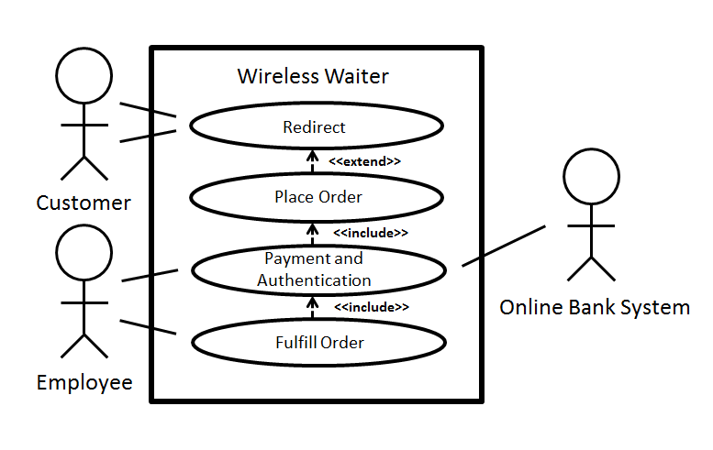

*3.3.1 Actors*

* Customer - a person entering the restaurant planning on using the Wireless Waiter system to place their order and gain Wi-Fi access.
* Employee - a person who triggers authentication for Wi-Fi access for customers and fulfill orders.
* Online Bank System (PayPal) - an online banking system that accepts payment and triggers authentication for Wi-Fi access.

*3.3.2 Use Cases*

* Redirect - redirect the customer from any webpage to the locally hosted webpage
* Place order - allow the customer to order anything from the locally hosted webpage
* Authenticate - the employee is able to authenticate the orders placed. It also directs all payments to PayPal
* Fulfill Order - the employee is able to fulfill any orders place by the customer and delete orders completed

1. **Non-Functional Requirements**

## Software Quality Attributes

4.1a) The customer’s credit card information will be held secure through the use of PayPal’s secure payment software and no employees will have access to the information.

4.1b) The program will be able to always run with a load time of no more than 5 seconds during the ordering process by the customer.

4.1c) The software will be able to handle 200 customers at once while still maintaining the previously established load times.

4.1d) The customer’s name will be discarded once their order has been completed to protect their privacy.

4.1e) The software will only use MAC addresses to keep track of repeat customers.

4.1f) The software will be available to menu updates on the fly to better reflect the restaurant’s current offerings and potential shortages.

4.1g) The system will run on Windows 7 or later machines only upon initial launch.

4.1h) The system will have an easy to use interface for the user with clear images and buttons to improve navigation.

-----------------------------------------------------------------------------------------------------------------------------------

**- INITIAL ANALYSIS & DESIGN MODELLING -**

1. **Architectural Representation**

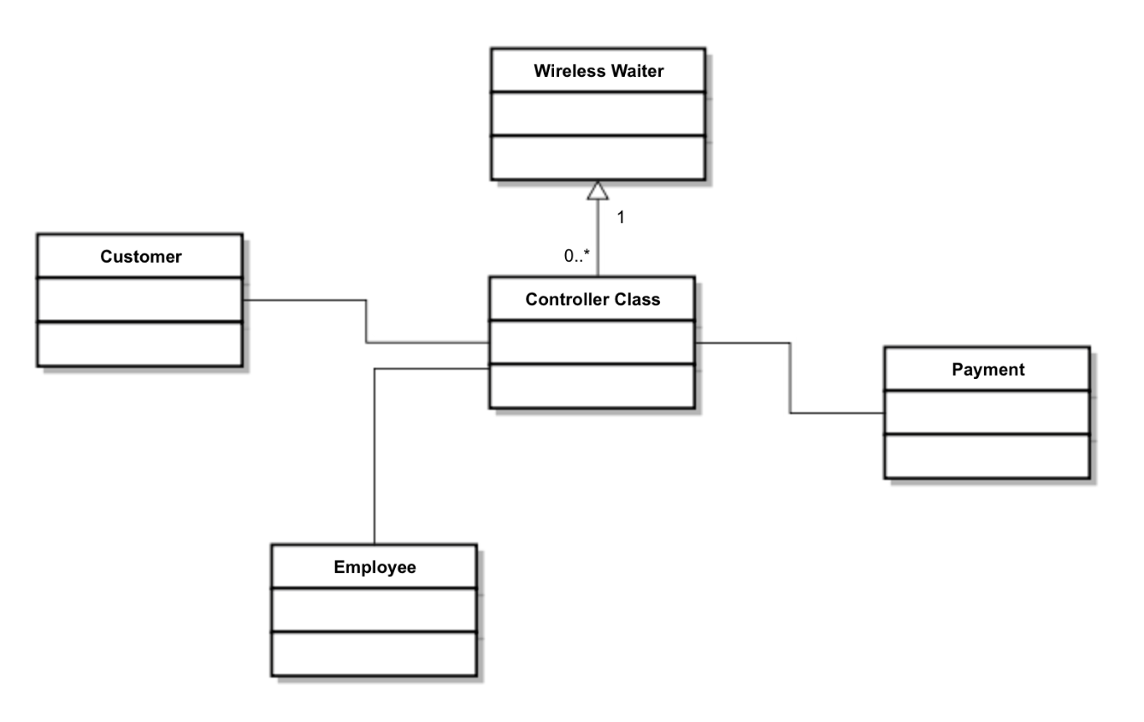

1. **Architecture Development**
   1. **Classes/Objects**

Wireless Waiter:

Class1: Controller Class, the system that allows the customer to connect to the internet, help process payments, and contains a list of all orders.

Class2: Customer, contains individual customer information and lets them place orders and connect to the hotspot.

Class3: Employee, contain employee information and process orders from customers.

Class4: Payment, process the payment made by customer.

* 1. **Class Risk List**

High: Controller Class

Medium: Customer, Employee

Low: Payment

* 1. **Event Flow/Class Modeling**
     1. *Scenario:*

Customer walks into a restaurant and attempts to connect to their Wi-Fi. Instead, he/she is redirected to the ordering screen. Upon placing the order and providing payment, the customer will be allowed to connect to the internet as the employees work on completing the order.

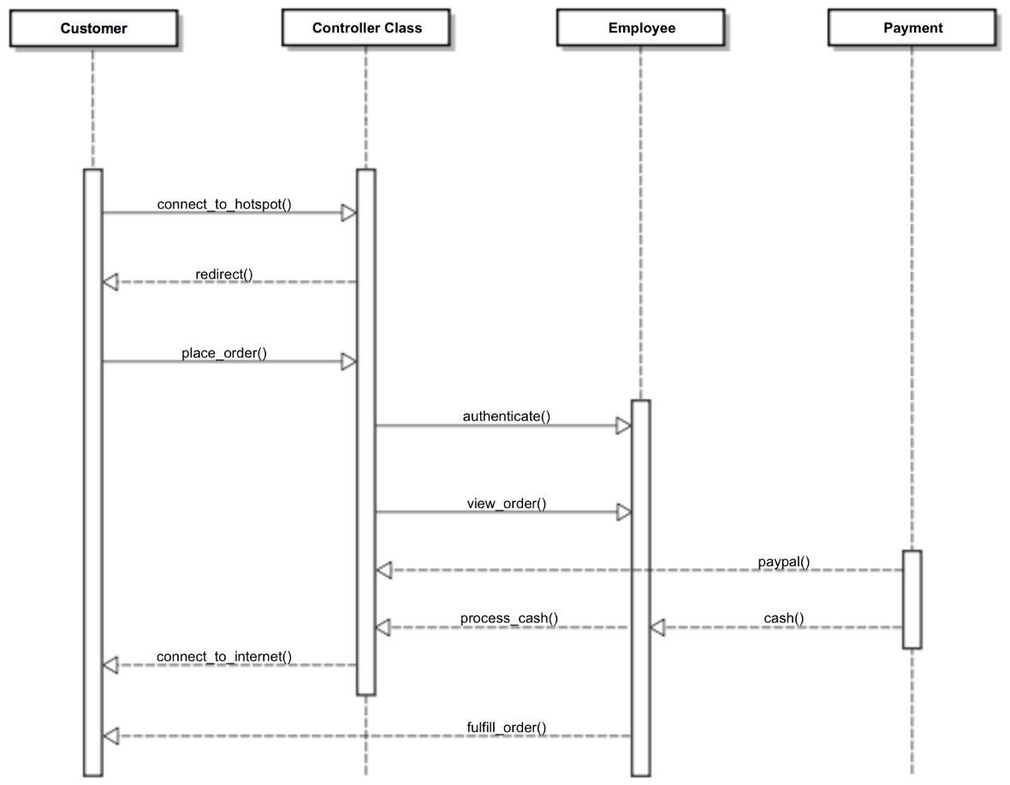

1. **System Class Diagram (Including most important attributes & methods)**

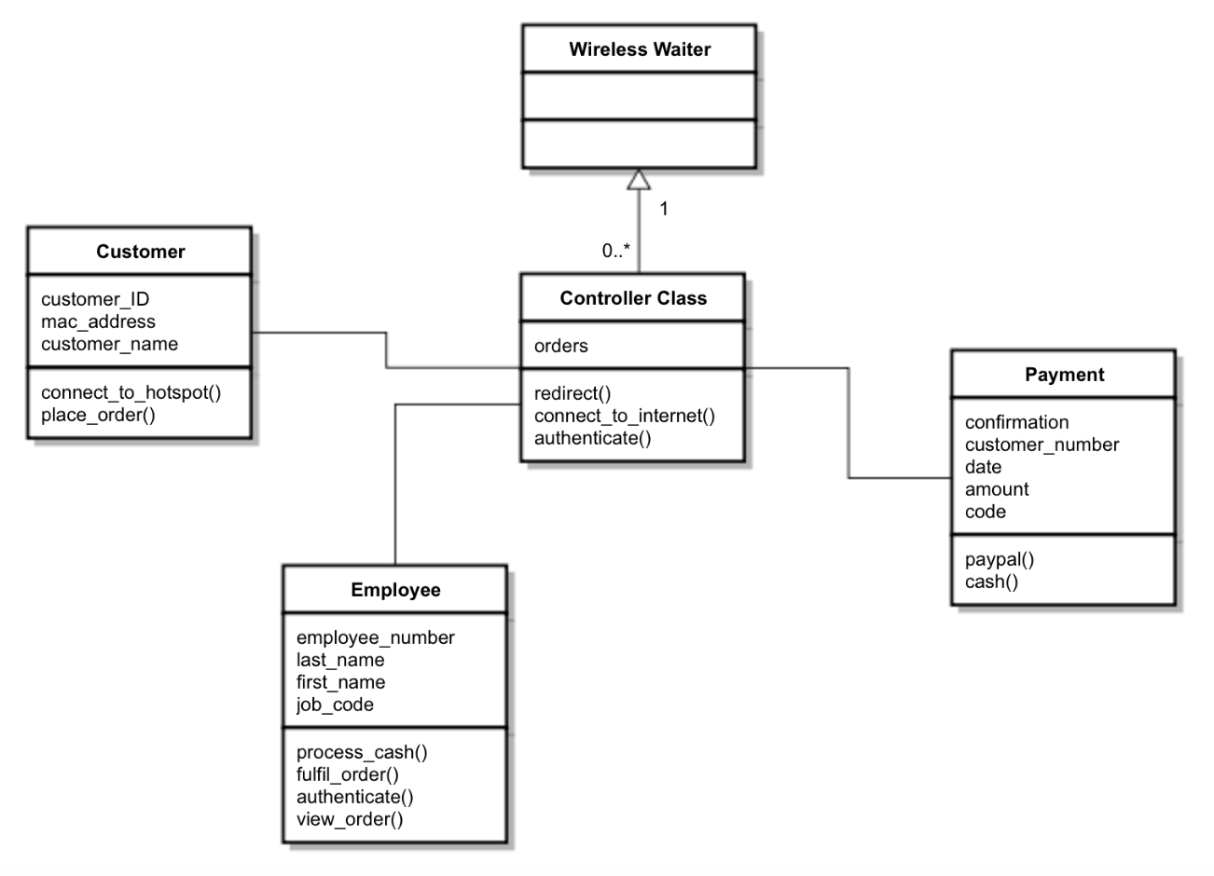

**Appendix A – Group Log**

A.1) Group Meetings

* + Monday, April 4th, 2016
    - 2 hours
  + Sunday, March 13th, 2016
    - 2 hours
  + Monday, March 18th, 2016
    - 3 hours

A.2) Brainstorming/Communication

* + Group texts and emails