DSA HW#2 B03901023 許秉鈞

**2.2 Arrays, Linked List, and Recursion**

(2) (10%) A lower triangular matrix *A* is a matrix with *A*[*i*][*j*] = 0 whenever *i < j*. Describe how  
you can store *A* with a dense one-dimensional array without wasting space on the entries with  
value 0 at the upper triangular part. You need to describe the memory layout and the function for  
getting/putting values from/to the matrix.

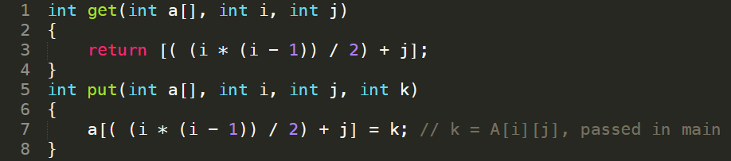

(3) (10%) Do Exercise C-3.22 of the textbook.

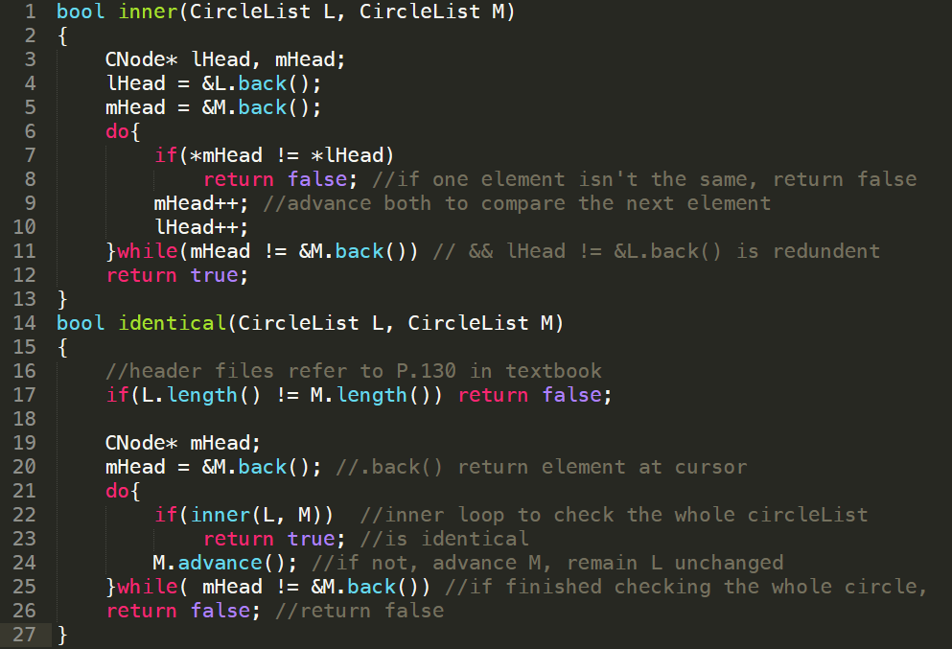

(4) (10%) Do Exercise C-3.18 of the textbook using either C/C++ or pseudo code.  
(5) (Bonus 10%) Do Exercise C-3.18 of the textbook, but use **one single loop** instead of recursion.

