Design of an IEEE 802.11ac Network for the Teleoperation of an LHD Vehicle in Underground Mining Galleries | Adrián Álvaro López Pascual  Telecommunications Engineering  a.lopezp@pucp.edu.pe | Advisor: Dr. Pastor David Chávez Muñoz

Abstract
Manual operation of load-haul-dump (LHD) vehicles in underground mining exposes operators to rockfalls, gases and moving machinery. This work designs and validates through simulation an IEEE 802.11ac network that enables teleoperation of an LHD from a safe control room, carrying real-time video, control commands and telemetry. Over the real geometry of level NV1640 at the Nexa Cerro Lindo mine, a fiber-optic ring backbone and a 12-node access mesh with WMM prioritization are dimensioned; propagation follows a two-slope tunnel model calibrated against a TamoGraph site survey, and performance is validated in ns-3. Every KPI is met with margin across ten independent runs.
Keywords
Teleoperation, IEEE 802.11ac, underground mining, quality of service, network simulation.
- Introduction
In 2024, 12 of the 14 fatal mining accidents reported by the Peruvian regulator OSINERGMIN — and 13 of their 15 victims — occurred underground. Teleoperation removes the operator from the production front, but demands a network that sustains real-time driving video, low-latency commands and continuous telemetry inside confined galleries with junctions, reflections and a moving on-board node. The case study is level NV1640 of the Nexa Cerro Lindo mine (El Teniente block-caving layout).
- Background
A systematic review (Kitchenham method) compared communication technologies for tunnels and mines: LPWAN/WSN lack video capability, private LTE/5G adds complexity and cost, and optical links are alignment-sensitive. Industrial IEEE 802.11ac provides the required capacity, mining-grade equipment and standard WMM traffic prioritization.
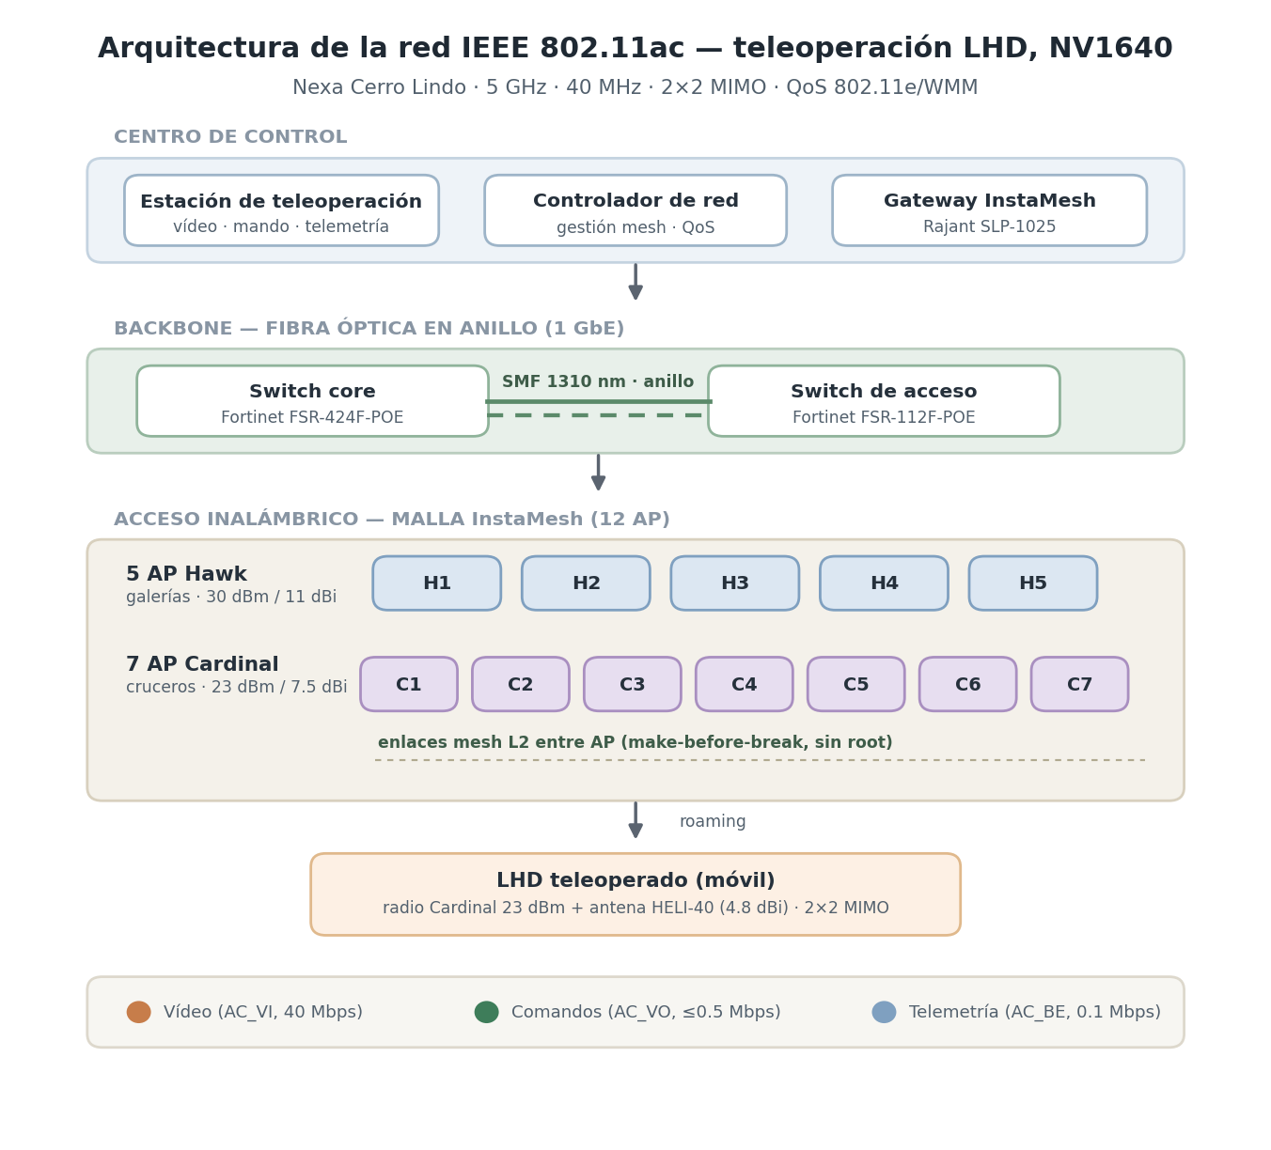Figure 1. Network architecture and QoS classes.
- Objectives
- Characterize the tunnel propagation channel and design the physical and logical network architecture.
- Dimension the radio and antenna subsystem and define the QoS and mobility policies.
- Validate end-to-end performance by packet-level simulation and assess technical-economic feasibility.

- Methods
The work applies the Design Thinking methodology of TEL143/TEL147: empathize with the operator's risk, define requirements and KPIs, ideate and compare technologies, prototype in ns-3 over the real NV1640 geometry, and test against the site survey. The network combines a fiber-optic ring backbone with a 12-node access mesh (five 30-dBm Hawk and seven 23-dBm Cardinal APs); the LHD carries an on-board radio with a HELI-40 antenna. Eighteen 300-s simulations cover ten operation seeds, a baseline, stress and handover scenarios.
- Results
- Command one-way delay: 3.04 ± 0.26 ms (≤ 20 ms); control-loop RTT: 6.12 ms (≤ 40 ms).
- Video end-to-end latency: 35.9 ± 0.3 ms (≤ 150 ms); goodput 40 Mbps (≥ 38 Mbps).
- Video jitter P95: 0.28 ms (≤ 10 ms); packet loss: 0.01 % (≤ 1 %).
- Availability: 100 % (≥ 99.9 %); handover interruption: 0.88 ms (≤ 150 ms).
- All KPIs met in 10 of 10 seeds; margins hold under 50-Mbps video and 4-m/s stress.

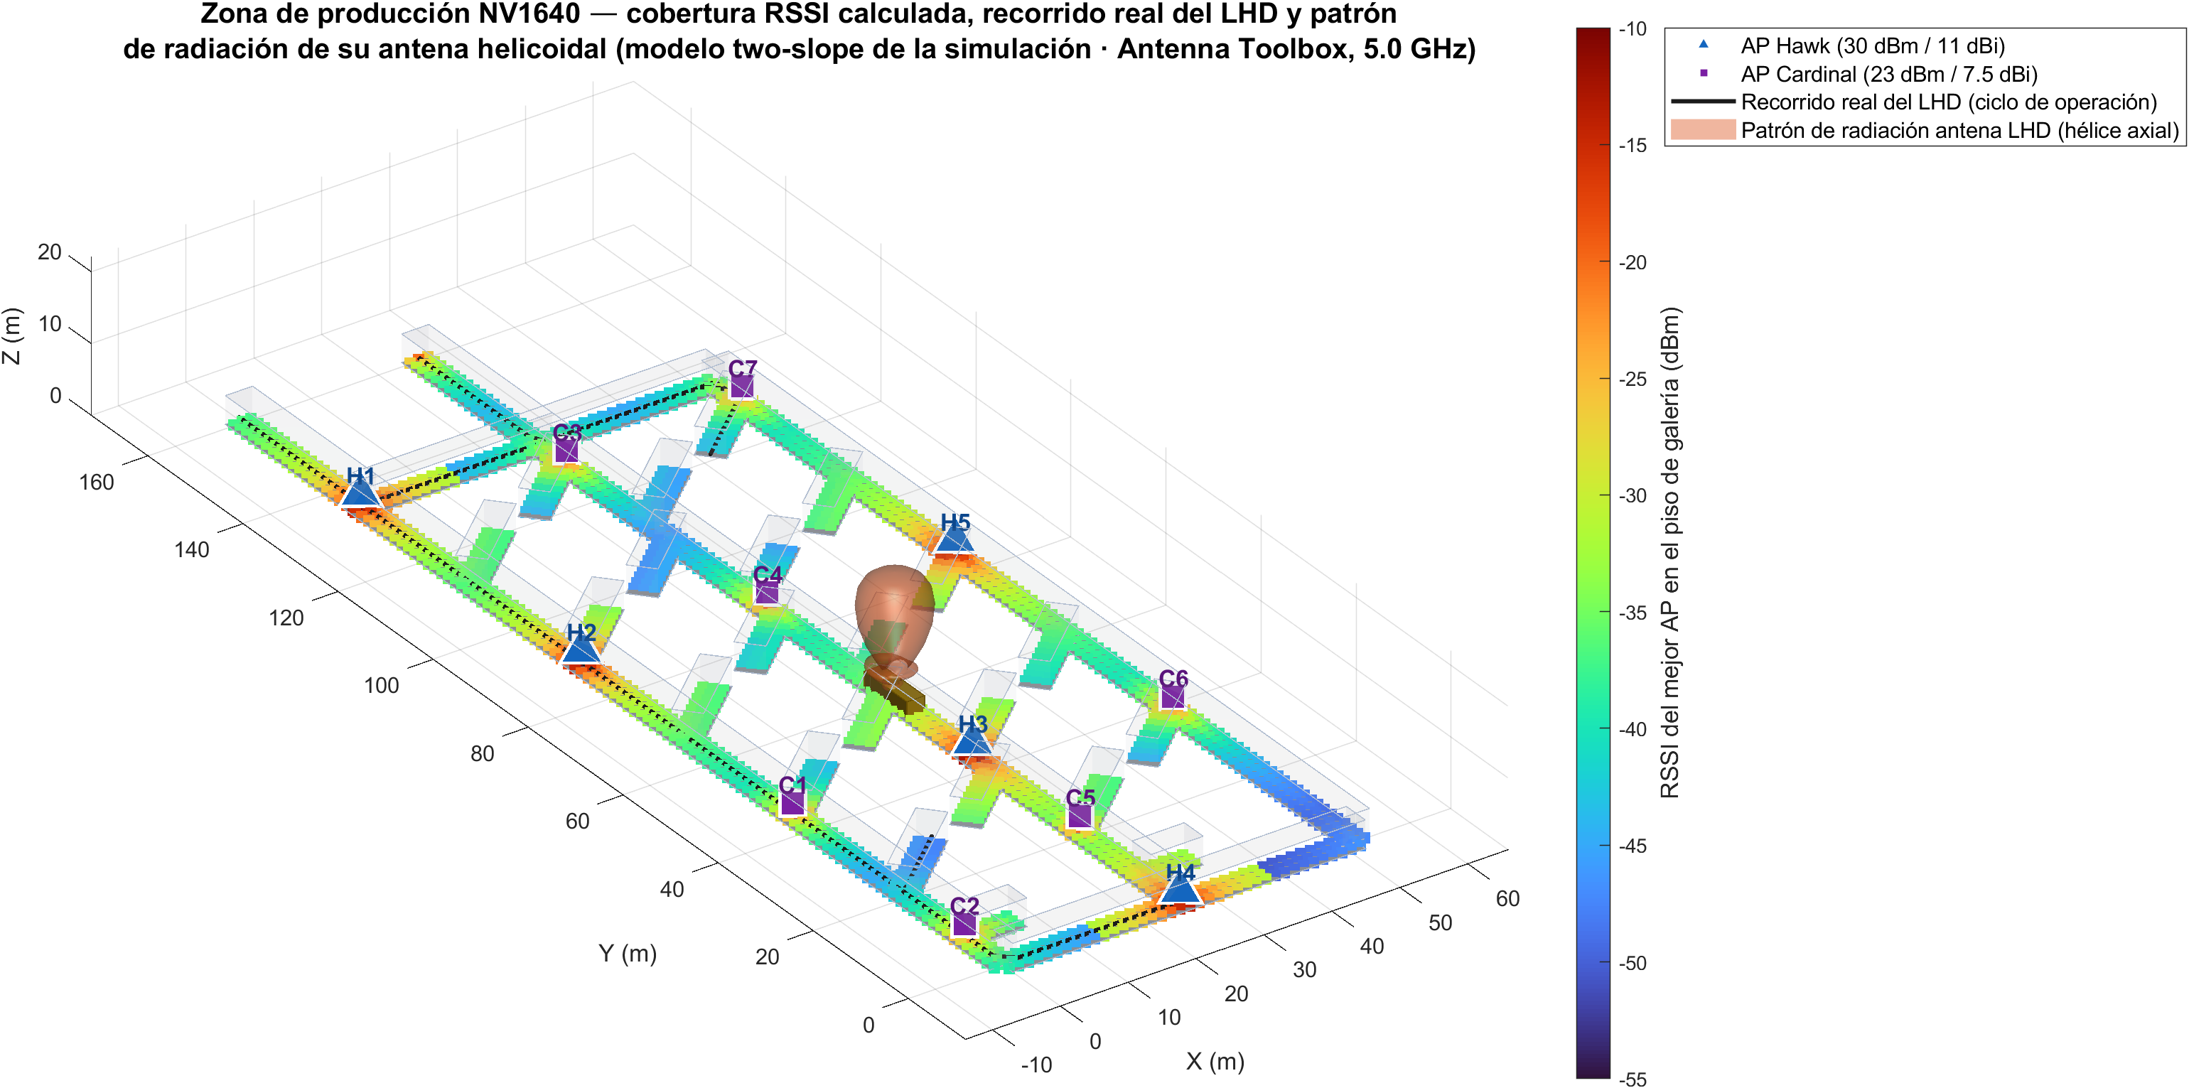 Figure 2. Level NV1640 in 3D: galleries, the 12 APs and the LHD antenna pattern.
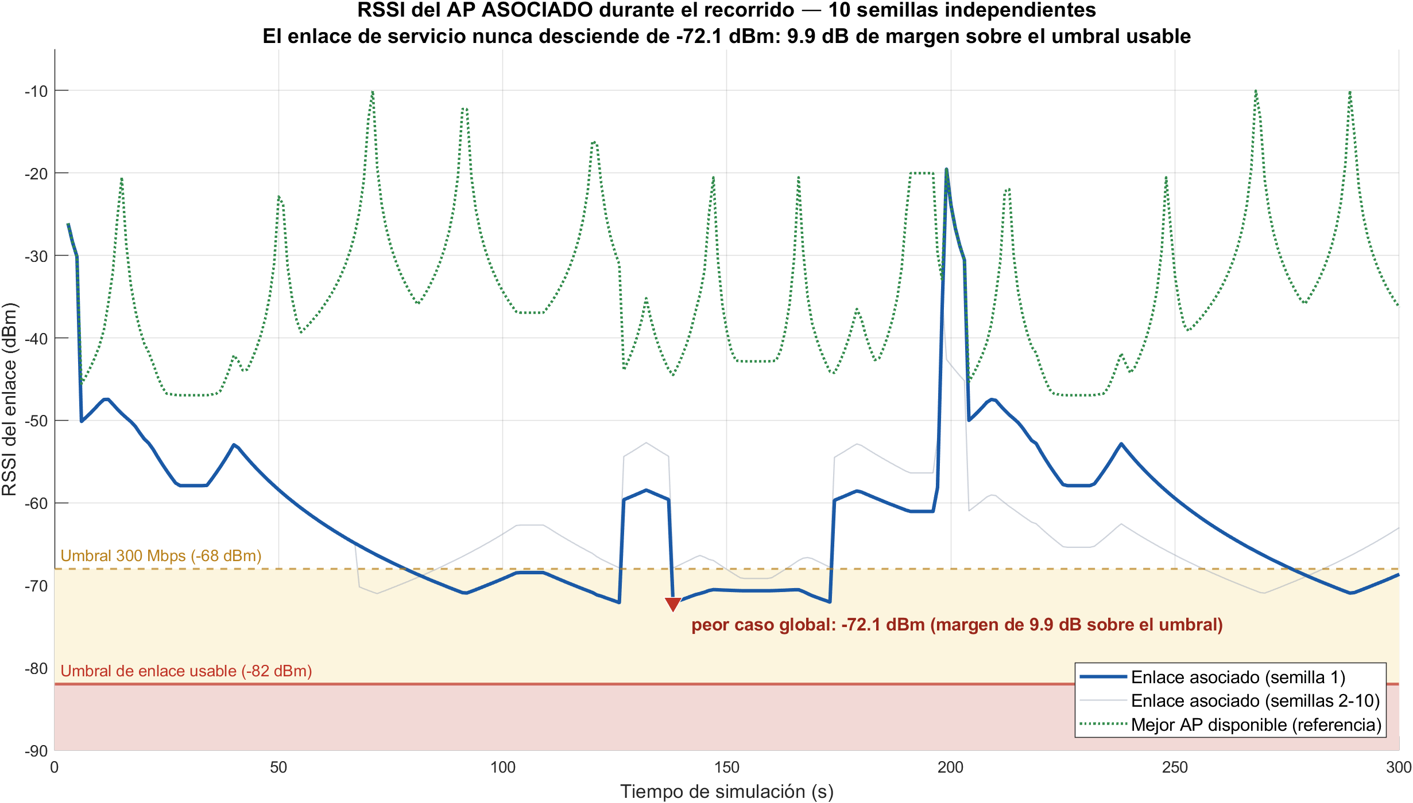 Figure 3. Serving-link RSSI: never below −72.1 dBm.
- Discussion
The design favors stable make-before-break roaming over chasing the nearest AP, avoiding reassociation micro-outages. Stress scenarios still meet every criterion, evidencing dimensioning margin. The deterministic, conservative model means real industrial mesh equipment can only improve these figures; field trials are identified as future work.
- Conclusions
- The network meets every teleoperation KPI on the real NV1640 geometry, with statistical support.
- The solution is economically incremental and complies with Peruvian regulation (license-free 5 GHz band; mining safety code).
- Removing the operator from the hazard zone is a direct, replicable safety contribution for Peruvian mining.
- Acknowledgments
To my advisor, Dr. Pastor David Chávez Muñoz, and to PUCP's Telecommunications Engineering program.
- References
- Z. Sun, I. F. Akyildiz, "Channel modeling for wireless networks in tunnels," 2010.  - Rajant Corp., "InstaMesh white paper," 2015. | - E. Egea-López et al., "Wireless comms. in underground mines," 2019.  - ns-3 Consortium, "ns-3.40 documentation," 2024.

