Implementing a generic Attribute Domain Validation model (draft).

Introduction
In almost every database application ever designed and built there has been a requirement to hold and maintain Attribute Value Constraints (a.k.a. Domain Values, Enumerated Values, Reference Codes etc.) that define the valid values that are allowed for a particular Attribute.
In it’s simplest form (as generated by many CASE packages such as Oracle Designer) this is simply a lookup table with the following structure:
Attribute | Data Type | Null | Definition
#Domain Name | String | No
#Domain Value | String | No
Meaning | String | No | A free text description
However, in all but the most trivial cases, this is a simplistic implementation and has the following limitations:
- It only supports validation of defined values for a Domain but does not support validation of generic characteristics of the Domain such as “Uppercase String” or “Integer between 1 and 5”.
- It assumes that any existing entry in the Domain is always, and has always been, valid whereas most databases store and maintain data over time and different Domain Values may be valid in the Domain at different points in time.
- Does not handle Values that are common across Attributes in multiple Entities.
- Does not deal with sub-sets of Attribute Values being valid for Sub-Types of an Entity and the dependencies of the Entity sub-types.
- Does not handle Attribute Synonyms i.e. where the Attribute has a different name in different application data models.
The purpose of this article is to discuss the various functional enhancements that can be made to the basic model to overcome the above limitations and develop a generic data model to support those requirements.

Benefits of a Generic Model
Once in place and populated as part of the development process the information recorded in a robust and maintainable Domain Validation data model has numerous uses, some of which are:
- Provides a generic “List of Values” functionality for any column populated via an interactive User Interface.
This is so common that I hope that the benefits are already really obvious.
- Automatic generation of User Defined Type (UDT) Classes (for those that really like Objects).
Once the metadata for a UDT is defined in a consistent format it is very easy to create a code-generator to interpret the data and generate the necessary structures and validation code required for the language. (I’ve already done PL/SQL, C, C++ and Java generators).
In my experience about 50% of the information stored in most databases is done using some sort of Domain Validation so being able to quickly generate all these Base Classes in whatever language we require (e.g. Java front-end, C++ back-end, C bulk loading programs) is a real benefit.
This is one of the reasons that I prefer data modelling tools that are implemented using an public database repository (such as Oracle Designer) rather than a private repository (such as CaseWise) because if I can get at the underlying repository it should be easy to extract the required information to populate most of the Domain information once the data model is signed off.
- Reduced time for testing.
If data validation is being implemented in the code rather than the database (the infamous “Design by Contract” paradigm which I really hate) then I’ve found that it helps the Testing people immensely if I generate (Pre-Event) Check Triggers to check that the implementation matches the specification.
Can also generate test cases very quickly as it is just a case of finding an Attribute Value that is allowed and another one that is not allowed for each Attribute.
- As less procedural code needs to be created this should reduce the time required to implement the Application Data Model.
All UDT classes / libraries / components / “whatever we’re using” are effectively skeleton definitions with constructor / mutation functions implemented as calls to a generic check_value() function (ideally a database function).
This way we almost guarantee a consistent implementation across the entire application.
- Provides flexibility in iterative development because new Domain Values can simply be inserted into the database i.e. from the analysis it is sufficient to know that the Attribute will be validated without caring what the actual values are.

Defining the Extended Model

Domain validation
There are two types of Domain validation that may be required in an application:
Checking that an enumerated or code value assigned to a Domain is an allowed value for that Domain. This is the functionality provided by the Lookup table described above.
Secondly we have Data Type Constraints checking that the value being assigned to an Attribute is of the correct datatype (e.g. “Employee Surname” is String, “Date of Birth” is Date, “Number of Children” is Integer), in the correct format (e.g. “Employee Surname” is Alphabetic or “Address Postcode” is Uppercase, “Product Code” format is “999-9-XXX”) or is within a valid range of values (e.g. “Number of Children” between 0 and 10).
This type of validation is normally performed by creating a User Defined Datatype (UDT) which is perfectly acceptable in a “closed” database application where the developed programs are the only method of manipulating the data.
However in large scale systems where many different applications may be sharing sub-sets of the data and different programming languages are used to perform different functions (e.g. Java for the GUI, C for large volume back-end feeds, stored procedures for replication, an ETL package for Data Warehouse loading etc.) the use of a single UDT may not be compatible across the entire user community.
Having this information in a central user maintainable place, that is the database, and using the information appropriately (a good idea with any information system!) resolves many of the incompatibility problems.
In addition, even if we restrict the model to only performing Domain Value Validation we still need a sub-set of the datatype constraints in order to ensure that the codes we are maintaining conform to the characteristics of the Domain they will be assigned to.
Satisfying this requirement is done by adding a new Domain entity as a parent of the Domain Value entity (Diagram 1).

Diagram 1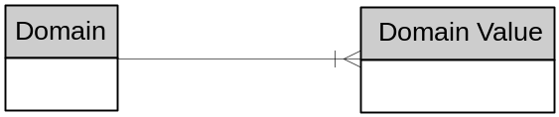 – Addition of Domain
At this point, it was tempting to introduce sub-types on the Domain entity based on the underlying datatype of the Domain (e.g. “String Domain”, “Numeric Domain” etc.) to describe the characteristics of the Domain which would have been the rigorous and correct way of implementing a Domain. However because we are discussing Domain Values validation and are discussing usage rather than maintenance of Domain Values, I decided to leave the issue of Domain sub-typing until later.
The essential attributes of the Domain entity are:
Attribute | Data Type | Null | Definition
#Domain Name | String | No | The Name of the Domain for which we are recording Domain Values.
The other attributes of the new Domain Entity are purely dependent on the characteristics that will be validated. The most common characteristics are:
Attribute | Data Type | Null | Definition
Data Type | String |  | The primitive data type that the domain is based on such as String, Number, Date.
Data Length | Number
Data Precision | Number
Uppercase | String
Minimum Value | Number
Maximum Value | Number
Format | String
However the scope of the data model, at the moment, is providing the ability to validate a known Domain Value against a Domain rather than maintaining the Domain Values.
Once we get on to the issue of data maintenance we will return to the task of defining the attributes required for maintenance.

Multiple Attributes sharing a Domain
<Put something in here>
The following model fragment illustrates this:
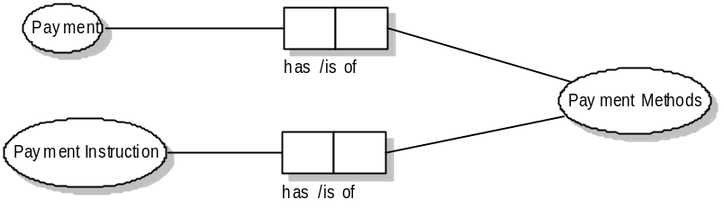
In an ideal world (usually a virgin development) it is good practice to ensure that the same attribute name is used consistently throughout the model that is, in our example, both Payment and Payment Instruction would have an attribute named Payment Method and, therefore, it is very obvious that the Payment Method Domain is used to validate the contents of both Payment Method Attributes.
However in many large scale applications, especially ones that are initially created by integrating two or more existing systems, consistent attribute naming across the entire application is very unlikely to have happened.
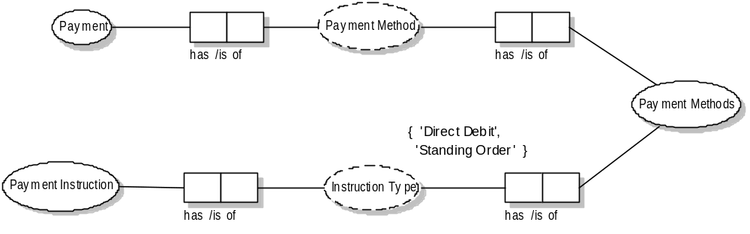
For example, in our model fragment, Payment may already be defined in a Purchase Ledger application and Payment Instruction (a mandate to take payments as and when required) may already be defined in a Customer Management application. Combining the two parts together and we have the situation shown below where two attribute with different names are validated against a single Domain.:
Consequently we now have the case where we need to separate the Attributes from the Domains they are validated against. To resolve this requirement we need to add an Attribute entity, relating many Attributes to a single Domain, into our model.

Diagram 2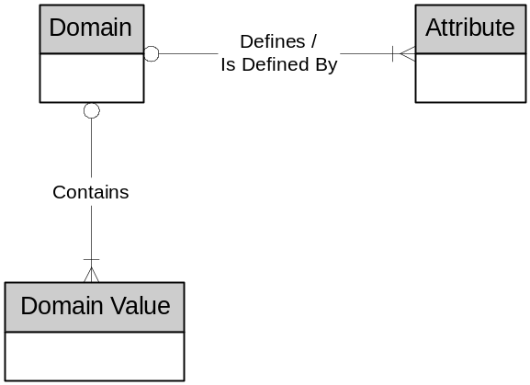 – Addition of Attribute
The essential attributes of the Attribute entity are:
Attribute | Data Type | Null | Description
#Entity Name | String | No
#Attribute Name | String | No
Domain Name | String | No | Reference to the Domain that this Attribute is referenced against.

Synonyms
Nowadays with stateless, message based applications and geographically distributed development teams becoming more popular it is possible to develop any application without knowing the name of the persistent Attribute that a value will be stored in. Instead all the application programmer has access to is the Screen Name / Field Name the data will be maintained through or a Message Name / Field Name used to pass the data across the front-end / back-end interface..
Consequently because we have an additional level of data hiding it is necessary to be able to refer to an Attribute by many different names.
To implement this we simply require a Synonym entity to hold the alternative names that an Attribute may be known by.

Diagram 3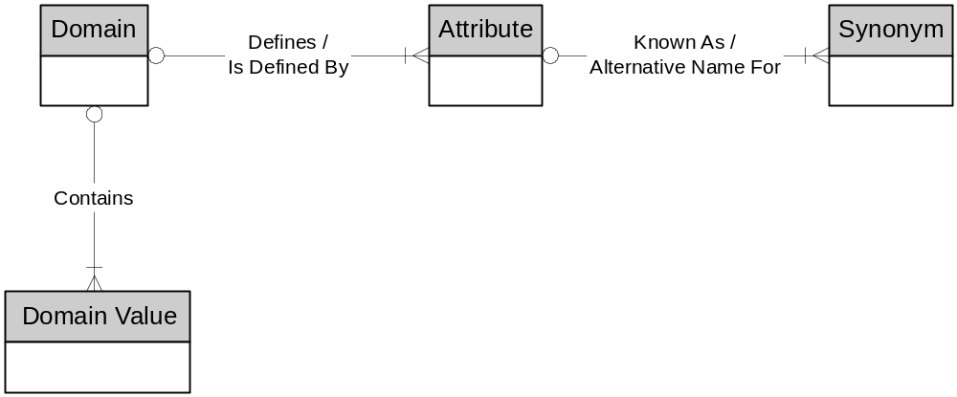 – Addition of Synonym
This does of course assume that a particular screen field consistently displays the same list of values and is not overloaded to map to different persistent Attributes during the same transaction.
The essential attributes of the Synonym entity are:
Attribute | Data Type | Null | Description
#Entity Name | String | No
#Attribute Name | String | No
#Alternative Entity Name | String | No
#Alternative Entity Name | String | No
No other attributes are required because, as it is an alternative name for an Attribute, the Synonym should inherit all it’s characteristics and allowed values from the Attribute it is linked to.

Sub-Domains or Sub-Sets (Collections)
We have two possible ways of groups Domain Values together into Sub-Domains
- Non-Overlapping
- Overlapping
In practice, particularly in the area of super-types and sub-types, it is common for an Attribute to only allow certain Domain Values depending on the sub-type but each sub-type may allow Domain Values common to other sub-types.
For example if we recorded Payment Method (with Domain Values of {Direct Debit, Standing Order, Cash} against a Payment and Payment had two sub-types of Manual Payment and Electronic Payment then it may be required to restrict Electronic Payment : Payment Method to {Direct Debit, Standing Order} and Manual Payment : Payment Method to {Cash}.
The question then is how to model groups of Domain Values using our basic Domain → Attribute structure.
The two choices we have are:
- Model an hierarchy of Domains at the Domain level
- Model groups of Values at the Attribute level

If we decided to implement a Domain hierarchy (and we maintain our restriction that a Domain Value is unique within a Domain then we need to create non-overlapping sub-domains with a potential sub-domain being required for each discrete intersection in the domain.
For two attributes the VENN diagram of the possible non-overlapping sub-domains is:
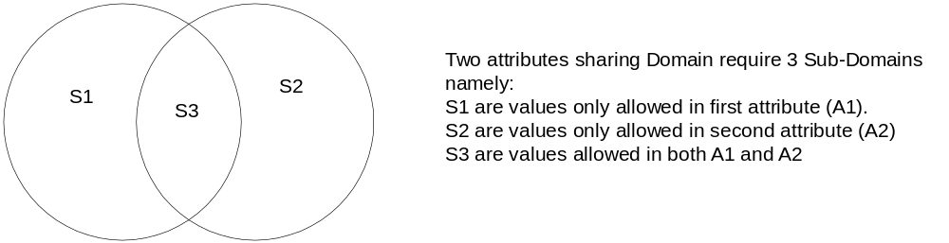When three Attributes share the Domain the diagram becomes:

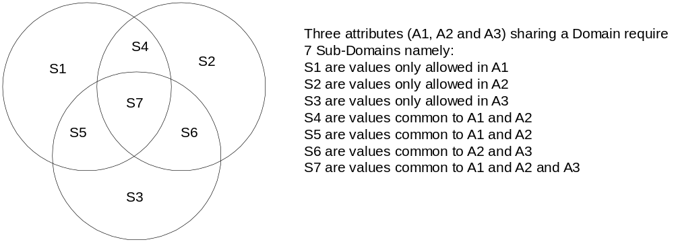Further progressive analysis of three, four, five … etc. attributes reveals that there is actually a exponential progression where the number of distinct Domains (D) required to exhaustively model all the sub-domain combinations for N distinct attributes sharing the Domain can be expressed as:
D = 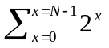 or D = 2^{N} - 1

In any complex data model we would almost certainly also have a super-type / sub-type hierarchy on at least one of our entities. An extreme (real-life) case of such an hierarchy is shown in Diagram 7.
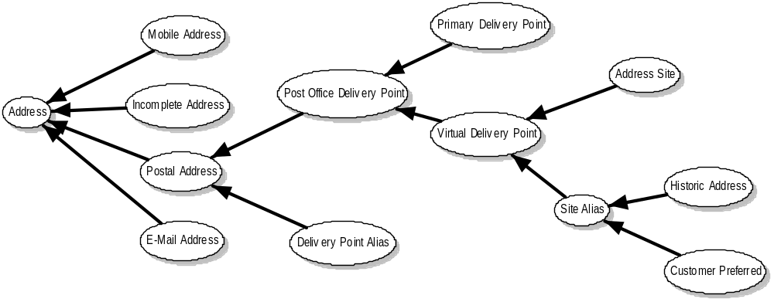
To fully exhaust all possible Sub-Domains for the above hierarchy we would potentially have to create a possible 255 Sub-Domains ordered into a six tier hierarchy. Admittedly this is an extreme example of a Sub-Type hierarchy but three and four tier hierarchies are not uncommon.
Consequently it is reasonable to say that implementing Sub-Domains is impractical and should not be included in the model. Instead the Domain structure should be a single level flat structure where each Domain contains all the values allowed for that Domain and there is no relationship between one Domain and another.
Instead we allow for the definition of discrete collections of Domain Values against an Attribute by adding an Attribute Value entity as follows:

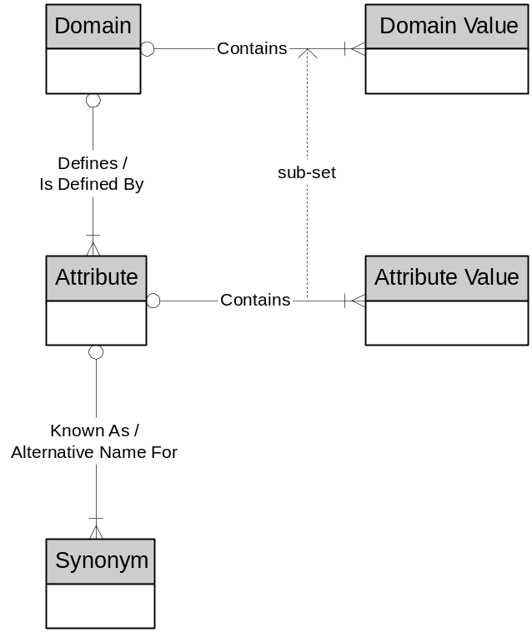Diagram 1 - Addition of Attribute Value
The main restriction of the Attribute → Attribute relationship is that an Attribute Value must be one of the Domain Values contained in the Domain that the Attribute is defined by.
Attribute | Data Type | Null | Description
#Entity Name | String | No
#Attribute Name | String | No
Domain value | String | No
No other attributes, such as Meaning, are required because these are inherited from the Domain Value attributes of the equivalent Domain Value.

Inclusion or Exclusion
Having now decided to model Domain sub-sets as Attribute Value sets we should also decide whether the Attribute Values should use an “included” or “excluded” syntax for restricting the Domain Value.
[More explanation here]

Super-Types and Sub-Types

Single Inheritancy
However the structure we have defined so far does not fully ensure the consistency of the Sub-Type hierarchy.
By definition a Sub-Type can only further restrict an inherited Attribute and never relax the constraints therefore it is a requirement of an inherited Attribute that it does not allow more Values than it’s immediate Super-Type equivalent allows:
For example given the following entity hierarchy:
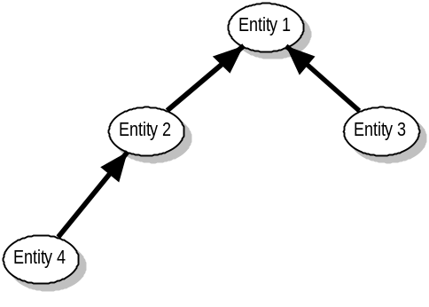If Entity 1 had a Status attribute then all of its Sub-Types would inherit that attribute and all the restrictions placed on that attribute so, for example, if Entity1:Status allowed {A,B,C.D} then Entity2.Status could not allow {E}, which is an illegal relaxation of the super-type constraint, but it could be further restricted to only allow {A,B,C} and exclude {D}.
The same applies to Entity4, the Status attribute would only be allowed to further restrict the values as defined for Entity2 and by inference Entity1, but as the hierarchy is recursive we only have to check the immediate Super-Type for allowed values.
Consequently in order to correctly validate an inherited Attribute we need to link Attributes together in a super-type / sub-type hierarchy.
We could place a recursive relationship on the Attribute entity to link many sub-type Attributes to the super-type Attribute they are based on. However, in the spirit of normalisation, the Attribute Name part of the Attribute primary key should be the consistent for all Attributes inherited within the type hierarchy. Consequently only the Super-Type Entity Name is required to identify the super-type Attribute and, in a single inheritance hierarchy where all occurrences of a particular sub-type Entity always have the same super-type Entity, the super-type / sub-type hierarchy can be keyed on the sub-type Entity Name.
This leads us to the introduction of an “Entity” entity into the model with a relationship to many Attributes link to one Entity and a recursive relationship on Entity linking many sub-type Entities to a single super-type Entity as shown below.

Data Model 4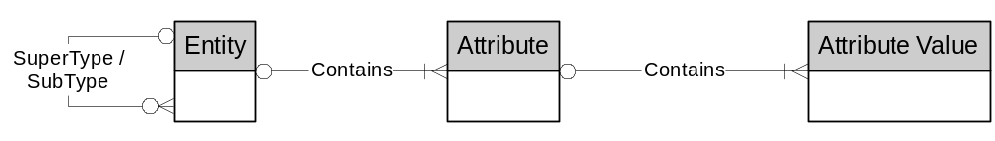 – Addition of Entity
The essential attributes of the “Entity” entity are:
Attribute | Data Type | Null | Description
#Entity Name | String | No
Supertype Entity Name | String | No
No other attributes are required

Multiple Inheritance
Having established that we need to add an “Entity” entity with a recursive relationship to link Super-Types to their Sub-Types to deal with single inheritance, we now need to consider the possible requirements for Attributes with multiple inheritance

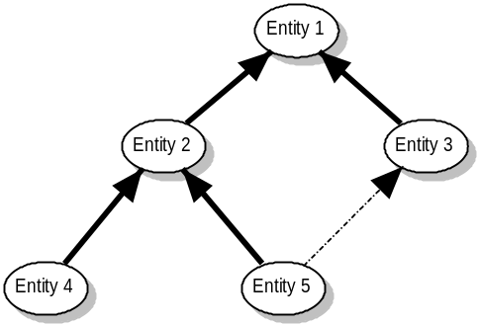In this case because a Sub-Type must be a instance of the Super-Type and Entity5 has two Super-Types then the allowed values for the Status attribute on Entity5 would be the intersection of the Status attributes for Entity2 and Entity3
That is, if Entity2 allowed {A,B,C} and Entity3 allowed {A,C,D} then Entitry5 could at most allow {A,C} in order to be a valid instance of both Super-Types, {B} is not allowed because although Entity5 would be a valid Entity2 it would not be a valid Entity3.
In addition this is the simple case of a single hierarchy with all Sub-Types sharing the same ultimate Super-Type. In the very rare case of two Sub-Types inheriting from two non-related Super-Types, as can happen with Object Orientated Design when designers get carried away with Abstract Classes, the problem becomes even more complex as we need to ensure that not only is the Value allowed for each of the Super-Types but also that the Value has the same meaning within the Domain of the Super-Types.
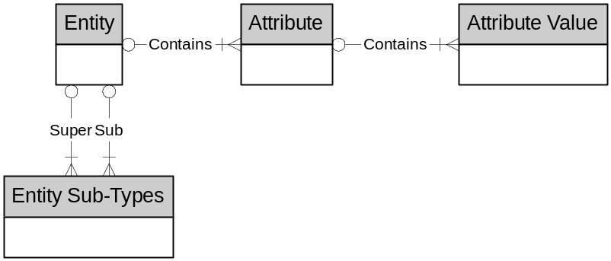At this point it is time to take a reality check on whether we actually want to support multiple inheritance for Attribute Value validation. Given that this is an implementation model rather than a conceptual design model because I don’t think we do! There are two reasons for this conclusion:
- Multiple inheritance of an Attribute is not that common in practice and is completely unknown in Physical Data Models as most DBMS’s do not support it.
- Most programming languages do not implement multiple inheritance, for example Jave, C, Cobol and VB have no support whatsoever for multiple inheritance.
Where a language, such as C++, does allow multiple inheritance this is usually implemented by specifying which of the possible Super-Types a particular attribute is inherited from essentially reducing the problem to one of single inheritance.
This is the behaviour that is implied in the example diagram where the Primary Super-Type is Entity2 and Entity3 is a secondary Super-Type denoted by a dotted, rather than solid, connector.
Consequently, because we would almost certainly never have to implement Attribute Value checking for attribute with multiple inheritance I decided to not include it in the data model.

Conclusion to Part One
So far we have developed a robust metadata model for handling point in time validation of attributes in a data model and a number of constraints that need to be applied to the data held in that model to ensure internal consistency.
Namely:

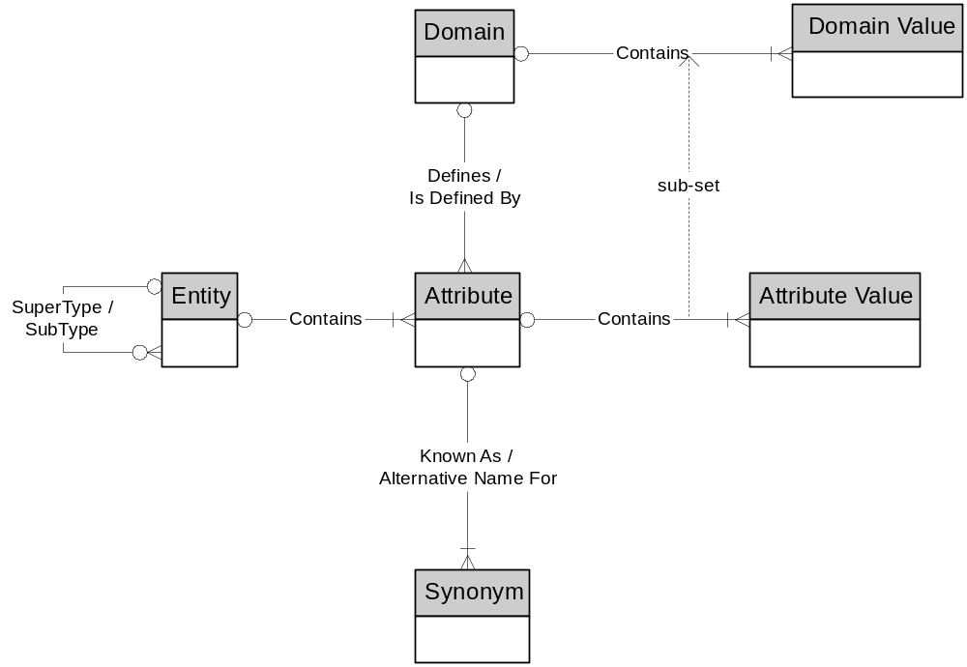
With the following basic entity definitions:
Name | Definition
Domain
Attribute | Data Type | Null | Definition
#Domain Name | String | No | The Name of the Domain for which we are recording Domain Values.
Data Type | String |  | The primitive data type that the domain is based on such as String, Number or Date.
Data Length | Number
Data Precision | Number
Uppercase | String
Minimum Value | Number
Maximum Value | Number
Format | String
Relationships | Definition
Domain Value | Domain may contain one or more Domain Values
Attribute | Domain may be define one or more Attributes

Name | Definition
Domain Value
Attribute | Data Type | Null | Definition
#Domain Name | String | No
#Domain Value | String | No
Meaning | String | No | A free text description
Relationships | Definition
Domain | Domain Value must be in one Domain

Name | Definition
Attribute
Attribute | Data Type | Null | Description
#Entity Name | String | No
#Attribute Name | String | No
Domain Name | String | No | Reference to the Domain that this Attribute is validated against.
Relationships | Definition
Domain | Attribute must be defined by one and only one Domain
Entity | Attribute must be part of one and only one Entity
Attribute Value | Attribute may contain one or more Attribute Values
Synonym | Attribute may be known by one or more Synonyms

Name | Definition
Synonym
Attribute | Data Type | Null | Description
#Entity Name | String | No
#Attribute Name | String | No
#Alternative Entity Name | String | No
#Alternative Entity Name | String | No
Relationships | Definition
Attribute | Synonym is an alternative name for one and only one Attribute

Name | Definition
Attribute Value
Attribute | Data Type | Null | Description
#Entity Name | String | No
#Attribute Name | String | No
Domain Value | String | No
Relationships | Definition
Attribute | Attribute Value must be part of one and only one Attribute
Domain Value (Derived) | Attribute Value must be one of the set of Domain Values allowed for the Domain that defines the parent Attribute.

Name | Definition
Entity
Attribute | Data Type | Null | Description
#Entity Name | String | No
Supertype Entity Name | String | Yes
Relationships | Definition
Attribute | Entity may contain many Attributes
Entity (Recursive) | Entity may be a sub-type of one and only one Entity.  Entity may be a super-type for many other Entities.  Entity must not itself be:  - A super-type of the super-type Entity being referenced (a descendant cannot be an ancestor of its own ancestor)  - A sub-type of the sub-type Entity referencing this Entity (ancestor cannot be a descendant of its own descendants).

However the model still has a number of limitations that need to be addressed and in subsequent articles we will expand this model to deal with changing Domain Values over time, validating Transition States and Data Maintenance.

References
In all honesty everything documented in this article is derived from basic principles over a number of different database projects (I produced my first Reference Codes table in Oracle5) or because I simply wanted to know which rules did and did not work.
However the following publications in particular prompted the production of this article and provided me with some background thinking about some of the aspects / requirements of a data model:
Author | Title | Publisher
Patrick Hallock | Dealing with De-Normalisation of Lookup Tables | Journal of Conceptual Modelling
Martin Fowler | Analysis Patterns – Reusable Object Models | Addison Wesley
C J Date | What not How : The Business Rules approach to Application Development | Addison Wesley

In the UK, the Royal Mail Postal Service currently uses an alphanumeric Zip / Postcode for mailing addresses.
A Data Model repository (such as Oracle Designer) also serves exactly this purpose. However it is not always feasible or desirable to provide end-user access to the entire Data Model just for the purpose of maintaining Domain Values.
This is desirable behaviour with programming languages such as Java that feature introspection in Classes because if the attribute can discover its own name then it can also dynamically identify the Domain it needs to validate itself against at runtime.
Visio Modeller applied the dotted line as a default to denote the secondary Super-Type.

