|  |  |
| --- | --- |
| **Homework 4**  **Due June 26 2018 at 11:30pm** | **Chapter 13 – Abstract Classes and Interface** |

**Objectives**

To design and use abstract classes (§13.2).

■ To process a calendar using the **Calendar** and **GregorianCalendar**

classes (§13.4).

■ To specify common behavior for objects using interfaces (§13.5).

■ To define interfaces and define classes that implement interfaces (§13.5).

■ To define a natural order using the **Comparable** interface (§13.6).

■ To make objects cloneable using the **Cloneable** interface (§13.7).

■ To explore the similarities and differences among concrete classes,

abstract classes, and interfaces (§13.8).

■ To design classes that follow the class-design guidelines (§13.10).

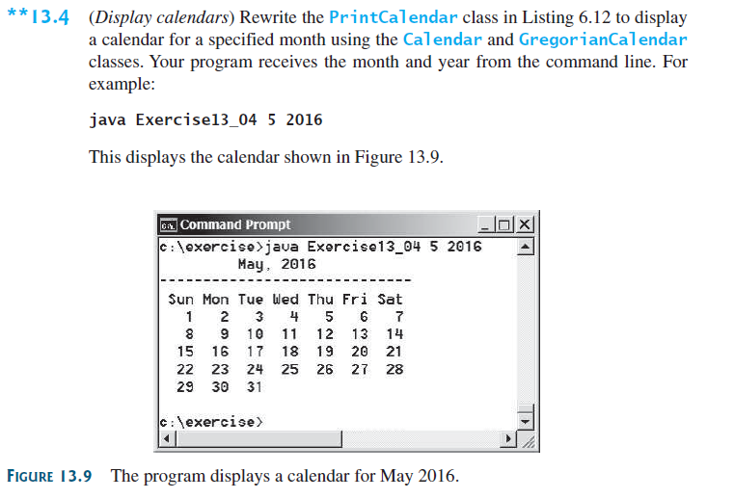

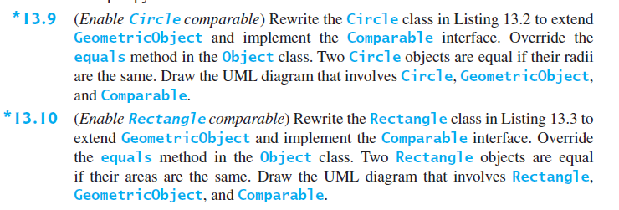

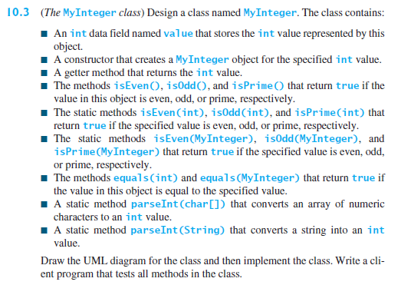

## Task List

You are required to complete the following activities by the deadlines specified and submit the appropriate *deliverables* through eLearning.

|  |  |
| --- | --- |
| Activity | Deadline |
| Create Class Files having its own main method for each of the problems in this assignment. ________________________________________________  Compile, Execute and Test your program | June 26 |
| Zip the Java Files and submit on eLearning |

## Guidelines

You will be graded according to the following guidelines:

* You are required to submit files through eLearning by the specified deadline. You can earn a maximum of 100 points.
* If the files do not compile, you will receive a 0 for the program.
* You are graded primarily on the design of your class and the adequate testing of your class. Poor design or inadequate testing will result in loss of points.
* Your files should be adequately commented. Up to -15 points will be deducted for poor indentation and documentation.