Configuration and setup management
Bioreactor v1

Content

Device mapping ……..…………………………………………………………………………. | 2
Wi-Fi setup …….………………………………………………………………………………. | 4
PH meter wiring …….………………………………………………………………………….. | 5
Firmware upgrade ………..…………………………………………………………………….. | 6
Updating UI files ………………...……………………………………………………………. | 7

Device mapping

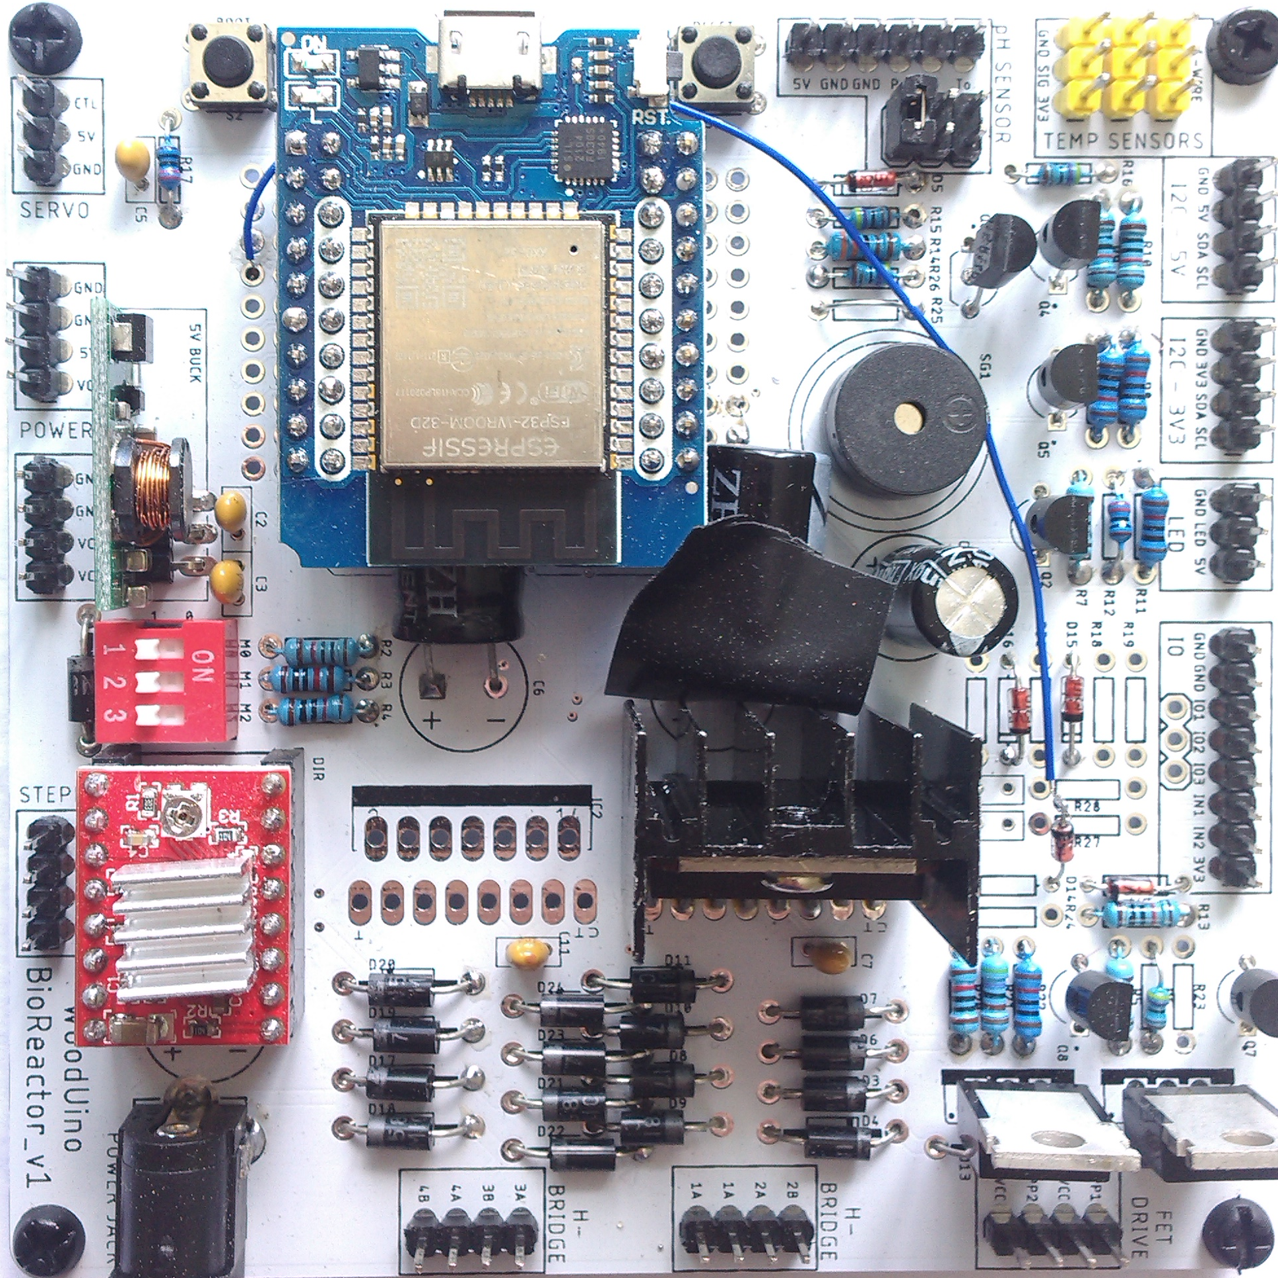
Pic 1. Board schematic

Currently software supports three sensors – for temperature, PH measurement and light intensity.
- To hook up temperature, use DS18B20 probe and connect it to any of 3 connection ports (Pic 1 temp sensors pins).
- PH sensor wiring described below in details, just one thing to remember – it has to be calibrated before using.
- Light sensor is an I2C device here, can be connected to any of I2C pins on the board. Tested with BH1750 sensor.

There are 8 devices managed by reactor:
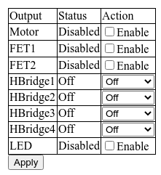
Pic 2. Main page pane with devices state, every state can be altered

1. Motor – STEPPER pins (refer to Pic 1 here and further). NEMA cable can be connected in forward and reverse way.
2. FET1 - fet drive PP1, VCC pins. Designed to provide permanent power supply.
3. FET2 – fet drive PP2, VCC pins.
4. Hbridge1 – h-bridge 1A, 1A(board misprint ) pins. Designed for intermittent supply.
5. Hbridge2 – h-bridge 2A, 2B pins
6. Hbridge3 – h-bridge 3A, 3B pins
7. Hbridge4 – h-bridge 4A, 4B pins
8. LED – led\GND\5V pins. Can be attached to be on or off by default

Wi-Fi setup

- Connect to the device

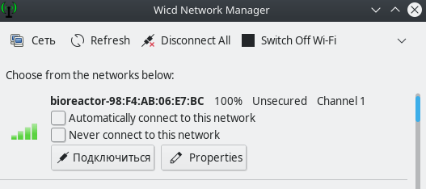

- Open in your browser http://bioreactor.local/settings, or http://192.168.4.1/settings and enter your WiFi point name and pass, then save it.

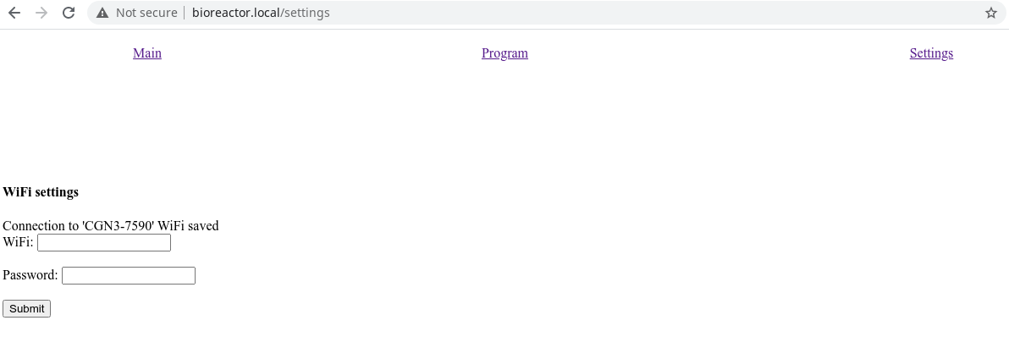

- reboot the device. You can then connect to your wifi and access the reactor by visiting http://bioreactor.local/

PH meter wiring

PH Probe connection is a straightforwad process, one thing to note however is that cable has to be twisted, so that Vcc pin on the reactor board will match Vcc pin on ph board
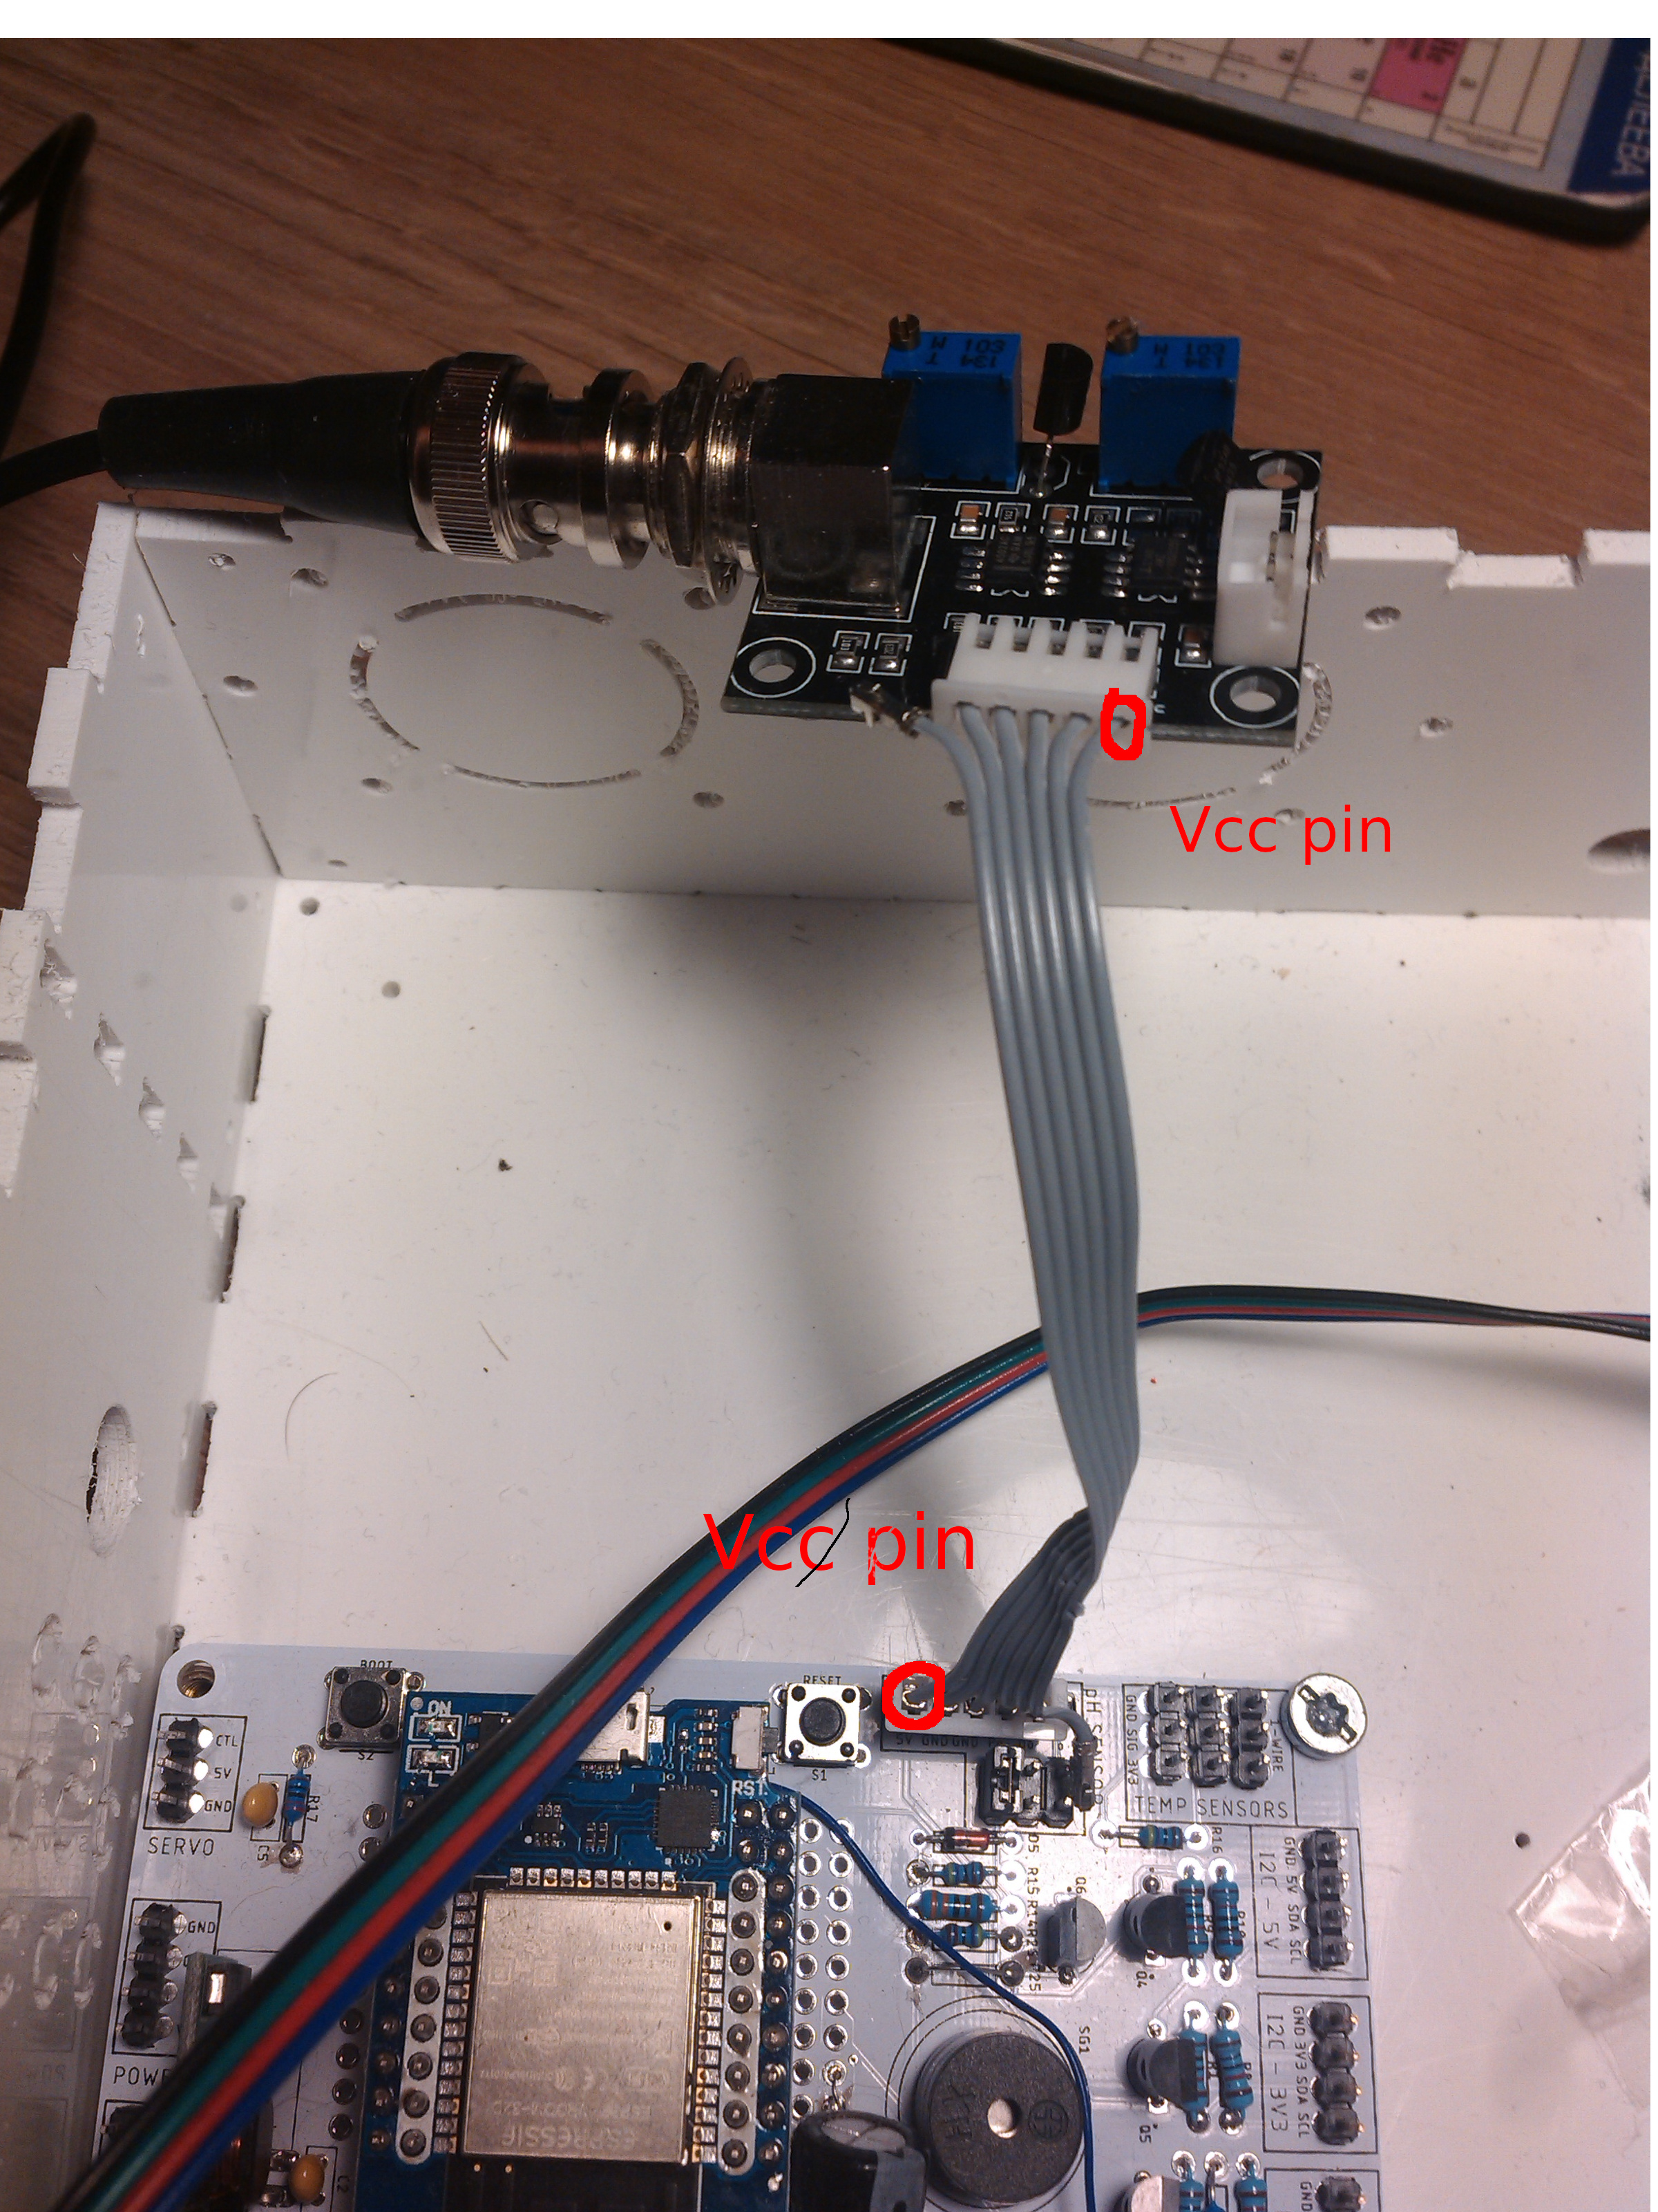

Firmware upgrade

- Open http://bioreactor.local/settings page.
- Click on ‘Choose file’ button of ‘Update ESP32 firmware’ section and find ’bioreactor.bin’ file on your file system

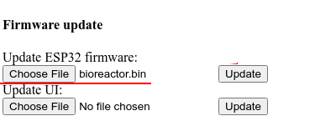

- Click update and wait till confirmation appears
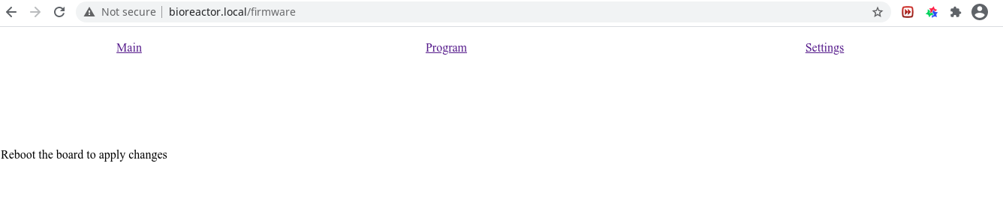

- After rebooting your fimrware should be updated

Updating UI files

- Open http://bioreactor.local/settings page.
- Click on ‘Choose file’ button of ‘Update UI’ section and find html or js file on your file system

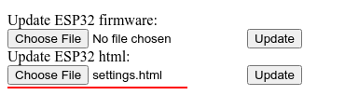

- Click update. You should be able to see confirmation promptly. No reboot required, new changes should be applied immediately



