Project Portfolio Manager
Architecture & Process Flow Document
Senior Architect Analysis | April 2026

Node.js (Runtime) | Express 4 (Framework) | PostgreSQL (Database) | EJS (Templating) | Sequelize (ORM)

HTML5 / CSS3 / SCSS | Bootstrap 4 | JavaScript (jQuery) | SendGrid (Email) | JWT (Auth tokens)

Generated by automated architectural analysis of the pp.zip project archive.

1. Executive Summary
This document provides a complete architectural review of the Project Portfolio Manager web application. The application is a multi-tenant, session-based project management platform built on a classic MVC (Model-View-Controller) pattern using a Node.js / Express backend and a PostgreSQL database. It enables organisations to manage projects, people, phases, priorities, tags, statuses, and change logs, with a dashboard that surfaces portfolio-wide budget and effort analytics.
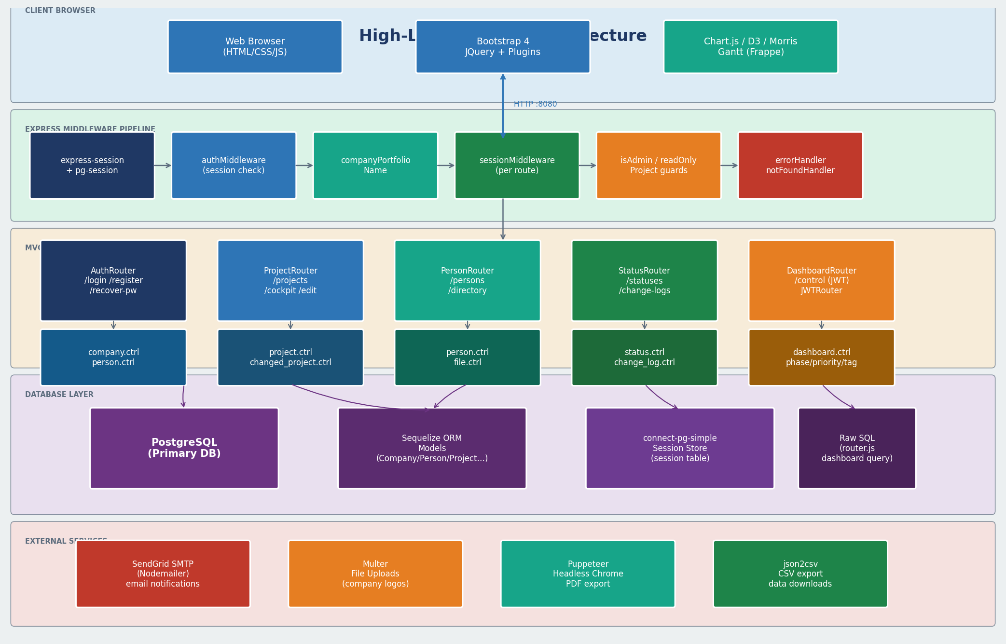
Figure 1 — High-Level System Architecture

Attribute | Value
Application Name | Project Portfolio Manager (lexa_node)
Runtime | Node.js with Express 4.x
Database | PostgreSQL (via Sequelize ORM + connect-pg-simple sessions)
Templating | EJS (Embedded JavaScript) with express-ejs-layouts
Authentication | Session-based (express-session + bcryptjs) + JWT tokens
Email | Nodemailer via SendGrid SMTP
File Uploads | Multer (company logos)
Architecture Pattern | MVC – Models (Sequelize), Views (EJS), Controllers (Express)
Default Port | 8080 (configurable via .env PORT)

2. Technology Stack
The project uses a deliberately minimal dependency set, relying on mature, well-supported npm packages.
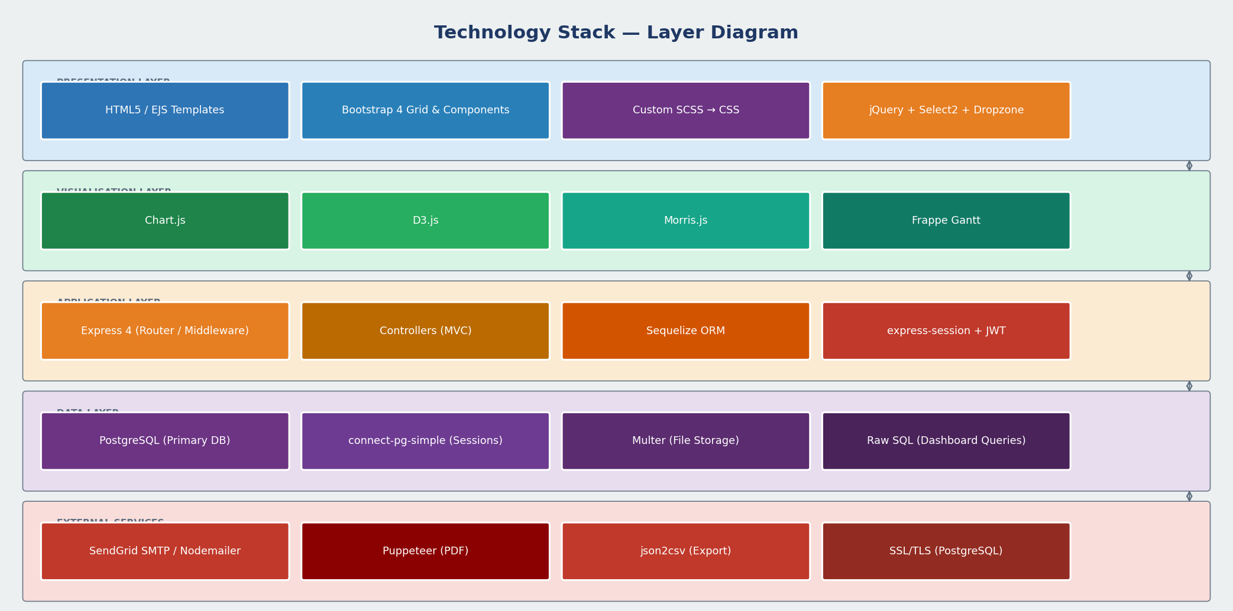
Figure 4 — Technology Stack Layer Diagram

Category | Technology | Purpose
Backend Runtime | Node.js | Server-side JavaScript execution environment
Web Framework | Express 4 | HTTP routing, middleware pipeline, static files
Templating Engine | EJS + express-ejs-layouts | Server-side HTML rendering with shared layouts and partials
Database | PostgreSQL | Primary relational datastore (multi-tenant via company_id_fk)
ORM | Sequelize 6 | Model definitions, raw SQL queries, query builder
Session Store | connect-pg-simple | PostgreSQL-backed sessions (session table)
Password Hashing | bcryptjs | One-way password hashing and comparison
Token Auth | jsonwebtoken | JWT tokens for dashboard/API routes (JWTRouter)
Rate Limiting | express-rate-limit | Brute-force protection on sensitive routes
Input Validation | express-validator | Request body sanitisation and validation
Email Service | Nodemailer + SendGrid | Transactional emails: welcome, password reset
CSS Framework | Bootstrap 4 | Responsive grid, components, utility classes
Frontend Scripts | jQuery + plugins | DOM manipulation, AJAX, datepicker, charts (Chart.js, D3, Morris)
Styling | SCSS → CSS | Custom theming compiled from /public/assets/scss/
Gantt Charting | frappe-gantt | Timeline/Gantt chart views for project scheduling
File Upload | Multer | Multipart form parsing for company logo uploads
Date Handling | Moment.js | Date formatting and timezone utilities
PDF Generation | Puppeteer + jsPDF | Headless Chrome PDF export and in-browser PDF creation
CSV Export | json2csv | Project data CSV download

3. Directory & File Structure
The project follows a conventional MVC layout. Below is the annotated directory tree.

Path | Description
index.js | Application entry point – configures Express, session, middleware and HTTP server
router.js | Root router – dashboard home page and /terms
config/ | Database connection config (db.config.js) + SQL data dumps
models/ | Sequelize model definitions: Company, Person, Project, Phase, Priority, Tag, Status, ChangeLog, etc.
controllers/ | Business logic handlers for each entity (CRUD + specialised queries)
routes/ | Express Router files – one per domain entity + Auth, Dashboard, JWT
middleware/ | authMiddleware, sessionMiddleware, isAdminMiddleware, readOnlyProject, companyPortfolioName, errorHandler, notFoundHandler
views/ | EJS templates – Pages, Dashboard, Partials, Charts, Tables, Email templates, UiElements
views/Partials/ | Reusable EJS partials: Header, Footer, Sidebar, Breadcrumb, add-project modal
utils/ | asyncHandler, dateUtils, emailSender (SendGrid), db-monitor
public/ | Static assets: CSS (compiled Bootstrap + custom SCSS), JS plugins (Chart.js, D3, Morris, Dropzone, Select2), fonts, images
scripts/ | Utility SQL scripts, Odoo integration hook (Blaze-Odoo-hook.js)
ssl/ | SSL CA certificate for secure database connections

4. Data Model (Entity Relationship Overview)
All entities are scoped to a Company (multi-tenant). The key relationships are shown below.
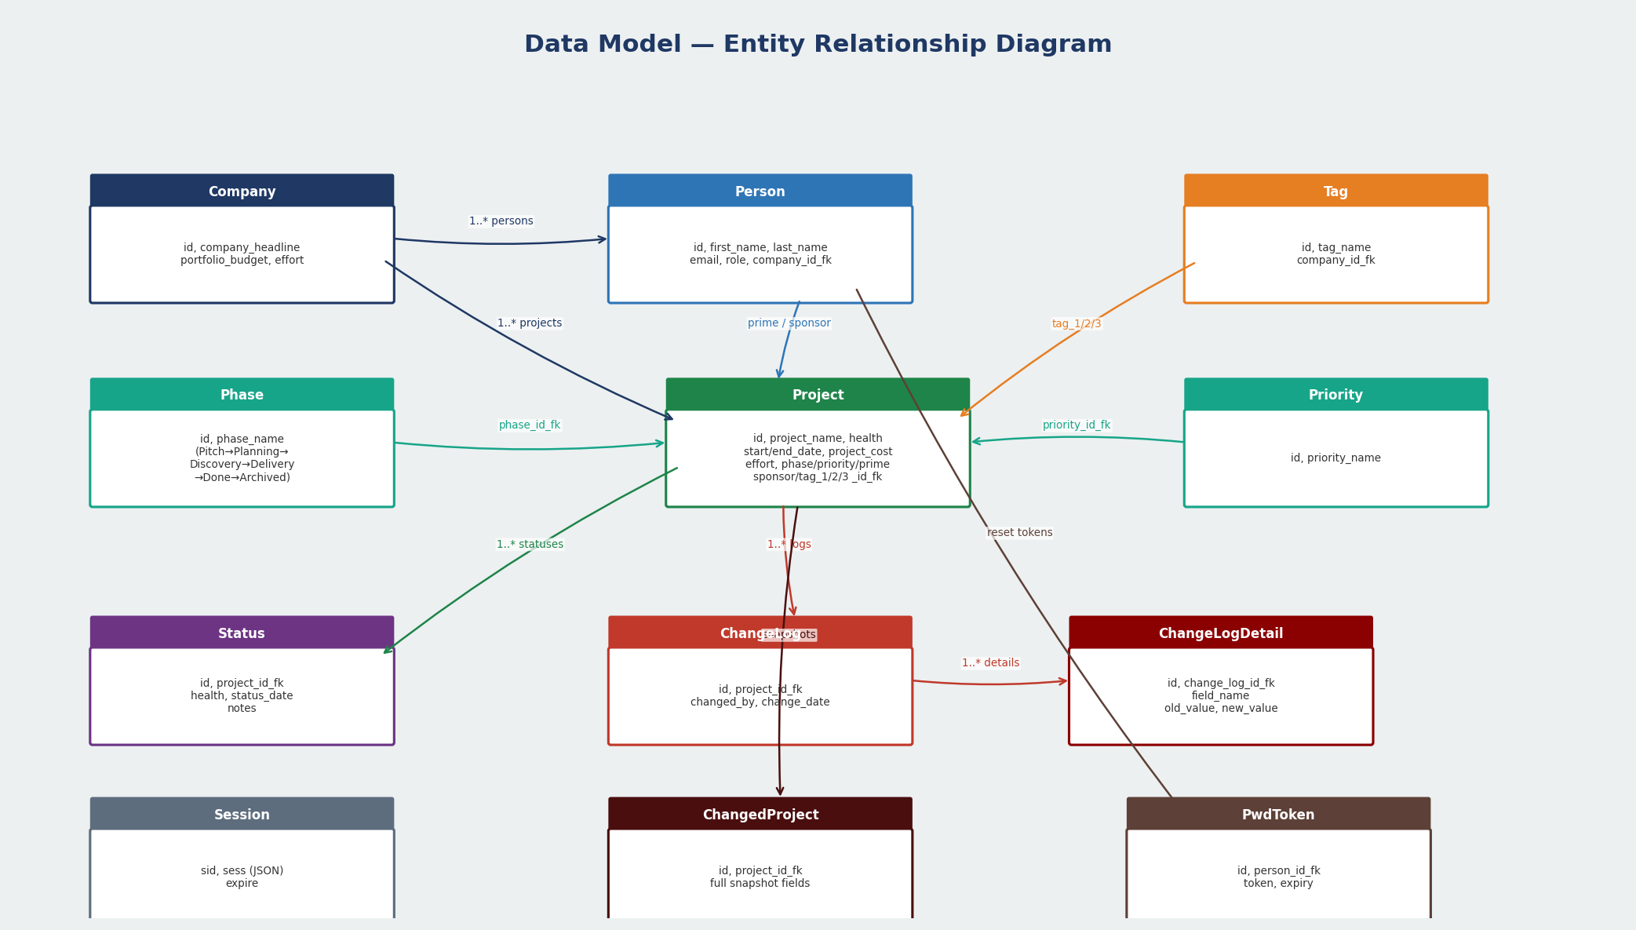
Figure 3 — Entity Relationship Diagram

Entity | Key Fields | Relationships
Company | id, company_headline, portfolio_budget, effort | Root tenant entity; owns all Persons and Projects
Person | id, first_name, last_name, email, role, company_id_fk | Belongs to Company; acts as Prime or Sponsor on Projects
Project | id, project_name, start_date, end_date, health, project_cost, effort, phase_id_fk, priority_id_fk, prime_id_fk, sponsor_id_fk, tag_1/2/3 | Central entity; references Phase, Priority, Person (x2), Tags, Company
Phase | id, phase_name | Lookup: Pitch → Planning → Discovery → Delivery → Done → Archived
Priority | id, priority_name | Lookup; assigned to Project
Tag | id, tag_name, company_id_fk | Up to 3 tags per Project (tag_1, tag_2, tag_3 FK columns)
Status | id, project_id_fk, health, status_date, notes | One-to-many with Project; latest record drives dashboard health indicator
ChangeLog | id, project_id_fk, changed_by, change_date | Audit trail per Project; links to ChangeLogDetail rows
ChangeLogDetail | id, change_log_id_fk, field_name, old_value, new_value | Field-level diff record for each ChangeLog entry
ChangeReason | id, reason_text | Reason lookup used in change log workflow
ChangedProject | id, project_id_fk, snapshot fields | Stores full project snapshot on each change event
ChangedPasswordToken | id, person_id_fk, token, expiry | One-time password reset tokens
Session | sid, sess (JSON), expire | PostgreSQL session store managed by connect-pg-simple

5. Request Lifecycle & Process Flow
Every HTTP request travels through the following middleware pipeline before reaching a controller and returning an EJS-rendered response.
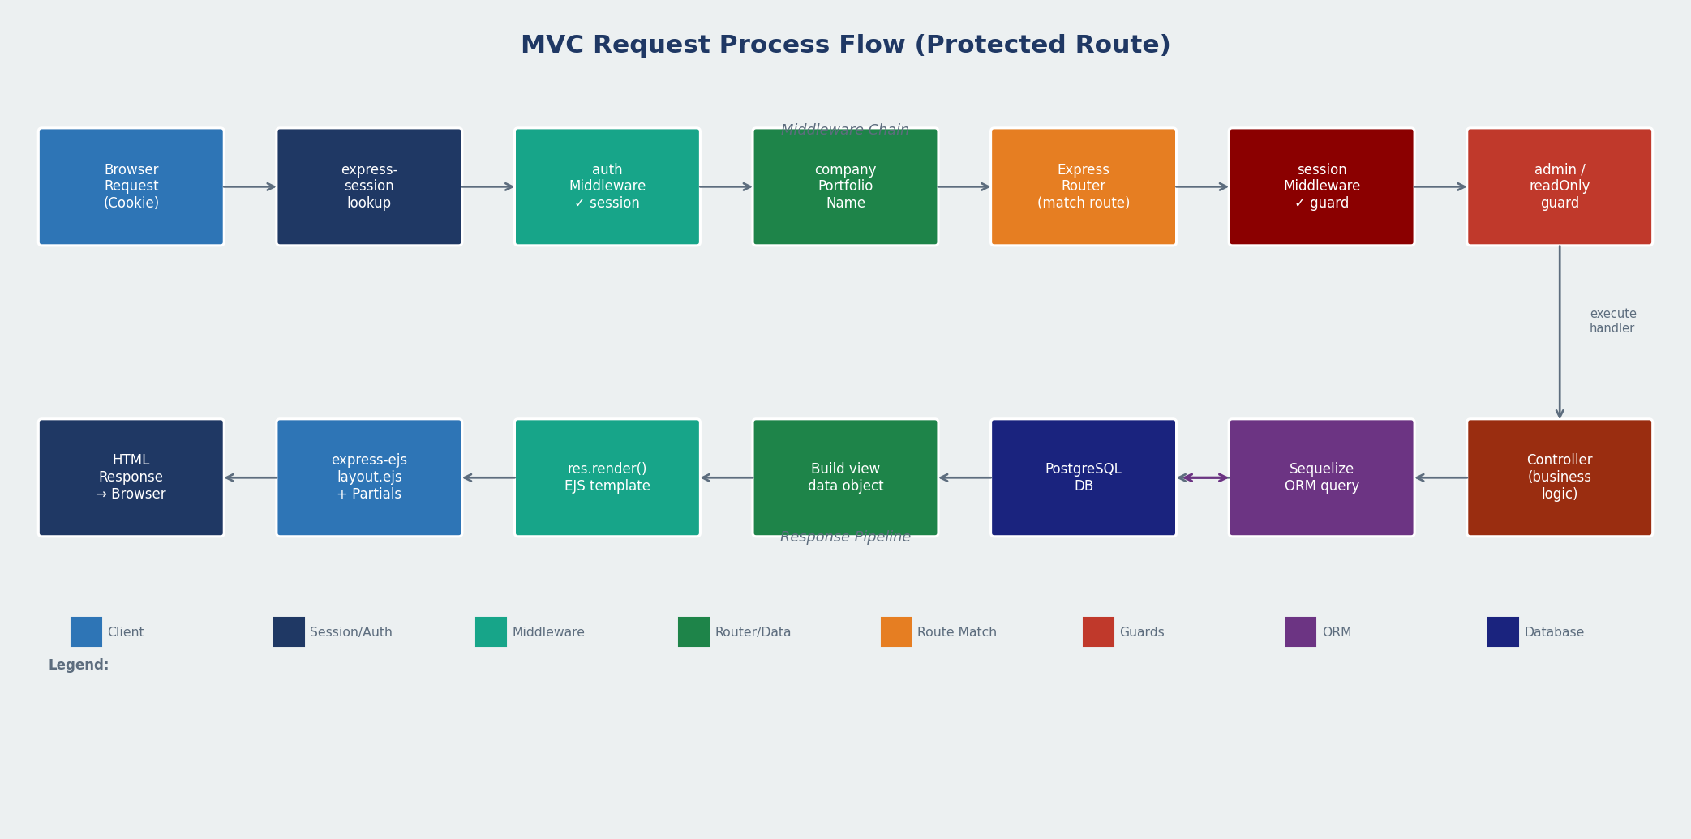
Figure 2 — MVC Request Process Flow

5a. Public Route Flow (Login / Register / Password Reset)
These routes bypass session checks and are served by AuthRouter directly.

Browser Request | ▶ | Express HTTP Server
Express HTTP Server | ▶ | express-session middleware
express-session middleware | ▶ | AuthRouter (/login, /register, /recover-password)
AuthRouter | ▶ | persons.login / companies.create (Controller)
Controller | ▶ | PostgreSQL (Sequelize query)
PostgreSQL | ▶ | EJS Template Render (layout-public.ejs)
EJS Template | ◀ | HTML Response to Browser

5b. Protected Route Flow (Authenticated Users)
All routes beyond login/register pass through this full middleware chain.

Browser Request (cookie: connect.sid) | ▶ | Express HTTP Server :8080
Express HTTP Server | ▶ | express-session → pg-session store lookup
Session middleware | ▶ | authMiddleware (validates req.session.person)
authMiddleware | ▶ | companyPortfolioName (attaches company to res.locals)
companyPortfolioName | ▶ | Router (project / person / status / phase / tag…)
Router | ▶ | sessionMiddleware (validates company + person again)
[optional] isAdminMiddleware | ▶ | Admin-only route guard
[optional] readOnlyProject | ▶ | Read-only guard for archived projects
Route handler | ▶ | Controller (business logic + Sequelize query)
Controller | ▶ | PostgreSQL (SELECT / INSERT / UPDATE / DELETE)
PostgreSQL response | ▶ | Controller builds view data object
Controller | ▶ | res.render(EJS template, data) or res.json()
EJS render (layout.ejs + Partials) | ◀ | HTML Response → Browser

5c. Authentication Flow (Login)

POST /auth/login (email + password) | ▶ | persons.login controller
persons.login | ▶ | Person.findOne({ where: { email } })
PostgreSQL | ▶ | Return Person record
bcryptjs.compare(password, hash) | ▶ | Password validation
Valid: set req.session.person + req.session.company | ▶ | Redirect → Dashboard (/)
Invalid: flash error message | ▶ | Redirect → /login (401)

5d. Password Reset Flow

GET /recover-password (enter email) | ▶ | AuthRouter → persons.requestReset
persons.requestReset | ▶ | Generate UUID token → save ChangedPasswordToken
Save token to PostgreSQL | ▶ | emailSender (Nodemailer + SendGrid)
SendGrid SMTP → reset email link | ▶ | User inbox
GET /auth/reset-password/:token | ▶ | Validate token expiry in DB
POST new password | ▶ | bcryptjs.hash → Person.update + delete token
Success | ▶ | Redirect /login

6. Middleware Stack
Below is the complete ordered middleware chain registered in index.js and applied per-route.

# | Middleware | Responsibility
1 | express.json() | Parse JSON request bodies
2 | express.urlencoded() | Parse URL-encoded form data
3 | express.static(/public) | Serve static assets (CSS, JS, images, fonts)
4 | express-session + connect-pg-simple | Cookie-based sessions backed by PostgreSQL. 4-hour cookie lifetime.
5 | AuthRouter (/login, /register…) | Public unauthenticated routes – bypasses authMiddleware
6 | DashboardRouter (/control) | Special dashboard routes with JWT authentication
7 | authMiddleware | Validates req.session.person; re-fetches Person from DB on every request
8 | companyPortfolioName | Attaches company.company_headline to res.locals for template use
9 | router.js (root /) | Dashboard home page, /ping health check, /terms
10 | Entity routes (projects, persons…) | Per-entity CRUD routes each wrapped by sessionMiddleware
11 | sessionMiddleware (per route) | Guards each route; redirects to /session-expired if session missing
12 | isAdminMiddleware (admin routes) | Role guard; restricts access to admin-only endpoints
13 | readOnlyProject (edit routes) | Prevents mutations on archived/read-only projects
14 | errorHandler | Global error handler – formats and returns error responses
15 | notFoundHandler | 404 catch-all handler

7. API & Route Map
The application exposes both server-rendered page routes (GET → EJS) and JSON API endpoints (GET/POST/DELETE → JSON). All protected routes require a valid session.

Method | Route Pattern | Description
AUTH ROUTES (public)
GET | /login | Render login page
POST | /auth/login | Authenticate user, set session
GET | /logout | Destroy session, redirect /login
GET | /register | Render registration form
POST | /register | Create new Company + Person
GET | /recover-password | Render forgot-password form
GET | /auth/reset-password/:token | Render password reset form with token
DASHBOARD & PAGES (protected)
GET | / (root) | Portfolio dashboard – aggregated project metrics
GET | /ping | Health check – tests DB connectivity
PROJECTS
GET | /projects | List all projects for current company
POST | /projects | Create new project
GET | /projects/:id | Get single project (JSON)
POST | /projects/:id | Update project
DEL | /projects/:id | Soft-delete project (deleted_yn flag)
GET | /projects/cockpit/:id | Project cockpit page (full detail view)
GET | /projects/edit/:id | Project edit form
GET | /projects/archive/:id | Archive a project (move to Archived phase)
GET | /projects/funnel/view/ | Funnel view of projects by phase
GET | /projects/freezer/view/ | Freezer view of paused/archived projects
GET | /projects/radar/view/ | Radar chart view
SUPPORTING ENTITIES
GET/POST | /persons, /persons/:id | Person CRUD (team directory)
GET/POST | /companies, /companies/:id | Company/portfolio CRUD
GET/POST | /statuses, /statuses/:id | Project status updates
GET/POST | /phases, /priorities, /tags | Lookup table management
GET/POST | /change-logs, /change-log-details | Audit trail read/write

8. Languages & File-Type Breakdown

Language / Format | Layer | Usage
JavaScript (Node.js) | Backend | All server-side logic: index.js, router.js, controllers/, models/, routes/, middleware/, utils/
EJS | View / Template | All HTML page templates in views/ – rendered server-side by Express
JavaScript (Browser) | Frontend | jQuery, Chart.js, D3, Morris, Select2, Dropzone, Frappe Gantt, datepicker plugins in public/assets/
SCSS | Frontend Styles | Custom theming source in public/assets/scss/ – compiled to style.css
CSS | Frontend Styles | Compiled Bootstrap 4 and component-level stylesheets
SQL | Database | Raw query in router.js (dashboard aggregation), scripts/get-company-projects.sql, data dumps
JSON | Configuration | package.json, package-lock.json, scroller-demo.json (datatable sample)
Markdown | Documentation | readme files inside plugin directories

9. Key Functional Modules

9a. Dashboard & Portfolio Analytics
The root route (GET /) executes a multi-join SQL query against projects, persons, phases, companies, tags, and statuses. It calculates: project counts per phase, total portfolio cost and effort, used vs. available budget, health indicator colours, and renders dashboard1.ejs with these metrics. Date-range filtering is supported via query string parameters.

9b. Project Lifecycle Management
Projects move through six phases: Pitch → Planning → Discovery → Delivery → Done → Archived. The cockpit view (/projects/cockpit/:id) displays the full project detail sheet. Projects can be soft-deleted (deleted_yn flag) or archived (phase change). Change events are captured to the ChangeLog and ChangedProject tables on every update.

9c. Audit / Change Tracking
Every project field change generates a ChangeLog header row and one ChangeLogDetail row per modified field (storing old_value and new_value). A ChangedProject snapshot is also stored on each change event. This provides complete field-level audit history.

9d. Email Notifications
emailSender.js configures Nodemailer with SendGrid SMTP credentials from environment variables. EJS email templates (/views/emailTemplates/) are rendered server-side and sent for: new user welcome, password reset requests, and project status notifications.

9e. PDF & CSV Export
csv-to-pdf.js and the json2csv dependency enable project data export. Puppeteer (headless Chromium) is available for high-fidelity PDF generation. jsPDF is included on the frontend for in-browser PDF creation.

9f. Multi-Tenancy
All database queries are scoped by company_id_fk derived from req.session.company.id. Tags can be either global (company_id_fk = 0) or company-specific. This prevents any cross-tenant data leakage at the application layer.

10. Security Architecture

Control | Implementation
Password hashing | bcryptjs – passwords are never stored in plain text
Session security | express-session with PostgreSQL store; configurable secure cookie and 4-hour expiry; server-side session destruction on logout
JWT tokens | jsonwebtoken used for /control dashboard routes as an additional auth layer
Rate limiting | express-rate-limit applied to protect against brute-force login attempts
Input validation | express-validator sanitises and validates all inbound request data
Multi-tenant isolation | All queries gated by company_id_fk from authenticated session
Admin guard | isAdminMiddleware restricts sensitive management routes to admin role
Read-only guard | readOnlyProject prevents mutations on archived projects
SSL database connection | ssl/ca-certificate.crt used to enforce TLS on PostgreSQL connections
Password reset tokens | UUID one-time tokens with expiry stored in changed_password_token table
Environment variables | All secrets (DB credentials, JWT secret, SendGrid key) managed via dotenv / .env file

11. Architectural Recommendations

Based on the code analysis, the following improvements are recommended as next steps:

- Introduce CSRF protection (e.g., csurf or double-submit cookie pattern) on all state-mutating POST routes.
- Add a dedicated API versioning layer (e.g., /api/v1/) to separate JSON endpoints from page routes for easier future mobile/SPA consumption.
- Replace raw SQL in router.js with a dedicated service/repository layer to improve testability and separation of concerns.
- Implement a formal logging library (Winston or Pino) rather than console.log statements for structured production logs.
- Add automated tests (Jest + supertest) for controller functions and middleware.
- Consider moving from session-based to a hybrid JWT/refresh-token auth strategy to support stateless horizontal scaling.
- Replace the double-registration of phase.routes and priority.routes in index.js (currently mounted twice) to avoid duplicate route handling.
- Add a Content Security Policy (CSP) header and Helmet.js for additional HTTP security headers.

Prepared by: Senior Architect Analysis | April 2026

