

UNIVERSITY OF LIMPOPO

FACULTY OF HUMANITIES
SCHOOL OF LANGUAGES AND COMMUNICATION STUDIES
DEPARTMENT OF COMMUNICATIONS, MEDIA, AND INFORMATION STUDIES

EXTERNAL PRACTICUM REPORT
MY EXPERIENCE AT MODJADJISKLOOF LIBRARY

DISCIPLINE: INFORMATION STUDIES
STUDENT NUMBER: 202050258
SURNAME: MONARENG
NAME(S): LESEGO
MODULE CODE: HINC 042
DUE DATE: 12 SEPTEMBER 2025

Table of Contents

Introduction 1
Overview: Library Structure and Services 1
Shelving Structure 1
Library System 2
Study Areas 2
Internet Café Services 2
Administrative Desk 3
Library Operations Conducted 3
Challenges Encountered 4
Recommendations 5
Reflection 5
Conclusion 5
References 6
Appendix 6
Appendix I - Weeding 6
Appendix II – Display 15

Introduction
The purpose of this external practical training was to gain real-world experience in library operations and to apply theoretical knowledge acquired in the classroom to a professional environment. The students under Information Studies were arranged an external practicum for the duration of August to various libraries in South Africa, particularly in Gauteng, Limpopo, and Mpumalanga Province. I was accepted to conduct the practicals at Modjadjiskloof Library, located at the Greater Letaba Municipality; where I was exposed to daily operations, patron services, and resource management. This experience allowed me to understand the structure of library services, the challenges faced in daily operations, and the professional standards required of library staff.

Overview: Library Structure and Services
The library is structured to cater to a wide range of users and provides access to both physical and digital resources. The primary patrons are community members, learners, and UNISA students who are situated at home (around Duiwelskloof). The shelves are arranged systematically to enhance accessibility and user convenience. They are arranged in 3 parts: Collections, Alphabetically, and DDC (Dewey Decimal Classification).

Shelving Structure
Collections – Collections are arranged based on sets, or volumes. Most of these books are for children.
Alphabetically – Contain books about fiction. The first 3 letters of the authors surname are used to separate the books. They are further separated by age (adults and children). These are divided into Afrikaans and English. Both are divided into:
- Large print
- Small Print
For example, the call number would be EJF SMI. This would imply that the book is in English language, It’s for Juniors and it is Fictional. SMI represent the first three letters of the authors’ surname, i.e., Smith. Other examples are:
- AF SMI – Afrikaans Fiction, SMI (first three letters of the authors’ surname)
- AJF SMI – Afrikaans Junior Fiction, SMI (first three letters of the authors’ surname)
- EF – English Fiction, SMI (first three letters of the authors’ surname)
Classification Systems – materials organized numerically using the Dewey Decimal Classification (DDC). Books in this area are further arranged into more parts. These are Similar to the Alphabetical Divisions, except that a letter is placed before the classification number to represent the type of book. J – Junior, R – References. Reference Sections is then arranged according to age groups (junior and adult reference materials). RJ – Junior Reference books. Examples; 340.12 SMI (law book), J 340.12 SMI (junior law book), R 340.12 SMI (reference law book), RJ 340.12 SMI (junior reference law book).

Library System
The SLIMS system was used to manage cataloguing, circulation, and patron records. SLIMS (SITA Library Information Management System), powered by Brocade Library Services (CIPAL). Kirsh (2014) went in depth on explaining the SLIMS system and described it as a Library Management System, distributed in South Africa by SITA (State Information Technology Agency). The system is based on the Brocade Library Management System, distributed by Centre of Informatics in the Province of Antwerpen and Limburg (CIPAL) company in Belgium. In December 2008, SITA acquired the Brocade Library Information Management System from CIPAL. SLIMS has replaced most PALS (legacy library system) sites in South Africa.

Study Areas
Designated spaces for quiet study and group work. Study areas include materials provided by the municipality, such as political books, for learners and researchers.

Internet Café Services
Provided access to printing, internet browsing, and basic ICT support. Tokens with a limit of 1 hour each were provided.

Administrative Desk
Staff assisted patrons by answering inquiries, recommending study areas, and providing guidance on resources such as internet use.

Library Operations Conducted
During the placement, I actively participated in a variety of library operations, which enhanced both my technical and interpersonal skills:
Shelving – A major responsibility, including re-shelving books, shelf-reading to maintain order, and cleaning shelves. This operation took place every morning. On average, it took an hour to complete, then other operations would then take place.
Weeding – Assisted in the removal of outdated and damaged books, referencing records to justify removal. Junior Non-Fiction books which were issued before 2015 were weeded. Appendix I shows the full listing of the weeded material
Issuing and Returning Books – Gained experience in circulation processes using the SLIMS system.
Poster Creation – Designed and printed posters for learner programs for their school Ad Campaigns. On busy days, I utilized AI to design the poster, then I’d personally adjust it based on the learner’s recommendations
Display Creation – Helped organize themed displays for the month of September. The pictures are attached in Appendix II.
Mock Interviews – Participated in interview practice sessions for the Library Assistant position. Ms Bopape N.M went in depth about how I should answer questions related to library services and to learn more about the BANTU principles in a library context.
Information Support – Assisted patrons with academic queries, including explanations of the electromagnetic spectrum.
Acquisition Exposure – Learned that head office handles acquisitions through three-year contracts, while libraries attend book fairs to select relevant titles based on user needs.

Challenges Encountered
The main challenges I faced included:
- Time Management – balancing library duties with personal commitments such as applications, self-development, and AI-related learning. Whilst knowing the importance of being a librarian, the overall goal is to be a well-versed information specialist. Time management became a must as I had to juggle between the practicum duties and self-development, especially around AI mastery.
- Adjustment to Early Hours – adapting my body to the early routine in the first week. I created a weekly schedule to adapt to the new time, which then fell to time management. With a preference to utilize every hour, it becomes vital to plan ahead and adapt to changes.

Theory vs Practical Application
This practical experience highlighted the differences between theoretical study and real-world application. For example:
- The most overarching issue is the shelving structure. Whilst we were taught about the DDC, I had to learn about the new shelving structure and was also informed that shelving by colours will be introduced soon as Tzaneen Library uses it and seems to work well. Shelving by colours means exactly that, however, a colour will represent a certain aspect about a book. These are meant for children’s books. Red could be for fairy tales, blue for early childhood development etc…
- Library management theory was experienced directly through shelving, circulation, and weeding tasks.
- Career development was supported through mock interviews guided by Ms. N.M. Bopape, which provided insights into Library Assistant recruitment processes.

Recommendations
Based on my experience, I recommend the following improvements:
- Library Services – More signage and guidance for new patrons to navigate the library easily.
- Future Practicals – A structured orientation for interns to quickly adapt to library operations and exposure to acquisition processes.

Reflection
This practical experience was both enlightening and transformative. I improved my time management skills and gained insight into balancing professional and personal responsibilities. The exposure strengthened my appreciation for library services but also helped me realize that my career interests may extend further into Information Systems and Data, especially considering the growing impact of Artificial Intelligence in the field.
On a personal note, I found value in maintaining my health through outdoor exercise, which supported both my energy levels and work efficiency. I am deeply grateful to the library staff, who were welcoming, professional, and supportive throughout the practical. Additionally, the library’s cleanliness stood out, as it contributed to a positive learning and working environment.

Conclusion
Overall, this practical provided a strong foundation for applying theoretical concepts in a professional library setting. It improved my technical, interpersonal, and professional skills while also helping me reflect on my future career direction. The experience highlighted the importance of adaptability, teamwork, and professionalism in library operations. I conclude this report with a deep appreciation for the opportunity and a renewed motivation to continue developing in the field of information services.

References
Bopape, N.M., 2025. Guidance on Library Assistant interviews during practicum placement. Modjadjiskloof Library, Greater Letaba Municipality. (Unpublished).
Kirsch, A., 2014. Library automation in South Africa: The transition from PALS to SLIMS. Pretoria: National Library of South Africa.
National Library of South Africa (NLSA), n.d. Guide to Library Services. Pretoria: NLSA.

Appendix

Appendix I - Weeding
TITLE | Animals in Art
AUTHOR | Moore, Rosemary
CALL NO | J ENG 704,9432 MOO
NO OF COPIES | 1
LAST ISSUED | 2004-09-16

TITLE | Bach en sy tyd
AUTHOR | Millar, C
CALL NO | J 780,92 BAC
NO OF COPIES | 1
LAST ISSUED | 2002-05-21

TITLE | Kom ons kyk na musiek
AUTHOR | De Souza, C
CALL NO | J 780 DES
NO OF COPIES | 1
LAST ISSUED | 2001-03-22

TITLE | Clay
AUTHOR | Dixon, Annabelle
CALL NO | J 738,12
NO OF COPIES | 1
LAST ISSUED | 1998-11-05

TITLE | Houses
AUTHOR | Hall, Godfrey
CALL NO | J ENG 728 HAL
NO OF COPIES | 1
LAST ISSUED | 2006-05-16

TITLE | Fun Models
AUTHOR | Grater, Michael
CALL NO | J 745,5928 GRA
NO OF COPIES | 1
LAST ISSUED | 2004-10-29

TITLE | Maak jou eie geskenke
AUTHOR | Bawden, Juliet
CALL NO | J 745,5 BAW
NO OF COPIES | 1
LAST ISSUED | 2013-11-28

TITLE | Renaissance Art
AUTHOR | Harris, Nathaniel
CALL NO | J 709,024 HAR
NO OF COPIES | 1
LAST ISSUED | 2006-06-06

TITLE | Spooky Things
AUTHOR | King, Penny and Roundhill, C
CALL NO | J 745,5 KIN
NO OF COPIES | 1
LAST ISSUED | 2009-07-27

TITLE | Puppets
AUTHOR | McNiven, Hellen and Peter
CALL NO | J 745,59224 MAC
NO OF COPIES | 1
LAST ISSUED | 2004-05-25

TITLE | Leonardo en sy tyd
AUTHOR | Sachs, M
CALL NO | J 759,55 LEO
NO OF COPIES | 1
LAST ISSUED | 2001-05-09

TITLE | Houses
AUTHOR | Macdonald, Fiona
CALL NO | J 728,09 MAC
NO OF COPIES | 1
LAST ISSUED | 2002-08-07

TITLE | Models
AUTHOR | McNiven, Helen and Peter
CALL NO | J 745,592 MAC
NO OF COPIES | 1
LAST ISSUED | 2004-06-24

TITLE | Having fun with paint
AUTHOR | Medina, Sarah
CALL NO | J 751,4 MED
NO OF COPIES | 1
LAST ISSUED | 2013-10-28

TITLE | Modelling
AUTHOR | Moloney, Joa
CALL NO | J 731,42 MOL
NO OF COPIES | 1
LAST ISSUED | 1996-01-25

TITLE | Impressionism
AUTHOR | Welton, Jude
CALL NO | J 759,054 WEL
NO OF COPIES | 1
LAST ISSUED | 2003-02-28

TITLE | Pablo Picasso
AUTHOR | Raboff, E
CALL NO | J 759,6 PIC
NO OF COPIES | 1
LAST ISSUED | 2002-09-17

TITLE | Crafty ideas with musical instruments
AUTHOR | Rice, Melaine
CALL NO | J 784,1923 RIC
NO OF COPIES | 1
LAST ISSUED | 2002-05-29

TITLE | Stars
AUTHOR | Rowel Kay
CALL NO | J 781,63092
NO OF COPIES | 1
LAST ISSUED | 2004-01-28

TITLE | Block printing
AUTHOR | O’reilly, Susie
CALL NO | J 761 ORE
NO OF COPIES | 1
LAST ISSUED | 2001-05-09

TITLE | Focus on photography
AUTHOR | Keith, Wilson
CALL NO | J 770 WIL
NO OF COPIES | 1
LAST ISSUED | 2004-11-01

TITLE | Puppets
AUTHOR | Wright, Lyndie
CALL NO | J 745,59224 WRI
NO OF COPIES | 1
LAST ISSUED | 2007-02-14

TITLE | Toneelpoppe
AUTHOR | Wright, Lyndie
CALL NO | J 745,59224 WRI
NO OF COPIES | 1
LAST ISSUED | 2004-04-30

TITLE | Beethoven en sy tyd
AUTHOR | Kendall, A
CALL NO | J 780,92 BEE
NO OF COPIES | 1
LAST ISSUED | 2002-05-21

TITLE | World Music
AUTHOR | Thomas, Roger
CALL NO | J 781,4163 THO
NO OF COPIES | 1
LAST ISSUED | 2003-08-05

TITLE | Classical Music
AUTHOR | Thomas, Roger
CALL NO | J 781,168 THO
NO OF COPIES | 1
LAST ISSUED | 20003-09-11

TITLE | Music
AUTHOR | Blackwood, Alan
CALL NO | J 780 BLA
NO OF COPIES | 1
LAST ISSUED | 2001-03-22

TITLE | Rock, Pop and Dance
AUTHOR | Thomas, Roger
CALL NO | J 781,4163 THO
NO OF COPIES | 1
LAST ISSUED | 2003-08-05

TITLE | What they don’t tell you about music
AUTHOR | Barber, Nicola
CALL NO | J 780 BAR
NO OF COPIES | 1
LAST ISSUED | 2005-03-15

TITLE | Adventure in Alaska
AUTHOR | Kramer, S.A
CALL NO | J 798,8 KRA
NO OF COPIES | 1
LAST ISSUED | 2002-05-29

TITLE | Making Music
AUTHOR | Foster, Karen; Mahoney, Carole; Parker, Josephine
CALL NO | J 784,19 MAK
NO OF COPIES | 1
LAST ISSUED | 2006-11-20

TITLE | Projects for autumn
AUTHOR | Jones, Joan
CALL NO | J 790,1922 JON
NO OF COPIES | 1
LAST ISSUED | 2001-06-08

TITLE | All about Playtime
AUTHOR
CALL NO | J 790,1922 ALL
NO OF COPIES | 1
LAST ISSUED | 2004-08-26

TITLE | Games with papers and pencils
AUTHOR | Oakley, Ruth
CALL NO | J 790, 1922 OAK
NO OF COPIES | 1
LAST ISSUED | 2005-09-22

TITLE | Games of strength and skill
AUTHOR | Oakley, Ruth
CALL NO | J 790, 1922 OAK
NO OF COPIES | 1
LAST ISSUED | 2004-11-10

TITLE | Ball games
AUTHOR | Oakley, Ruth
CALL NO | J 790, 1922 OAK
NO OF COPIES | 1
LAST ISSUED | 1999-05-27

TITLE | Games with sticks, stones and shells
AUTHOR | Oakley, Ruth
CALL NO | J 790, 1922 OAK
NO OF COPIES | 1
LAST ISSUED | 2008-10-14

TITLE | Chasing Games
AUTHOR | Oakley, Ruth
CALL NO | J 790, 1922 OAK
NO OF COPIES | 1
LAST ISSUED | 2008-10-14

TITLE | Chanting Games
AUTHOR | Oakley, Ruth
CALL NO | J 790, 1922 OAK
NO OF COPIES | 1
LAST ISSUED | 2001-04-30

TITLE | Games with rope and string
AUTHOR | Oakley, Ruth
CALL NO | J 790, 1922 OAK
NO OF COPIES | 1
LAST ISSUED | 2004-04-30

TITLE | Spel en pret
AUTHOR | Marsh, Rob
CALL NO | J 790,192 MAR
NO OF COPIES | 1
LAST ISSUED | 2005-09-22

TITLE | Kom ons braai
AUTHOR | Firmin, Catherine
CALL NO | J 746,432 FIR
NO OF COPIES | 1
LAST ISSUED | 1998-09-21

TITLE | Leisure
AUTHOR | Rowe, Julian
CALL NO | J 790,0135 ROW
NO OF COPIES | 1
LAST ISSUED | 2002-11-05

TITLE | Canoeing
AUTHOR | Fox, Allan
CALL NO | J 797,122 FOX
NO OF COPIES | 1
LAST ISSUED | 2004-10-29

TITLE | The Movies
AUTHOR | Oxlade, Chris
CALL NO | J 791,4301 OXL
NO OF COPIES | 1
LAST ISSUED | 2004-11-10

TITLE | Magic
AUTHOR | Day, Jon
CALL NO | J 793,8 DAY
NO OF COPIES | 1
LAST ISSUED | 2004-12-01

TITLE | Fancy dress party book
AUTHOR | Gordon, Maria
CALL NO | J 793,21 GOR
NO OF COPIES | 1
LAST ISSUED | 2004-11-23

TITLE | Gymnastics
AUTHOR | Phelps, Monica
CALL NO | J 796044 PHE
NO OF COPIES | 1
LAST ISSUED | 2001-10-11

TITLE | Netball
AUTHOR | Lloyd, Gill and Jefferis, David
CALL NO | J 796,32
NO OF COPIES | 1
LAST ISSUED | 2001-10-11

Appendix II – Display
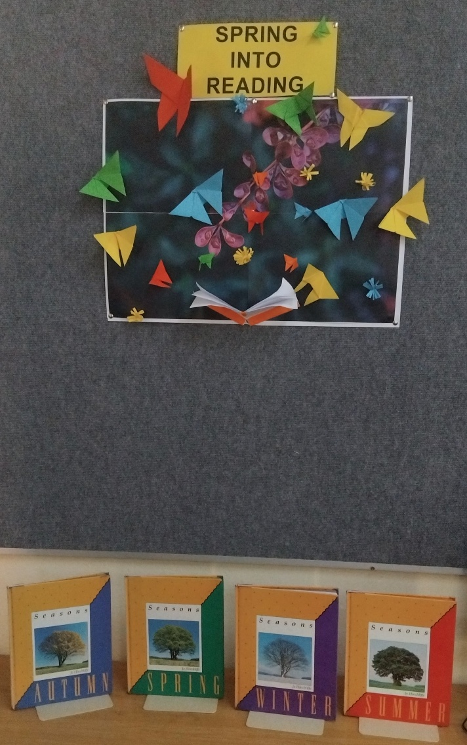 | 