Applied Research Report

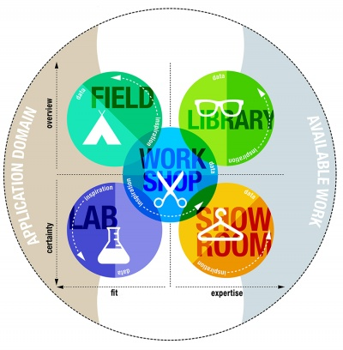

Topic: Stepper Motor
Author(s): Adrian Pacera
Document date / version: 2023/03/13
Document status: draft

- Contents
2 Rationale: Why Applied Research? 2
3 Abstract 3
3.1 Introduction 3
3.2 Main Question: 3
3.3 Sub questions: 3
3.4 Research strategies 3
4 Can we use stepper motor for 3D printer’s extruder tester? 4
4.1 Introduction: 4
4.2 Results 4
4.3 Conclusion 4
5 Which of the stepper motor types is ideal for our project from different variants? 5
5.1 Introduction: 5
5.2 Results 5
5.3 Conclusion 5
6 How can we control a stepper motor with a software? 6
6.1 Introduction: 6
6.2 Results 6
6.3 Conclusion: 7
7 References 8

Rationale: Why Applied Research?
The main reason to do Applied Research is to de-risk your project.
Every project has risks that should be mitigated before starting to implement things. Insufficient knowledge / experience with a certain technology is one of these risks. Formulating adequate research questions & sub-questions and methodically performing Applied Research to answer these questions is a meaningful way to mitigate knowledge gaps.


At Fontys ICT we use the DOT framework (HBOi, 2021) to perform Applied Research. It comprises a large set of research methods grouped in 5 clusters/strategies. Details can be found on: Methods - ICT research methods. Note that a physical card deck with these methods can be obtained at ISSD.

Some examples of meaningful research questions are:
- How should the overall HW architecture of our system look like?
- How should the overall SW architecture of our system look like?
What is the most suitable sensor/actuator for our project and how to integrate that into our system?
- How does MQTT work and how to implement MQTT in our system?

Hint: consult your teacher in every step of the Applied Research process!

Abstract

Introduction
As of currently our team is working on developing a testing environment for 3D printer’s components. We as a group discussed how we would test if an extruder moved correctly on x and y axis, or how would we test a homing functionality of an extruder. As a proposed solution we decided to use a motor to test if the movement goes smoothly and precisely.

Main Question:
Can we use stepper motor for 3D printer’s extruder tester?

Sub questions:
Which of the stepper motor types is ideal for our project from different variants?
How can we control a stepper motor with a software?

Research strategies
DOT framework strategy
Main question:
-Strategy I plan on implying will be “Library” since the topic of my research question is so far only on theoretical level as well as it is highly discussed in the community of embedded engineers.
-Definition of done consist of multiple factors. First factor is how much information do I need to be sure I can implement my research for the project, and I am able solve issues connected with the topic on the project. Second factor is how I can explain my research topic to my group mates, so they have general idea what is a stepper motor and how the stepper motor works.

Sub questions:
Which of the stepper motor types is ideal for our project, and what are the different varieties available?
-Usage of ‘available product analysis (from library)’ for seeing different candidates for using them in our project. Creating a list of stepper motors that we could possibly use.
- Usage of ‘community research (from library)’ to look for past people’s experiences with stepper motors, what other recommend and about what we should be wary then choosing specific type of a stepper motor
How can we control a stepper motor with a software?
- Usage of ‘community research (from library)’ look at some already made projects/applications which include using a stepper motor and see if there are any connections to my project context or if they are relevant.
- Usage of prototyping (from workshop) to test different behavior of the stepper motor under different software applications.

Can we use stepper motor for 3D printer’s extruder tester?

Introduction:
The motors which we could potentially use were DC, AC, stepper, and servo motors. The issue with DC, AC motor is that is does not provide an incremental motion which is required for testing purposes. The servo motor can provide an incremental motion; however, the problem is they do not provide such stopping accuracy and precision as stepper motor.

Results
Description of a stepper
- A stepper motor is a type of a motor which converts electrical energy to the mechanical energy through applying laws of electromagnetism. In comparison to other motors such as DC or AC motors which rotate continuously, stepper motor can move in small steps from where the name is derived from (step-per motor).
Architecture of a stepper motor
- The architecture of a stepper motor mainly consists of rotor and stator. The rotor is made from either a permanent magnet or a variable reluctance iron core and serves as the rotating inner part in the motor itself. The stator serves the static part of a stepper motor and is made from teeth where coils are wired.
Rotor in stepper motor:
- Permanent magnet or a variable reluctance iron core serves as a “rotor”, which aligns with the magnetic field produced by the stator circuit. This answer ensures both a decent torque and a detent torque. This implies that regardless of whether a coil is activated, the motor will oppose a change in position, although weakly. This solution's disadvantages include its slower speed and lesser resolution when compared to other kinds.
Stator in stepper motor:
- A static part of a stepper motor called “stator” produces the magnetic field that the rotor will align with. The stator circuit's primary attributes are the number of phases and pole pairs, as well as the wire arrangement. Whereas the number of pole pairs shows how many primary pairs of teeth are occupied by each phase, the number of phases represents the number of independent coils. The most used stepper motors are two-phase, whereas three-phase and five-phase motors are less often used.
Functionality of stepper motor:
- The motor shaft rotates step by step by using several electromagnetic coils that are activated in a particular order. Stepper motors are perfect for applications that demand precision positioning and speed control, such as in robots, CNC machines, and 3D printers since they are made to be exact and controlled. They may be controlled using several methods, including microcontrollers, stepper motor drivers, and specialized software. They are available in a variety of sizes and configurations, each having a unique torque and speed characteristic.

Conclusion
The stepper is a motor which would certainly fit to our project, consists of multiple parts such as rotor and stator. There are a lot of different types of stepper motor we as a group could use. It is powered by electromagnetism and can move by very precise steps. Additionally, the stepper motor can be controlled in multiple ways, such as controlling it with a software program.

Which of the stepper motor types is ideal for our project from different variants?

Introduction:
When one is choosing a stepper motor, there are different serval factors to take into consideration.
First is the torque. The amount of torque required for the motor to handle is very important. Second factor is speed and accuracy. Some stepper motors are more precise or faster than others, however they tend to be pricy. Last and most crucial factor, in the current context, is the budget. It is widely known that the motors with multiple features or capabilities tend to be more expensive.

Results
With these factors known, there are several types of stepper motors than could be possibly used in our project.
Bipolar stepper motor:
- This stepper motor requires a bipolar driver to operate since it has two coils per phase. It is frequently utilized in industrial and automation applications because it offers great torque and precision.
Linear stepper motor:
- A linear stepper motor is a type of stepper motor that travels linearly as opposed to rotating. Applications like 3D printing and CNC equipment frequently use it.
Unipolar stepper motor:
- This is a type of stepper motor that has one coil per phase and can be controlled with a simple unipolar driver. It is less expensive and easier to control than, for example, bipolar stepper motors, but typically provides lower torque and accuracy.
Geared stepper motors:
- These stepper motors have a gearbox attached to them, increasing their torque, and lowering their speed. It is frequently used in robotics and automation applications where high torque is necessary.
Type of stepper motor | Speed | Accuracy | Torque | Price
Bipolar | Fast | 5/5 | Great | 5/5
Linear | Average | 4/5 | Average | 4/5
Unipolar | Slow | 3/5 | Average | 1/5
Geared | Slow | 5/5 | Great | 4/5

Conclusion
As there are many great stepper motors than could be used for our project, majority of professional stepper motors are more expensive. In our project we take into consideration the factor of learning and possibility of accidently destroying the motor itself. That is why the unipolar motor would serve us the best. It may not be the most accurate option, but for our prototype purposes it is very lucrative, based off price to performance comparison. After the prototype stage, the motor could be switched to professional linear or bipolar stepper motor.

How can we control a stepper motor with a software?

Introduction:
The stepper motor may be configured to be controlled by software programs depending on criteria like the number of steps to move, the speed of the move, and the direction of the motion. More intricate movements, such curves, and angles, may be performed because to this degree of precise control, which also makes it simpler to incorporate the stepper motor into bigger control systems.

Results
The unipolar stepper motor can be controlled via driver. Unipolar stepper motor usually has 5-6 pins that need to be wires. The wires are connected to the driver which relates to microcontroller unit which can communicate with the driver via 4 input pins.
Stepper motor itself also requires external power supply of 5V-12V. This power supply needs to be directly connected to the driver of a stepper motor.
Scheme for connecting Arduino uno with unipolar stepper motor 28BYJ-48:
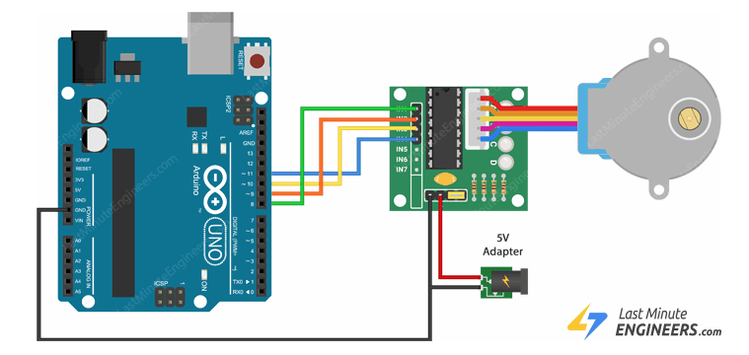
To control the motor, we must wire inputs a digital signal. After double checking the wiring, we can proceed to create a simple program.
The program used for writing such a code is Visual Studio, since I have the most experience in it. Before coding, it is best to think of a logic what the code should do. The goal is to move a motor clockwise and then counter clockwise for the same amount or steps.
Library we can use for simplifying code is by default in Arduino framework and is called Stepper.h.
Example of an application:
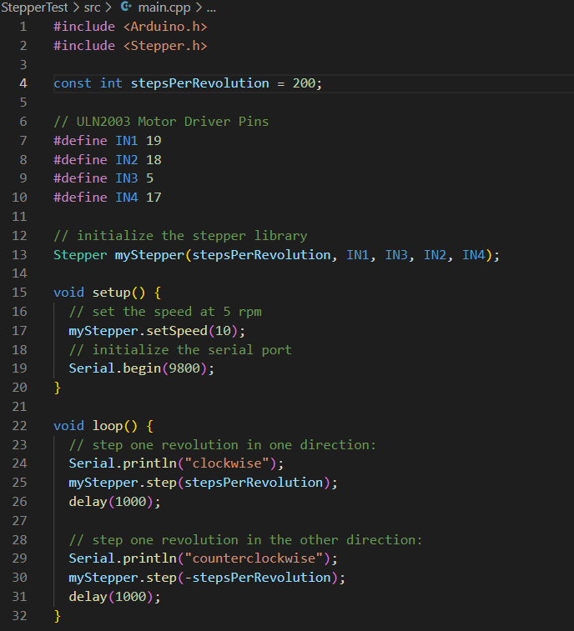

The provided code has a comments for explanation of every step.

Conclusion:
For our project we decided to use a unipolar stepper motor (28BYJ-48), which can be controlled via software application, driver, and external power supply. The procedure of wiring the motor with driver and microcontroller is straight forward as coding it with C/CPP application. With the provided library we can control steps per revolution, RPM, and direction of a stepper motor, which allows as to manipulate it in multiple ways. With this knowledge acquired, we can build a testing environment for extruder part of 3D printer, by testing its movements on X, Y, axis.

References
Text resources:
[1] Agarwal, T. (2020b, December 19). Permanent Magnet Stepper Motor : Construction, Working & Applications. ElProCus - Electronic Projects for Engineering Students. https://www.elprocus.com/what-is-a-permanent-magnet-stepper-motor-its-working/
[2] Techopedia, W. I. A. S. M.-. D. F. (2015, 16 July). Stepper Motor. Techopedia.com. https://www.techopedia.com/definition/13345/stepper-motor
[3] Stepper Motors: Types, Uses and Working Principle | Article | MPS. (z.d.). https://www.monolithicpower.com/stepper-motors-basics-types-uses
[4]Stepper motor datasheet: https://components101.com/sites/default/files/component_datasheet/NEMA17.pdf
[5] Engineers, L. M. (2023b, February 1). Control 28BYJ-48 Stepper Motor with ULN2003 Driver & Arduino. Last Minute Engineers.
https://lastminuteengineers.com/28byj48-stepper-motor-arduino-tutorial/
[6] Tutorial: Stepper vs Servo. (z.d.-b).
https://www.amci.com/industrial-automation-resources/plc-automation-tutorials/stepper-vs-servo/
Picture, code references:
[1] Engineers, L. M. (2023b, February 1). Control 28BYJ-48 Stepper Motor with ULN2003 Driver & Arduino. Last Minute Engineers.
https://lastminuteengineers.com/28byj48-stepper-motor-arduino-tutorial/
[2] Santos, S., & Santos, S. (2021, 31 August). ESP32 Stepper Motor (28BYJ-48 and ULN2003 Driver) | Random Nerd Tutorials. Random Nerd Tutorials. https://randomnerdtutorials.com/esp32-stepper-motor-28byj-48-uln2003/

