GUARDING US

Adrian Rodriguez-Aguilar

Capstone Project Proposal

Grand Canyon University

Instructor: Professor Mark Reha

Revision: 2

Date: April 24, 2022

**ABSTRACT**

A good solution to be able to collect all this data for those who work in a subdivision as a security guard, would be to create a website and an application where the information of the visits and incidents is captured, instead of asking for the information of the visitors and write it down in a notebook. With this improvement, by saving the information in a database through an electronic device, we will have the assurance that our information will not be lost.

|  |
| --- |
| History and Signoff Sheet |

**Change Record**

|  |  |  |
| --- | --- | --- |
| **Date** | **Author** | **Revision Notes** |
| 9/17/2021 | Adrian | Initial draft for review/discussion |
| 4/22/2022 | Adrian | Final Version:  -Add Notifications as an admin and security guard  -Residents can see their messages  -Using the app with your mobile is moved to out of scope. |
|  |  |  |

|  |
| --- |
| **Overall Mentor Feedback/Comments**  A good project selection, since it is an ambitious one. |

**Integrated Mentor Feedback into Project Documentation**

Yes

**Project Approval**

Professor Mark Reha

**TABLE OF CONTENTS**

Project Overview and Project Objectives 4

Project Scope 5

Project Success Measures 6

Project High-Level Solution 7

Project Controls 8

Project Cost and Schedule 10

Appendix A – References 11

Appendix B – Copyright Compliance 12

Project Overview and Project Objectives

**State the Problem and Background**

This project is being carried out since I have seen that in the private subdivisions of my city they are not using the most effective method to be able to do their work. The method of how they are going to save the information is going to be more secure instead of doing that in the notebook. Another reason is that this project can be used for various security areas, especially for places that are occupied by guards, a school for example.

**Christian Worldview**

For what you are planning to do in this project, do not violate the statements that have to do with ethical, spiritual, legal, historical, etc. On the social issue, people will be more comfortable knowing that there is better security inside their subdivision. "Peace be within your walls and security within your towers!" Psalms 122: 7.

**Project Objectives**

Make an information survey of what are the needs of a subdivision, create a web page and an application, create a database structure, design a diagram on how the application should work, create interface models, and identify what tools are needed to get the job done.

**Challenges**

The possible cost of the applications to be used, learning a new way to create a web page, doing field research to determine functions the project must fulfill

**Benefits and Opportunities**

This can be offered to subdivisions in my city and is likely to be elsewhere. Security guard companies, schools. And any place that requires a security guard.

Project Scope

The scope of this project is that it can mainly be used for the subdivisions of my city and in the future for the rest of the country. Once the objective has been accomplished, it is expected that this project can be used not only in subdivisions, but also in schools, clubs, or any place that requires security guards.

In-Scope:

Everyone:

-Registration

-Login

Admin:

-Administrating Catalogs

-Send Notifications

-See Exit and Entrances History

Security Guard:

-Add Visitor’s information

-Send Notifications

-See Exit and Entrances History

Residents:

-Notifications

Out-of-Scope:

-Chat for residents

-Use the application with your cellphone

Project Success Measures

Get feedback from the people who are going to use our application, such as security guards for example. Confirm that all the functions of the page are perfectly stable. Keep a good work plan to be able to finish the project on time.

|  |  |  |  |  |  |
| --- | --- | --- | --- | --- | --- |
| Assumptions and Constraints | | | | | |
| ID | Description | Comments | Type | Status | Date Entered |
| 1 | Reuse the code that applies with the website to the mobile app. | Not all the website code will apply |  |  |  |
| 2 | Add some details with the mobile app | This must be done to be sure if it works on Android and IOS. |  |  |  |

Project High-Level Solution

**Introduction**

A need that is taken care of in the private subdivisions that exist in my city does not have enough tools to provide the security they live there. The way that security guards record the details of incoming visitors is not as effective if they do register at all. Another of the processes in which they are not very efficient is in the way they report incidents. The objective of the project is to increase the security of the subdivisions by creating a website and a mobile application, mainly giving the security guards certain functions to facilitate their work.

**Solution**

The software that will be used to start the project will be mainly with Visual Studio. With this software the web page and the mobile application will be created. The servers that Microsoft offers will be used.

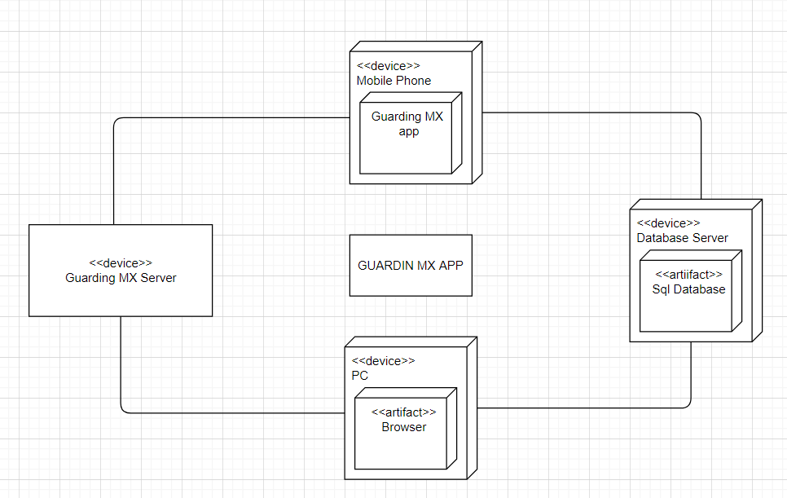

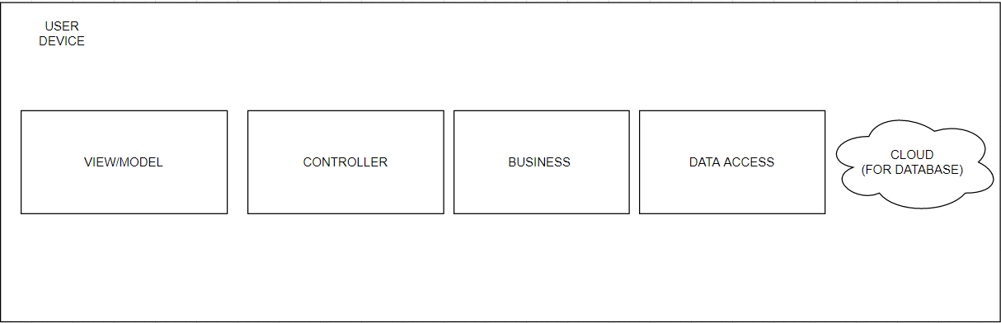

Project Controls

|  |  |  |  |  |
| --- | --- | --- | --- | --- |
| Risk Management | | | | |
|  | **Risk Probability** | **Risk Impact** |  |  |
| **Event Risk** | **(high, medium, low)** | **Risk Mitigation** | **Contingency Plan** |
| What is the risk? | What is the probability? | What is the impact if the risk occurs? | What can be done to minimize the risk? | What can be done to minimize the impact of the risk? |
| It cost me more work, since it is the first time doing this kind of application. | High | Not prepared | Research | Research |
| A lot of research | High | Unknown topic | Do research | Do research |
| I have very little knowledge of C # in Visual Studio. | Medium | Lack of practice | Learn | Learn |

Project Cost and Schedule

There are no costs when using the software necessary to be able to do the project, except in the salary that you must give the programmer when doing the project. Another thing is how much you have to pay for the server and for the computer to run the page.

Appendix A – References

Door Patrol. (2021, February 12). *Adminisitra tu Fraccionamiento desde el Celular*. <https://doorpatrol.com/#easy-to-customize>

*SEGUSER*. (n.d.). Seguser. Retrieved September 27, 2021, from <https://seguser.com/>