GUARDING US

Adrian Rodriguez-Aguilar

Capstone Project Requirements Document

Grand Canyon University

Instructor: Professor Mark Reha

Revision: 2

Date: April 24,2021

**ABSTRACT**

A good solution to be able to collect all this data for those who work in a subdivision as a security guard, would be to create a website and an application where the information of the visits and incidents is captured, instead of asking for the information of the visitors and write it down in a notebook. With this improvement, by saving the information in a database through an electronic device, we will have the assurance that our information will not be lost.

|  |
| --- |
| History and Signoff Sheet |

**Change Record**

|  |  |  |
| --- | --- | --- |
| **Date** | **Author** | **Revision Notes** |
|  | Adrian | Initial draft for review/discussion |
| 4/20/22 | Adrian | Final Revision |
|  |  |  |

|  |
| --- |
| **Overall Instructor Feedback/Comments** |

|  |
| --- |
| **Overall Instructor Feedback/Comments** |

**Integrated Instructor Feedback into Project Documentation**

Yes  No

**TABLE OF CONTENTS**

Functional Requirements 4

Non-Functional Requirements 5

Technical Requirements 6

Logical System Design 7

User Interface Design 8

Reports Design 9

Functional Requirements

**Use Cases**

|  |  |  |
| --- | --- | --- |
| **Use Case or User Story** | **Approval Date** | **Justification** |
|  |  |  |

User Stories located on the excel document, which is “User Stories”, in the “Use Case Functional Requirement” section.

Non-Functional Requirements

**Use Cases**

User Stories located on the excel document, which is “User Stories”, in the “Non Functional Requirements” section.

|  |  |  |
| --- | --- | --- |
| **Use Case or User Story** | **Approval Date** | **Justification** |
|  |  |  |

Technical Requirements

**Use Cases**

User Stories located on the excel document, which is “User Stories”, in the “Technical Requirements” section.

|  |  |  |
| --- | --- | --- |
| **Technology or Tool** | **Approval Date** | **Justification** |
|  |  |  |

Logical System Design

Provide a diagram of the logical architecture of the system.

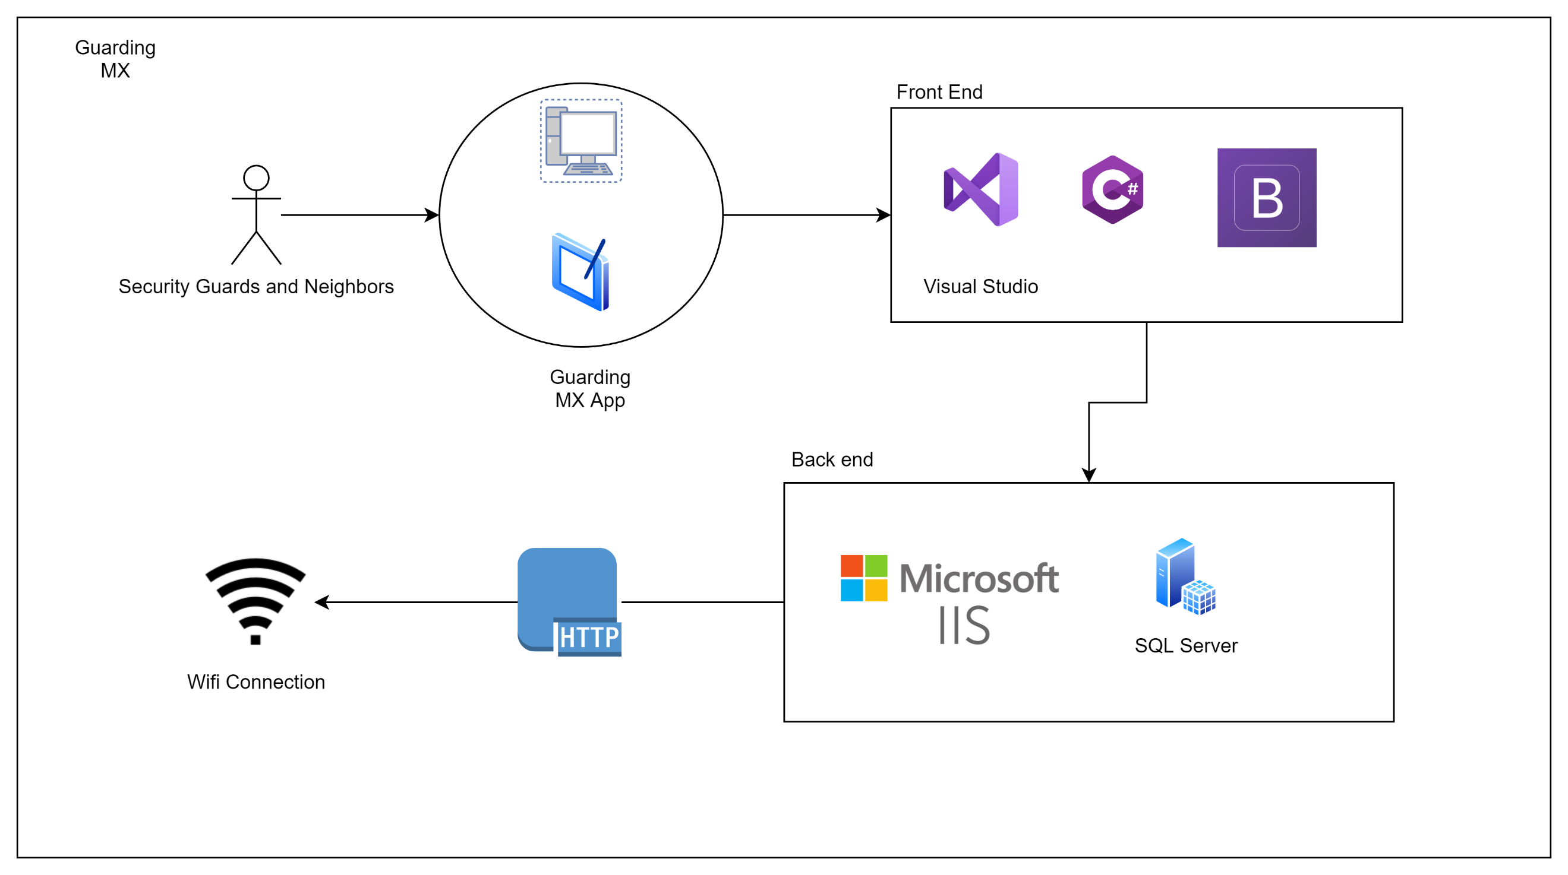

User Interface Design

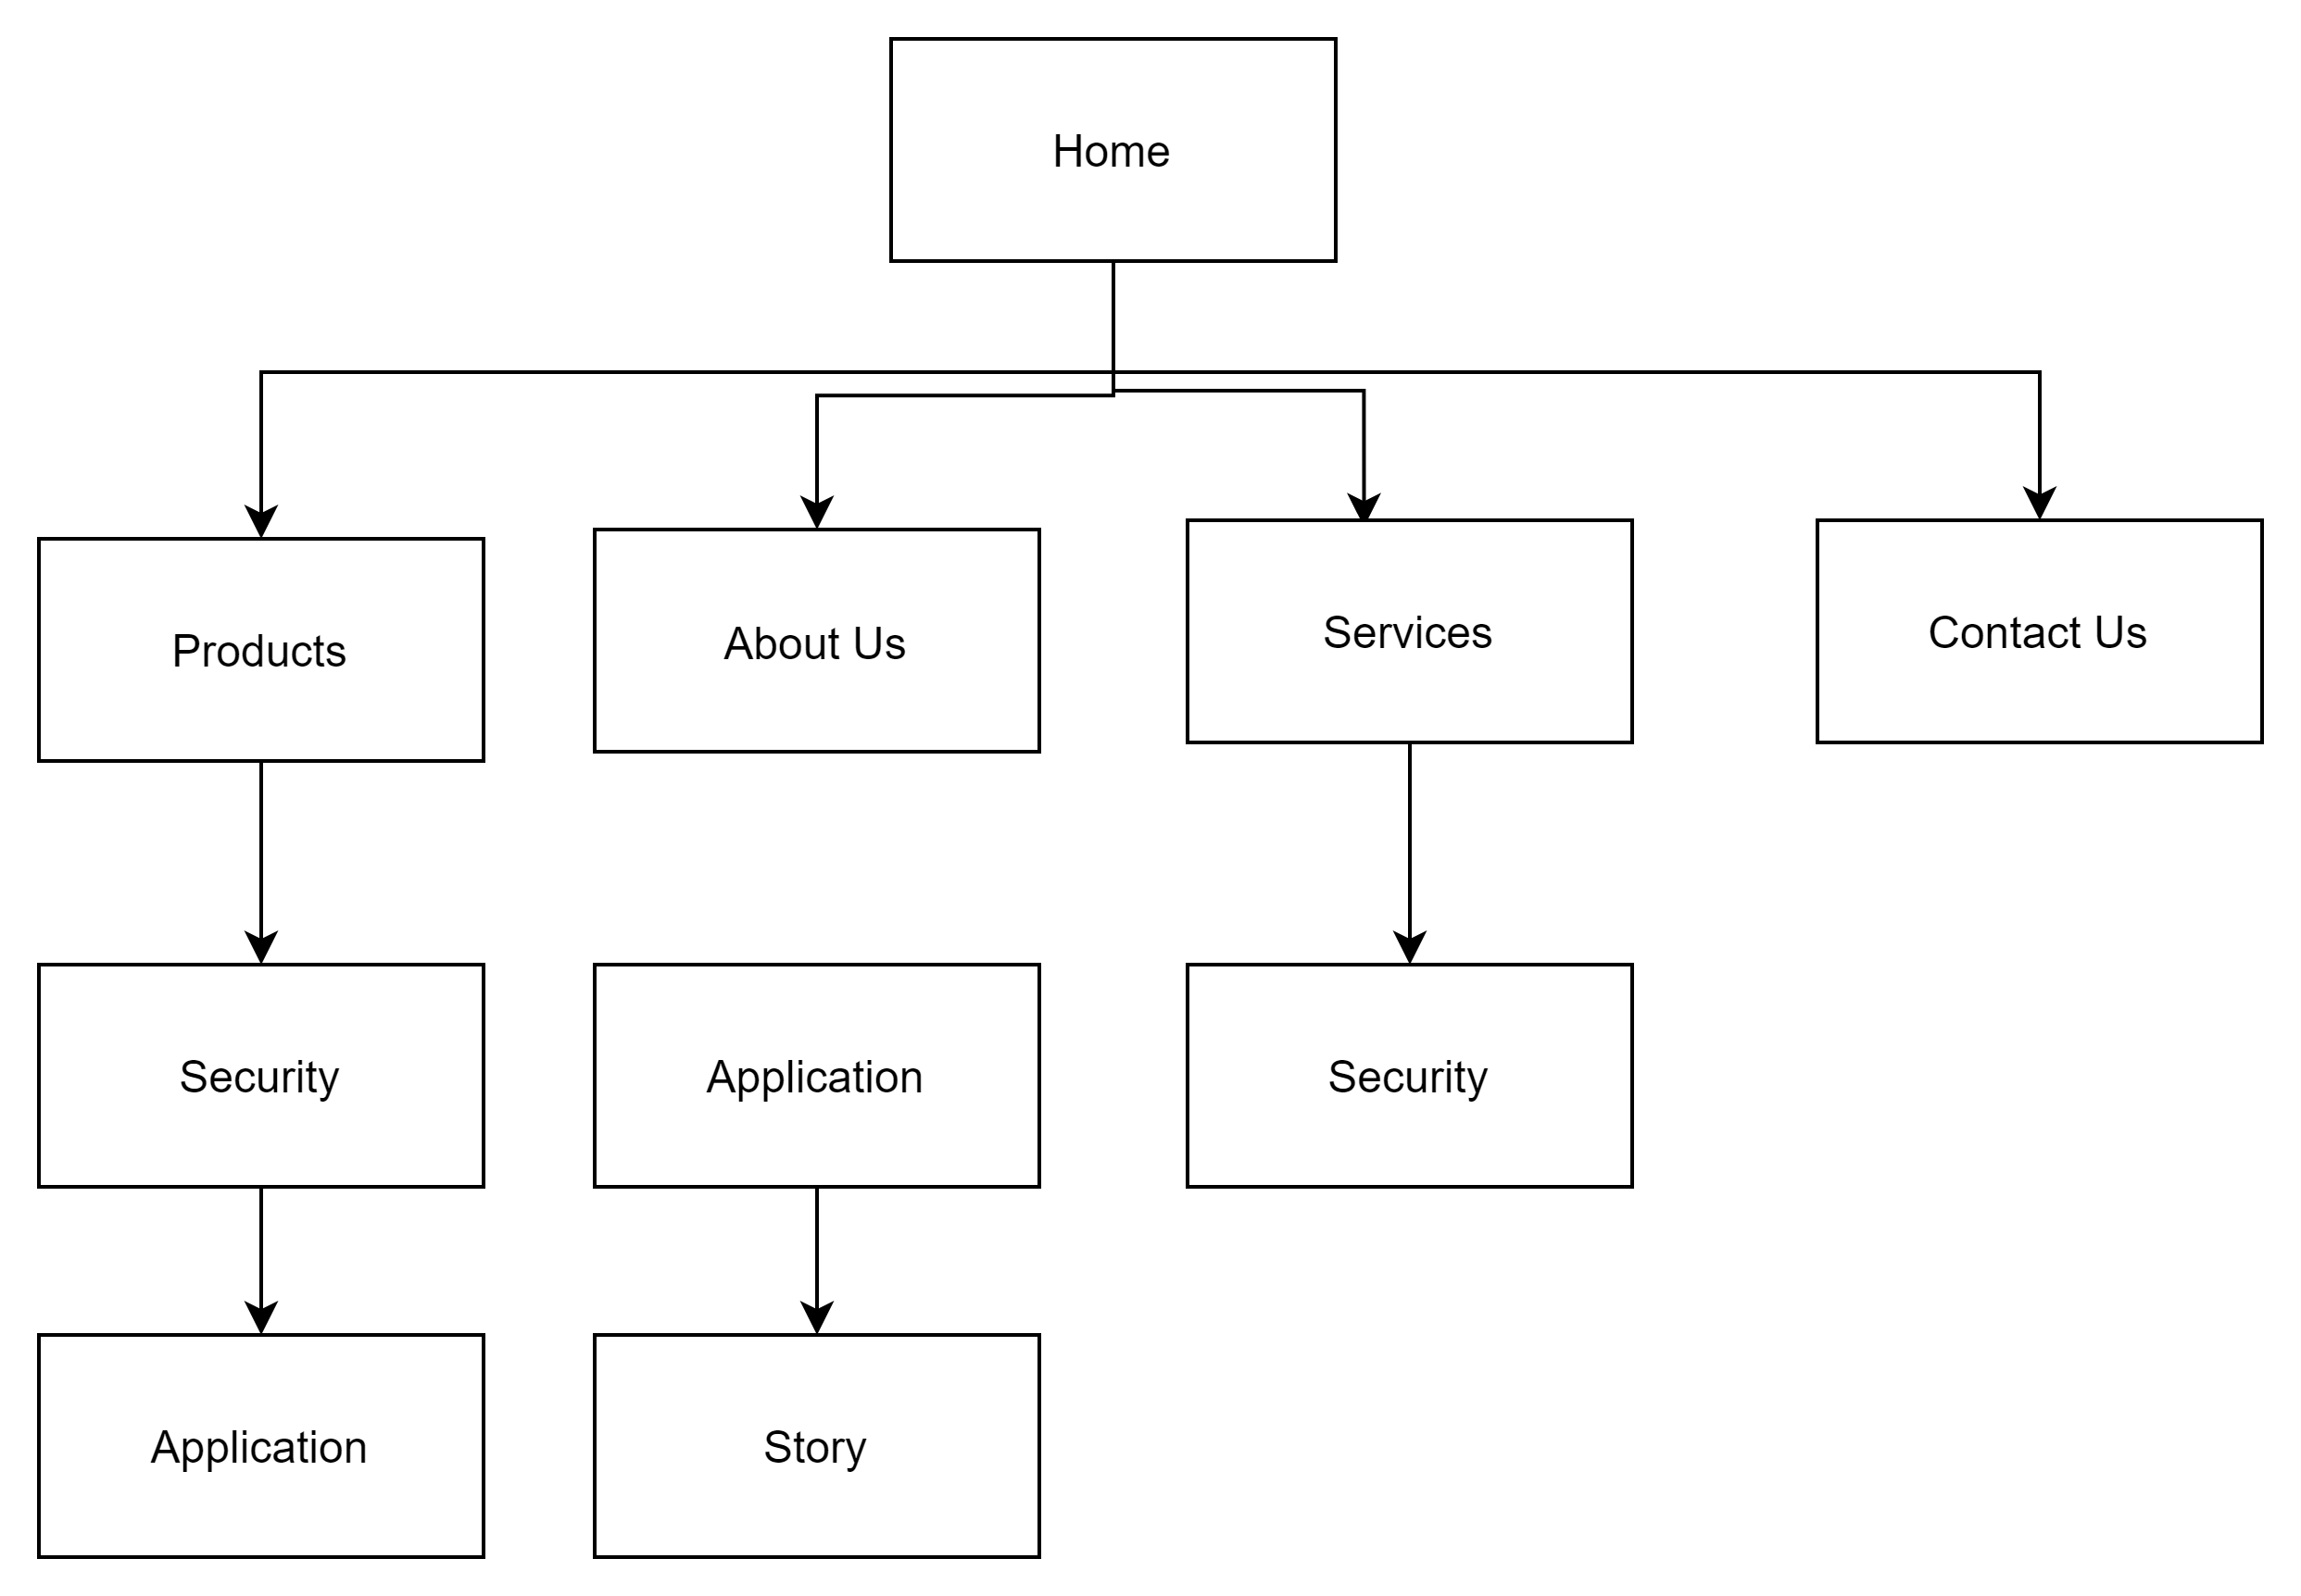

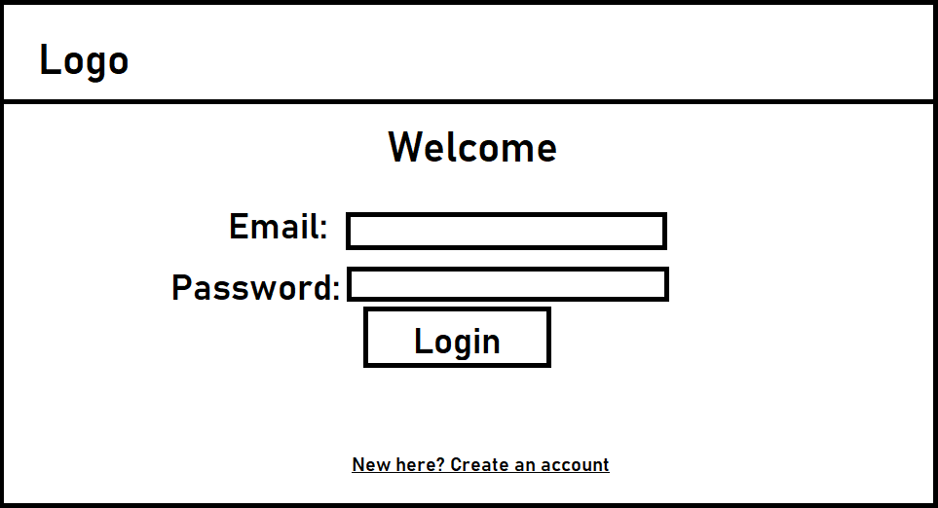

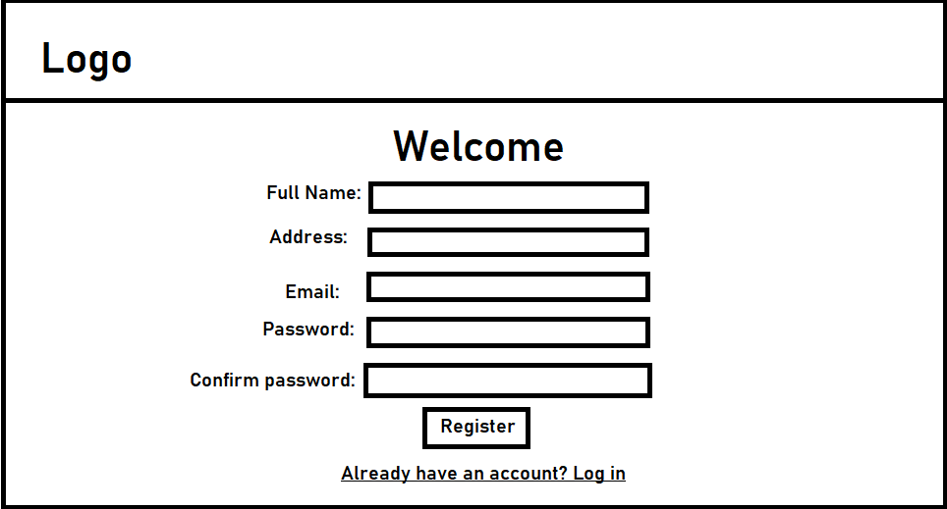

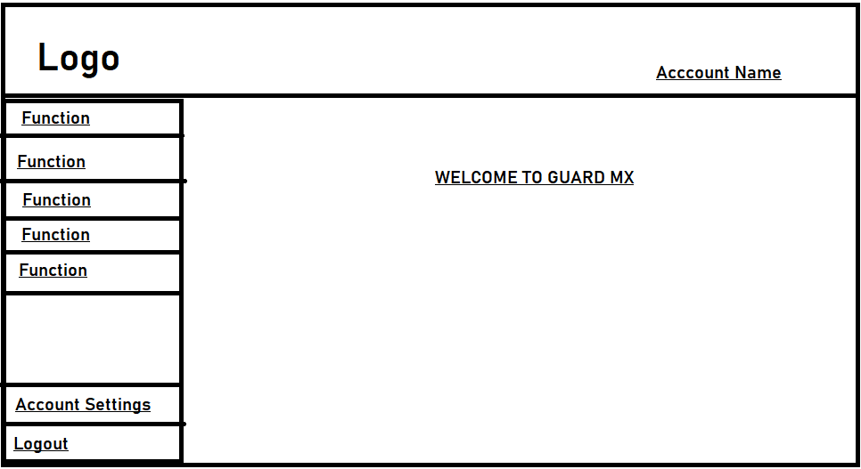

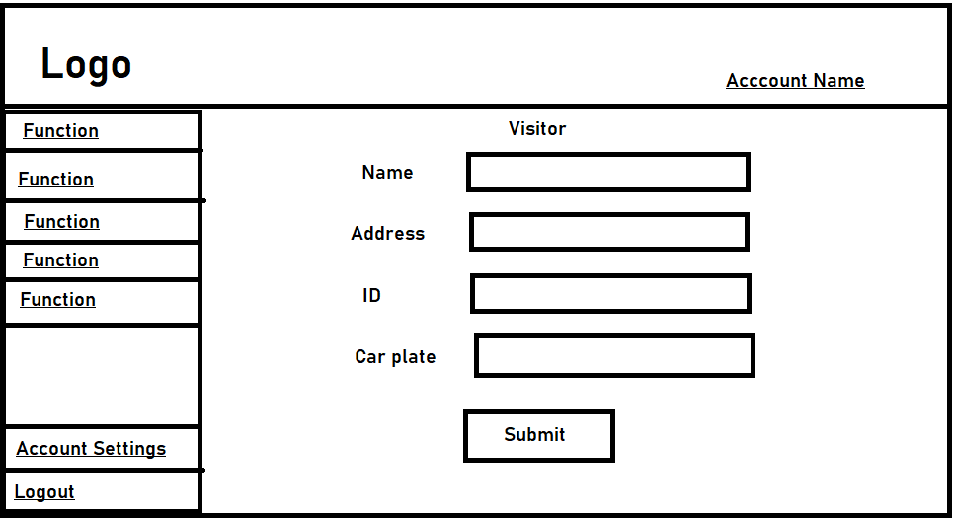

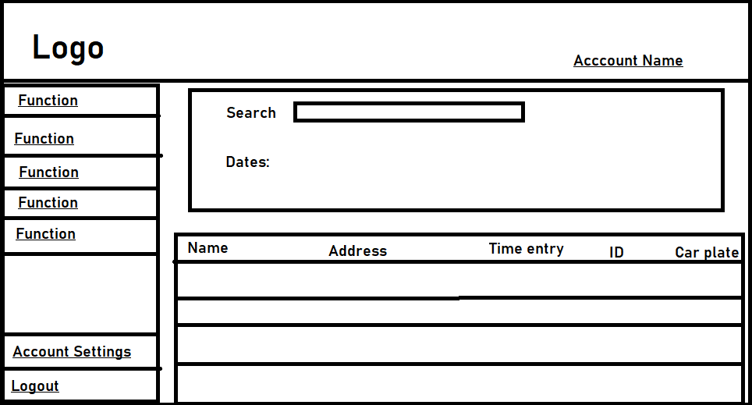

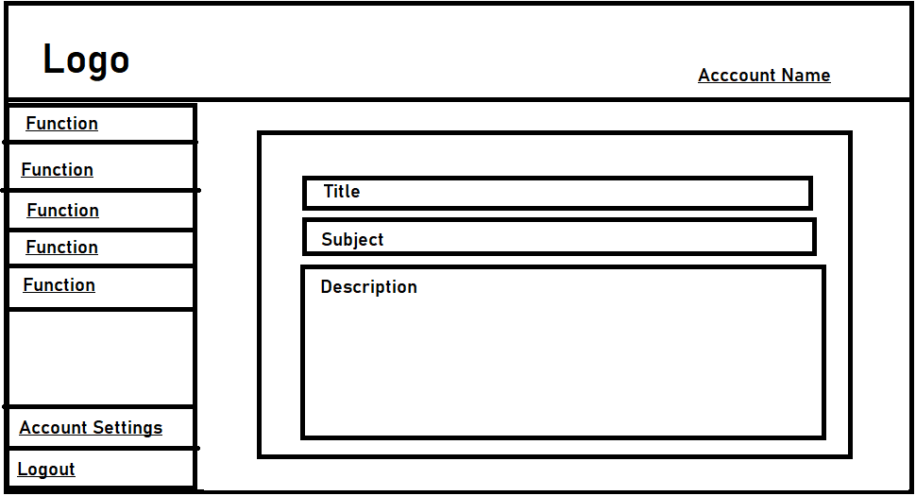

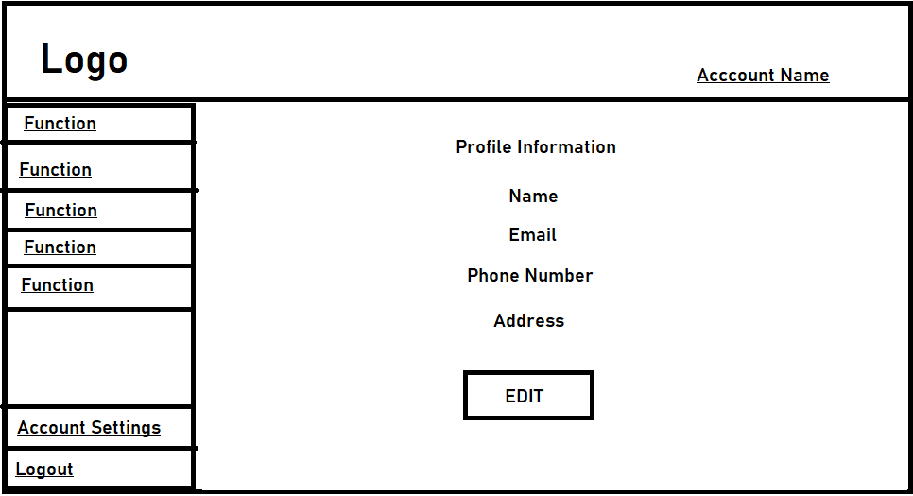

Neighbors



