Accounting notebook

Delivery files:
1 - https://github.com/AdrianRissola/agileengine-accounting_notebook/blob/dev/target/moneyaccountingsystem-0.0.1-SNAPSHOT.jar for launch project by a single-line-command.

2 - https://github.com/AdrianRissola/agileengine-accounting_notebook/blob/dev/moneyaccountservice.json exported from Advanced REST Client.

1 -
On Windows 8.1 64bits
Run:
java -jar moneyaccountingsystem-0.0.1-SNAPSHOT.jar from Git Bash

From Windows PowerSheell:
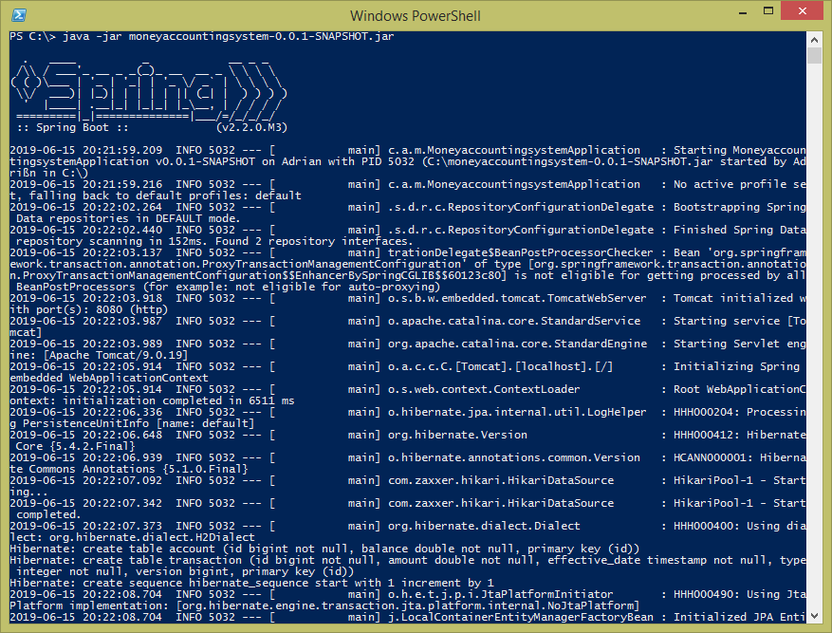
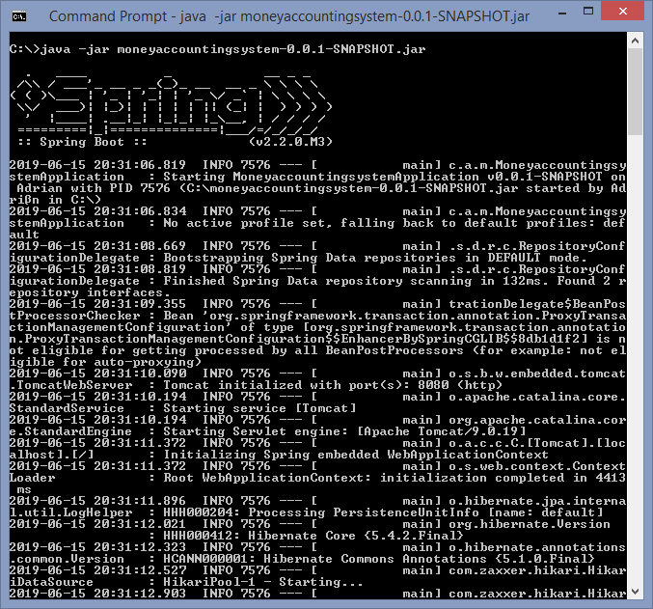
From Command Prompt:

Check localhost:8080

2 - From Advanced REST Client:
GET

POST (TODO: it should be PUT)
Request:

Response:

