Food groups that are considered Carbohydrates:

- Beans, grains, pastas, breads
- Starchy vegetables
- Dairy products, milk alternatives
- Fruits
- Snacks and baked goods
- Condiments, salad dressing

GESTATIONAL DIABETES NUTRITION
CARBOHYDRATE INTAKE: 1 serving = 15 grams
30 GRAMS OF FOR BREAKFAST ( 2 servings )
15 GRAMS FOR A SNACK
30 - 45 GRAMS FOR LUNCH ( 2-3 servings )
15 GRAMS SNACK
30 - 45 GRAMS FOR DINNER ( 2-3 servings )
15 GRAM SNACK
VEGETABLES:
VEGETABLES INTAKE SHOULD BE HALF OF YOUR PLATE 2 TIMES PER DAY EVERYDAY 7 DAYS A WEEK.
PROTEIN:
CHOOSE LEAN MEATS:
EXAMPLES: CHICKEN, COOKED FISH, GROUND TURKEY, EXTRA LEAN GROUND TURKEY.
*EGGS, NUTS AND PEANUT BUTTER ARE ALSO SOURCES OF PROTEIN
SNACKS: 15 GRAMS AND ADD PROTEIN TOO!
CHOOSE HEALTHY SNACKS EXAMPLES INCLUDE;
, FRUITS, NUTS, BOILED EGGS, VEGETABLES, LOW FAT YOGURT OR CHEESE,
AVOCADOS AND PEANUT BUTTER-NUT BUTTER ADD TO CRACKERS OR
FRUITS, HUMMUS WITH VEGGIES. PROTEIN SHAKES LIKE "GLUCERNA SMART'

- WALKING 30 MINUTES 5 -7 DAYS A WEEK IS RECOMMENDED.
- MAKE SURE TO CHECK AND LOG YOUR SUGARS 4 TIMES A DAY EVERY DAY. SUGAR GOALS; FASTING ≤95 AND ≤ 120 AFTER EACH MEAL

MY PLATE RATIO AMOUNTS
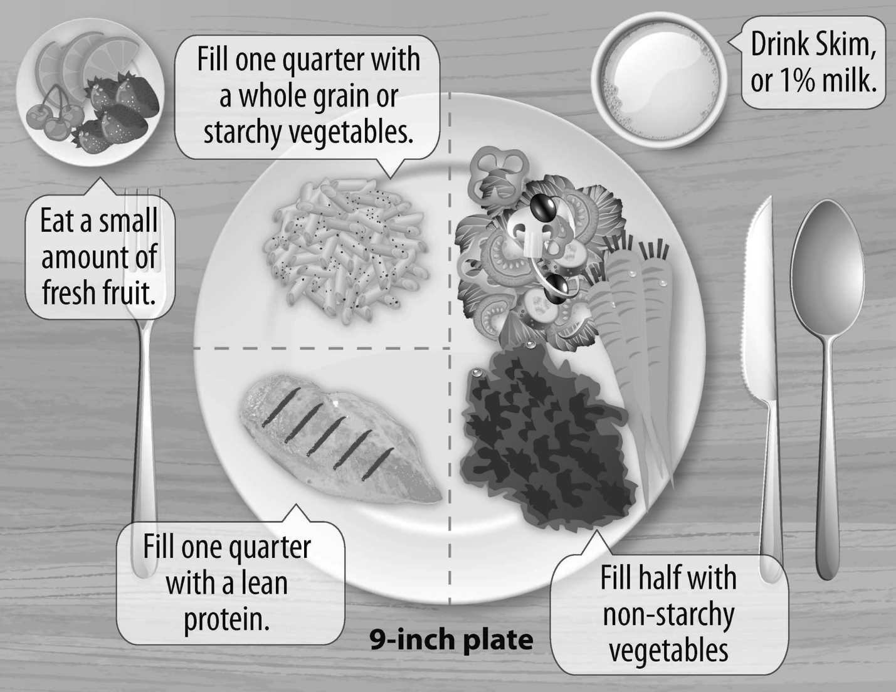
- Vegetables: Make half your plate non-starchy vegetables. Try fresh, frozen or low-sodium canned.
- Protein: Examples include chicken, turkey, lean cuts of beef, eggs, nuts, fish and tuna. Make sure that these meats are baked, boiled, sautéed, rotisserie, grilled instead of fried.
- Carbohydrates: Consume recommended carbohydrate amounts as directed, always chose whole grain products.
Remember eat 3 meals and 3 snacks (add a protein) on a schedule try to eat at the same times everyday!***

