:\Users\YourName\OneDrive\Documents\Visual Studio 2017\Templates\ProjectTemplates

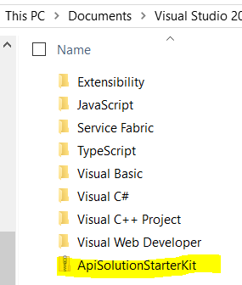

Appears in Visual Studio 2017 New Project Dialog window