<https://carlos.mendible.com/2017/08/24/net-core-code-analysis-and-stylecop/>

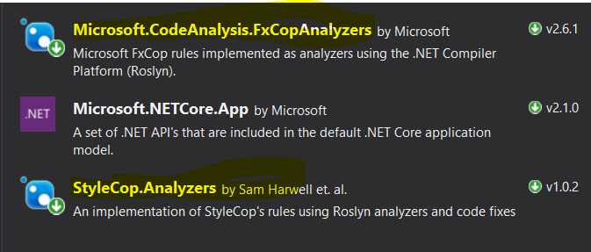

Right-click on any of the rules below and set severity level.

This will update the ruleset file that is referenced by the project file.

The ruleset file will get created if not exists, when these rules are modified and the project file will reference it automatically.

Unload the project to change the path to it, etc.

