**Farmland Composition Analyzer**

**User’s Manual**

**ENSC 26 – Computer Applications in Engineering**

**University of the Philippines Los Baños**

**May 22, 2017**

Table of Contents

**Brief Introduction ……………………………………………………………………………………… 3**

**The User Interface ……………………………………………………………………………………... 4**

**Capturing Farmland Image …………………………………………………………………………... 5**

**Capturing the Scale …………………………………………………………………………………… 8**

**Image Processing ……………………………………………………………………………………… 9**

**Features after Processing**

1. **Land Area Computation ………………………………………………………… 14**
2. **Show Pie Chart of Land Composition Percentages ……………………………. 18**
3. **Highlight Grass and Soil Areas …………………………………………………. 19**
4. **Other Features …………………………………………………………………… 21**

**Brief Introduction**

Computers are very convenient; it enables the user to create programs in which the principles of their fields of interest are put into application. With the sufficient knowledge in the field and computer programming, the programs become very useful and convenient, considering that all the desired functions are met. However, to make programs run properly, the codes must be written completely and correct. Also, the interface must be user-friendly and be able to function properly through the codes.

This manual shows how to use one of the applications of computer in engineering. The program is called *Farmland Composition Analyzer*, which determines what percentage of a certain land area is composed of grass, soil, and other unknown materials. This manual shows the step-by-step procedure on how to use the user interface.

Also it is important to note that the program is only suitable for farmlands. Other images captured from Google Maps aside from that will yield inaccurate results.

**The User Interface**

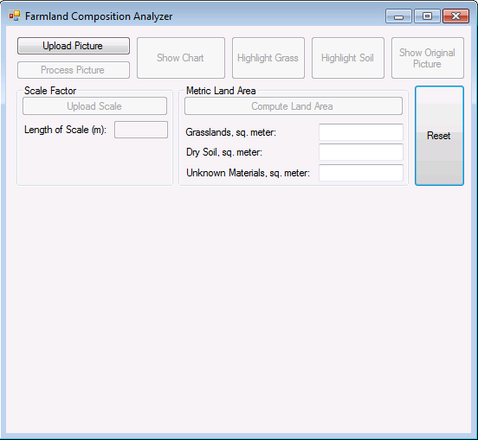

Upon opening the program, only the Upload Picture and Reset buttons are enabled. Since the Reset button will only return the program in its initial state, it is not yet necessary to click. Thus, a picture must be uploaded first.

**Capturing Farmland Image**

The first thing to do is to capture a farmland from Google Maps. In order to do this, the user must open Google Maps first from the Internet, and then switch the map into satellite mode.

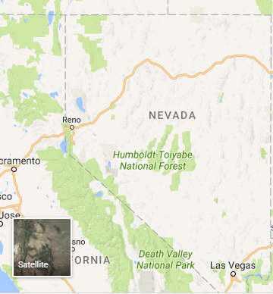

Click here to switch into satellite mode

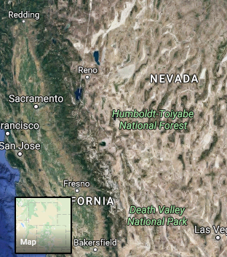

**Example of a Satellite Image**

Afterwards, use the Snipping Tool from the Computer and capture a farmland. A farmland should look like this: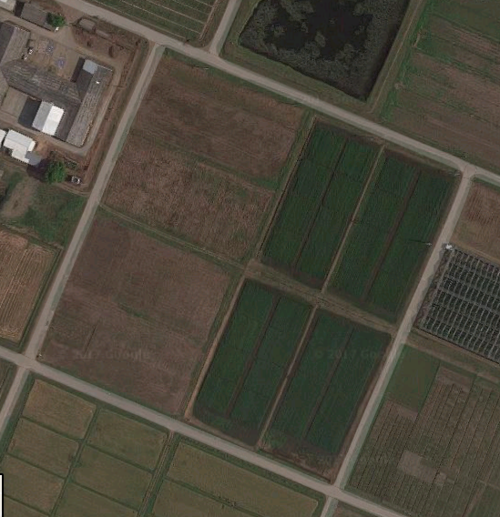

**Capturing the Scale**

Along with the image, the scale (image and value), should be captured as well. This will be used in the program, especially in the calculation of land area. The scale can be found in the bottom right portion of Google Map.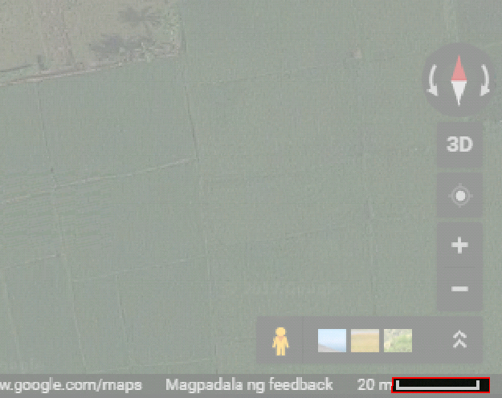

Use snipping tool to crop the scale. Also take note of the value beside the scale image

After capturing the image and scale, it must be uploaded to the program. The next section will show how to upload and process the captured image.

**Image Processing**

**Step 1:** Click the Upload Picture button



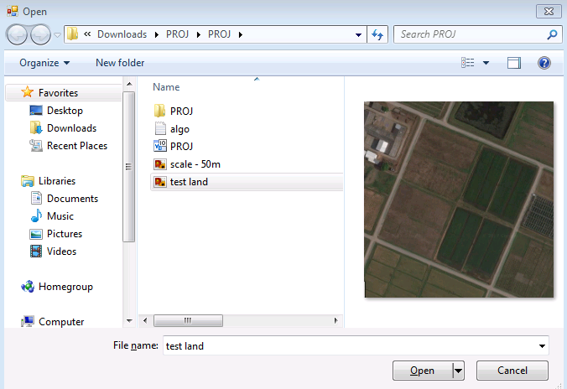

**Step 3:** After selecting, click Open Button

**Step 2:** Select the map to be uploaded

Upon clicking, a dialog box will appear, and will require the user to upload pictures. Specifically, farmland images from Google Maps should be uploaded.

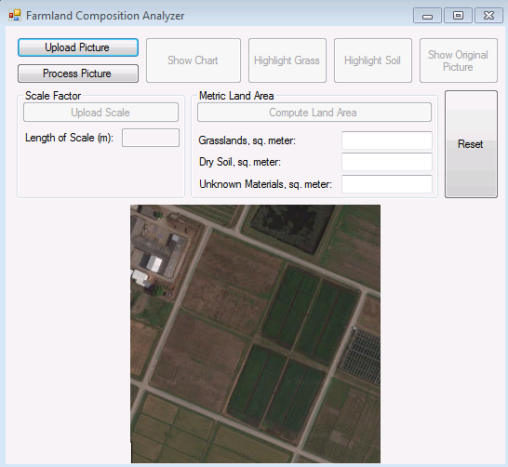

After uploading the image, it will appear on the center bottom part of the interface. The image is now ready to be processed and analyzed.

**Step 4:** Click on the Process Picture Button



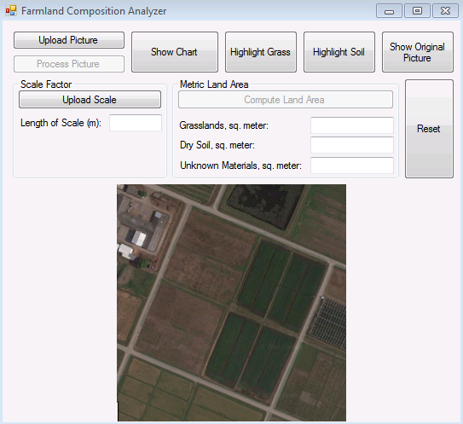

After processing the image, the Process Picture will be disabled, and the other buttons are now enabled. These only mean that the image has been analyzed.

**Features after Processing**

1. **Land Area Computation**

To enable the land area computation function, a scale must be specified. The following steps show how to compute the land area of each composition.



**Step 1:** Click the Upload Scale button

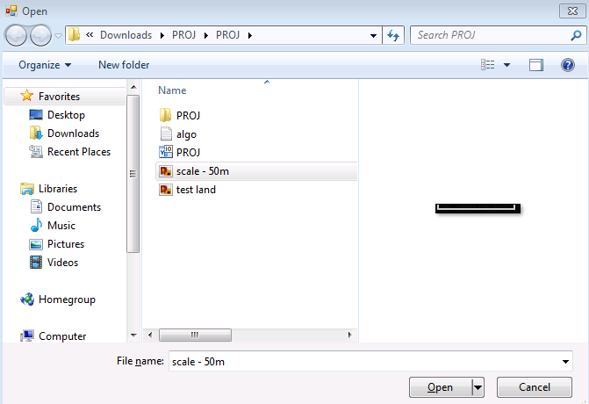

**Step 3:** Click the Open button

**Step 2:** Select the scaling image

Once after it is done, the Compute Land Area button should have been enabled. The next thing to do is to specify the scale and to finally show the result

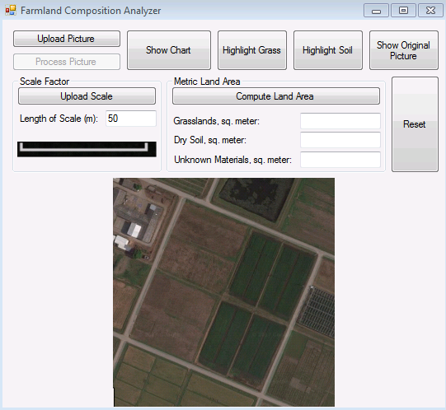

Step 3: Specify the scale

**Step 4:** Click the Compute Land Area button

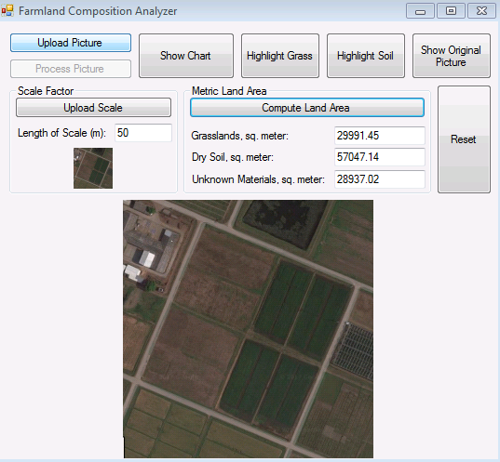

**Final Output**

1. **Show Pie Chart of Land Composition Percentages**

After processing, the program has already determined how much of the land is composed of grass, dry soil, and other unknown materials. To view this by percent, a pie chart will be shown by clicking the Show Chart button.

Click the Show Chart button

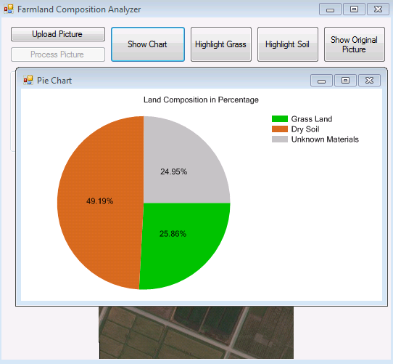

A pie chart will appear in a separate window, as shown.

1. **Highlight Grass and Soil Areas**

To highlight the grass or the Soil areas, click on the Highlight Grass button or Highlight Soil button, respectively. The output will be a grayscale image, in which the highlighted areas are white, while the rest are in black.

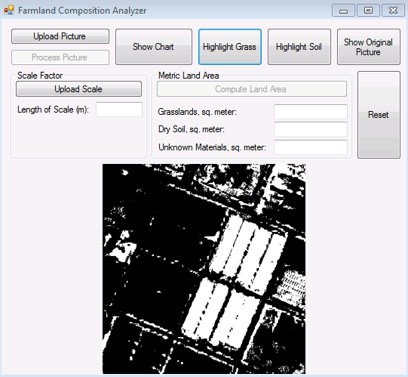

**Grass Areas are Highlighted**

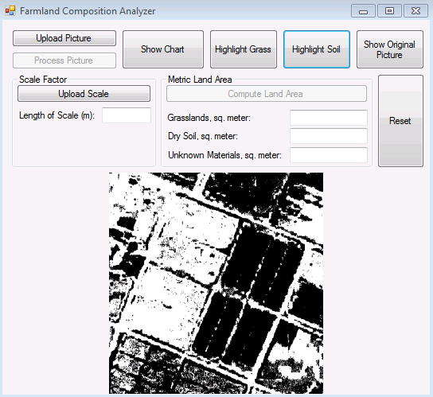

**Soil Areas are Highlighted**

**Other Features**

1. **Show Original Picture** button – If the displayed image highlights either the grass or soil area, clicking this button will display the original image
2. **Reset** button – clicking this button will return the program to the state when it was opened.

**References**

Microsoft. (n.d.). Bitmap Methods. Retrieved May 20, 2017, from https://msdn.microsoft.com/en-us/library/system.drawing.bitmap_methods(v=vs.110).aspx

Satellite Imaging Corporation. (n.d.). Agriculture Mapping. Retrieved May 20, 2017, from http://www.satimagingcorp.com/applications/natural-resources/agriculture/

StackOverflow. (n.d.). Converting RGB to Gray scale? Retrieved May 20, 2017, from http://stackoverflow.com/questions/17216883/converting-rgb-to-gray-scale