Game Treatment Document

Gerald De Vera, Jackson, Adrian Manrique, JP, Andrew

**Gameplay**

The gameplay for our roguelike game is aimed to be fast paced. The player should be able to launch the game and get into the game easily. The game will have a top down view to allow the player to see most of the room, and make their decisions quickly.  
 The enjoyment comes from a gameplay loop evident in other existing roguelike games, where the player is able to go into a new playthrough of the game and it won’t be the same run as any previous run. There would also be a sense of progression for the player where they gain powers and become stronger as they progress through the game.

**Story Architecture**

The story of the game is a very simple story, as we are focused more on the gameplay. You start out in the depths of a dungeon without your memories, but there’s one thing you know you have to do. Escape. You start with a basic weapon, and nothing to your name. You must fight your way through an ever changing dungeon and try to escape, or perish trying.

**Roguelike Aspect and Sense of Progression**

A key feature to this game is it’s roguelike genre. The player is able to go through the game and replay it freely. As the character does subsequent runs, there will eventually be a point where the player has gone through all possible runs and routes. As to help with the sense of the progression, and include extra replayability is to allow the player to unlock items throughout subsequent runs for completing challenges. For example, if the player manages to beat the boss for the first time, they may unlock a new starting weapon or new upgrade to play with in their next playthrough of the game.

**Room Design**

The following drawing (Figure 1.0) is a concept room drawn for level design. Each room will be an instance or scene that the player will enter. Within each room, there will be enemies to fight that are required to beat in order to move on to the next level. To ensure that each room is unique, there can be traps or hazards located in the room that the player must look out for. After clearing the room, the player may be able to obtain an upgrade that will stick with them throughout the rest of the game.

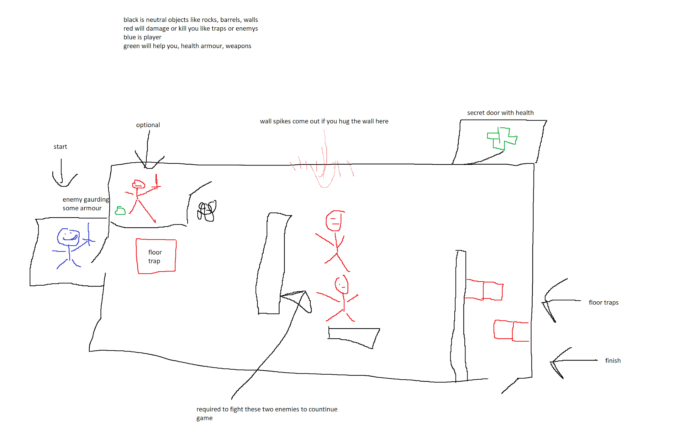  
 Figure 1.0

**Storyboard and Level Design**

The following images showcase a simple path that the player may take. The rooms themselves may be randomized, and each room they tackle is different. The player may also have the choice of having a more challenging room, but rewards them with extra benefits. Both figures (Figure 1.1, Figure 1.2) showcase how at the end of each run contains a boss for the player to fight before the end of the game.

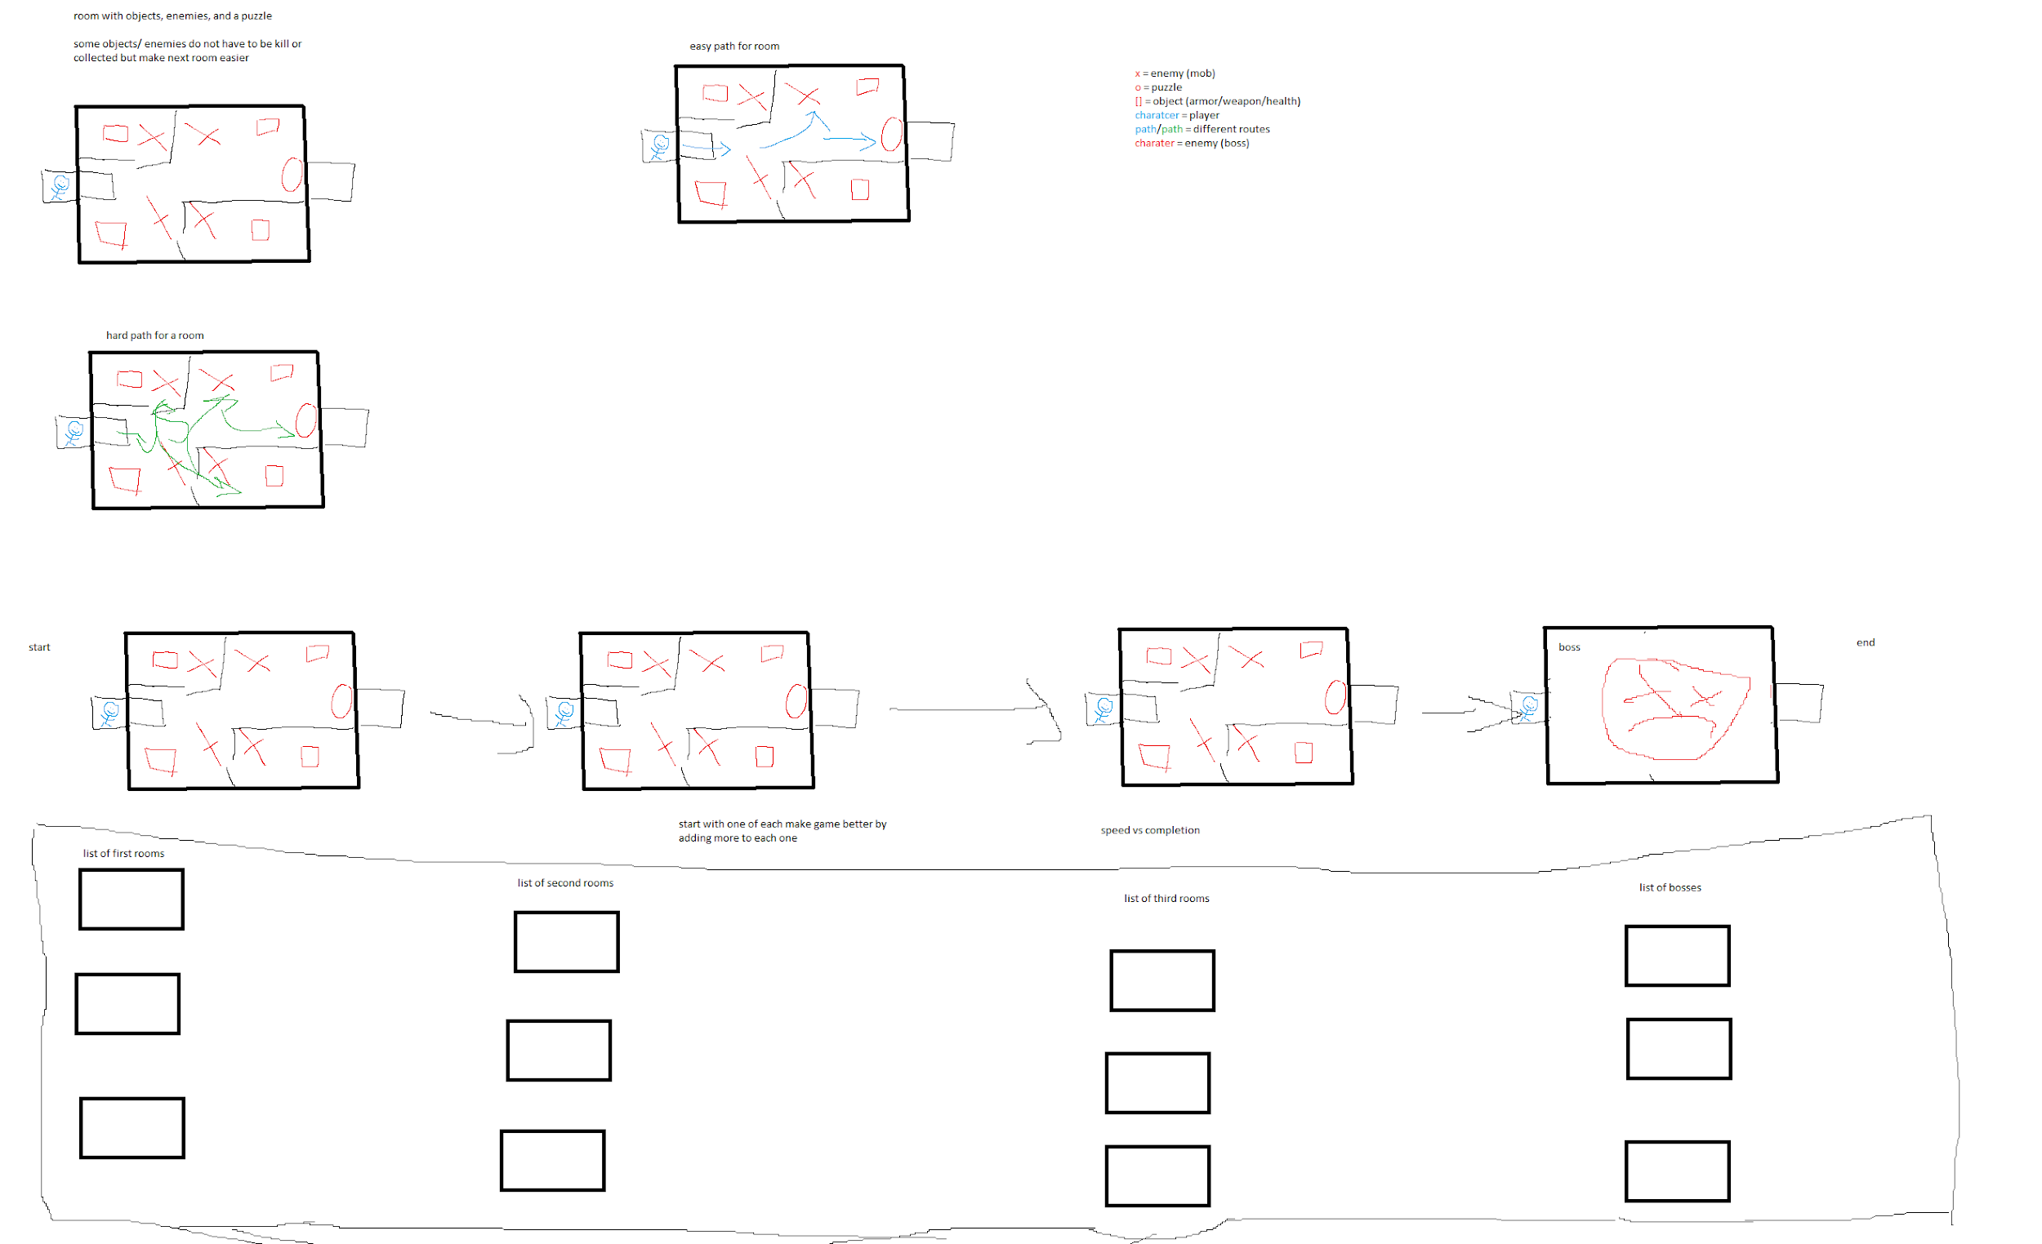  
 Figure 1.1  
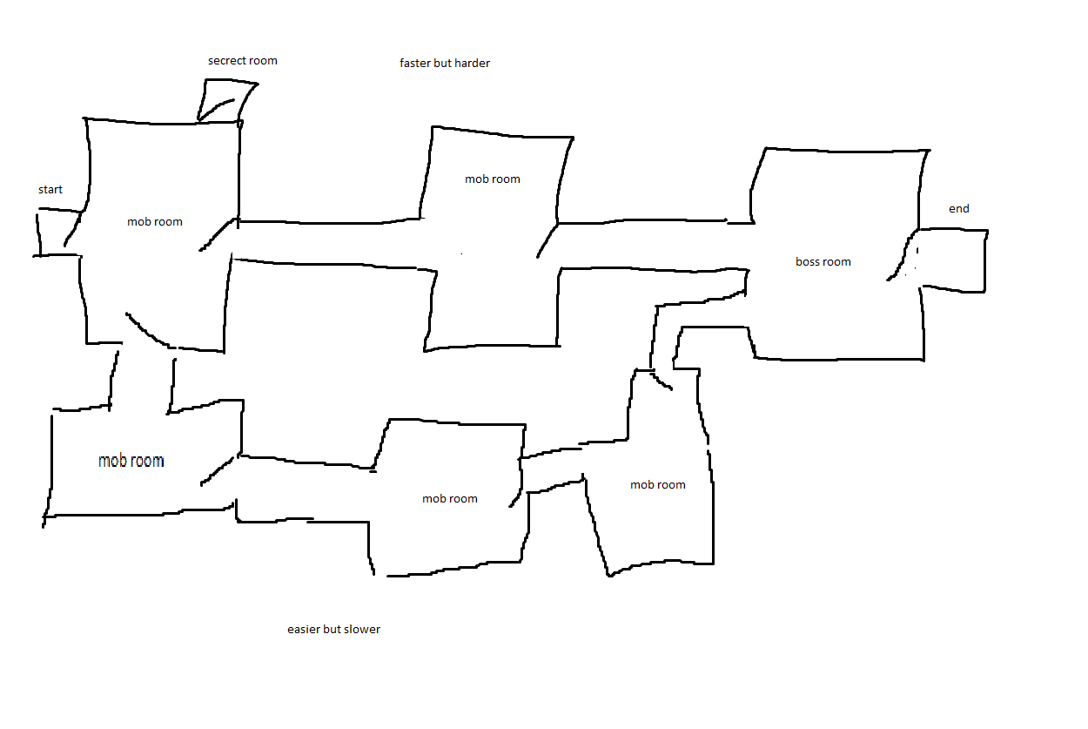  
 Figure 1.2

**Role Split**

|  |  |  |  |
| --- | --- | --- | --- |
|  |  | **Role Split Table** |  |
|  | **Roles** | **List of duties in detail** | **Plans for good execution of the duties** |
| **Jackson** | Programmer and Sound Engineer | Make sure to find or produce any sounds we may need for the game, such as sfx or even music.  Will be on the programming team to make sure the game can function | Communication with the team to confirm and talk about what is needed for the game  Find fitting sounds, coins should sound like coins, blood splatters like squishes and so on.  Program the game in such a way that all code is reusable. Rooms should only change by what enemies spawn and what's in the room. Everything else is the same. |
| **Adrian Manrique** | App Design  Project Documentation | Come up with game design and level ideas.  Document and record status of the game throughout different stages. | Communicate with the team about the ideas and find new inspirations for the game.  Work with the other project documentation manager to make sure that documentation is properly recorded |
| **JP Currie** | Programmer  Testing | Will be on the programming team to make sure the game can function  Run tests on the game and report how it is to the app designers and programmers | Work with the other programmer to make sure that their codes and ideas coincide for easy merging, and compatibility.  Ensure that communication with the app designers, and programmers is sufficient to express any concerns or issues that may occur when testing the game |
| **Andrew** | App Design  3D Modeling | Come up with game design and level ideas.  Find or create new models for the game that fit the theme of the game | Communicate with the team about the ideas and find new inspirations for the game.  Find fitting models that fit the visual style and theme of the game, while also making sure to confirm with the team about the models. |
| **Gerald** | Management  Project Documentation | Manage the team, and assign roles to others to make sure everyone is working to their utmost ability.  Make sure all proper documentation and progress of the project is recorded and followed. | In order to make sure that this project works smoothly, it’s important to communicate with the team, and talk to everyone regularly  Document each new step taken between the last report and the most recent one.  Show the progression of the game. What build are we on. What have we changed. What have we added/given up on. Basically report on everything that's taken place from the moment we started to when we submit the final project. |