Project Proposal

Gerald De Vera, Jackson, Adrian Manrique, JP, Andrew

**Workflow Planning**

**Working together** Most of the work can be done individually, and we will have weekly meetings in order to maintain workflow order, and that each task is being completed successfully. Programming, documentations, and app ideas can be done with groups of two, if both parties are available and wish to work together at said time. In terms of programming, we can utilize pair programming style, otherwise we have a shared unity account and use unity collaboration in order to have people work on the program and upload any new programs or assets they added.  
 **Meetings**

As stated in the prior section, we will have a meeting every week in order to determine the status of the game, and make sure that workflow is efficient. We can communicate to each other via direct messaging, or using Discord. If someone is having trouble with a task, then they can bring it up to the group, or during the meetings. All problems that individuals or subgroups may have can be addressed to the team.

**Sub-Teams**

Pairs who have the same tasks can work together in order to work on tasks together to help improve work efficiency.

**Storyboard**

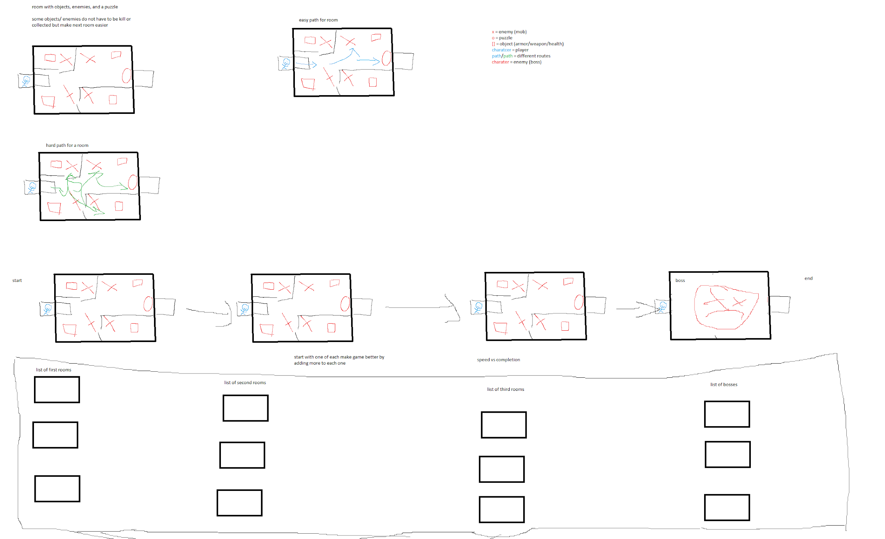

This is a storyboard for the game that provides base ideas and routes a player may take for a level. The player will enter a room, and be presented with enemies, challenges, and a bonus. The player can choose how they wish to tackle the room, and how they wish to proceed. As the player moves from room to room, a different scene will be loaded each time and after 2-3 encounters, the player will be put into the final stage which will contain a boss monster for the player to fight.

**Work Milestone Planning**

|  |  |
| --- | --- |
| Week 9 | Proposal |
| Week 10 | Solidify Game Idea + Get at least one level of game in working order |
| Week 11 | Initial Prototype Demo |
| Week 12 | Create more custom powerups, enemies, etc  Solidify assets, models, sfx, etc. |
| Week 13 | Create different variations for rooms, and levels to play through |
| Week 14 | 2nd Prototype Demo |
| Week 15 | Polish up game and create final boss if possible |
| Week 16 | Final Project Demo |

**Trello Screenshot**  
