# Lab: Defining Classes

Problems for exercises and homework for the ["C# OOP Basics" course @ SoftUni](https://softuni.bg/trainings/1636/c-sharp-oop-basics-june-2017).

You can check your solutions here: <https://judge.softuni.bg/Contests/674/Defining-Classes-Lab>

# Part I: Defining Classes

## Define Bank Account Class

Create a class named BankAccount.

The class should have private fields for:

* id: int
* balance: double

The class should also have public properties for:

* ID: int
* Balance: double

You should be able to use the class like this:

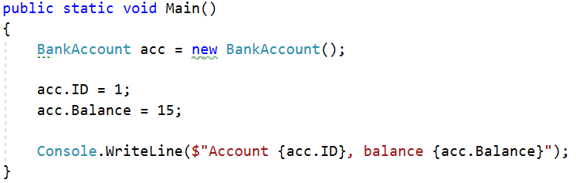

### Solution

Create a **new class** and ensure **proper naming**

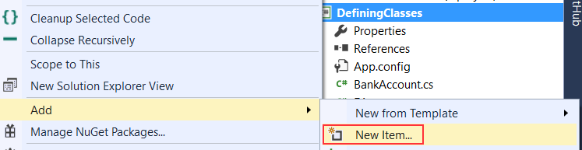

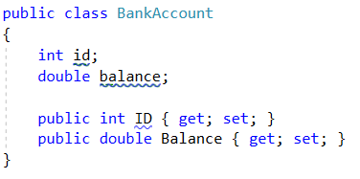

## Methods

Create a class BankAccount (you can use class from previous task)

The class should have private fields for:

* id: int
* balance: double

The class should also have properties for:

* ID: int
* Balance: double
* Deposit(Double amount): void
* Withdraw(Double amount): void

Override the method ToString().

You should be able to use the class like this:

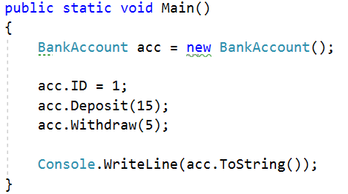

### Solution

Create a method Deposit(double amount)

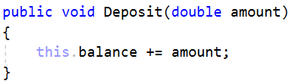

Create a method Withdraw(double amount)

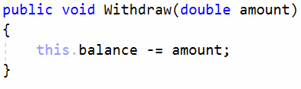

Override the method toString()

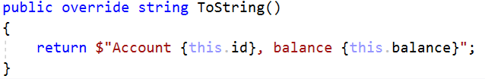

## Test Client

Create a test client that tests your BankAccount class.

Support the **following commands**:

* **Create {Id}**
* **Deposit {Id} {Amount}**
* **Withdraw {Id} {Amount}**
* **Print {Id}**
* **End**

If you try to create an account with existing Id, print **""**.

If you try to perform an operation on **non-existing account** with existing Id, print **"****Account does not exist"**.

If you try to withdraw an amount larger than the balance, print **"****Insufficient balance"**.

The Print command should print **"Account ID{id}, balance {balance}"**. Round the balance to the second digit after the decimal separator.

### Examples

|  |  |
| --- | --- |
| **Input** | **Output** |
| Create 1  Create 1  Deposit 1 20  Withdraw 1 30  Withdraw 1 10  Print 1  End | Account already exists  Insufficient balance  Account ID1, balance 10.00 |
| Create 1  Deposit 2 20  Withdraw 2 30  Print 2  End | Account does not exist  Account does not exist  Account does not exist |

### Solution

Create a Dictionary<int, BankAccount> to store existing accounts

Create the input loop

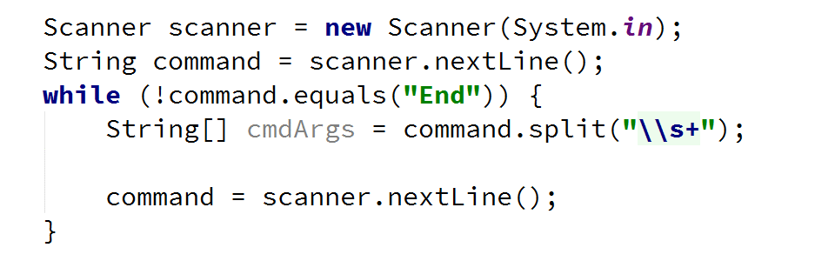

Check the **type of command** and **execute** accordingly (***optional:*** *you can create a separate method for each command*)

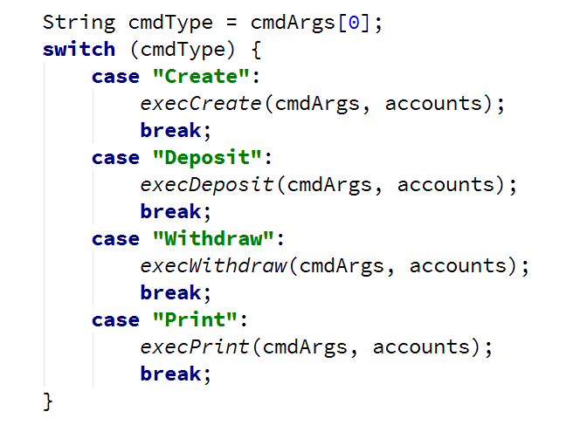

Implement the Create command

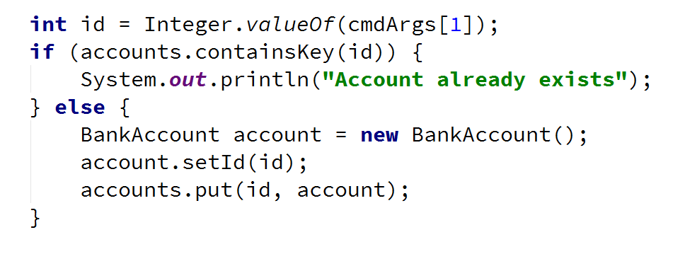

Implement the rest of the commands following the same logic

## Define Person Class

Create a **Person** class.

The class should have **private fields** for:

* Name: **string**
* Age: **int**
* Accounts: List<BankAccount>

The class should have **constructors**:

* Person(string name, int age)
* Person(string name, int age, List<BankAccount> accounts)

The class should also have **public methods** for:

* GetBalance(): double

### Solution

Create the class as usual

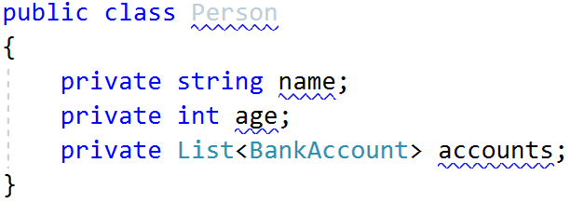

Create a constructor with two parameters

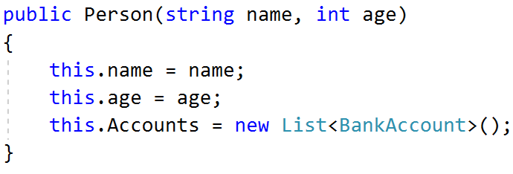

Create a constructor with three parameters

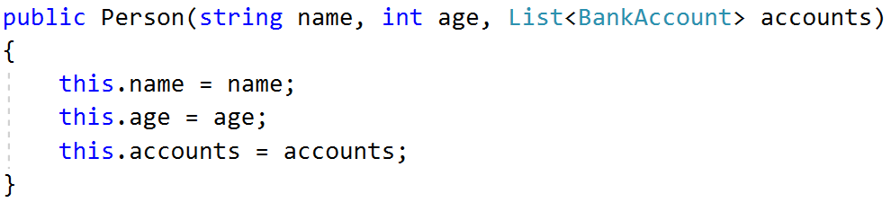

Create method GetBalance()

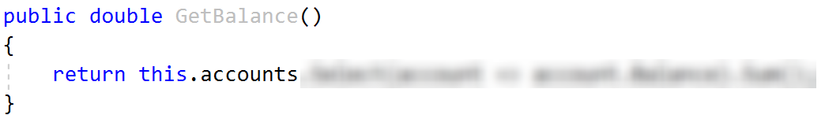

***Optional:*** You can take advantage of **constructor chaining**

