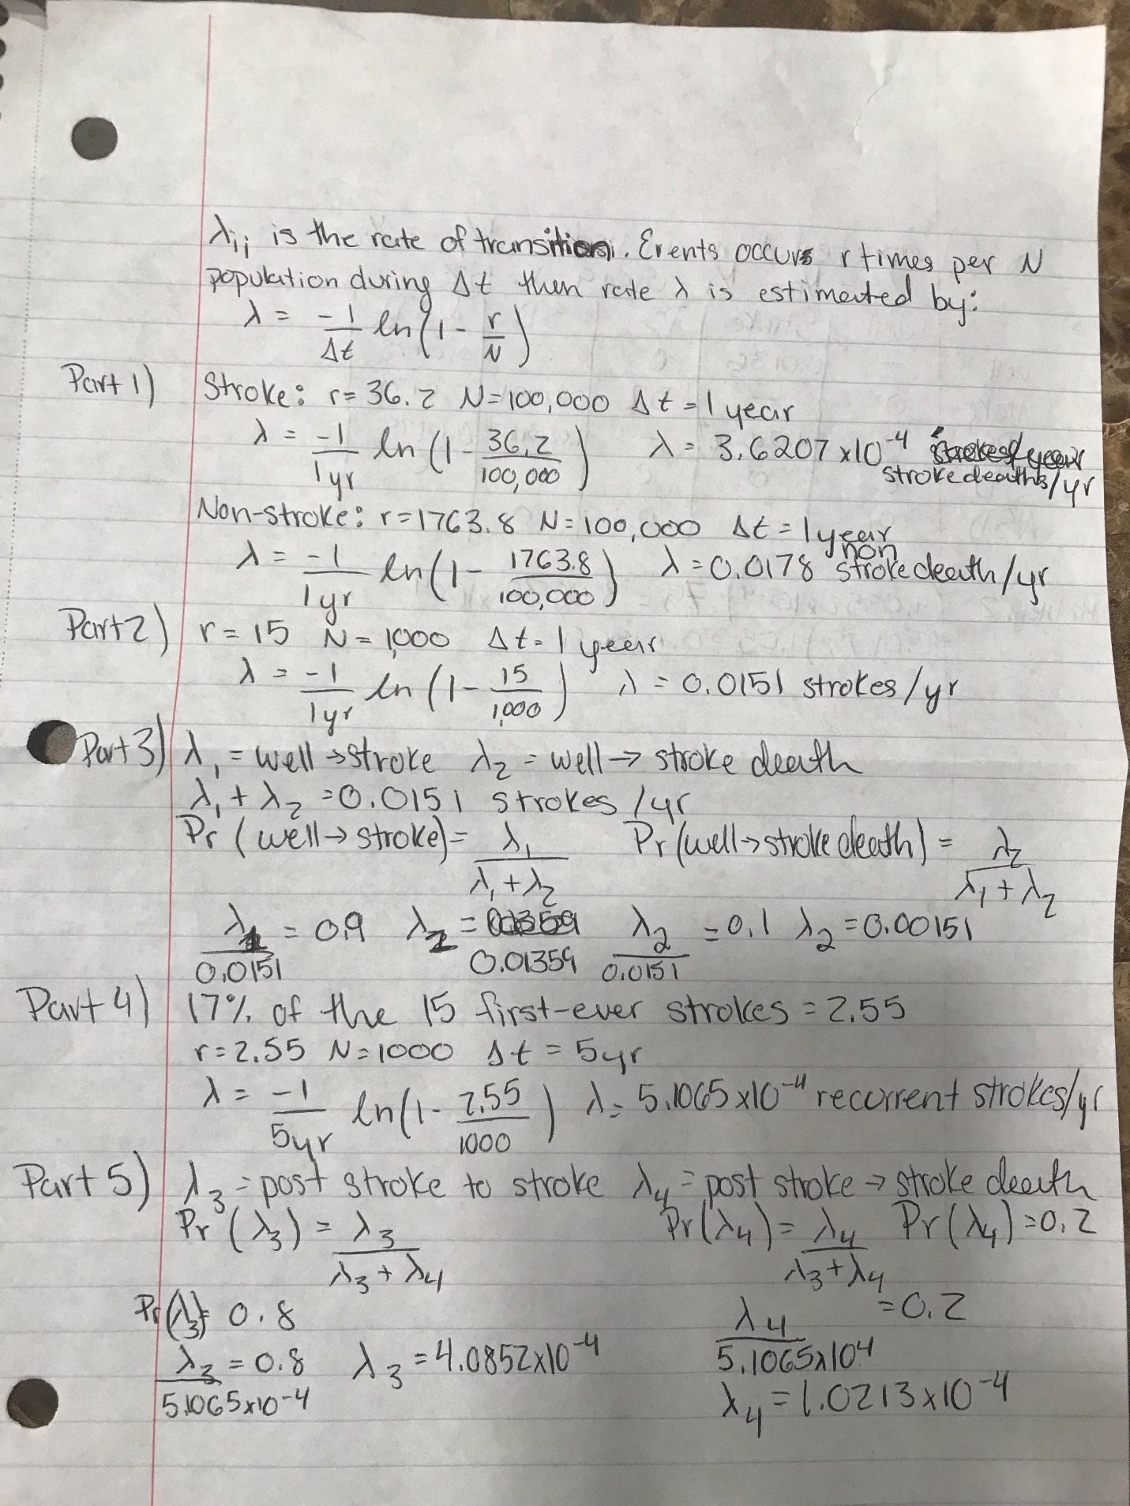

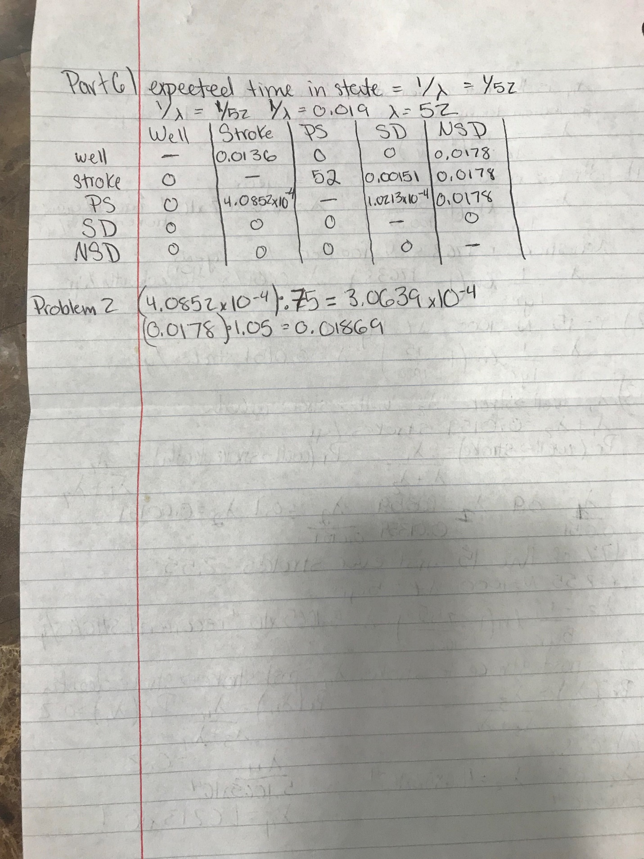

RATE_MATRIX = [  
 [**None**, 0.0136, 0, 0.0151, 0.0178],  
 [0, **None**, 52, 0, 0],  
 [0, 0.00040852, **None**, 0.00010213, 0.0178],  
 [0, 0, 0, **None**, 0],  
 [0, 0, 0, 0, **None**]  
 ]  
  
RATE_TREAT = [  
 [**None**, 0.0136, 0, 0.0151, 0.0178],  
 [0, **None**, 52, 0, 0],  
 [0, 0.00030639, **None**, 0.00010213, 0.01869],  
 [0, 0, 0, **None**, 0],  
 [0, 0, 0, 0, **None**]  
]