# Building Intuition For Fourier Series (Part I)

Start by loading the “Fourier: Making Waves” applet if it isn’t already open. Your screen should end up looking like this:

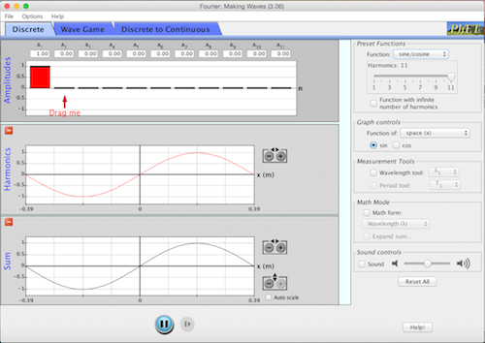

1. Click on the “Wave Game” tab. Select “Preset” from the “Level” drop-down menu. Each selection in the menu will generate a pink curve in the bottom plot. Your goal is to find the relative strengths of various sine curves that need to be added together to reconstruct this curve. Take turns going through all the preset options except the “triangle” (there’s a problem with the software for that one). Then try Levels 5 and up.

For the next two questions, go to <http://www.falstad.com/fourier/>. You’ll end up with something that looks like this:

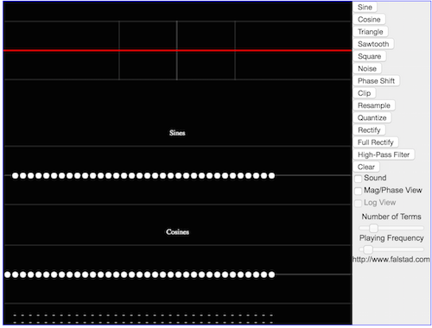

The app does pretty much the same thing as the previous one, but this one doesn’t restrict you to just sine curves and allows you to mix together sines and cosines.

1. Each white dot represents the strength of a sine or a cosine curve of a different period. Drag some of them up or down to get a sense for this. Then click “Clear” to reset your screen.
   1. Play around with only the cosine “dots”, keeping all the sine dots at zero. What sort of functions can you create? Are they symmetric in any sort of way?
   2. Now do the same with the sine “dots”. What sort of functions can you create now? Are these symmetric?
2. How do I create a “spike” at the origin? Play around with the white dots to find out. What’s unusual about the strengths of the sines and cosines needed to make a spike, compared to the other examples we’ve seen so far? Can you explain why your mixture of sines/cosines give a spike? For this exercise, it may be handy to check your answers by going back to the original applet and using the “Auto scale” feature in the “Discrete” tab.