# Building Intuition For Fourier Series (Part II)

As we saw in lecture, it is often possible to “eyeball” the coefficients of a Fourier series. In particular, one can sometimes use symmetry arguments to show that certain coefficients must be zero, without resorting to explicit calculation. Here’s a recipe:

1. Does the function have an average of zero? If so, the constant term zero.
2. Is the function even (i.e., reflection symmetric about the vertical axis)? If so, all the sine terms are zero.
3. Is the function odd (i.e., antisymmetric or rotationally symmetric by 180 degrees about the origin)? If so, all the cosine terms are zero.
4. Do the overlap integrals suggest that some of the coefficients are zero?

Below are two functions for you to try your hand at Part D of the recipe above. Try to decide whether the first few Fourier coefficients are positive, zero, or negative. Space is provided on the next few pages for sketching things out. When you’re done, use the “Fourier: Making Waves” applet to check your answers.

1. Square wave

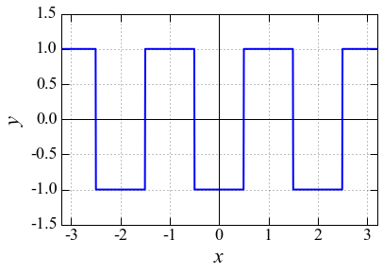

1. Sawtooth wave

