Website Project
Student Name and Number: Adriana Jankiewicz - B00105953
Lecturers: Orla McMahon / Robert Smith

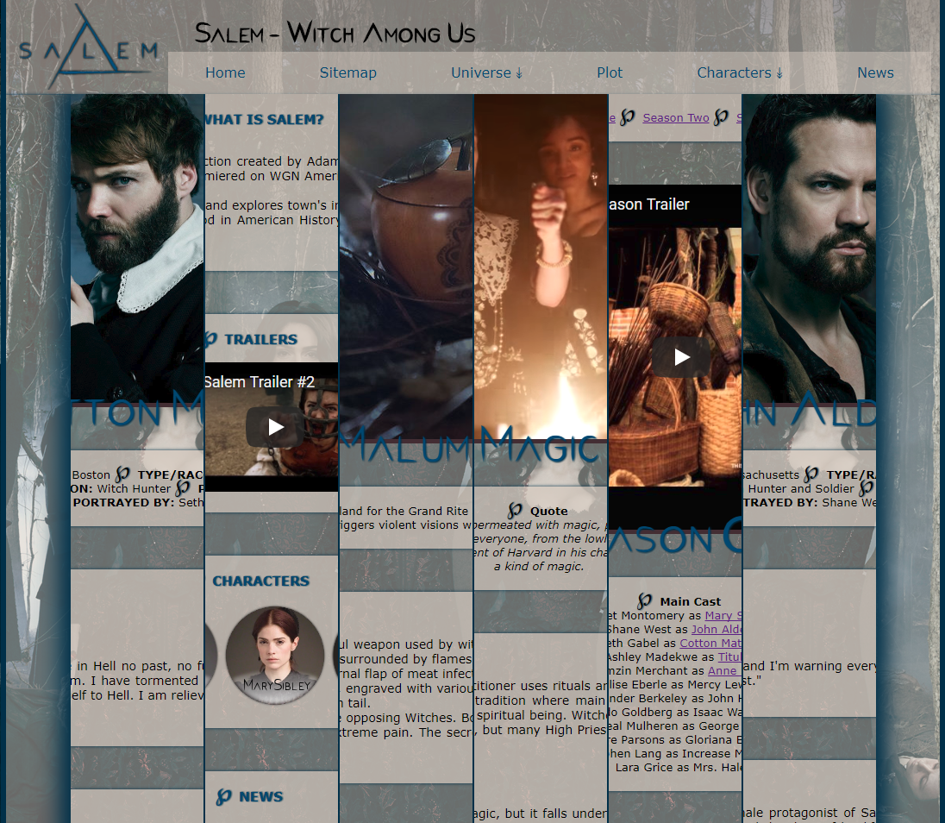

Table of Content

- Abstract ….........................................................................................................................................2
- Wireframe ….....................................................................................................................................3
- Website Structure …..........................................................................................................................5
- How Application Works …................................................................................................................6
- Included Features …..........................................................................................................................6
- What I have learned from this project …...........................................................................................8
- References ….....................................................................................................................................9
- Appendix: Images Used …................................................................................................................9

Abstract
This report is about website project assignment given in the first semester of the first year in Web Development. My theme was Salem, a tv show about supernatural horror and historical fiction done by WGN America.
In this piece of work, I included how I came up with the wireframe and web structure for my website, as well as I included where most of the required features can be found. There is also a short paragraph of what I have learned from this project and all the sources I used.
Wireframe
Long before starting the project, I have made wireframes to fit under each of my web pages –Home, News Enchanted Objects, Magic, Plot and a template page for every character that I wanted to describe.

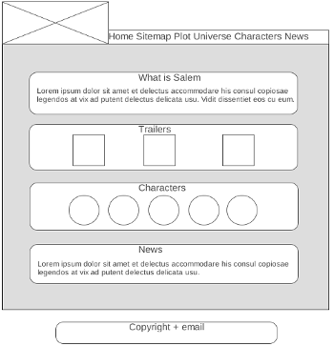
Home Page
I wanted the homepage to act as a teaser showing what Salem – the TV show I picked – is. I decided to include a short description of who created the show, what is it about and where it is set.
Trailers also seemed like a good and unique way to fill out the front page and possibly interest the reader to have a look at what the show is about.
I included the pictures of the main characters and linked them to the full webpages about them.
The news was mostly added in to inform the reader that the show was canceled.

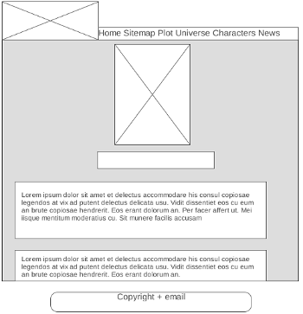
Character/Magic Template
When I was creating the wireframe, I wasn't exactly sure what kind of information I wanted to put in, hence the lack of titles on this one.
I went with a design that is completely different to the standard Wikipedia style where the image is to the side of the screen. Instead, I put it in the very middle of the page to make it the focal point. Underneath I decided to include basic information – where is the character from, occupation, race, powers and who the character is portrayed by. Under that, I included the most memorable quote, description of the character and quick trivia.
This template also works for the Magic webpage.
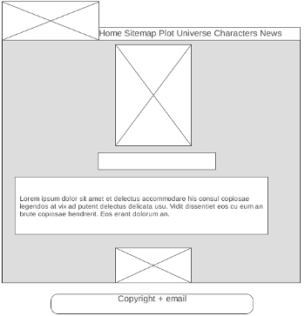
Template for Enchanted Object / Plot
For Objects, I decided to include an image of the item, a short version of what is it used for and a longer description for people who wanted to find out more about them.
I decided to use the same template for Plot webpage as it seemed to suit it very well. Instead of images, I introduced trailer to each season, cast list and summary.

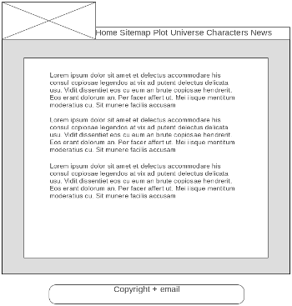
News
This particular webpage was probably the easiest to imagine and to create the wireframe. I wanted to keep it plain.
Website Structure
A website's structure is how the website is set up and how each individual subpages are linked together for easy access. I created this diagram just before I started working on the coding, just to give me an idea of how I want my pages linked. I also use this kind of structure for my navigation bar.
Following this design, I created my sitemap.
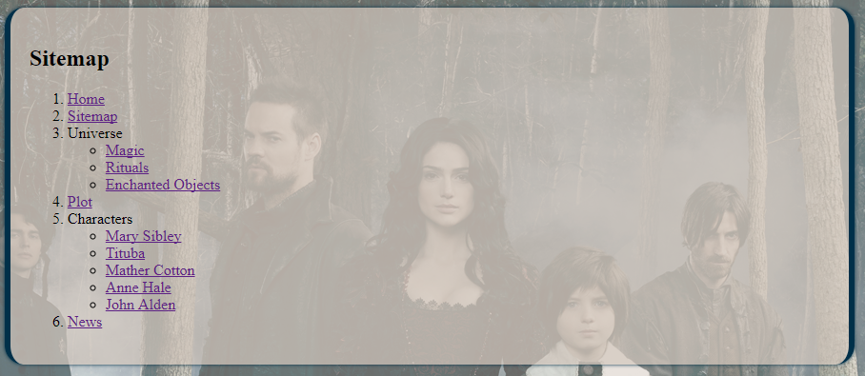
How Application Works
This application works using HTML5 (Hypertext Markup Language - allows for the creation of website) and CSS (Cascading Style Sheets – describes how HTML elements are to be displayed.)

Included Features
For this project, I was asked to demonstrate the following:
- Navigation bar
- Use of background, fonts and colours
- Images with alt tags
- Indented code and comments
- Use of lists – definition, ordered, unordered, nested.
- Use of entities
- Use of internal links, external links, image links, email links and bookmark lists
- Sitemap that connects all pages.
I feel that I included all of the above-required features and they can be seen in use on the following screenshots and on the website. (Sitemap image can be seen on the previous page – shows nested, ordered and unordered lists)
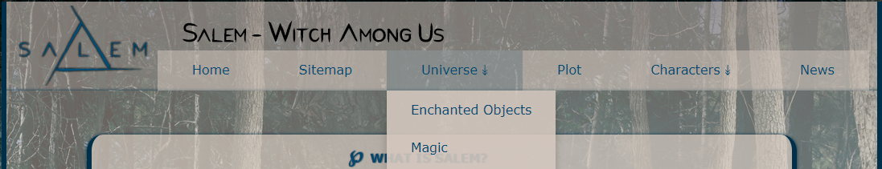Navigation bar, use of entities, colour, font style and background.
Usage of email link and entities once again.
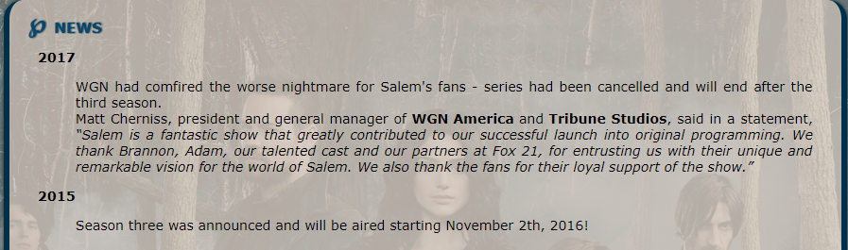Usage of Definition lists and entities.
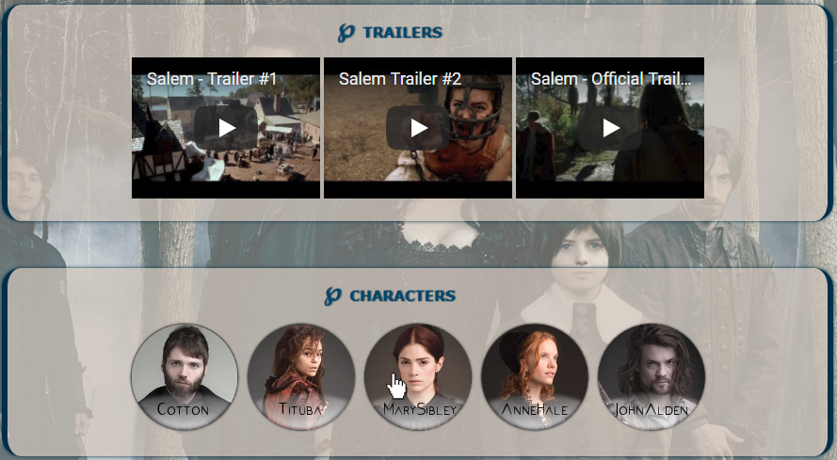Usage of External links(videos) and Image links
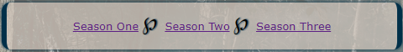Bookmark links - leads to the trailer for clicked season
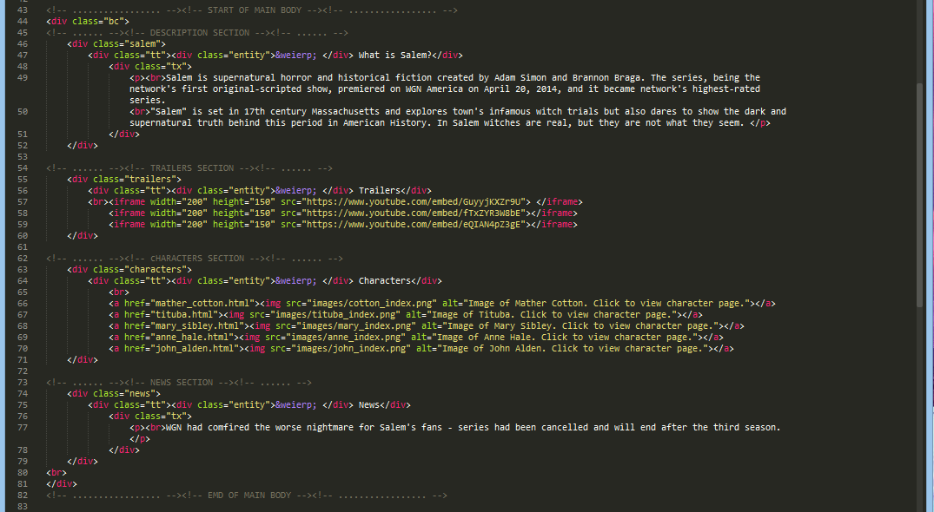Usage of indented code, comments and image alts
What I learned from this project
I learned a lot from this project. While I had previous experience with HTML and CSS, it was never to the extent of creating a whole functional website from scratch, so this project surely expanded my knowledge of coding and how to deal with problems that may arise when you do something for the first time.
I never used codes for the definition list, bookmark link, and email link, so they proved to be a little bit more difficult to get a hang of, especially the first two. It took me a while to get the bookmark links working on the Plot webpage but I was so happy when it finally worked.
Navigation bar was also difficult, as it required a lot of CSS, but I managed to get it working with the notes from the lectures.

Overall, I think this project was a big success as I learned a lot and most importantly, had fun doing it.
References

- www.wireframe.css – wireframe page 4
- www.draw.io - website structure page 6

Appendix
LOGO
logo.png (Image edited – colour change, shadow added)
https://upload.wikimedia.org/wikipedia/en/6/69/The_logo_for_TV_series_Salem.png

BACKGROUND
background.png
http://www.tvgoodness.com/wp-content/uploads/2015/04/CAST_SALEM_S2-Gallery.jpg

MARY SIBLEY
mary.png (Image cropped)
https://vignette.wikia.nocookie.net/the-salem/images/5/5a/Mary_Sibley_S03_Official_photoshoot.jpg/revision/latest?cb=20160826021747

mary_index.png (Image cropped and edited)
https://vignette.wikia.nocookie.net/the-salem/images/5/52/Tumblr_nnqt7u51dW1t0ntu8o2_400.jpg/revision/latest?cb=20150823144051

TITUBA
tituba_index.png (Image cropped and edited)
https://vignette.wikia.nocookie.net/the-salem/images/5/52/Tituba_s01still04.jpg/revision/latest?cb=20160409204428

tituba.png (Image cropped)
https://vignette.wikia.nocookie.net/the-salem/images/1/1b/Tituba_S03_Official_Photoshoot.jpg/revision/latest?cb=20160826021521

MATHER COTTON
cotton_index.png
https://vignette.wikia.nocookie.net/the-salem/images/7/75/S01_--_Photoshoot_--_Rev_Cotton_Mather_03.jpg/revision/latest?cb=20171012084037

cotton.png
https://vignette.wikia.nocookie.net/the-salem/images/b/b5/Cotton_Mather_S03_Official_photoshoot.jpg/revision/latest?cb=20160826021935

ANNE HALE
anne.png (Image cropped)
https://vignette.wikia.nocookie.net/the-salem/images/f/ff/Anne_Hale_S03_official_photoshoot.jpg/revision/latest?cb=20160826021553

anne_index.png (Image cropped and edited)
https://vignette.wikia.nocookie.net/the-salem/images/6/6e/S01_--_Photoshoot_--_Anne_Hale_03.jpg/revision/latest?cb=20171012084041

JOHN ALDEN
john_index.png (Image cropped and edited)
https://vignette.wikia.nocookie.net/the-salem/images/8/89/Tumblr_nnqt7u51dW1t0ntu8o8_1280.jpg/revision/latest?cb=20150823144232

john.png (Image cropped)
https://vignette.wikia.nocookie.net/the-salem/images/7/74/John_Alden_S03_official_photoshoot.jpg/revision/latest?cb=20160826021339

ENCHANTED OBJECTS
malum.png (Image cropped)
https://vignette.wikia.nocookie.net/the-salem/images/8/83/WGN_Salem_The_Malum.jpg/revision/latest?cb=20160103031149

mask.png (Image cropped)
https://vignette.wikia.nocookie.net/the-salem/images/9/91/Normal_salem0202-0958.jpg/revision/latest?cb=20150527193825

angel_tear.png (Image cropped)
https://vignette.wikia.nocookie.net/the-salem/images/0/09/Red_Mercury_globe.jpg/revision/latest?cb=20170213000132

MAGIC
magic.png (Image cropped)
https://vignette.wikia.nocookie.net/the-salem/images/8/87/S02E03_Mary_offering_blood.png/revision/latest?cb=20150409235500

VIDEOS - INDEX
Salem Trailer 1:
https://www.youtube.com/watch?v=GuyyjKXZr9U

Salem Trailer 2:
https://www.youtube.com/watch?v=fTxZYR3W8bE

Salem Official Trailer:
https://www.youtube.com/watch?v=eQIAN4pZ3gE

VIDEOS – PLOT
Season 1
https://www.youtube.com/watch?v=xyBp01IVem4

Season 2
https://www.youtube.com/watch?v=6-2gsJ4lQs4

Season 3
https://www.youtube.com/watch?v=-zYwtonSZus

