|  |
| --- |
|  |
| The Documentation |
| [Type the document subtitle] |
|  |
| **[Your Name]** |
| **[Pick the date]** |

[Type the abstract of the document here. The abstract is typically a short summary of the contents of the document. Type the abstract of the document here. The abstract is typically a short summary of the contents of the document.]

Table of Contents

[To update the table of contents, right click the message below and select Update Field (F9 on PC, ⌥⌘U on Mac).]

**No table of contents entries found.**

1. Pages
   1. Page Tree

superpollo  
 login  
 menu  
 Gestion cliente  
 Consulta cliente  
 Cerrar sesion  
 Información

* 1. superpollo
     1. User Interface

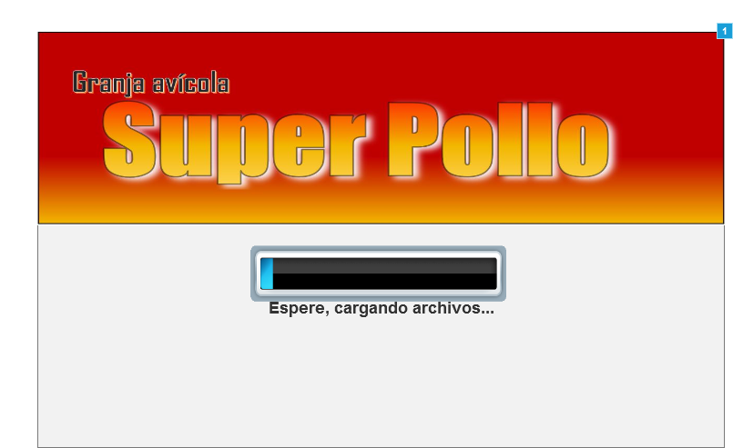

* + 1. Widget Table

| Footnote | Interactions |
| --- | --- |
| 1 | OnLoad:  Case 1:  Wait 6000 ms  Open login in Current Window |

* 1. login
     1. User Interface

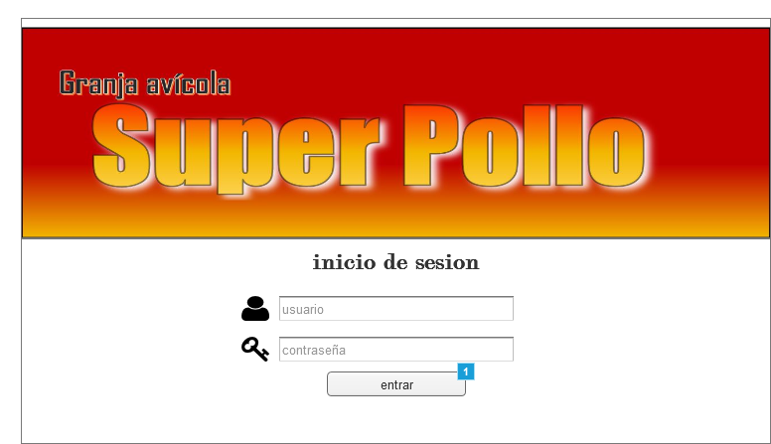

* + 1. Widget Table

| Footnote | Interactions |
| --- | --- |
| 1 | OnClick:  Case 1:  Open menu in Current Window |

* 1. menu
     1. User Interface

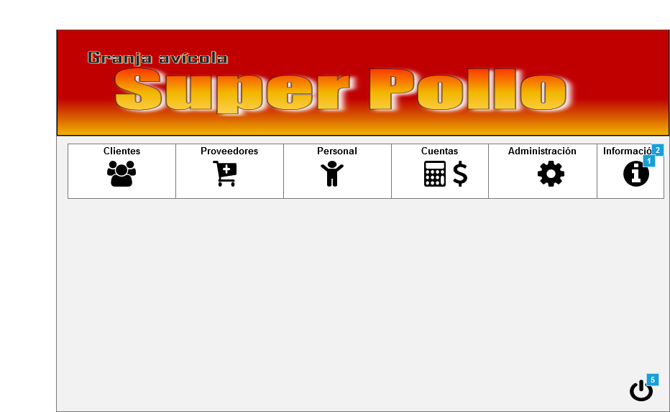

Menu Object

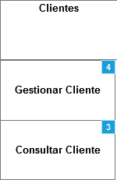 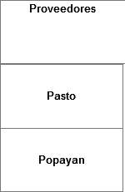 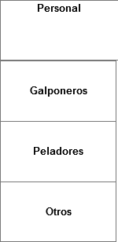 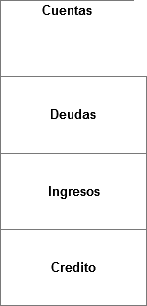 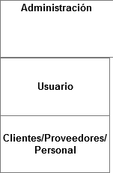

* + 1. Widget Table

| Footnote | Interactions |
| --- | --- |
| 1 | OnClick:  Case 1:  Open Información in Popup Window |
| 2 | OnClick:  Case 1:  Open Información in Popup Window |
| 3 | OnClick:  Case 1:  Open Consulta cliente in Current Window |
| 4 | OnClick:  Case 1:  Open Gestion cliente in Current Window |
| 5 | OnClick:  Case 1:  Open Cerrar sesion in Current Window |

* 1. Gestion cliente
     1. User Interface

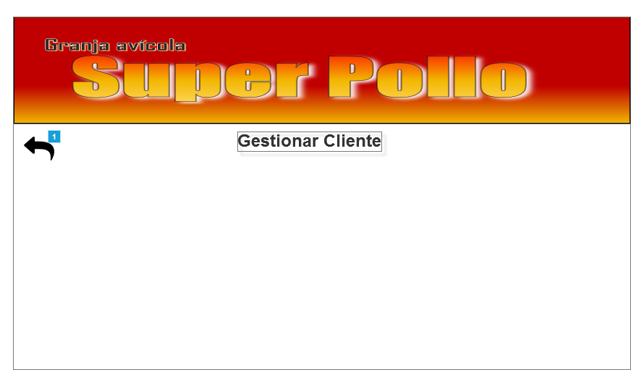

* + 1. Widget Table

| Footnote | Interactions |
| --- | --- |
| 1 | OnClick:  Case 1:  Open menu in Current Window |

* 1. Consulta cliente
     1. User Interface

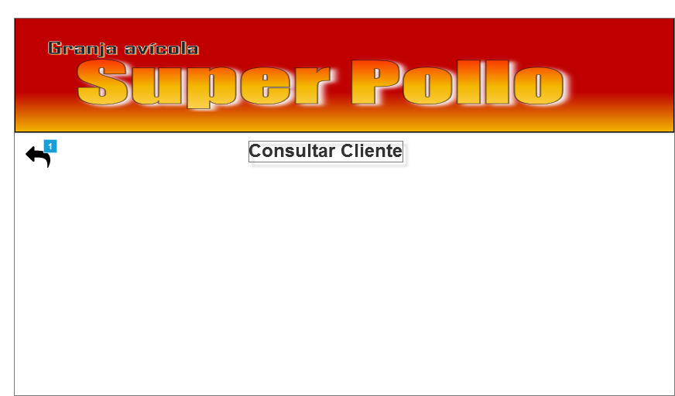

* + 1. Widget Table

| Footnote | Interactions |
| --- | --- |
| 1 | OnClick:  Case 1:  Open menu in Current Window |

* 1. Cerrar sesion
     1. User Interface

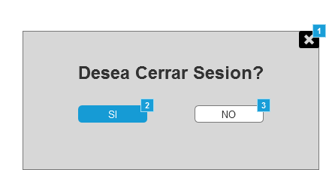

* + 1. Widget Table

| Footnote | Interactions |
| --- | --- |
| 1 | OnClick:  Case 1:  Open Back in Current Window |
| 2 | OnClick:  Case 1:  Open login in Current Window |
| 3 | OnClick:  Case 1:  Open Back in Current Window |

* 1. Información
     1. User Interface

