adrianasandersart.com

My name is Adriana Sanders, and I am a Concept Artist from Michigan State University, specializing in both realistic and stylized art for video games. Check out my portfolio for examples of my work!

My whole life I have been drawn to games that make the user feel warm and cozy, while also being immersive. Games like *Skyrim* and *Halo* inspired me to become a concept artist and create art that completely sucks the player into the game. At Michigan State University, I have designed my own games and studied what makes a game good and well designed. I have spent countless hours creating concept art, modeling 3d props, and coding with my hardworking peers to design games that we love. As you view my art, I hope you find yourself wanting to know more about the characters and the environment, and that they evoke a plethora of feelings.

Personas

**Emma, Riot Games Recruiter Will, Concept Artist Ashley, Gamer**

Comps

Shown below are the Wireframes made for my portfolio website, one showcasing work, and another being an about page:

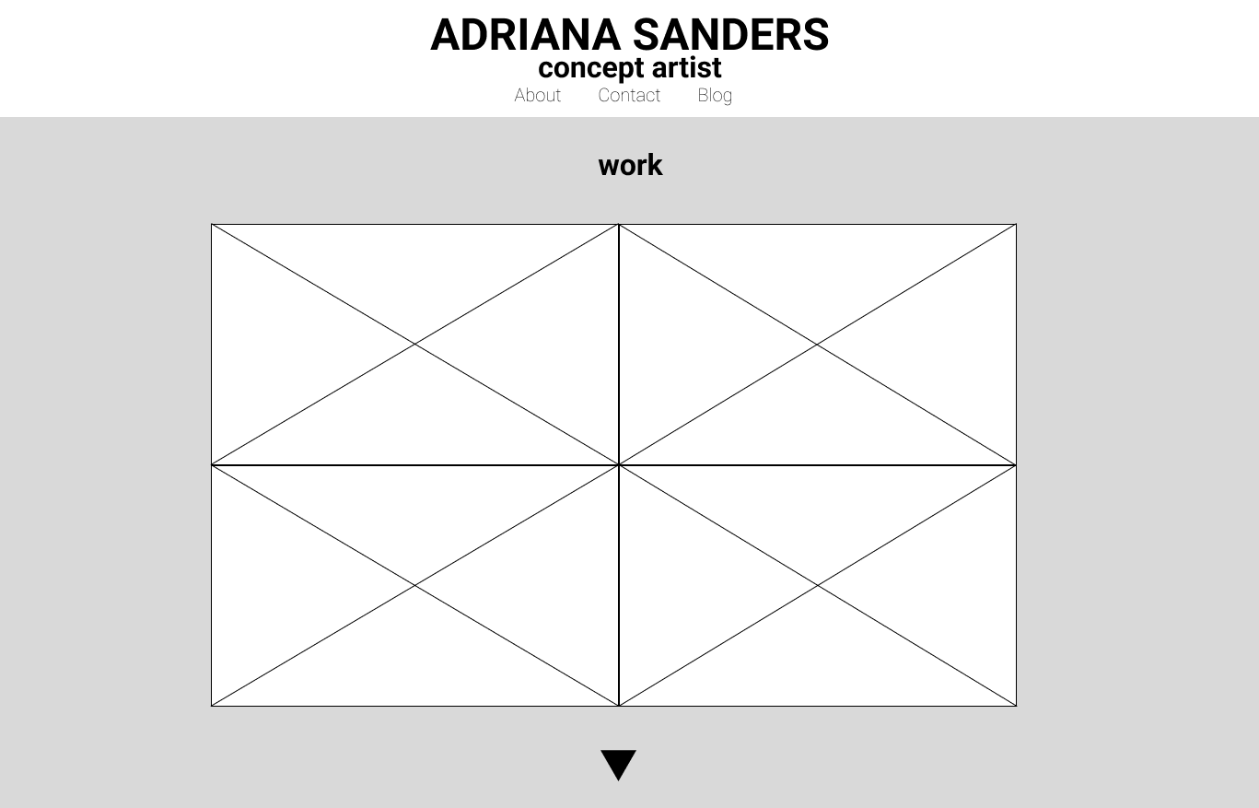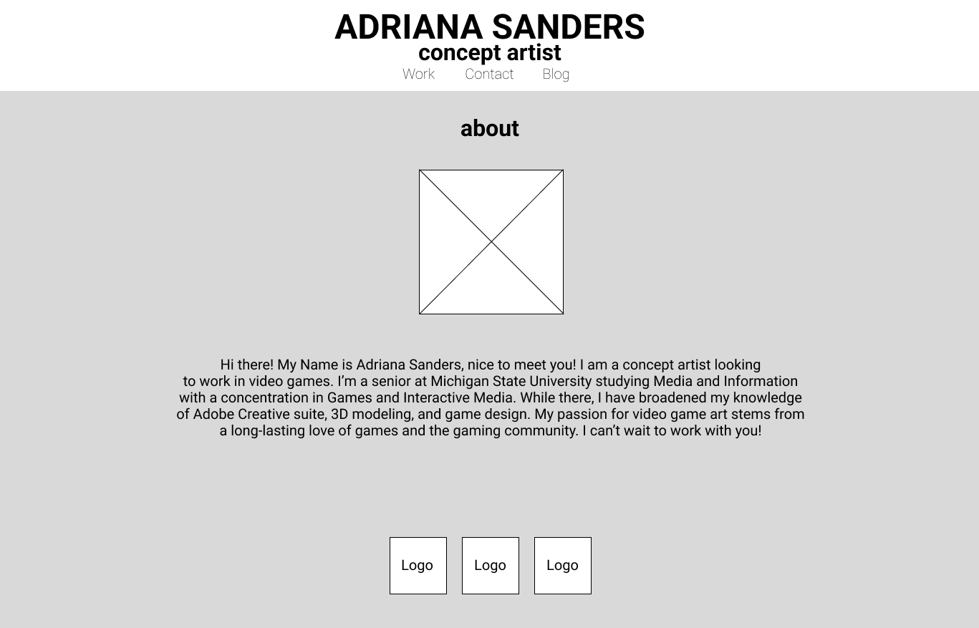

Next, I fleshed out my Wireframes into Comps, showcasing what I want the final to look more like:

Pages will be fully interactive and flow evenly between images, websites, etc.