1. USPS: United States Postal Scripts.
   1. This product serves as a tool for both pharmacies and customers and allows them to submit requests for prescription drug orders to be sent via mail.
   2. Functionality for the available roles:
      1. Customer à Add and update personal information such as Name, Address, phone number, payment method, drug allergies, request refills, and view tracking information.
      2. Pharmacy à View, add and update customer’s information in all fields, in addition to adding prescriptions, refill count, doctor information and view tracking information.
      3. Admin à view, read, and edit all data, and generate reports.
   3. The application is developed on C# and SQL. The program will need to be downloaded and installed in a local environment, which will still require internet connection to make changes or requests to the SQL database.
2. Future implementation:
   1. Implement feature to allow users to set the database address at initial install so that a custom build is not required for each database used.
3. How to install and run the program
   1. Download the .msi installer and run.
   2. When Windows displays a warning stating that the app is untrusted, click on ‘More info’ and then ‘Run Anyway’ as this is normal behavior for an unsigned program.
   3. Run the SQL script included in the repository within your chosen database server (SQL Server, Azure, etc.) to build the database.
   4. Run your own SQL scripts to insert your unique data, or insert your data manually.
   5. Create logins within the database. Each time a new user needs access to the program, the database administrator must create a new login for the user. This ensures that bad actors cannot create their own logins.
4. How to use the Project/program, Provide:
   1. The panel visible to the user of the program will depend on their role. For example, customers will only see the general user panel, pharmacists will see the pharmacist panel and administrators will see the admin panel.
   2. A new user should be instructed to tick the ‘New User’ checkbox at the time of login, but a failsafe will check for whether their data exists regardless.
      1. 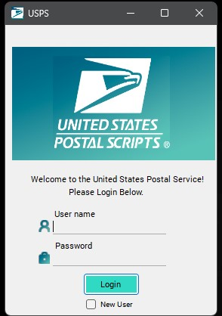
   3. New or current users can then insert or update their information as needed.
      1. 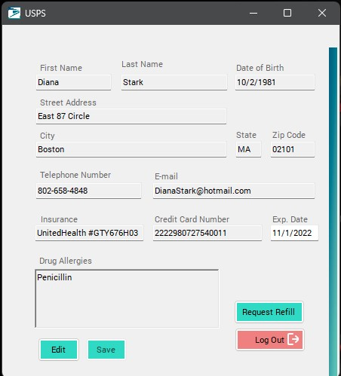
   4. Pharmacists can search by customer first name, last name or date of birth, as well as edit information and view customers’ doctor contact information.
      1. 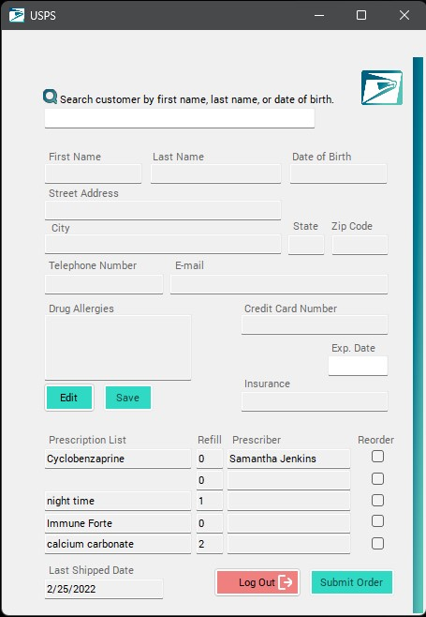
   5. Administrators have the same functionality as pharmacists, with the added ability to generate reports.
      1. 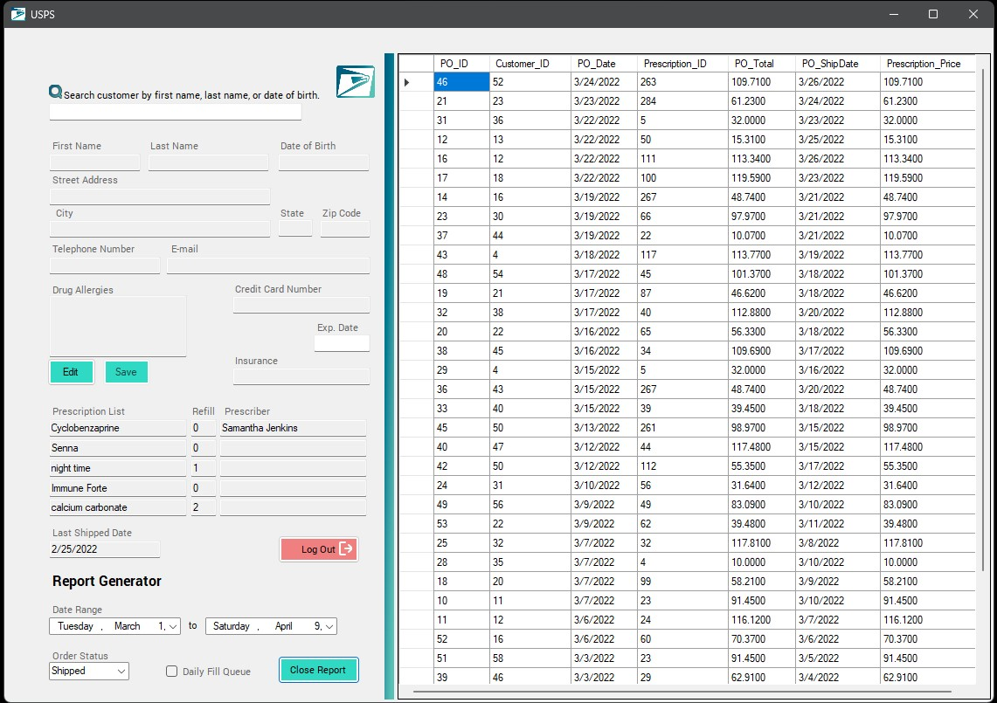
5. The Team
   1. James Soy (Database Design and Implementation)
      1. <https://github.com/JimSoy>
   2. Sara Pak (UI Design)
      1. <https://github.com/Sara-Pak>
   3. Adrian Bartholomew (Programming)
      1. <https://github.com/Adrianbartholome>