case study: animal shelter

## calauit safari park

By: Adriane Troy U. Alariao CC5L Information Management 1

# Introduction

* Calauit Safari Park is a wildlife sanctuary in the Philippines that was originally created in 1976 as a game reserve featuring large African mammals, translocated there under the orders of Ferdinand Marcos during his 21-year rule of the country. It is a 3,700-hectare (37 square kilometers) island off the coast of Palawan in Calamian Island chain home to various species of exotic animals from Africa and endemic Palawan flora and fauna as well. The animals include Zebras, Giraffes, Eland, Waterbucks, Calamian deer, monkeys, fresh water crocodiles, bear cats, bushbuck, porcupines, peacocks and a variety of birds roams freely.

# statement of the problem

* Due to the Island’s capacity and animals roaming freely, the reproduction rate of these animals would be fast and with that the need for registering the offspring as inhabitants will rise. Currently, there are no existing system that allows the management of Caluit safari park to register the existing animals as they are doing it manually using pen and paper. Additionally, the animals aren’t segregated because there are no predators included in the sanctuary, the animals are all in the same enclosure which is the entire Island itself making it harder to monitor the animals.
* Aside from counting the number of the population of each animal, there is also a need to monitor their health of each animals from different species to protect them from diseases and poaching incidents.
* There is also a need to determine the number of staffs from different departments (from the ones that accommodates tourists to the ones who focuses on the well-being of the animals).

# statement of the proposed solution

* The solution that I have come up with is to create a system which lists the number of animals and separate them by species to easily monitor their health status and identify problems like diseases or poaching incidents.
* Aside from their health status, the system will also help in monitoring their behavioral changes in a span of days, weeks, and even months.
* The animals will be separated by their numbers, species, age, gender, and name/code to be easily recognizable.
* The system will also register each staff of the management to keep track of how many individuals are in each department and how well they perform.

# requirements of the business

* For applying as a staff:
  + PSA Birth Certificate
  + SSS E1
  + NBI Clearance
  + Pag-ibig
  + PHILHEALTH
  + Tax forms
  + Diploma & TOR (Transcript of Records)
* For touring:
  + The Island is part of a touring destination as a set

# assumptions and constraints

* The researcher assumed that there are a significant number of animals which reside in the sanctuary.
* The animals are mostly herbivores and there are no predators enclosed with them.
* The provincial government does not allow outsiders to walk in the enclosure freely without guide.
* The local management does not collect tourist information.
* The enclosure is the animal’s permanent residence.
* There is a limit on how much tourist can come each round.
* There is a limit on how many staff can be on-duty.
* The management staff resides near the enclosure but not in the enclosure itself.
* There are many different species of animals in the sanctuary like mammals, birds, reptiles, etc.

# business rules

* The management does not accept imported animals anymore and are focused solely on maintaining the survival of the animals who were translocated there during President Marcos’ term.
* The Safari Park sanctuary used to be a private, non-profit organization, Conservation and Resource Management Foundation (CRMF), was placed in charge of the forest preserve and wildlife sanctuary but was transferred to the provincial government of Palawan on 2008.
* The provincial government keeps a list of the flora and fauna located in the safari park sanctuary’s vicinity.
* The animals roam freely on the island and are monitored by the staff on duty.
* The tourists need to be careful in feeding the giraffes and close contact are limited per animals.
* The management collects information like population, species, age, and gender of each animals.
* Poaching is an illegal act and people caught will get criminal offense.
* The animals are categorized based on species (Mammals, reptiles, amphibians, etc).
* The staff are categorized based on roles (departments focused on touring, monitoring animals, and maintenance).

# create, READ, update, delete (Crud)

|  |  |  |
| --- | --- | --- |
| Entity | Interview notes or Business rules | CRUD Function |
| Animal | Animals which exists in the current sanctuary and newborn offspring from the old animals.  Must be registered with an assigned id and monitored. | CREATE  READ  UPDATE  DELETE |
| Species | The specific information of the animals that are registered in the database.  The species are kept as they should to keep track of which animals reside and have resided in the sanctuary.  The species are assigned with specific id. | CREATE  READ  UPDATE |
| Staff | Management individuals on different departments focusing on tourism and the general welfare of animals in the sanctuary.  The staff should be categorized based on their roles and assigned an id to keep track of their performance.  The timestamps of each staff on-duty must be collected. | CREATE  READ  UPDATE  DELETE |
| Tourist | A list of tourists should be recorded each time they set foot on the island to keep track of how many visitors the sanctuary gets every day, week, month, and year. | CREATE  READ  UPDATE |

# entity relationship diagram (erd)

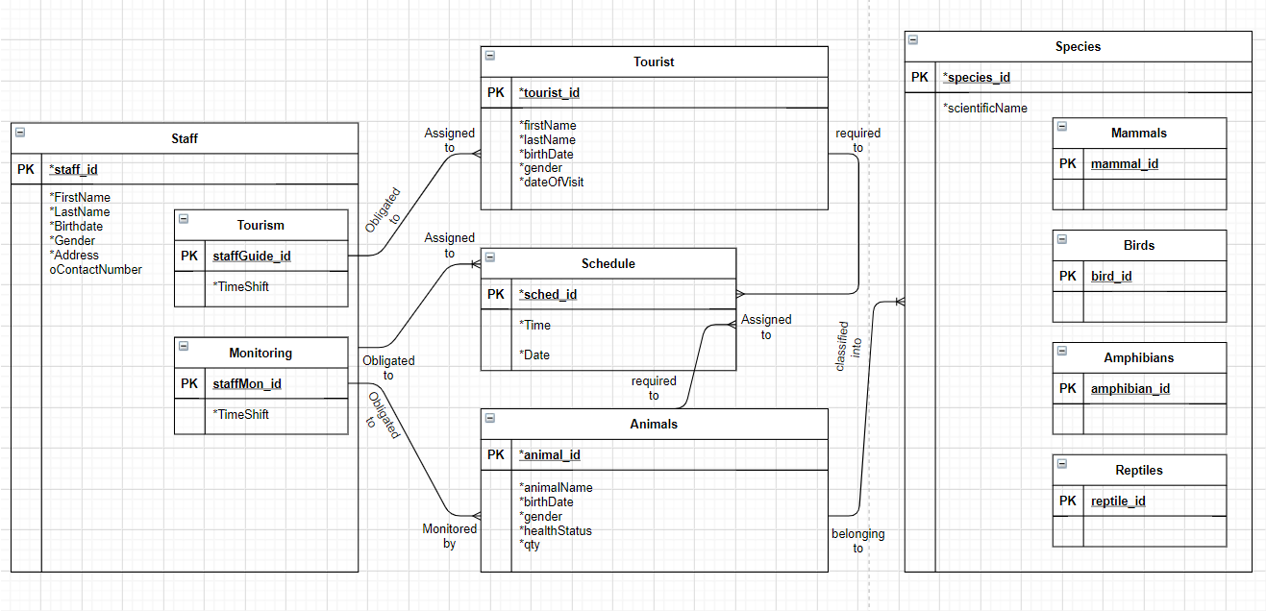

# tables with data sample

Staff_tbl

|  |  |  |  |  |
| --- | --- | --- | --- | --- |
| Attribute | Data Type | Parameter | Description | Sample |
| Staff_id | int | 11 | Persons’ primary key | 1 |
| FirstName | Varchar | 255 | Staff first name | Adriane Troy |
| LastName | Varchar | 255 | Staff last name | Alariao |
| Birthdate | Date | - | Staff birthdate | 03/05/2000 |
| Gender | Varchar | 255 | Staff gender | Male |
| Address | Varchar | 255 | Staff address | Purok Dama de Noche, Brgy. Maunlad, PPC, Palawan |
| ContactNumber | Varchar | 255 | Staff contact number | 9079034450 |

Tourism_tbl

|  |  |  |  |  |
| --- | --- | --- | --- | --- |
| Attribute | Data Type | Parameter | Description | Sample |
| staffGuide_id | int | 11 | Tourist guide’s primary key | 1 |
| TimeShift | DATETIME | - | Tourist guide’s shift | 08/10/2021 10:42PM |

Monitoring_tbl

|  |  |  |  |  |
| --- | --- | --- | --- | --- |
| Attribute | Data Type | Parameter | Description | Sample |
| staffMon_id | int | 11 | Monitoring staff’s primary key | 1 |
| TimeShift | DATETIME | - | Tourist guide’s shift | 08/10/2021 10:42PM |

Tourist_tbl

|  |  |  |  |  |
| --- | --- | --- | --- | --- |
| Attribute | Data Type | Parameter | Description | Sample |
| tourist_id | int | 11 | Tourist’s primary key | 1 |
| FirstName | Varchar | 255 | Tourist’s first name | Adriane Troy |
| LastName | Varchar | 255 | Tourist’s last name | Alariao |
| Gender | Varchar | 255 | Tourist’s gender | Male |
| dateOfVisit | Date | - | Tourist’s date of visit | 08/10/2021 |

Schedule_tbl

|  |  |  |  |  |
| --- | --- | --- | --- | --- |
| Attribute | Data Type | Parameter | Description | Sample |
| sched_id | int | 11 | Schedule’s primary key. | 1 |
| Time | Timestamp | - | Schedule’s time | 10:46 PM |
| Date | Date | - | Schedule’s date | 08/10/2021 |

Animal_tbl

|  |  |  |  |  |
| --- | --- | --- | --- | --- |
| Attribute | Data Type | Parameter | Description | Sample |
| animal_id | int | 11 | Animal’s primary key | 1 |
| animalName | Varchar | 255 | Animal’s name | Cassey |
| birthDate | Datetime | 255 | Animal’s birth date | 08/10/2021 |
| Gender | Varchar | 255 | Animal’s gender | Female |
| qty | int | 11 | Number of animal family | 1 |

Species_tbl

|  |  |  |  |  |
| --- | --- | --- | --- | --- |
| Attribute | Data Type | Parameter | Description | Sample |
| species_id | int | 11 | Species’ primary key | 1 |
| scientificName | Varchar | 255 | Species’ scientific name | Equus quagga |

Mammals_tbl

|  |  |  |  |  |
| --- | --- | --- | --- | --- |
| Attribute | Data Type | Parameter | Description | Sample |
| mammal_id | int | 11 | Species’ primary key | 1 |

Birds_tbl

|  |  |  |  |  |
| --- | --- | --- | --- | --- |
| Attribute | Data Type | Parameter | Description | Sample |
| birds _id | int | 11 | Species’ primary key | 1 |

Amphibians_tbl

|  |  |  |  |  |
| --- | --- | --- | --- | --- |
| Attribute | Data Type | Parameter | Description | Sample |
| amphibians_id | int | 11 | Species’ primary key | 1 |

Reptiles_tbl

|  |  |  |  |  |
| --- | --- | --- | --- | --- |
| Attribute | Data Type | Parameter | Description | Sample |
| reptiles _id | int | 11 | Species’ primary key | 1 |