Pulled docker image from docker hub

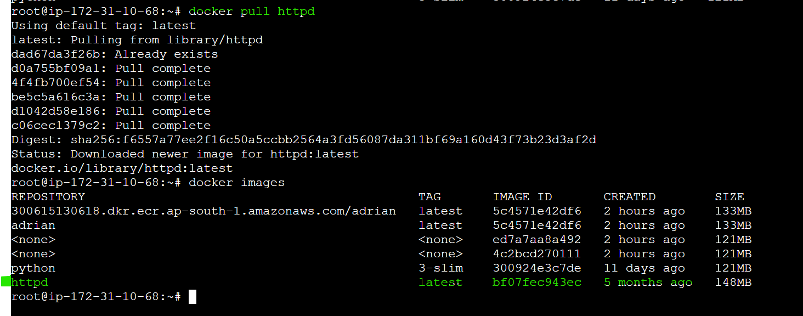

Created container from docker image

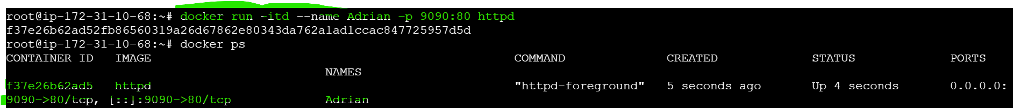

Created docker volume and mounted as below



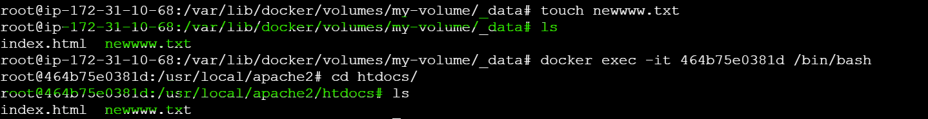

Using Docker Network “host” and created container , able to access with default host port for httpd

