Created Folder structure as below

My-docker/ app/

─ app.py

─ templates/ index.html

My-docker/

Dockerfile

docker-compose.yml

requirements.txt

app/app.py

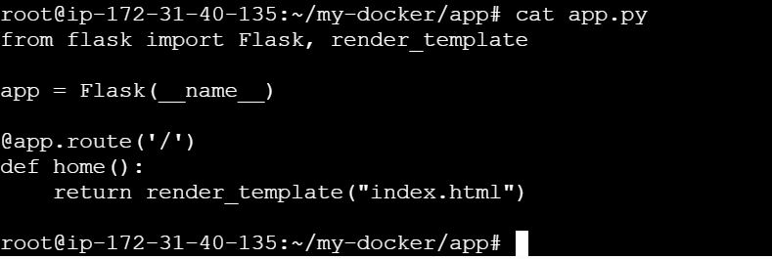

app/templates/index.html

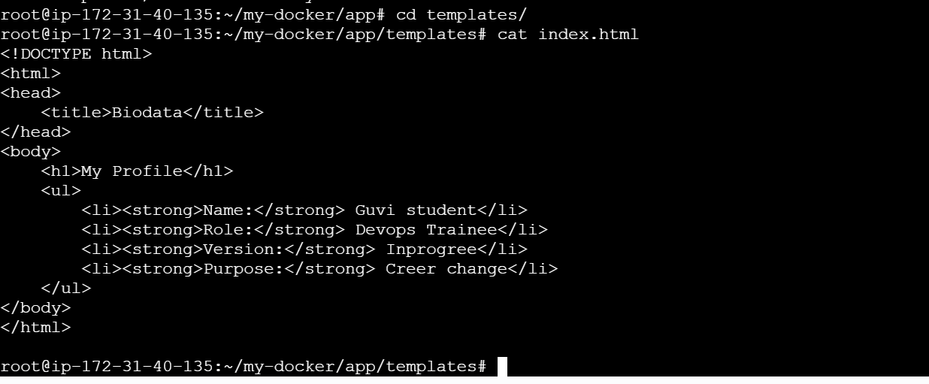

Dockerfile

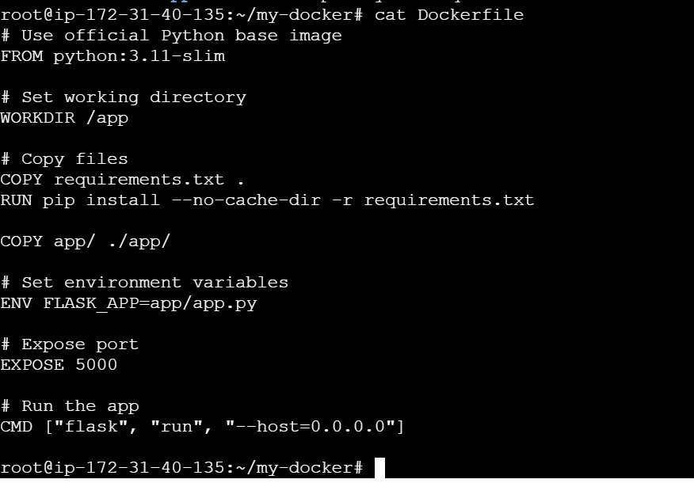

Docker Requirment.yaml

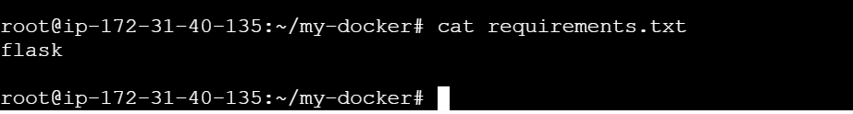

Docker compose.yaml

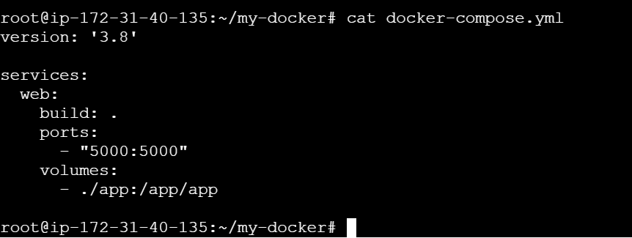

Docker – compose build with detached mode

