Below is the folder structure

task-3-docker/

* Dockerfile
* Html/index.html
* Docker-compose.yaml

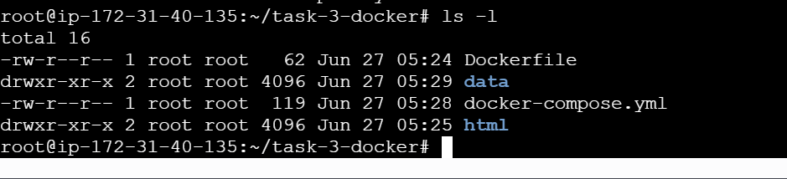

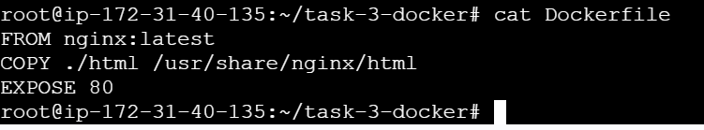

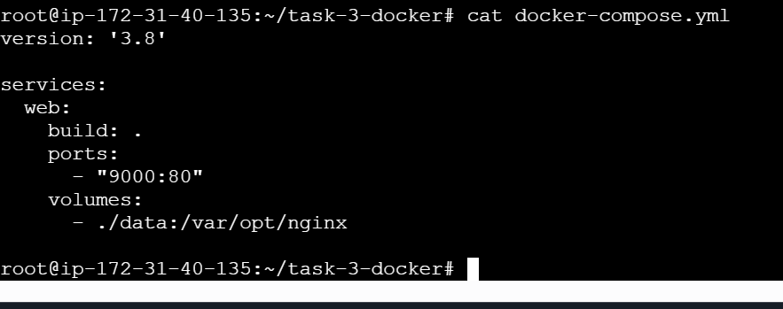

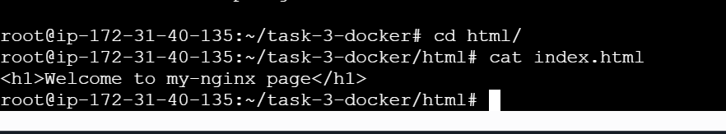

Docker-compose build with detached mode

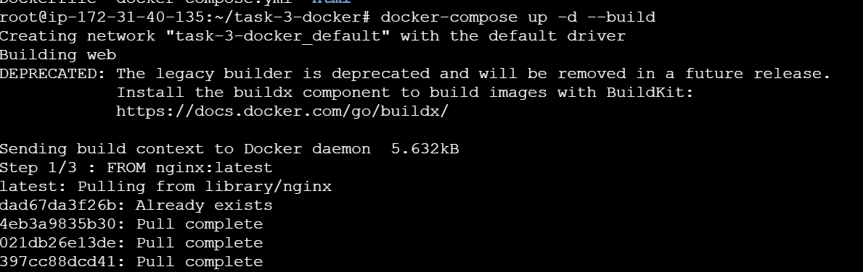

Docker Image



Docker login to push the image

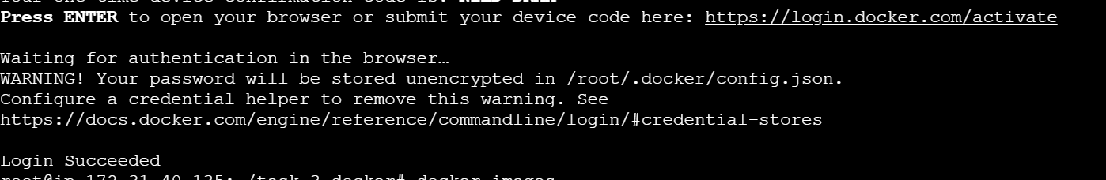

Docker tag

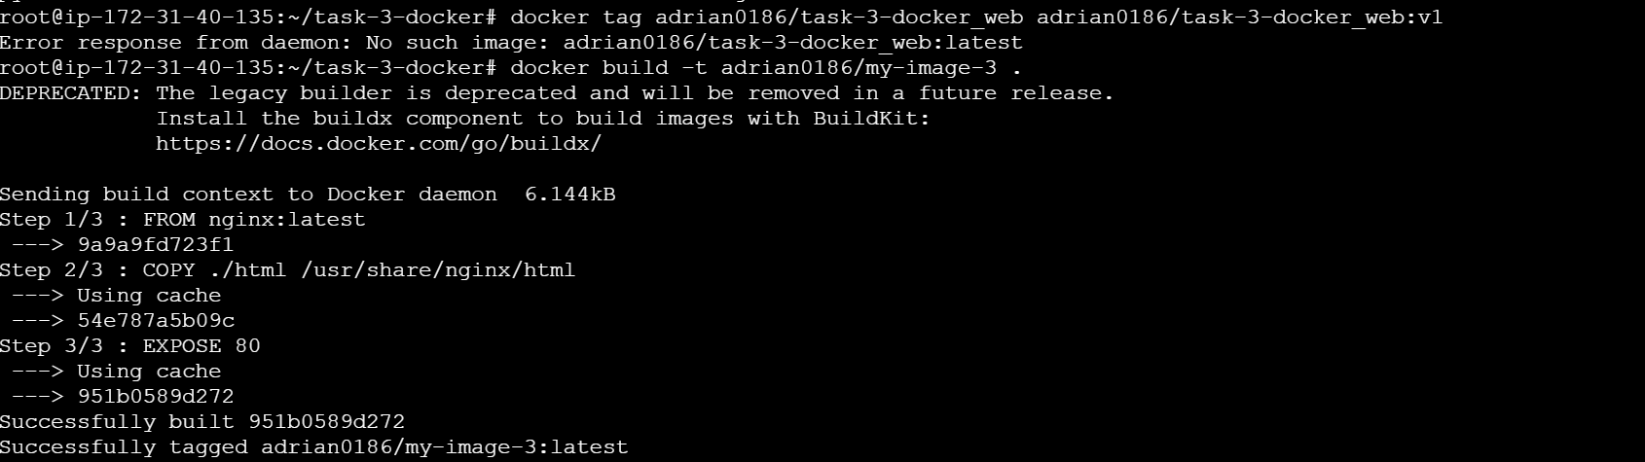

Docker tag image

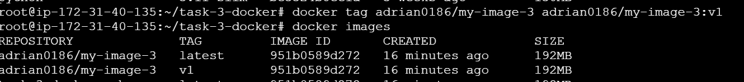

Pushing the image to docker hub

