Installed terraform and configured EKS cluster through terraform

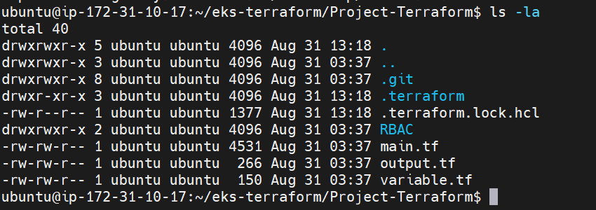

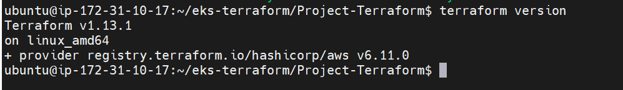

Terraform init

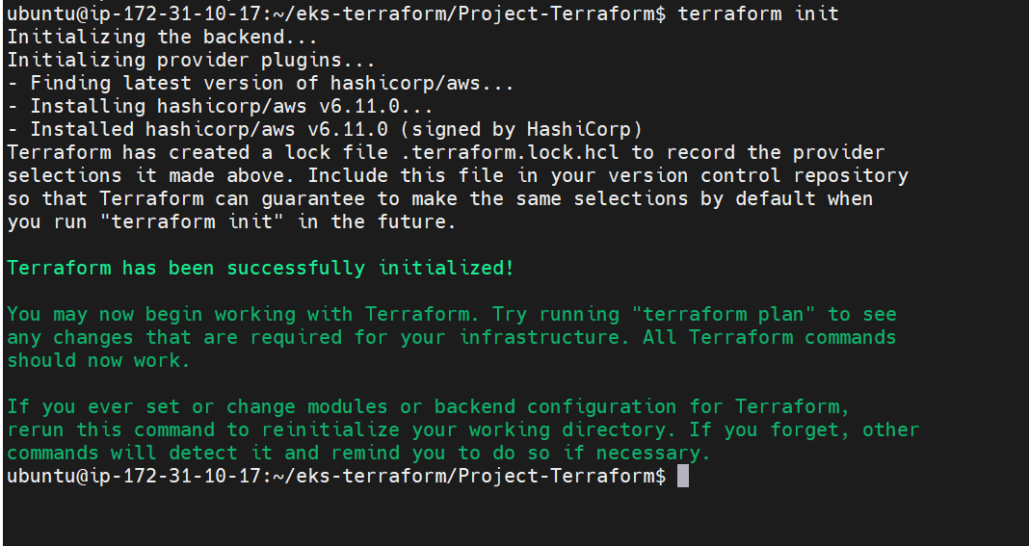



Terraform plan

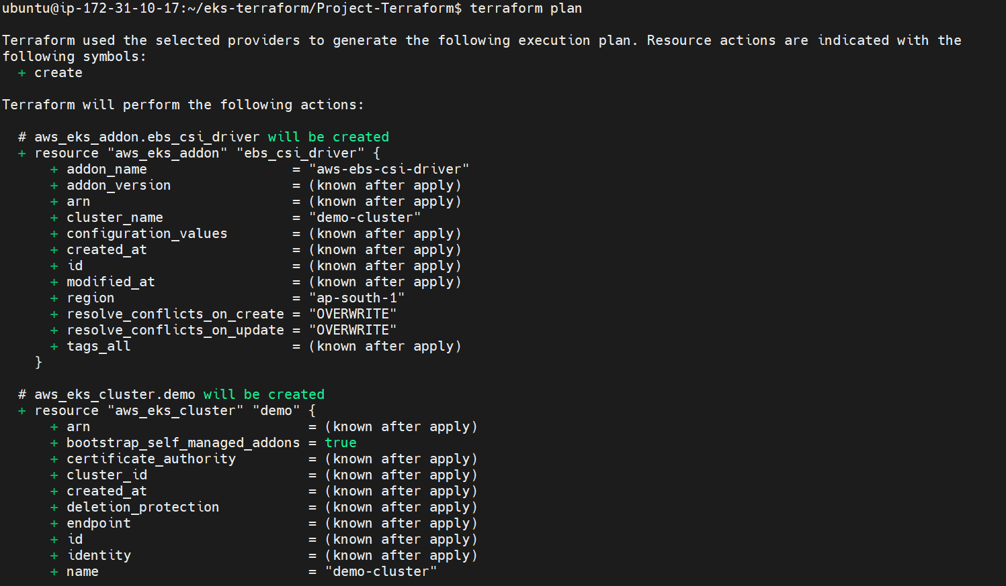

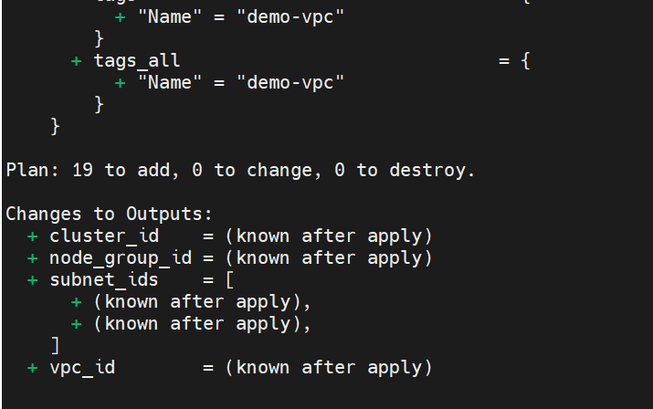

Terraform apply –approve-auto

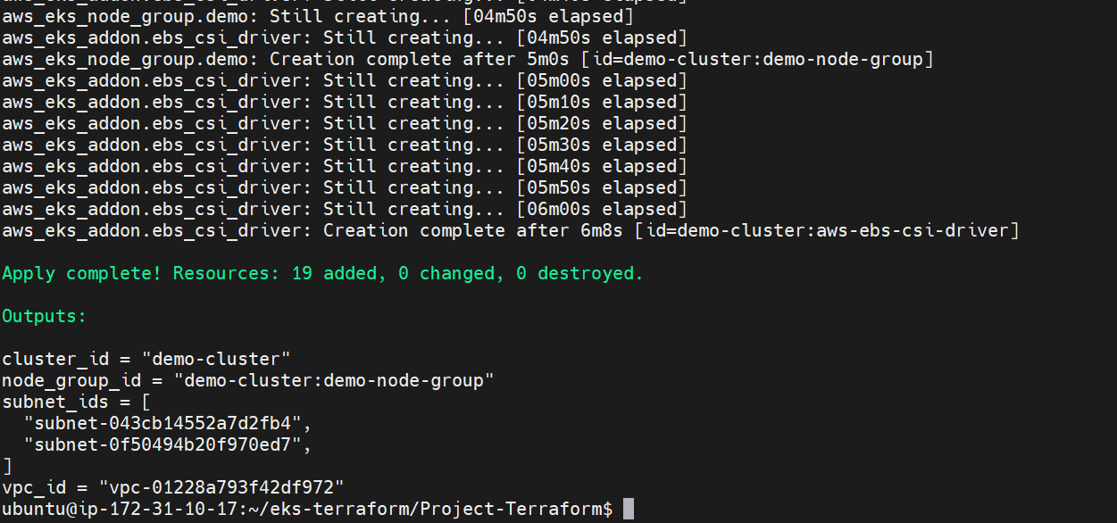

Nodes created

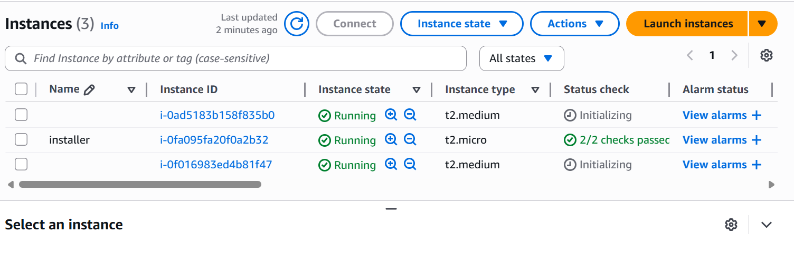

Cluster created

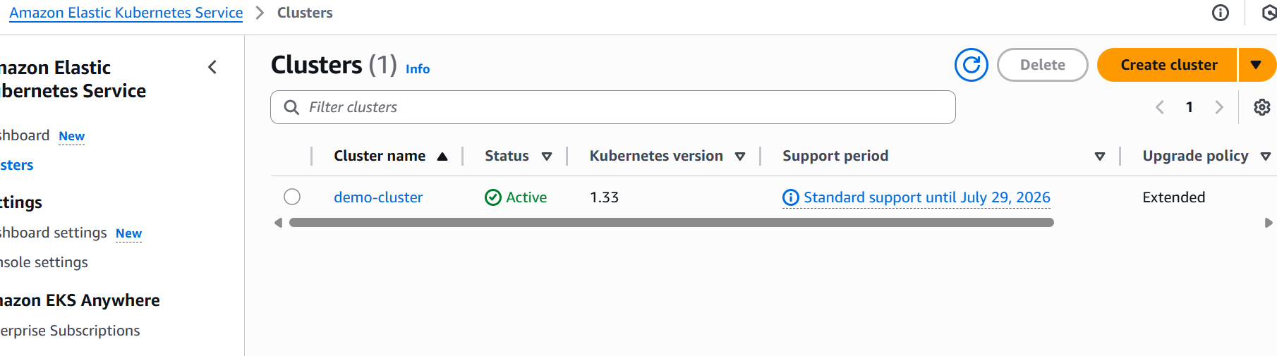

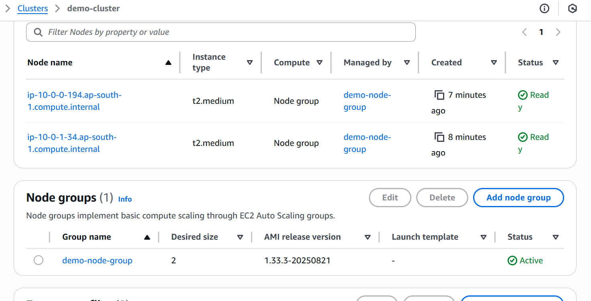

Installed Kubectl to interact and work with eks

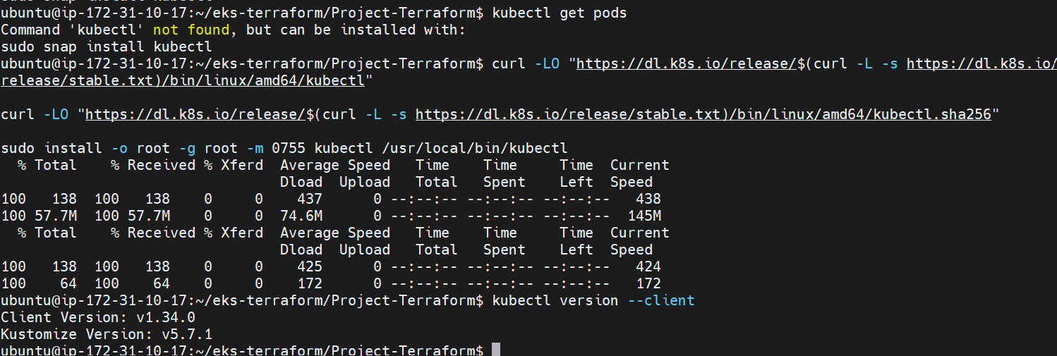

Connected the cluster and region with kubeconfig update

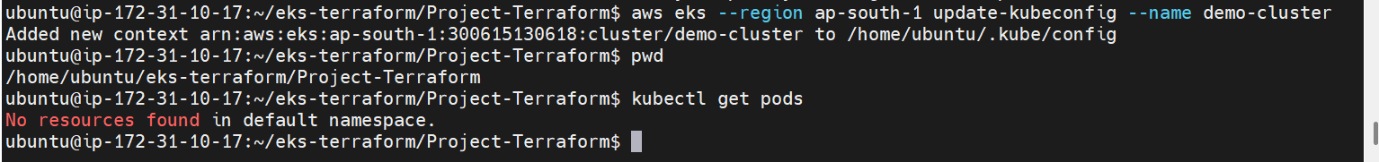

Deployment created

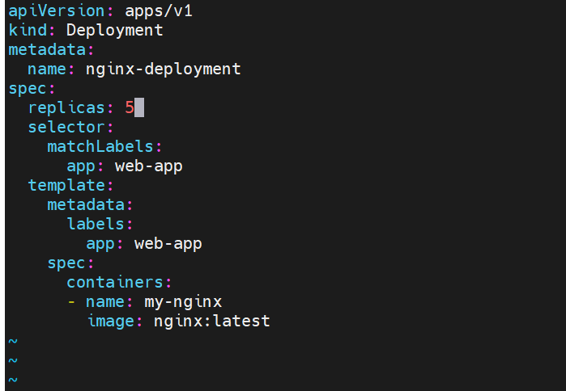

LB created

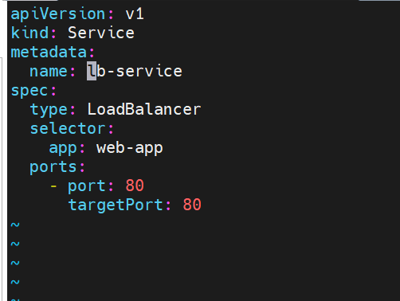

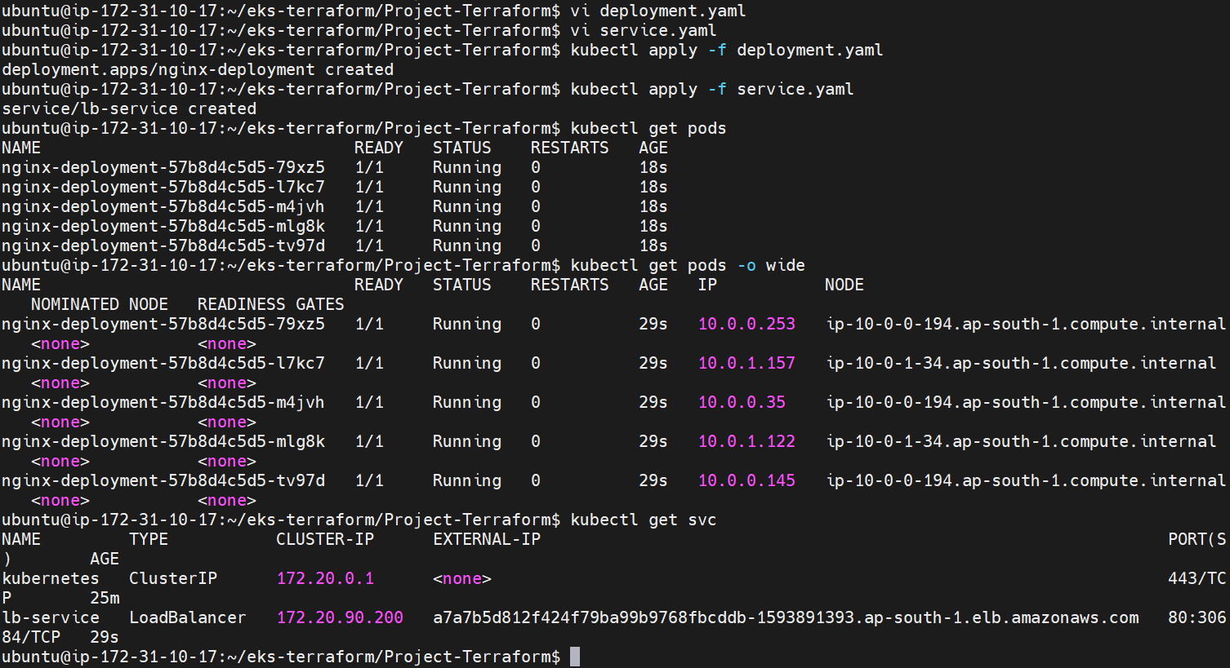

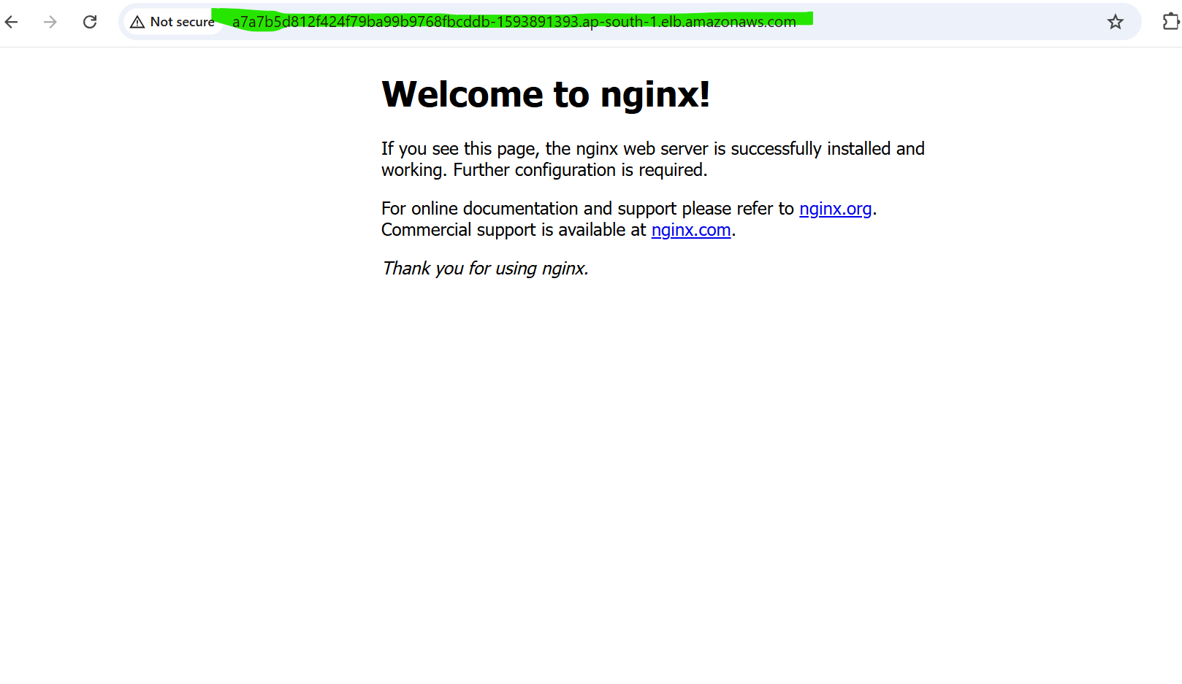

Finally installed eksctl and deleted the cluster using eksctl cmd

**eksctl delete cluster --name demo-cluster --region ap-south-1**

**snapshot below**

