**R Code for Examples in the book**

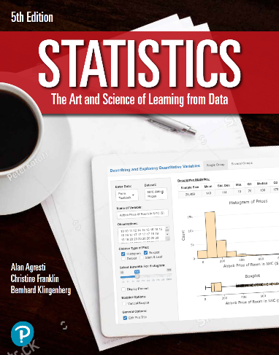

***“Statistics: The Art and Science of Learning from Data”***

**by Agresti, Franklin and Klingenberg, 5th edition**

**Chapter 10**

**Example 3: Standard Error for the Difference of Two Sample Proportions**

## Reading in data for the first proportion

x_1 <- 347  
n_1 <- 11535  
phat_1 <- x_1 / n_1

## Reading in data for the second proportion

x_2 <- 327  
n_2 <- 14035  
phat_2 <- x_2 / n_2

## To compute the mean of the difference

mean <- phat_1 - phat_2  
mean

## [1] 0.006783462

## To compute the standard error of the difference

se <- sqrt((phat_1 * (1 - phat_1) / n_2) + (phat_2 * (1 - phat_2) / n_2))  
se

## [1] 0.001923612