**R Code for Examples in the book**

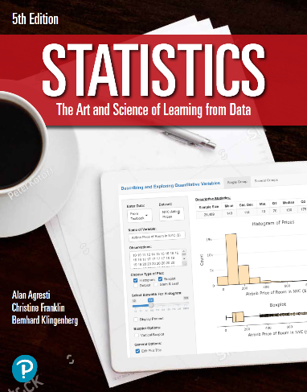

***“Statistics: The Art and Science of Learning from Data”***

**by Agresti, Franklin and Klingenberg, 5th edition**

**Chapter 10**

**Example 5: TV Watching - Significance Test Comparing Two Proportions**

## Reading in the data

x_1 <- 5  
n_1 <- 88  
x_2 <- 154  
n_2 <- 619

## To compute the sample proportions

phat_1 <- x_1 / n_1  
phat_2 <- x_2 / n_2

## Setting null hypothesis

p_0 <- 0

## Computing pooled estimate of the common proportion p under the null hypothesis

phat <- (x_1 + x_2) / (n_1 + n_2)

## To compute the standard error for the test

se_0 <- sqrt(phat * (1 - phat) * ((1 / n_1) + (1 / n_2)))

## To find the test statistic

z <- ((phat_1 - phat_2) - p_0) / se_0

## To compute the p value of the two sided hypothesis test

2 * pnorm(z)

## [1] 5.439141e-05

## 

## Alternatively, you can use the prop.test() function

prop.test(c(5, 154), c(88, 619), correct = FALSE)

##   
## 2-sample test for equality of proportions without continuity  
## correction  
##   
## data: c(5, 154) out of c(88, 619)  
## X-squared = 16.289, df = 1, p-value = 5.439e-05  
## alternative hypothesis: two.sided  
## 95 percent confidence interval:  
## -0.2511242 -0.1328162  
## sample estimates:  
## prop 1 prop 2   
## 0.05681818 0.24878837