**R Code for Examples in the book**

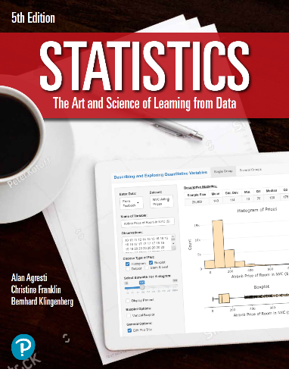

***“Statistics: The Art and Science of Learning from Data”***

**by Agresti, Franklin and Klingenberg, 5th edition**

**Chapter 10**

**Example 7: Standard Error for the Difference of Two Sample Means**

## Reading in data

data <- read.csv(file='https://raw.githubusercontent.com/artofstat/data/master/Chapter10/text_and_graph.csv')

## To subset data to make the two groups

text_and_graph <- subset(data, Graph == 'Yes')  
text_only <- subset(data, Graph == 'No')

## To find sample mean, sample standard deviation, and sample size

xbar_1 <- mean(text_and_graph$Rating)  
xbar_2 <- mean(text_only$Rating)  
sd_1 <- sd(text_and_graph$Rating)  
sd_2 <- sd(text_only$Rating)  
n_1 <- length(text_and_graph$Rating)  
n_2 <- length(text_only$Rating)

## To compute the standard error for the difference

se <- sqrt((sd_1 ** 2 / n_1) + (sd_2 ** 2 / n_2))  
round(se, 3)

## [1] 0.335