**R Code for Examples in the book**

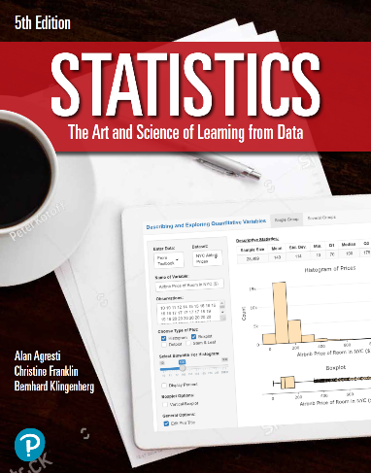

***“Statistics: The Art and Science of Learning from Data”***

**by Agresti, Franklin and Klingenberg, 5th edition**

**Chapter 10**

**Example 8: Confidence Interval for the Difference of Two Means**

## Reading in data

data <- read.csv(file='https://raw.githubusercontent.com/artofstat/data/master/Chapter10/text_and_graph.csv')

## To subset data to make the two groups

text_and_graph <- subset(data, Graph == 'Yes')  
text_only <- subset(data, Graph == 'No')

## To find a 95% confidence interval for the difference of two means

t.test(text_and_graph$Rating, text_only$Rating, conf.level = 0.95)

##   
## Welch Two Sample t-test  
##   
## data: text_and_graph$Rating and text_only$Rating  
## t = 2.1019, df = 57.515, p-value = 0.03995  
## alternative hypothesis: true difference in means is not equal to 0  
## 95 percent confidence interval:  
## 0.03344012 1.37516203  
## sample estimates:  
## mean of x mean of y   
## 6.833333 6.129032